DY2508 25MACE-14A Deployment
Contact
Robert Levine, AFSC/MACE
Robert.Levine@noaa.gov
Work: (206) 526-4337, Mobile: (914) 391-9490

Mooring placement
Preferred site is M14 mooring cluster. If M14 will not be visited, M2 is the secondary choice. Only criteria for alternative location is that bottom depth cannot exceed 90 m.

Immediately prior to deployment
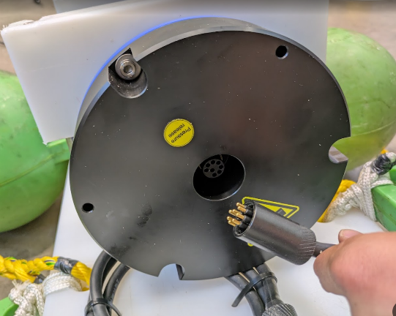
- Attach release/weight assembly to echosounder package via the small anchor shackle. The shackle is noted in red on mooring diagram below. The mouth of the shackle should fit around the release pad eye with the pin passing through the eye. Seize shackle with included wire.
- Connect transducer to pressure case. Remove the two dummy plugs and connect the transducer to the echosounder pressure case using the 8-pin SubConn microcircular connectors.
Note: All instrumentation was powered/enabled prior to shipping, no activation/testing required.
Deployment
- Run slip line to be used for deployment through either of the yellow deployment/recovery rope loops on the sides of the echosounder package.
- Lift mooring over side and lower until echosounder package is at surface.
- Release slip line and allow mooring to fall to seafloor.
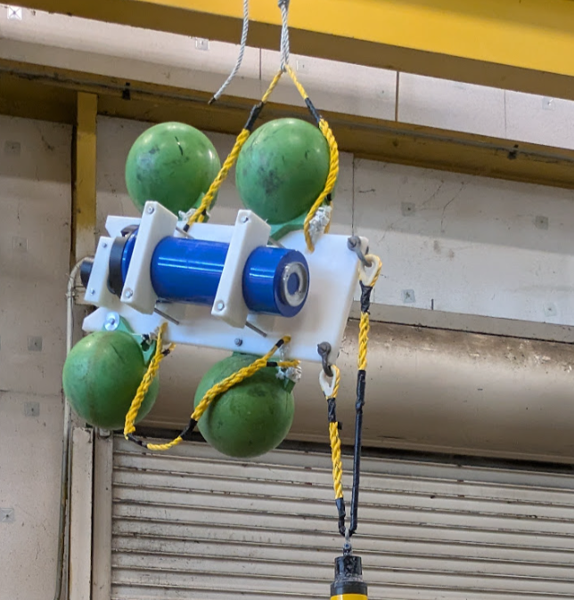
Slip line
Deployment loop
Shackle attachment between echosounder package and release

25MACE-14A Specifications

Total weight (in air): 200 lbs
Total weight (in water): 60 lbs
Total height off bottom: 3.7 m
Operating frequencies: 30 kHz, 200 kHz
Instrument duty-cycle: 2.5%, every 4 hours starting at 0030 UTC
EL Serial No.: 2407590
MF Release Serial No.: 53395

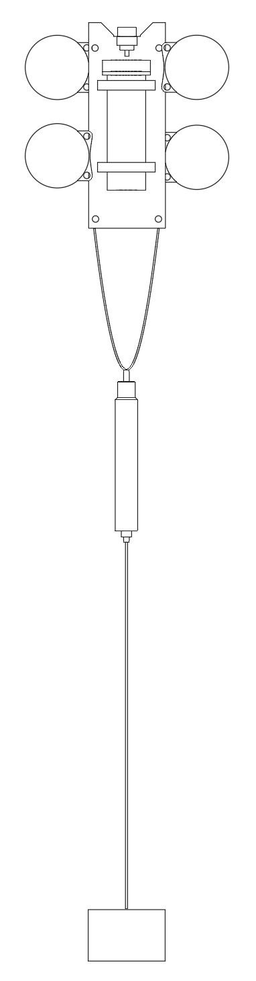
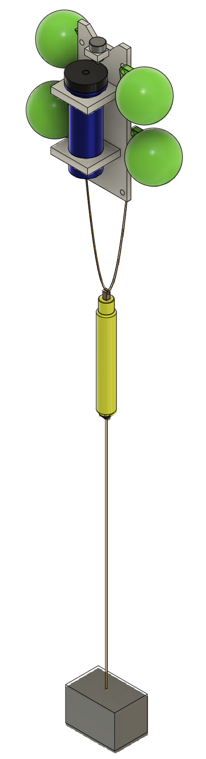
0 m: Weight (92 lbs)
0.75” Shackle
0.5” Poly-pro rope
2.3 m (top): Acoustic release (0.7 m tall)
0.3125” Shackle
0.3125” Shackle
0.5” Shackles
3.7 m (top): Echosounder package (0.8 m tall)
0.5” Poly-pro rope

