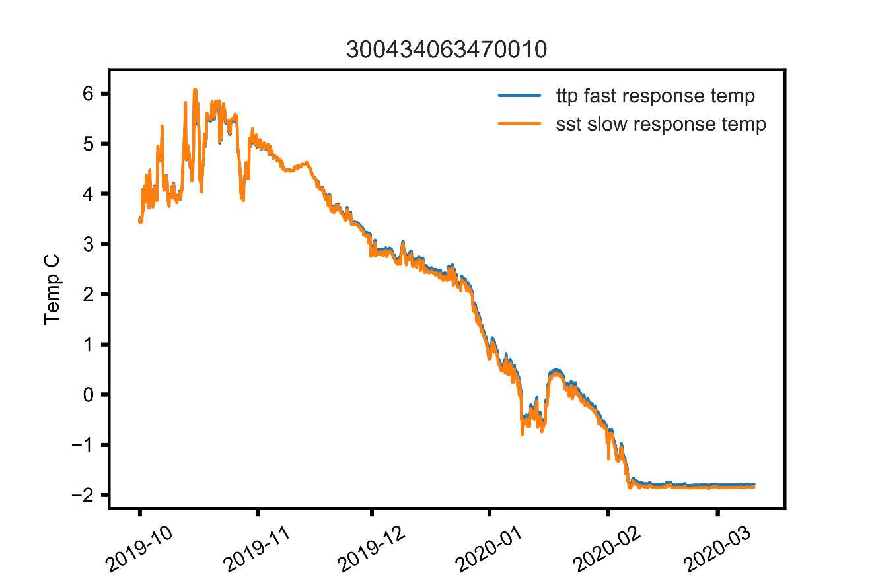

Figure 1. *Hourly bottom temperatures recorded at 60.6118 N 173.4542 W from 2019-10-01 to 2020-03-10 show the timing of the formation of the Bering Sea cold pool to be in the first week of February in 2020.*