Name: chartext
Nav in the middle of banner. CSS only, requires NO JavaScript.



Name: chartext2
Same as above except it has a different html file for a nav at the bottom of the banner

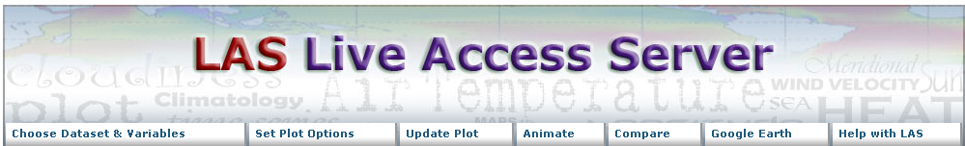

Name: metallicGrn
Requires minimal JavaScript for the hover menus

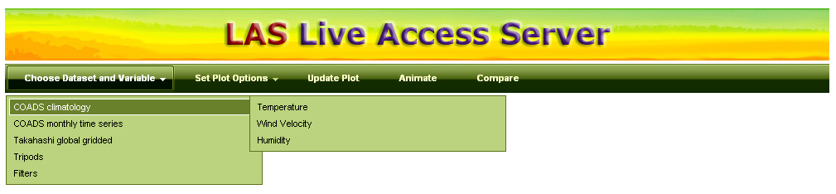

Name: metallicPurp

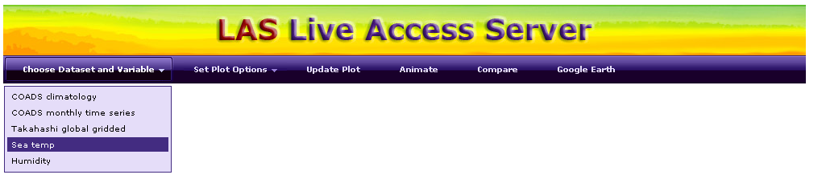

Name: airtemp



This one is obviously the least complicated. It has no artwork (for the navigation), no JavaScript, and minimal CSS (included in the html).

