Load Cell v0

Manual And Operating procedures

Matthew Casari

2016

Table of Contents

1. Introduction 2

2. Operating Procedures 2

2.1. Electrical Characteristics. 2

2.2. Physical and Serial Connections 2

2.3. User Interface 4

2.3.1. Data Retrieval 4

2.3.2. Main Console 4

Appendix A: Mathematical References 11

Statistical Data Pseudo-Code: 11

Mean: 11

Max: 11

Min: 11

STD: 11

Slope & Intercept Calculations Pseudo-Code: 11

# Introduction

After extensive testing of existing load cells on the industrial market, PMEL has concluded that the strain-gauge style load cells do not accurately report load over an extended deployment and therefore has decided to develop their own load cell using measurements from a digital, temperature compensated pressure sensor which converts to load values.

The PMEL Load Cell v0 is the first iteration of a pressure based load cell. It uses the Keller-Druck PA7LD temperature compensated digital pressure sensor and a custom load cell.

# Operating Procedures

## Electrical Characteristics.

Table 1 shows the electrical characteristics of the Load Cell.

Table . System Characteristics

|  |  |
| --- | --- |
| Voltage Input | 2.5 – 24VDC |
| Current Draw (average) | 3.16mA @12VDC |
| Current Draw  (peak) | 4.75mA @12VDC |

## Physical and Serial Connections

Figure 1 diagrams the input connection between the user and the Load Cell.

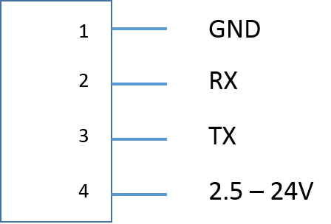

Figure . Main Power/Signal Connector

Figure 2 diagrams the pinout of the power and signal lines between the Load Cell PCB and the Keller PA7LD sensor. Please reference the PA7LD data sheet and user manual to ensure the correct connections when wiring.

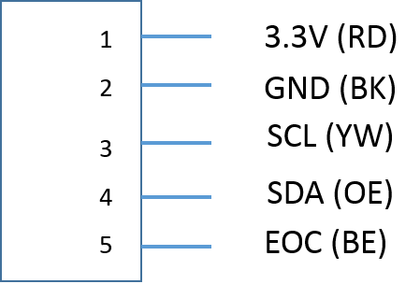

Figure . Keller Connector Pinout

The serial connection parameters between the user and the Load Cell are documented in Table 2.

Table . RS-232 Settings

|  |  |
| --- | --- |
| Baud Rate | 9600 |
| Bits | 8 |
| Parity | No |
| Stop Bit | 1 |
| Transmit | CR & LF |

## User Interface

When the unit is powered on, the system goes into an automatic sampling mode. It will sample at 1-Hz and collect data for 120 seconds. After 120 seconds the buffer will continue to roll over on every sample, providing the most recent 120 seconds worth of data. When commanded by the user, the sampling program stops and calculates the mean load, standard deviation of the load data, and the maximum and minimum loads seen. The mean temperature is also calculated. The data is then transmitted back to the user over the RS-232 connection.

### Data Retrieval

When the user (console or control module attached via RS-232) issues a “**D**” or “**d**”, the sampling mode will halt, the data will be processed and returned via the RS-232 bus to the user. The returned data takes the form seen below:

**@@@[CRC16][LENGTH],[MEAN Load],[STD Load],[MAX Load],[MIN Load], [MEAN Temp]\r\n**

Where:

@@@ is the message header  
[CRC16] is two ASCII (8-bit) values representing 16-bit CRC of all the data from the first comma through \n  
[LENGTH] is two ASCII (8-bit) values representing 16-bit number of ASCII characters following the length  
[MEAN Load] is a ASCII represented floating point value of mean load of the sample  
[STD Load] is an ASCII represented floating point value of the load sample standard deviation  
[MAX Load] is an ASCII represented floating point value of the samples maximum load  
[MIN Load] is an ASCII represented floating point value of the samples minimum load

### Main Console

To enter the console, press **CTRL-C** three (3) times within 10 seconds. You should see the text shown in Figure 3 . From this screen, you can choose from six options (1, 2, 5, 6, 9 or Q) corresponding to: Calibration Mode, Manual Calibration Input, Display Calibration Points, Display Slope & Intercept, Update Serial Number, and Exit.

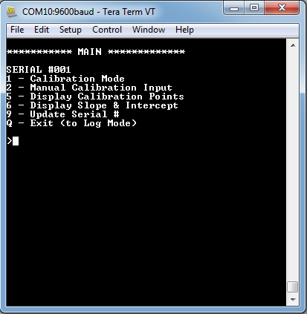

Figure . Console Main Menu.

#### Calibration Console

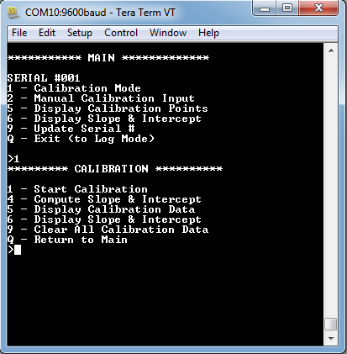

Figure . Calibration Sub-Menu.

In Calibration Mode (seen in Figure 4Figure 4. Calibration Sub-Menu.), the user has six options (1,4,5,6,9,Q) corresponding to: Start Calibration, Compute Slope & Intercept, Display Calibration Data, Display Slope & Intercept, Clear all Calibration Data, and Return to main (1,4,5,6,9,Q).

#### Start Calibration

When entering the ‘Start Calibration’ function, the user is prompted to input the load in lbs. This value should be obtained from an accurate and reliable load cell in-line with this sensor and entered to as many decimal points as known to be reliable.

Once entered and return is pressed (CR & LF must be enabled in the terminal Transmit), the sensor will take 1Hz measurements of the pressure sensor for 10 samples and compute the average. The user input load and the average pressure are stored in temporary memory. The user is then prompted if that data should be saved. If the user responds ‘N’ or ‘n’, the temporary memory will be cleared and the calibration will exit to the calibration menu. If ‘Y’ or ‘y’ is chosen, the temporary memory will be saved into non-volatile memory and the user will be prompted to decide if the new slope and intercept metadata should be saved. If ‘N’ or ‘n’ is chosen, then temporary slope and intercept data will revert to the previous existing slope and intercept data. If ‘Y’ or ‘y’ is chosen, the temporary slope and intercept data will be stored in non-volatile memory, the slope and intercept data will be displayed on the screen, and the program will exit to the Calibration Menu.

NOTE: If this is the first data to be saved since the most recent ‘Clear All Calibration Data’ has been requested, the slope and intercept may register ‘nan’ or an extremely large or small number. Two data points at minimum are required to compute slope and intercept. Run ‘Start Calibration’ again to input another load value with new pressure readings. Up to six data points can be input/collected at this time. If the user commands ‘Start Calibration’ for a seventh time, the first data point will be overwritten. Ensure that there is a large range of values for load so that the line-fitting routine is most accurate.

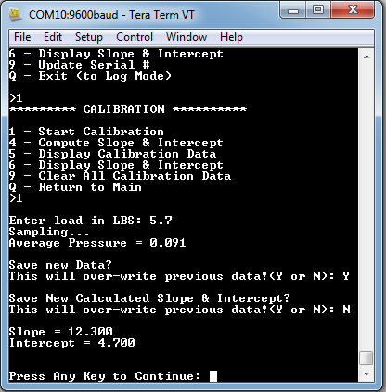

Figure . Entering New Calibration.

#### Start Calibration

This function is not currently enabled.

#### Display Calibration Data

See section 2.3.2.3 for an explanation of this sub-menu.

#### Display Slope & Intercept

See section 2.3.2.4 for an explanation of this sub-menu.

#### Clear All Calibration Data

This menu prompts the user to enter a Yes or No response to clearing all previously recorded data. If commanded ‘Y’ or ‘y’, the calibration points are removed from local memory AND from non-volatile memory, and therefore cannot be retrieved. If ‘N’ or ‘n’ is input, the program returns to the Calibration Menu.

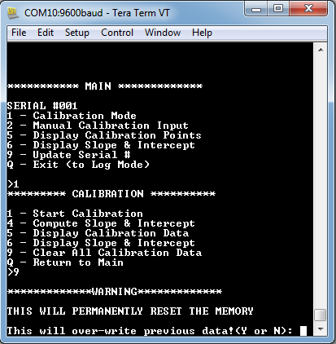

Figure . Clearing Previous Calibration Data.

#### Return to Main

If the user inputs ‘Q’ or ‘q’, the program will exit the Calibration Menu and return to the Main Menu

#### Manual Calibration Mode

Manual calibration mode allows the user to manually input Slope & Intercept metadata values. This may be chosen if the calculated six-point slope & intercept is decided to be too inaccurate. Advanced users can back calculate the pressures from many data points extending beyond the max six data points this sensor allows, calculate their own slope & intercept values, and input them back into the sensor. These values override the sensor computed slope & intercept.

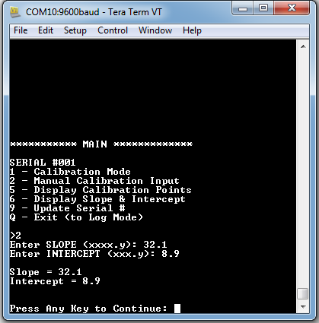

Figure . Manual Metadata Input.

#### Display Calibration Points

The ‘Display Calibration Points’ menu allows the user to view the existing input load and pressures data points used to calculate the slope & intercept metadata.

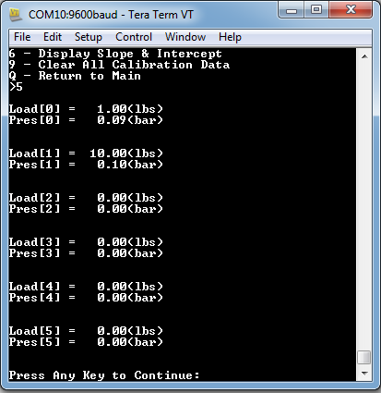

Figure . Displaying Calibration Data in Memory.

#### Display Slope & Intercept

The ‘Display Slope & Intercept’ menu displays the currently used slope & intercept metadata generating output load on data collection.

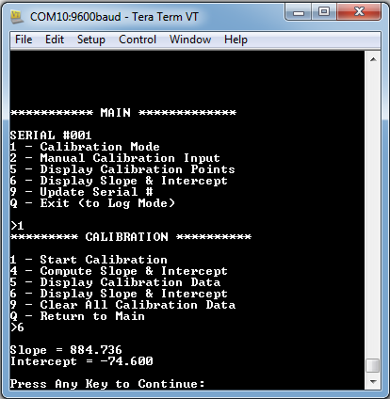

Figure . Displaying Slope & Intercept Metadata.

#### Update Serial Number

The ‘Update Serial Number’ Menu allows the user to input a unique serial number, allowing for tracking of multiple devices across multiple projects. Currently, this is an unsigned integer value, but may be upgraded to an alphanumeric string in future revisions.

#### Quit (to Log Mode)

By entering ‘Q’ or ‘q’, the console clears all the existing data in the buffer and returns the sensor to sampling mode. (See 2.3.1 for how to retrieve data).

# Appendix A: Mathematical References

## Statistical Data Pseudo-Code:

### Mean:

**for (i = 0; i < length of data set; i++)**

**sum += data[i]**

**MeanValue = sum/length;**

### **Max:**

**for (i = 0; i < length of data set; i++) {**

**if(data[i] > DataMax) {**

**DataMax = data[i] }}**

### Min:

**for (i = 0; i < length of data set; i++) {**

**if(data[i] < DataMax) {**

**DataMax = data[i] }}**

### STD:

**for (i = 0; i < length of data set; i++) {**

**Diff = data[i] – MeanValue  
 Diff *= Diff  
 Variance += Diff }**

**Variance /= length**

**STD = sqrt(Variance)**

## Slope & Intercept Calculations Pseudo-Code:

This formula is follows the sum of least squares to determine slope & intercept

**// Calculate the averages of load and pressure**

**for (i = 0; i < length of data set; i++) {**

**MeanLoad += load[i]  
 MeanPressure += pressure[i]**

**}  
MeanLoad /= length  
MeanPressure /= length  
  
// Calculate the slope  
for (i = 0; i < length of data set; i++) {  
 tempLoad = load[i] – MeanLoad  
 tempPressure = load[i] – MeanPressure  
 numerator += (tempLoad * tempPressure)  
 denominator += (tempPressure ^2)  
}  
Slope = numerator/denominator  
  
// Calculate the intercept  
Intercept = MeanLoad – (slope * MeanPressure)**