THE TOGA-COARE BULK AIR-SEA FLUX ALGORITHM
August 22, 2018

C. W. Fairall, Byron Blomquist, and Ludovic Bariteau (NOAA/ERSL/PSD, Boulder, USA)
J.B. Edson (WHOI, Wood Hole, MA)

History
The international TOGA-COARE field program took place in the western Pacific warm pool over 4 months from November 1992 to February1993. Development of a bulk air-sea flux algorithm for use by the COARE community began almost immediately. Based on the model of Liu, Katsaros and Businger (1979, LKB), it took account of the light wind, strongly convective conditions over tropical oceans. Version 1.0 was released in November 1993, and included modifications to the basic LKB code for wind roughness length (Smith, 1988), Monin-Obukhov profile functions for strong convection, and low-wind "gustiness" (Godfrey and Beljaars, 1991). Version 2.0 (August 1994) included code to model the ocean cool skin physics (Saunders, 1967), and also daytime near-surface warming based on a simplified version of the Price, Weller and Pinkel (1986) ocean mixing model (Fairall et al., 1996a). These optional features enabled conversion from bulk to true skin temperature for calculating the fluxes. Calculation of fluxes of momentum (Caldwell and Elliott, 1971) and sensible heat (Gosnell, Fairall and Webster, 1995) due to rainfall were incorporated in the code, as was the so-called Webb correction to latent heat flux which arises from the requirement that the net dry mass flux be zero (Webb et al., 1980). The formalism of this version of the algorithm was fully described in Fairall et al. (1996b).
A major modification to the algorithm was made at a COARE Air-Sea Interaction (Flux) Group Workshop (Bradley and Weller, 1995). Transfer coefficients were reduced by six percent to give better average agreement with covariance latent heat fluxes from several COARE ships. This version 2.5, was used successfully on ocean-atmosphere field campaigns by members of the Flux Group, at various locations and from a variety of platforms. At the following workshop (Bradley and Weller, 1997) it was agreed that, after minor faults were corrected, a version 2.5b COARE bulk algorithm "package", consisting of the Fortran source code, a test data set, and the corresponding computed flux results, would be made generally available. This was released at the final Flux Group workshop (Bradley, Moncrieff and Weller, 1997), and available from several archive sites. Shortly after, a Matlab version was posted on the NOAA web site.
Version 2.5b had been developed using COARE measurements exclusively, which were limited to wind speeds in the range 0-12 ms⁻¹ and the tropical environment. Nevertheless, the algorithm was frequently applied beyond these limits, including by the authors. Between 1997 and 1999 the NOAA air-sea interaction database expanded with directly measured covariance and inertial dissipation fluxes from cruises at higher latitudes and in stronger winds. This enabled further development of the COARE algorithm (Bradley et al. 2000, Fairall et al. 2001). In January 2000 version 2.6a was posted in both Fortran and Matlab codes. It was updated in June 2001 with version 2.6bw, which included the option to calculate momentum roughness lengths using surface gravity wave information. At this stage, with little further modification to either physics or parameterizations, the formalism of the algorithm was published (Fairall et al. 2003), as version 3.0a at the suggestion of a reviewer who felt the advances over 2.5b warranted this. The COARE model framework was adapted to the physics/chemistry of air-sea gas transfer and described by Hare et al. 2004 and later updated as the COAREG31 codes (Fairall et al. 2011).
Version 3.5 was released in 2013 following the publication of Edson et al. 2013, which made adjustments to the wind speed dependence of the Charnock parameter based on a large data base of direct covariance stress observations (principally from a buoy). This led to an increase in stress for wind speeds greater than about 18 m/s. The roughness Reynolds number formulation of the scalar roughness length was tuned slightly to give the same values of Ch and Ce as version 3.0. The diurnal warm layer model was structured as a separate routine instead of embedded in a driver program.
This document describes the new release of version 3.6. There are three components of the new versions:
Meteorological fluxes (stress, sensible, latent heat) – coare36vn_zrf. The notation is 36=version, vn means vectorized code, zrf means it returns values of wind speed, temperature and humidity at user-specified reference heights.
Gas fluxes – coareG36vn_xxx. The notation xxx specifies the gas. Current gases are co2, dms, co, ozone, sf6, and hel. It also returns also returns all met fluxes and means at user-specified reference heights
Hurricane fluxes. The hurricane model is not considered part of the COARE suite because it includes the effects of sea spray and will not be discussed here.

Significant differences between versions 3.5 and 3.6
COARE 2.5 versions were based on concepts and empirical relationships carried over from LKB, modified as described in Fairall et al. (1996b) on the basis of about 800 hours of quality controlled eddy-flux measurements on Moana Wave during the COARE IOP. These were mostly for wind speeds less than 10ms⁻¹. For versions 2.6 and 3.0, transfer coefficients were obtained using a dataset which combined COARE data with those from three other NOAA field experiments, and a reanalysis of the HEXMAX data (DeCosmo et al. 1996). This extended the range to around 20ms⁻¹. The algorithm thus formulated was then validated against a covariance flux database containing 7216 hours of data from all NOAA cruises to 1999, including about 800 hours with wind speeds exceeding 10ms⁻¹ and 2200 hours at high latitudes (Fairall et al. 2003). COARE 3.5 was based on Edson’s buoy data (Edson et al. 2013) and was compared to a large data base (a total of 16,000 hours of observations) combining observations from NOAA, WHOI, and U. Miami (Fairall et al. 2011).
The principal advances in version 3.6 are built around improvements in the representation of the effects of waves on fluxes. This includes improved relationships of surface roughness, z_{o}, and whitecap fraction, W_{f}, on wave parameters.
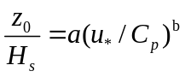 (1a)

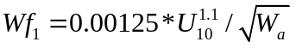 (1b)

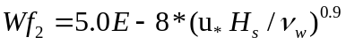 (1c)

Here a and b are constants (0.15 and 2.2), H_{s} the significant wave height, C_{p} the phase speed of waves at the peak of the frequency spectrum, W_{a}=C_{p}/U₁₀ is the wave age, and υ_{w} the kinematic viscosity of seawater. The advances are due to better observations in the HIWINGS field program (Brumer et al. 2017a,b; Blomquist et al. 2018) and the use of a wave model (Banner and Morison 2010; Zappa et al. 2016) to allow us to span the phase space of wave parameters. Equation 1b is from the wave model and 1c from a direct fit to HIWINGS data (see Fig. 1). The whitecap fraction result is critical to capture the bubble enhancement effects in gas transfer. Version 36 also allows near-surface ocean salinity to be specified; Ss=0 is appropriate for lakes while Ss=35 is typical for the ocean.
The major change to the gas transfer algorithm is the adoption of a new specification of whitecap fraction. COAREG specifies the gas transfer velocity, k, as the combination of air-sea and ocean side transfer velocities. Details are provided in the companion writeup, but if we normalize the waterside k_{w} by water-side Schmidt number of 660 (equivalent to CO2 at 20 C), then k660 is approximately the sum of turbulent-molecular diffusivity and bubble-mediated components
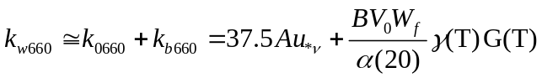 (2)
Here u_{*υ} is friction velocity characterizing the viscous part of the surface stress, α(20) the solubility of the gas at 20 C, γ and G are temperature dependent functions of the gas solubility and Schmidt number, and A and B are constants. The first term on the RHS of (2) is the same for all gases; the second term scales with whitecap fraction and is larger for less soluble gases. For example, the ratio of the second term for CO2 to that for DMS is 5 to 6 (depending on temperature). So, given a specified function for Wf, we use measurements of k for DMS and CO2 to determine B as a function of wind speed. The value of B is sensitive to W_{f} but the value of A is not. Previous versions of COAREG (Hare et al. 2004; Fairall et al. 2011) used a Wf specification proportional to U^{3.4}. The forms given above (Eqs 1b and 1c) yield much lower whitecap fractions at high wind speeds. In COAREG31 A=1.6 and B=1.8; in COARE3.6 we are currently using W_{f2} with A=1.2 and B=2.5.

The bulk algorithm "package"
The "package" consists of the bulk algorithm programs as described above plus additional programs that exercise the algorithms by calling input data files and making some comparison plots. The programs and data files are found on
ftp://ftp1.esrl.noaa.gov/BLO/Air-Sea/bulkalg/cor3_6/

Programs
Meteorology:
coare36vn_zrf .m and coare36vnWarm.m (COARE matlab source code). coare36vn_zrf .m is a vectorized matlab code that takes a specified single line of data or a matrix and returns 42 different parameters. coare36vnWarm.m requires a time series of data because it computes the diurnally forced warm layer which depends on time integrals of the forcing. It is intended to allow a correction of an ocean temperature measurement made at depth (say a ship’s TSG with an intake at 5 m). coare36vn_zrf .m is embedded in the warm layer code.
Exercise programs:
test_coare36.m. No datafile, specifies basic conditions and computes fluxes as a function of wind speed (2 -20 m/s). An example figure shows Cd and Ce as a function of wind speed (Fig. 2)
red_VP_bulk_36.m. Datafile VP_test_data_1.txt. Small dataset from a buoy with bogus values for variables the buoy does not measure. A sample graph shows the time series of latent heat flux (Fig. 3). This program compares versions 3.0 and 3.6.
WarmCoolLayer_check_36.m. Datafile Revelle10minutesLeg3_r3.mat taken from leg3 of the DYNAMO field program. This program exercises the vectorized version of the warm layer code using the Dynamo time series. Fig. 4 shows the time series of water temperature from the PSD seasnake (near surface), the shp’s TSG at 5 m depth, and an estimate of SST computed from TSG and the model warm layer value.
COAREG:
coareG36vn_xxx.m. The notation xxx specifies the gas. Current gases are co2, dms, co, ozo, sf6, and hel.
Exercise programs:
read_vectorCO2_DMS_36.m. Datafiles Avemet10new.mat, DeltaCO2.mat, and SO_GASEX_UH_DMS_Flux_Hourly_Ver2b_nohds2.txt. This program reads data from the GASEX08 field program and graphs comparisons for CO2, DMS, SF6, and He (see Fig. 5).
Test_red_HIWINGS_v5_hr.m. Datafile flux_HIWINGS.mat. Reads the data from HIWINGS field program and compares mean values of algorithm with direct measurements as a function of wind speed. Mean values of k660 for DMS and CO2 are shown in Fig. 6.

Matlab programs

Meteorology
A=coare36vn_zrf(u,zu,t,zt,rh,zq,P,ts,Rs,Rl,lat,zi,rain,Ss,cp,sigH,zrf_u,zrf_t,zrf_q)

% Input:
%
% u = water-relative wind vector magnitude (m/s) at height zu(m)
% t = bulk air temperature (degC) at height zt(m)
% rh = relative humidity (%) at height zq(m)
% P = surface air pressure (mb) (default = 1015)
% ts = water temperature (degC) see jcool below
% Rs = downward shortwave radiation (W/m^2) (default = 150)
% Rl = downward longwave radiation (W/m^2) (default = 370)
% lat = latitude (default = +45 N)
% zi = PBL height (m) (default = 600m)
% rain = rain rate (mm/hr)
% Ss = sea surface salinity (PSU)
% cp = phase speed of dominant waves (m/s)
% sigH = significant wave height (m)
% zu, zt, zq heights of the observations (m)
% zrf_u, zrf_t, zrf_q reference height for profile. Use this to compare observations at different heights
%
%

Warm Layer
B=coare36vnWarm(yday,Ur,zu,Tair,zt,RH,zq,Pair,Tsea,Solar,IR,Lat,Lon,zi,Rainrate,ts_depth,Ss,cp,sigH,zrf_u,zrf_t,zrf_q);

*********** input data **************
% yday= day-of-year
% Ur= wind speed (m/s) relative to water at height zu
% zu= height (m) of wind measurement
% Tair= air temp (degC)at height zt
% zt= height (m) of air temperature measurement
% RH= relative humidity (%) at height zq
% zq= height (m) of air humidity measurement
% Pair= air pressure (mb)
% Tsea= bulk surface sea temp (degC) at ts_depth
% Solar= downward solar flux (w/m^2) defined positive down
% IR= downward IR flux (w/m^2) defined positive down
% Lat= latitude (deg N=+)
% Lon= longitude (deg E=+)
% zi= inversion height (m)
% Rainrate= rain rate (mm/hr)
% ts_depth depth (m) of water temperature measurement
% Ss = sea surface salinity (PSU)
% cp = phase speed of dominant waves (m/s)
% sigH = significant wave height (m)
% zu, zt, zq heights of the observations (m)
% zrf_u, zrf_t, zrf_q reference height for profile. Use this to compare observations at different heights
%

Gas Transfer
[A,G]=coareG36vn_co2(u,zu,t,zt,rh,zq,P,ts,Rs,Rl,lat,zi,rain,Ss,cp,sigH,zrf_u,zrf_t,zrf_q,dCO2)
%

% Input:
%
% u = water-relative wind vector magnitude (m/s) at height zu(m)
% t = bulk air temperature (degC) at height zt(m)
% rh = relative humidity (%) at height zq(m)
% P = surface air pressure (mb) (default = 1015)
% ts = water temperature (degC) see jcool below
% Rs = downward shortwave radiation (W/m^2) (default = function of latitude)
% Rl = downward longwave radiation (W/m^2) (default = function of latitude)
% lat = latitude (default = +45 N)
% zi = PBL height (m) (default = 600m)
% rain = rain rate (mm/hr)
% Ss = sea surface salinity (PSU)
% cp = phase speed of dominant waves (m/s)
% sigH = significant wave height (m)
% zu, zt, zq heights of the observations (m)
% zrf_u, zrf_t, zrf_q reference height for profile. Use this to compare observations at different heights
% dCO2 air-sea delta fCO2, micro-atmospheres
%
In this case, A is the same matrix as returned by coare36vn_zrf while G contains the gas transfer information. The output files are lengthy and described in the codes. If wave information is not available or wind speed formulation is preferred, set cp and sigH=NaN. The codes are configured to compute the cool skin correction to SST (assumes it is a bulk sensor). Cool skin requires To turn off cool skin correction set jcoolx=0. If the water temperature measurement is made at depth, you might consider using the warm layer code.

Example

The COARE routines (coare36vn_zrf.m and coareG36vn_xxx.m) can be executed with a single line of data or with multiple lines in a matrix. Here is a simple example of a single line execution to illustrate using it to compare measurements made from a buoy with those from a ship. The example is taken from Fairall and Bradley (2007), see Fig. 7 (Fig. A1 in their report). Measurements are made from the buoy: SST=25.22 C, ta=24.7 C (zt=2.88 m), u=5.0 m/s (zu=3.22 m), and RH=77 (zq=2.88 m). We use P=1010 mb and bogus values for Rl=320 W/m² and Rs=200, rain=0, and zi=600m. The ship sensors are at zrf_u=18 m, zrf_t=17.4 m, and zrf_q=17.4 m. We can execute the following line

u=5;At=coare36vn_zrf(u,3.22,24.7,2.88,77,2.88,1010,25.22,200,320,10,600,0,35,NaN,NaN,18,17.4,17.4);At(:,21:24) ;

and At will a line of data with 43 parameters – 21 through 24 will be the mean values at the ship heights.

u ta qa RH
At(21:24) ans = 5.5595 24.5417 14.4682 75.2592
Buoy values 5.0 24.7 77.0

Thus, we expect the wind speed at the ship sensors to be about 0.5 m/s higher, the air temperature about 0.15 C lower, and the RH to be about 1.7 % lower. Notice that if we reverse the process

u=5.56;At=coare36vn_zrf(u,18,24.54,17.4,75.26,17.4,1010,25.22,200,320,10,600,0,35,NaN,NaN,3.22,2.88,2.88);

Then we will recover the original values.

References

Banner, M.L., and R. Morison, 2010: Refined source terms in wind wave models with explicit wave breaking prediction. Part I: Model framework and validation against field data. Ocean Modelling, 33, 177-189. DOI: 10.1016/j.ocemod.2010.01.002.
Beljaars, A. C. M., and A. A. M. Holtslag, 1991: Flux parameterization over land surfaces for atmospheric models. J. Appl. Meteor., 30, 327-341.
Blomquist, B., C.Fairall, B.Huebert, S.Brumer, M.Yang, L.Bariteau, C.Zappa, I.Brooks, J.Prytherch, J.Hare, 2017: Wind speed and sea state dependencies of air-sea gas transfer: results from the High Wind speed Gas exchange Study (HiWinGS). J. Geophys., Res., 122, https://doi.org/10.1002/2017JC013181.
Bradley, E.F., and R.A. Weller, 1995: Third Workshop of the TOGA COARE Air-Sea Interaction (Flux) Working Group. Honolulu, 2-4 Aug 1995. UCAR/TCIPO. UCAR Communications, PO Box 3000, Boulder CO 80307-3000 USA.
Bradley, E.F., and R.A. Weller, 1997: Fourth Workshop of the TOGA COARE Air-Sea Interaction (Flux) Working Group. Woods Hole, 9-11 Oct 1996. UCAR/TCIPO. UCAR Communications, PO Box 3000, Boulder CO 80307-3000 USA.
Bradley, E.F, M.W. Moncrieff and R.A. Weller, 1997: Joint workshop of the TOGA COARE Flux and Oceans Working Groups, and the GEWEX GCSS Working Group 4. Boulder, Colorado, 14-16 May 1997. NCAR/MMM, PO Box 3000, Boulder CO 80307-3000 USA.
Brumer, Sophia E., Christopher J. Zappa, Ian Brooks, Hitoshi Tamura, Scott M. Brown, Byron Blomquist, Christopher W. Fairall, James B. Edson, and Alejandro Cifuentes-Lorenzen, 2017a: Whitecap coverage dependence on wind and wave statistics as observed during SO GasEx and HiWinGS. J. Phys. Oce., 47, 2211-2235, DOI: 10.1175/JPO-D-17-0005.
Brumer, S. E., C. J. Zappa, B. Blomquist, C. Fairall, A. Cifuentes-Lorenzen, J. Edson, I. Brooks, and B. Huebert, 2017b. Wave-related Reynolds number parameterizations of CO2 and DMS transfer velocities. Geophys. Res. Lett., 44, https://doi.org/10.1002/2017GL074979.
Caldwell, D.R. and W.H. Elliott, 1971: Surface stresses produced by rainfall. J. Phys. Oceanog. 1, 145-148.
DeCosmo, J., K. B. Katsaros, S. D. Smith, R. J. Anderson, W. A. Oost, K. Bumke, and H. Chadwick, 1996: Air-sea exchange of water vapor and sensible heat: The Humidity Exchange Over the Sea (HEXOS) results. J. Geophys. Res., 101, 12001-12016.
Edson, J.B., J. V. S. Raju, R.A. Weller, S. Bigorre, A. Plueddemann, C.W. Fairall, S. Miller, L. Mahrt, Dean Vickers, and Hans Hersbach, 2013: On the Exchange of momentum over the open ocean. J. Phys. Oceanogr., 43, 1589–1610. doi: http://dx.doi.org/10.1175/JPO-D-12-0173.1
Fairall, C.W. and E.F. Bradley, 2007: A guide to making climate quality meteorological and flux measurements at sea. NOAA Tech. Memorandum OAR PSD-311. ESRL, Boulder CO, pp109. ftp://ftp1.esrl.noaa.gov/../BLO/Air-Sea/wcrp_wgsf/flux_handbook/fluxhandbook_NOAA-TECH%20PSD-311v3.pdf
Fairall, C.W., E.F. Bradley, J.S. Godfrey, G.A. Wick, J.B. Edson, and G.S. Young, 1996a: The cool skin and the warm layer in bulk flux calculations. J. Geophys. Res. 101, 1295-1308.
Fairall, C.W., E.F. Bradley, D.P. Rogers, J.B. Edson, G.S. Young, 1996b: Bulk parameterization of air-sea fluxes for TOGA COARE. J. Geophys. Res. 101, 3747-3764.
Fairall, C.W., E.F. Bradley, J.E. Hare, A.A. Grachev, and J.B. Edson, 2003: Bulk parameterization of air-sea fluxes: Updates and verification for the COARE algorithm. J. Climate 16, 571-591.
Fairall, C.W., Mingxi Yang, Ludovic Bariteau, J.B. Edson, D. Helmig, W. McGillis, S. Pezoa, J.E. Hare, B. Huebert, and B. Blomquist, 2011: Implementation of the COARE flux algorithm with CO₂, DMS, and O₃. J. Geophys. Res., 116, C00F09, doi:10.1029/2010JC006884.
Godfrey, J.S., and Beljaars, 1991: On the turbulent fluxes of buoyancy, heat, and moisture at the air-sea interface at low wind speeds. J. Geophys. Res. 96, 22043-22048.
Gosnell, R., C.W. Fairall, and P.J. Webster, 1995: The sensible heat flux of rainfall in the tropical ocean. J. Geophys. Res. 100, 18437-18442.
Grachev, A.A., and C.W. Fairall, 1997: Dependence of the Monin-Obukhov stability parameter on the bulk Richardson number for unstable conditions over the ocean. J. Appl. eteorol., 36, 406-414.
Grachev, A. A., C. W. Fairall, and E. F. Bradley, 1999: Convective profile constants revisited. Bound.-Layer Meteorol., 94, 495-515.
Hare, J. E., P.O.G. Persson, C. W. Fairall, and J. B. Edson, 1999: Behavior of Charnock’s relationship for high wind conditions. Proc. 13th Symposium of Boundary Layers and Turbulence. AMS. Dallas, TX, Jan. 15-20, paper 5B.8.
Hare, J. E., C. W. Fairall, W. R. McGillis, B. Ward, and R. Wanninkhof, 2004: Evaluation of the NOAA/COARE air-sea gas transfer parameterization using GasEx data. J. Geophys. Res., 109 Art. No. C08S11, doi:10.1029/2003JC001831.
Liu, W.T, K.B. Katsaros and J.A. Businger, 1979: Bulk parameterization of the air-sea exchange of heat and water vapor including the molecular constraints at the interface, J. Atmos. Sci. 36, 1722-1735.
Price, J.F., R.A. Weller and R. Pinkel, 1986: Diurnal cycling: Observations and models of the upper ocean response to diurnal heating, cooling, and wind mixing, J. Geophys. Res. 91, 8411-8427.
Saunders, P.M., 1967: The temperature at the ocean-air interface. J. Atmos. Sci. 24, 269-273.
Smith, 1988: Coefficients for sea surface wind stress, heat flux, and wind profiles as a function of wind speed and temperature. J. Geophys. Res. 93, 15467-15472.
Webb, E.K., G.I. Pearman and R. Leuning, 1980: Correction of flux measurements for density effects due to heat and water vapour transfer, Q.J.R. Meteorol. Soc. 106, 85-100.
Yelland, M. and P. K. Taylor, 1996: Wind stress measurements from the open ocean. J. Phys. Oceanogr., 26, 541-558.
Zappa, C., M. Banner, R. Morison, and S. Brumer, 2016: On the variation of the effective breaking strength in oceanic sea states. J. Phys. Oceanogr., 46, 2049-2061. https://doi.org/10.1175/JPO-D-15-0227.1.

For more information, please contact:
Chris Fairall
NOAA/ESRL/PSD
325 Broadway
Boulder, CO 80303 USA
e-mail: chris.fairall@.noaa.gov
Phone: +1 303 497-3253
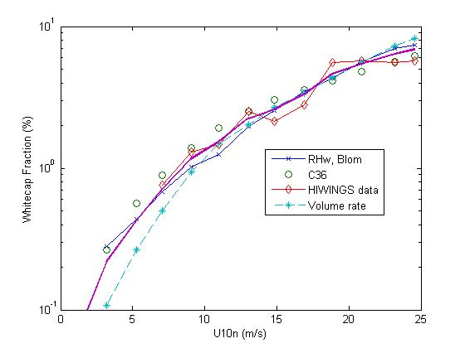
Figure 1. Mean whitecap fraction from HIWINGS.

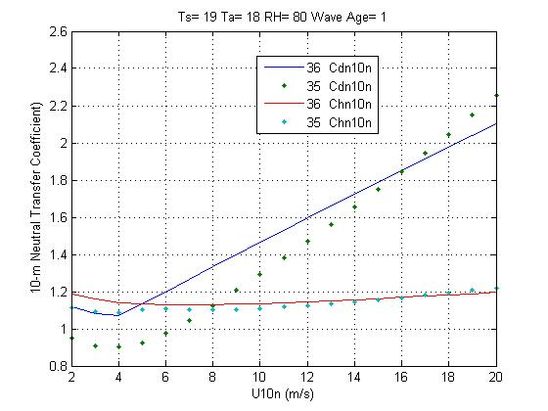
Figure 2. Cd10n and Ch10n from testCoare36.m.

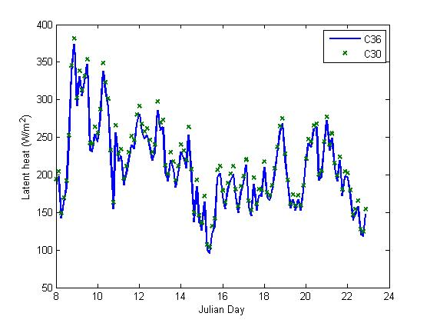
Figure 3. Latent heat flux time series from red_VP_bulk_36.m.
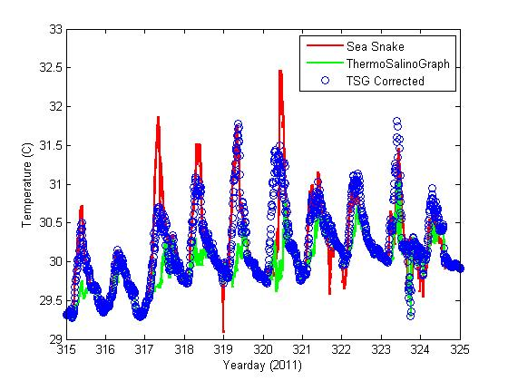
Figure 4. Time series of SST from DYNAMO using WarmCoolLayer_check_36.m.
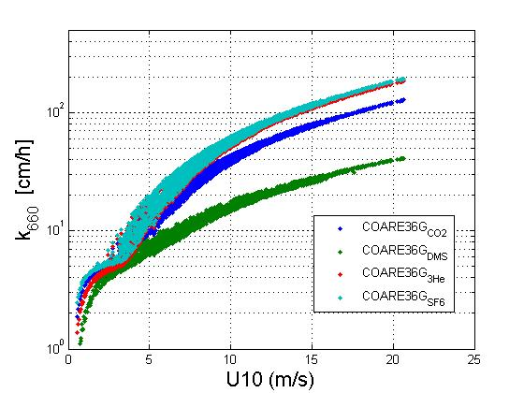
Figure 5. Schmidt-normalized gas transfer velocity vs wind speed from GASEX08 using read_vectorCO2_DMS_36.m.

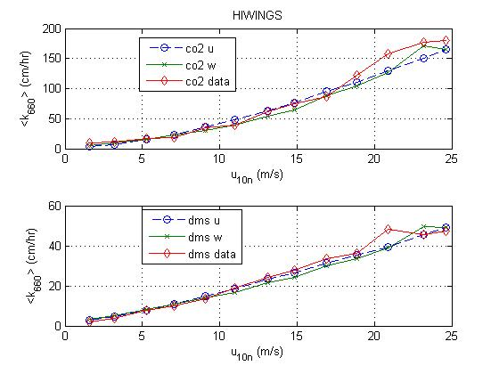
Figure 6. Mean k660 for CO2 and DMS from HIWINGS using Test_red_HIWINGS_v5_hr.m.
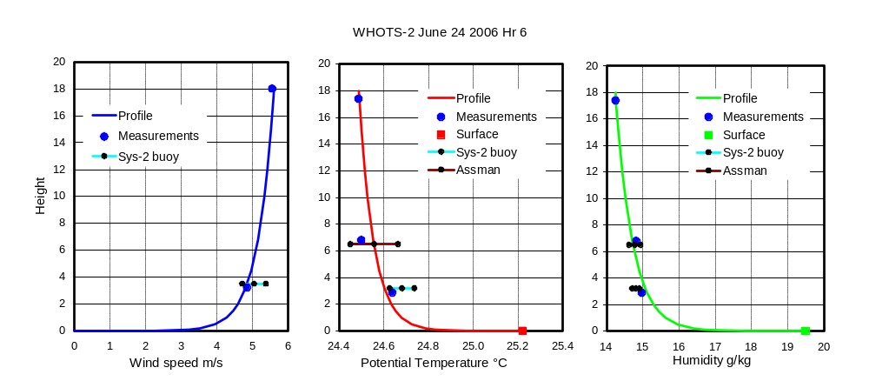
Figure 7. (Fig. A1 from Fairall and Bradley 2007). Example of need for height adjustment when comparing measured values at various levels above the sea surface. The ship’s anemometer was at 18 m on the foremast, and the temperature/humidity sensor at 17.4 m. Temperature and humidity were measured with an Assman psychrometer through a forward chock at 6.8 m height. The ship was standing about 0.25 nm downwind of the WHOI buoy, which had two wind sensors at 3.22 m above the sea surface and two temperature/humidity sensors at 2.88 m. The ship and buoy data points are hourly averages; the Assman values are spot readings. The profiles were constructed from flux/gradient parameters calculated using Version 3.0 of the COARE bulk flux algorithm as follows;
Parameter u* t* q* z_{o} z_{ot} , z_{oq} ψ_{m} ψ_{t} , ψ_{q} z/L
Units ms⁻¹ C g kg⁻¹ m m
Value 0.184 -0.026 -0.192 4.75e-5 7.74e-5 0.705 1.257 -0.427
Surface values (u₀, t₀ and q₀) were 0 ms⁻¹, 25.22 °C, and 19.57 g kg⁻¹ respectively; κ = 0.4.

