Merge Sort
Program Implementation & Output Record
Name: CHAUHAN PARTH ANANDKUMAR | Reg. No: 26MCA0088
Course Code: PAMCA501 | Subject Name: Data Structures and Algorithms

Problem Statement

Write a program to implement Merge Sort.

Source Code

#include<iostream> using namespace std;
void merge(int *arr,int s,int e){
int mid=(s+e)/2; int len1=mid-s+1; int len2=e-mid;
int *first=new int[len1]; int *second=new int[len2];
int mainArrayIndex=s;
//copy the value for(int i=0;i<len1;i++){ first[i]=arr[mainArrayIndex++];
}
mainArrayIndex=mid+1; for(int i=0;i<len2;i++){ second[i]=arr[mainArrayIndex++];
}
int index1=0; int index2=0;
mainArrayIndex=s;
while(index1<len1 && index2<len2){ if(first[index1] < second[index2]){ arr[mainArrayIndex++]=first[index1++];
}else{ arr[mainArrayIndex++]=second[index2++];
}
}

while(index1 < len1){ arr[mainArrayIndex++]=first[index1++];
}
while(index2 < len2){ arr[mainArrayIndex++]=second[index2++];
}
}
void mergeSort(int *arr,int s,int e){ if(s>=e){ return;
}
int mid=(s+e)/2;
mergeSort(arr,s,mid); mergeSort(arr,mid+1,e);
merge(arr,s,e);
}
void display(int *arr,int n){ for(int i=0;i<n;i++){ cout<<arr[i]<<" ";
}cout<<endl;
} int main(){ int arr[6]={5,3,10,14,2,40};
int n=6;
cout<<"Before Sorting Array:";
display(arr,n); mergeSort(arr,0,n-1); cout<<"After Sorting Array:";
display(arr,n); return 0;
}
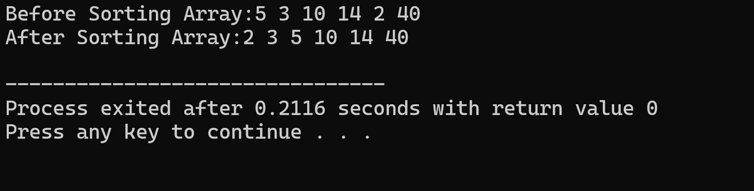
Output

