**Counting blinks**

1. Select EEG time-series file(s) just before the step where you would compute the FFT. Go to plugins/Blink detection and count.

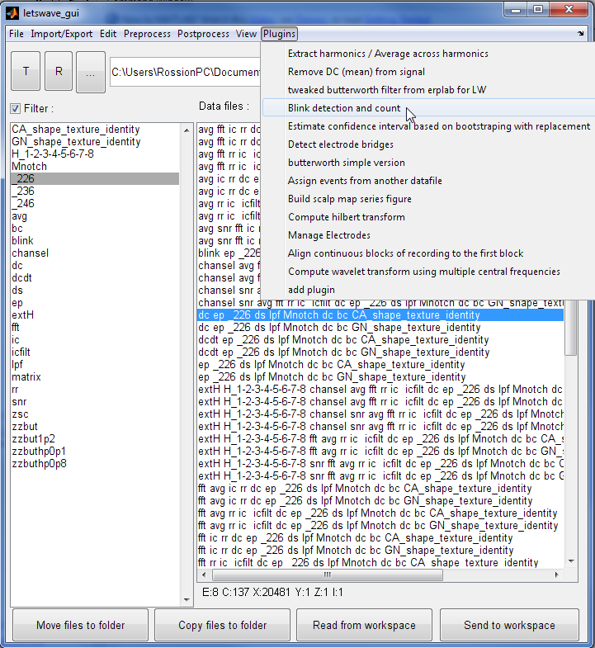

1. The blinks will be detected on a single **channel**. Best is to choose one of the vertical occular channel (EXG2 is probably best) but you can use another channel if you want. The algorythm search for large deflections that pass a **treshold**. You you can try multiple tresholds and see what it looks like but I would say 80-100 is probably good. Then you need to specify the **polarity** of the blinks on the particular channel you have chosen (do the blink go up -> positive or down -> negative). You can also choose ‘automatic’, which should be ok in most cases. A file showing the location of the blinks will be saved with the prefix that you choose.

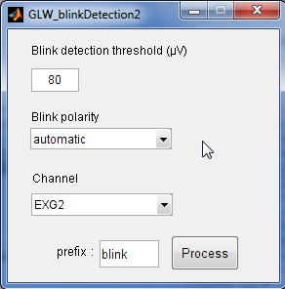

1. After running it you can check if the blinks are correclty detected. Select the original and the blink file and open in multiviewer.

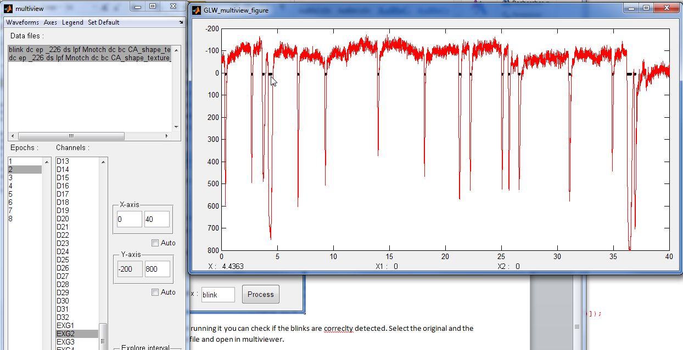

1. There is also a text file saved in your current folder called ‘blink’ and the date and time. Open it in excel, it contains, for each file (rows) and each epoch (columns), the value of blink per second.

