Quick Start【GetStart】

NOLO SDK VR Quick Start

1 - Project Creation
Step
1.From the Unreal Engine Launcher make sure that you have UE4 version 4.24.3 or later downloaded and installed. Then press the Launch button to open the Unreal Project Browser.
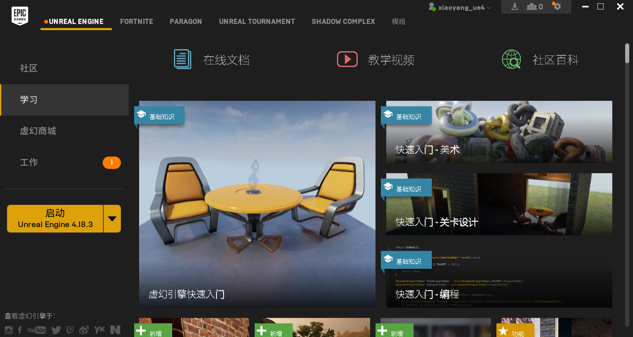
2.From the New Project tab of the Unreal Project Browser, create a new Blueprint based project that is Blank and uses the following settings.
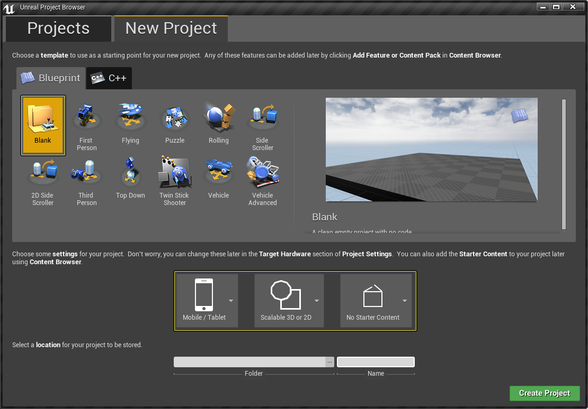

- Blank Project
- Mobile / Tablet
- Scalable 3D / 2D
- No Starter Content

3.Next, set the project's location and give it a name
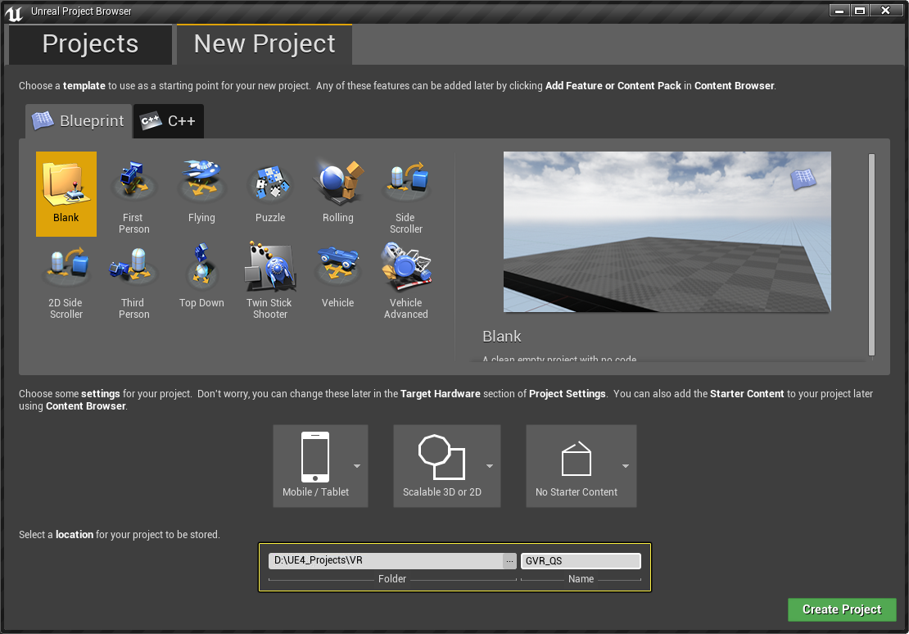

4.最后，按下位于右下角的Create Project按钮来创建项目
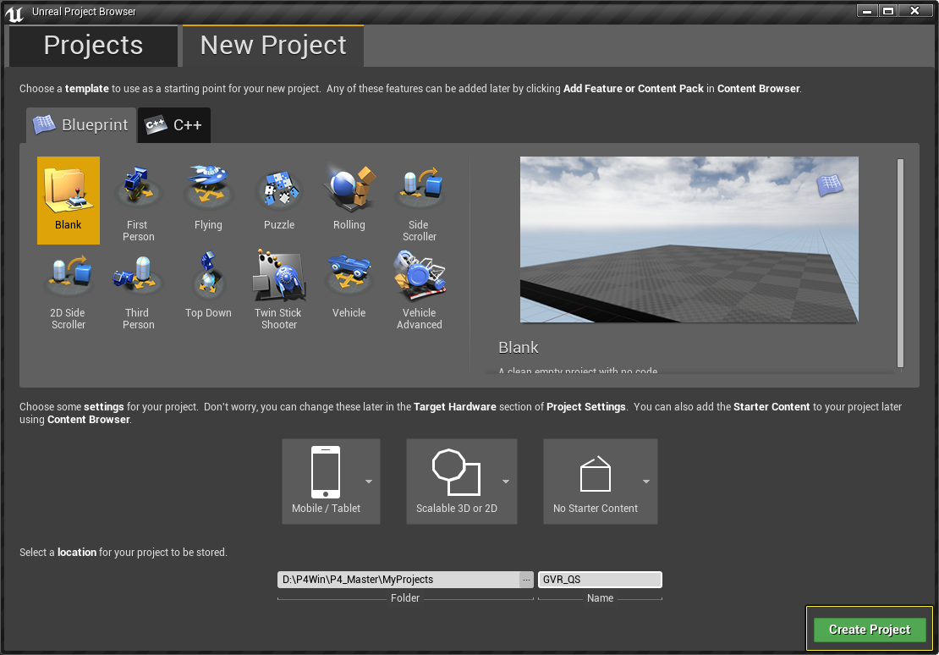

2 - Project Setup
Step
1.Once the Editor has loaded, from the Main Toolbar, open the Edit tab and select the Pluginsmenu item.
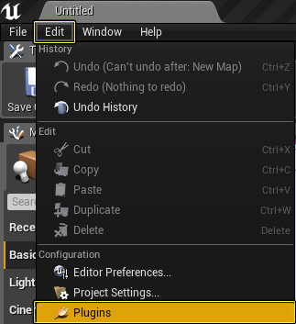

2.Inside of the Plugins menu, go the Virtual Reality section and make sure that Snapdragon VR and NoloVR is enabled.
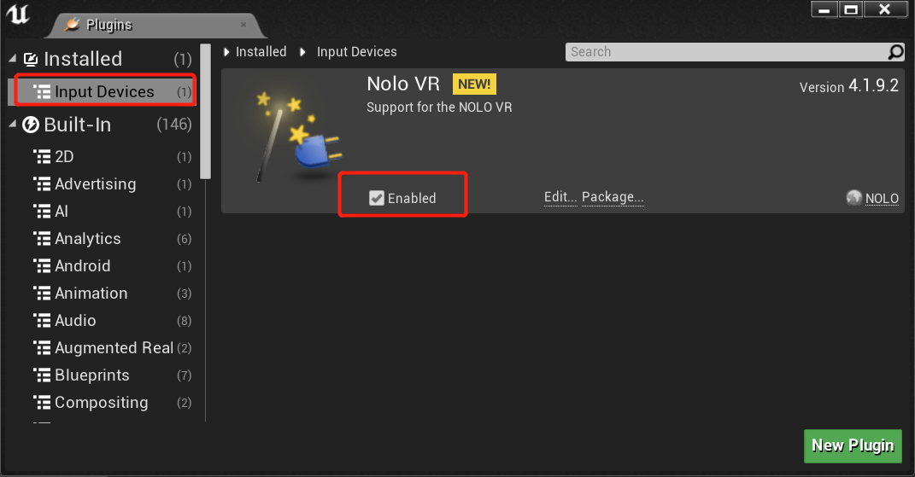
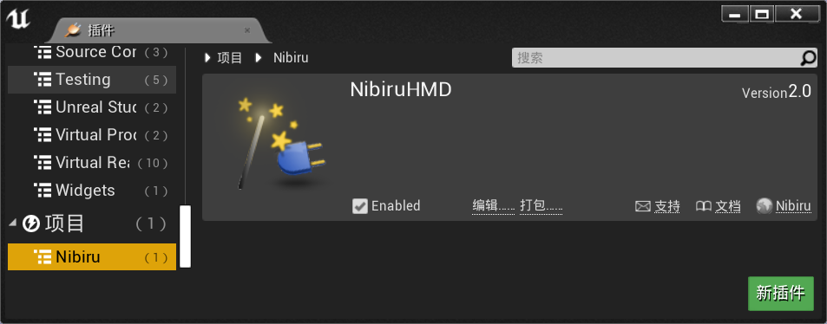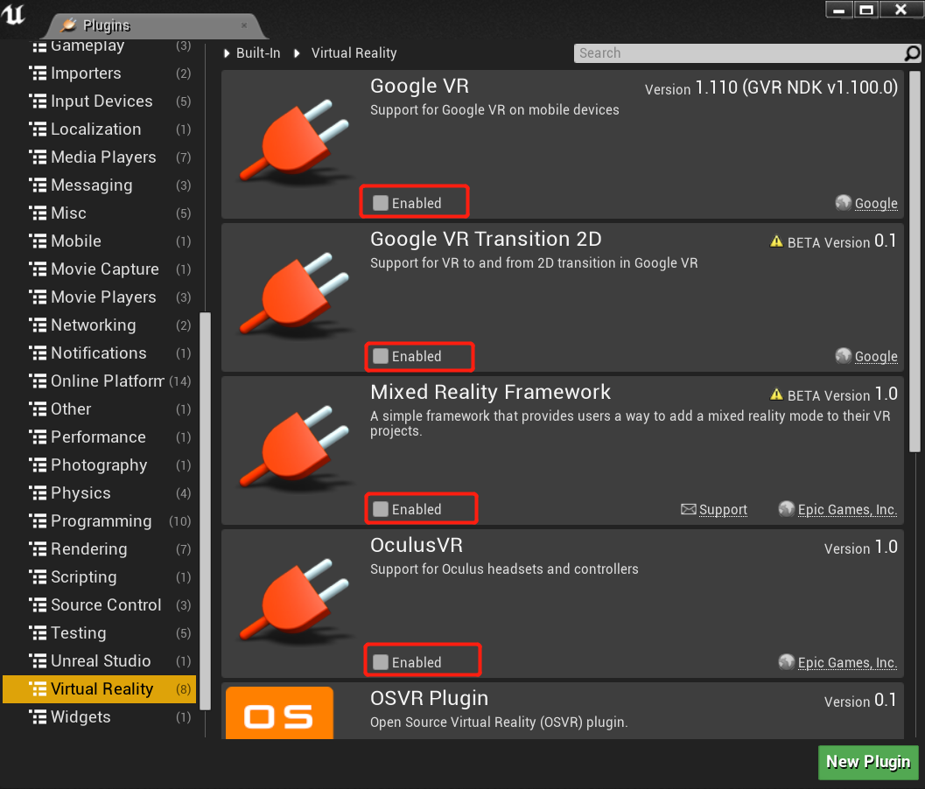
The Google VR Plugin should be enabled by default It can be enabled by clicking on the checkmark box next to Enabled.When you do this will be prompted to restart the Editor so that the changes can be applied.make sure that Other VR plugin is disabled.
3.From the Main Toolbar, select the File option and then click on the Save option to bring up the Save Level As window.

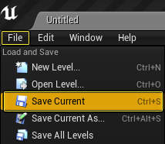

4.From the Save Level As window under the Name section, name the level EntryLevel and then press the Save button.

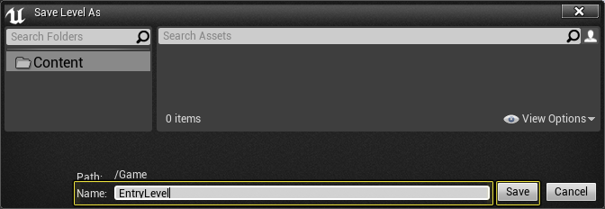

5.Back on the Main Toolbar, select the Edit menu option and then select the Project Settingsmenu option.
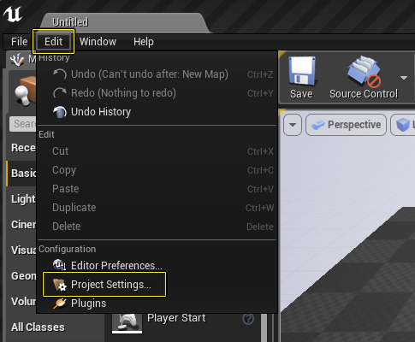

6.From the Project Settings menu, go to the Maps & Modes section. Under the Default Mapssection, change the Editor Startup Map and Game Default Map to EntryLevel to make sure that EntryLevel will be loaded when the project is run.

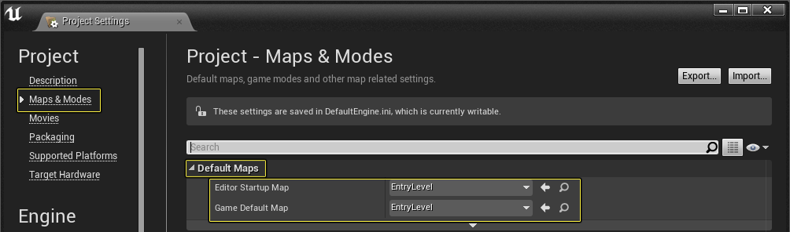

7.Under the Input section in the Mobile category, remove the DefaultVirtualJoysticks from the Default Touch Interface by clicking on the small white triangle next to DefaultVirtualJoysticks and selecting the Clear option from the drop-down list.
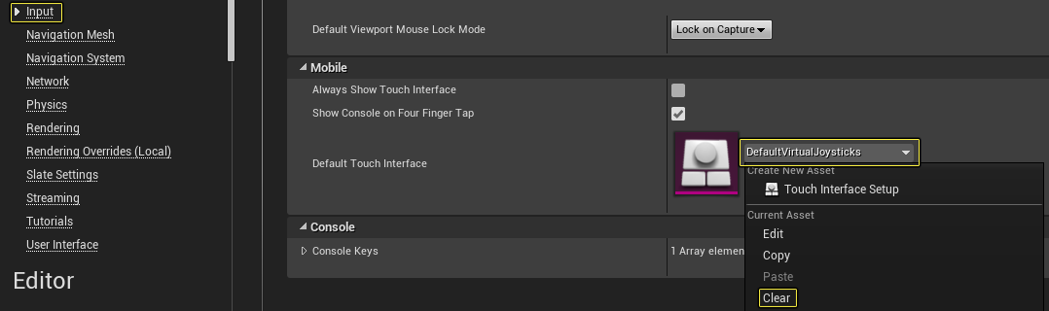
8.IUnder the Android section (in the Platforms heading), press the Configure Now button in both the APKPackaging and Google Play Services categories to ensure that our project can package correctly.

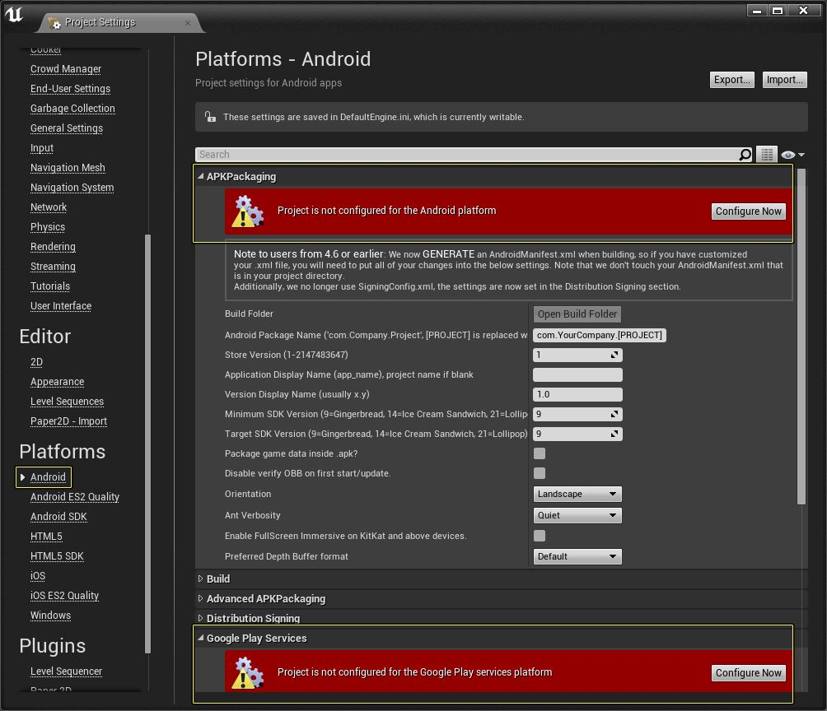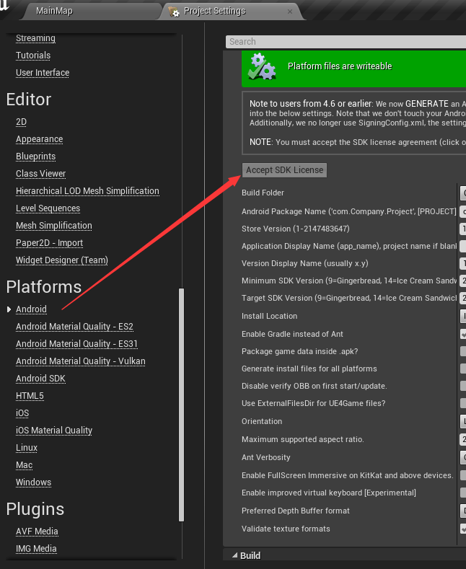

9.In the APKPackaging category, make sure you have the following options set:
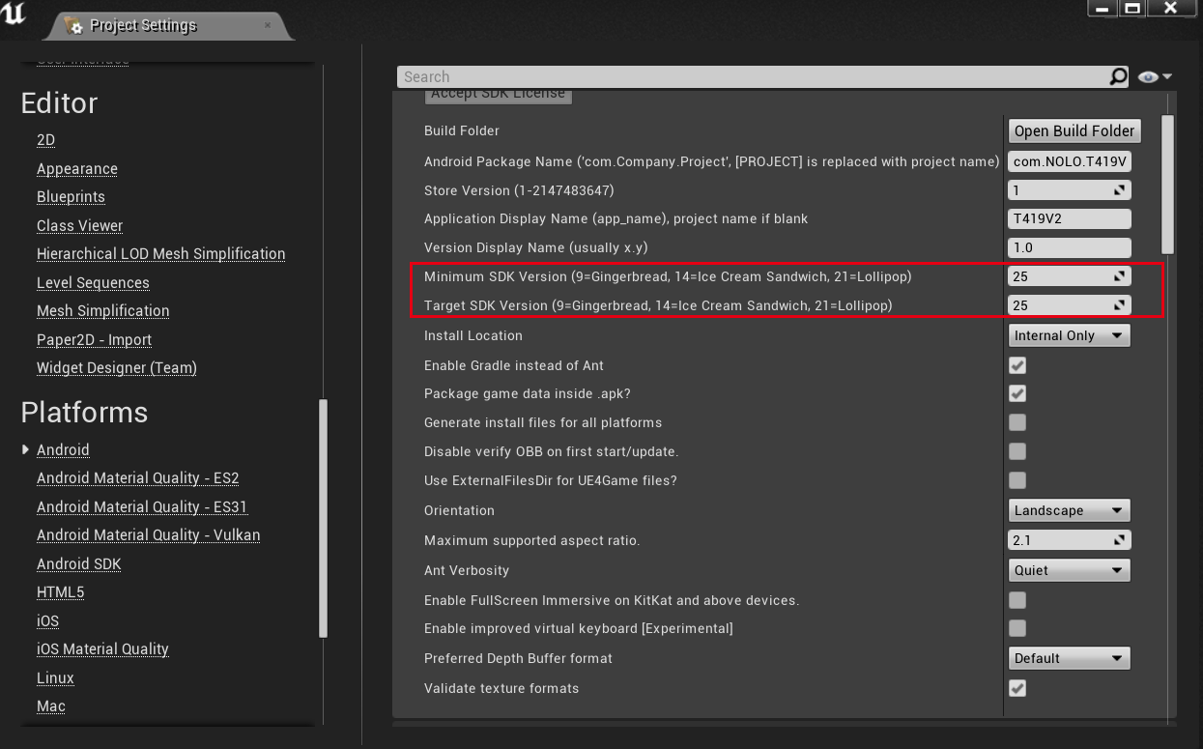
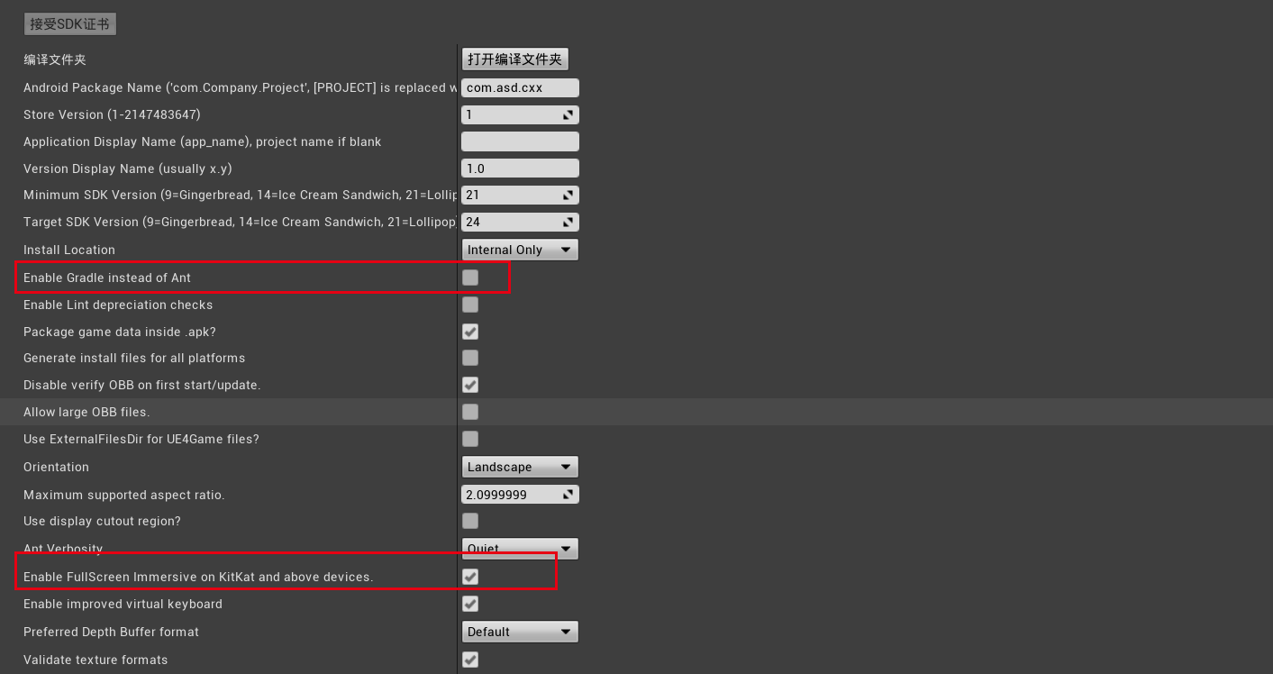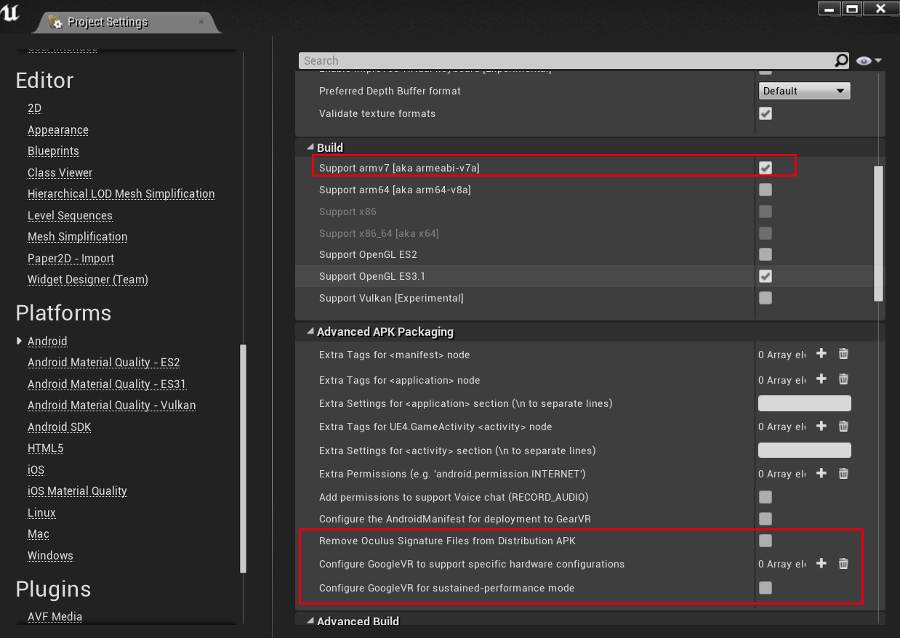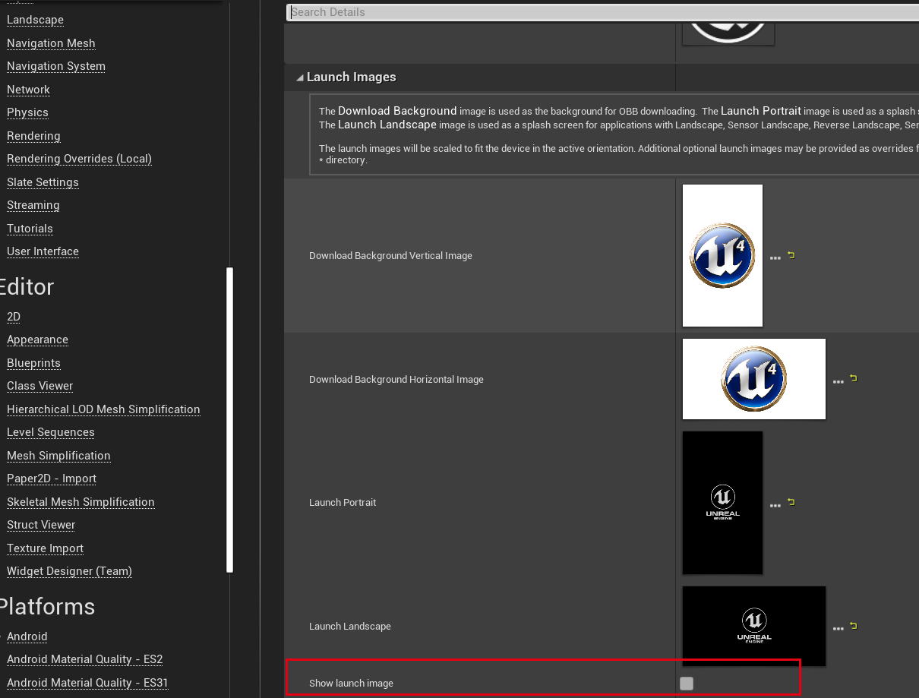

10.In the Android SDK section, under the SDKConfig category, set SDK API Level to latest and set the NDK API Level to android-24 to ensure that your project will be compiled against the most recent Android SDK.
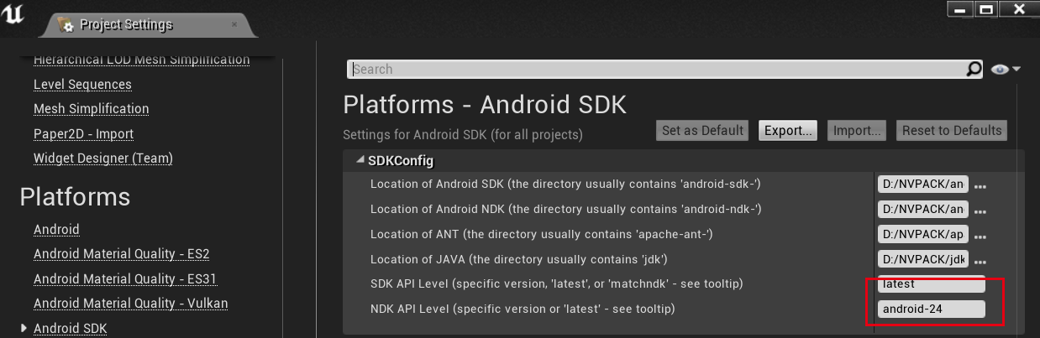
Android SDK平台24
Android NDK 12b
JDK 1.8
To see how to install additional Android SDK's check out Installing Additional Android SDK's for more information.
11.选择”Start in VR”

3 - NOLO VR Plugin usage
Step
1.Download NOLO VR Plugin
2.Import NOLO VR Plugin，place it in the project directory
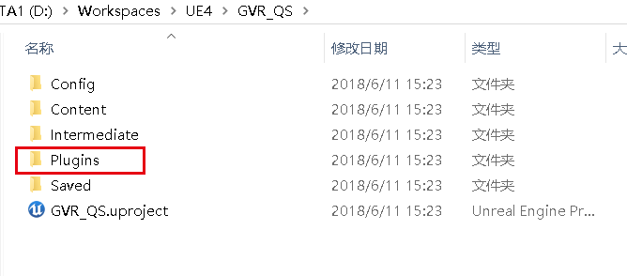

- Create VR Camera and Controller
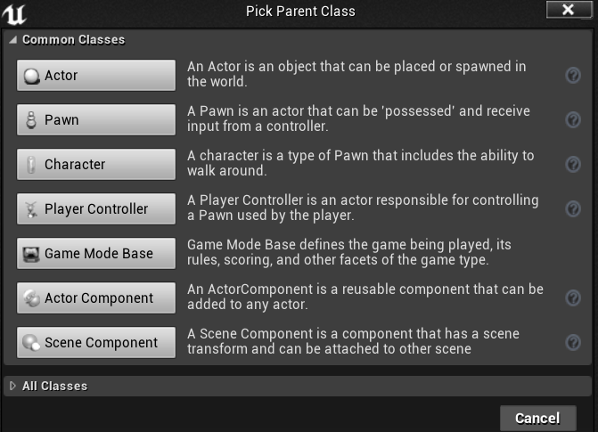
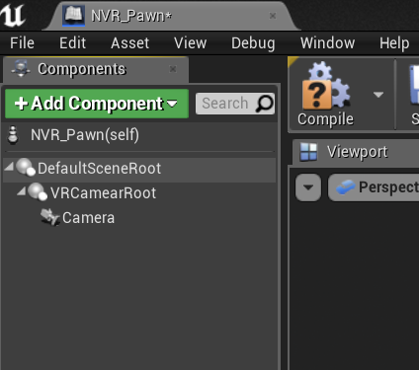
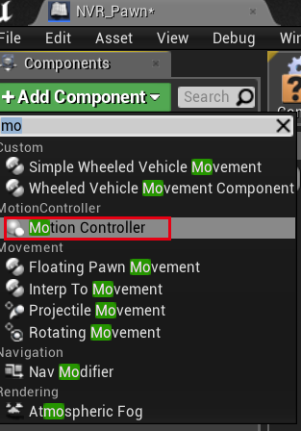
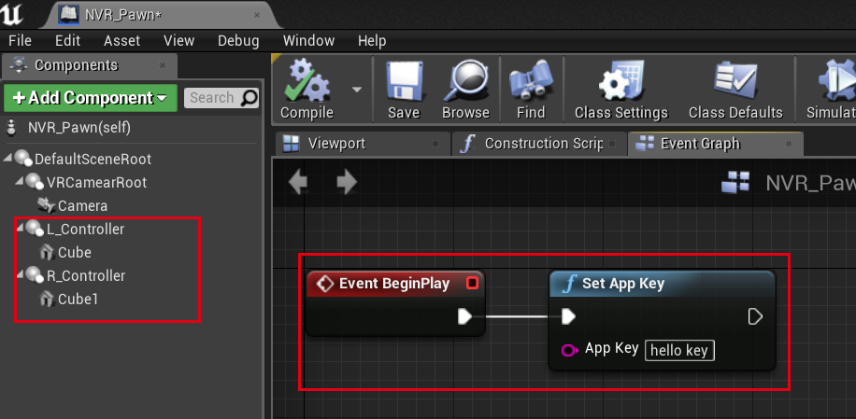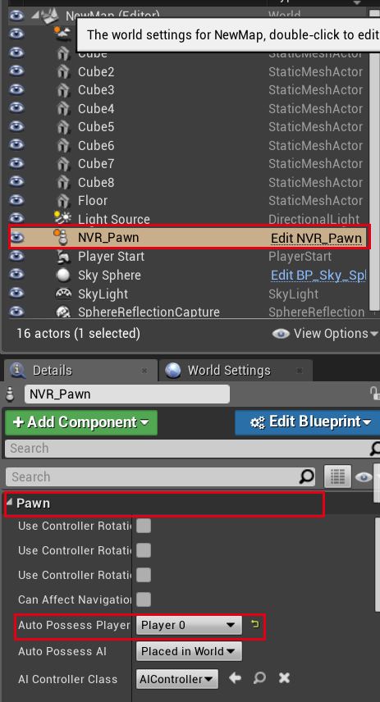

5.Feedback of key information [Refer to Interface Document]

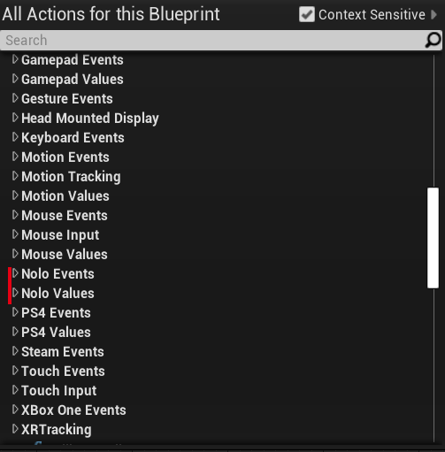
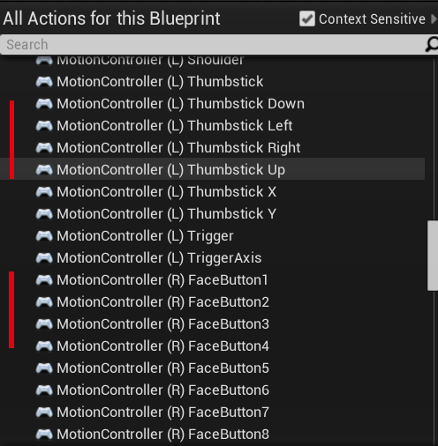

6.Vibration Information Feedback Case

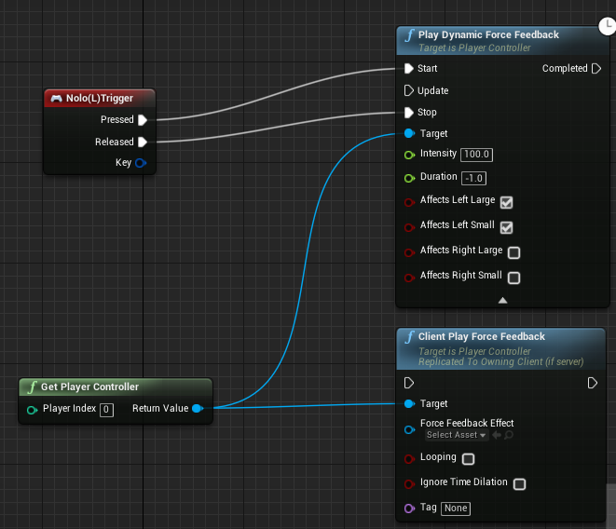

Final result
Completed a preliminary demo, and then packaged apk, running in NOLOX1 integrated machines!

4- Project Packaging & Deployment
Before going any further make sure that the Smartphone you are using is plugged into your development PC via a USB cable. Then make sure that ADB can see your phone as an authorized device. If you are unsure how to do or are having problems getting ADB to see your device, check out the following page for more information Android How To Set Up Your Android Device.Step
1.To start the packing process, go to the Main Toolbar and from the File menu go to Package Project > Android > Android (ASTC).
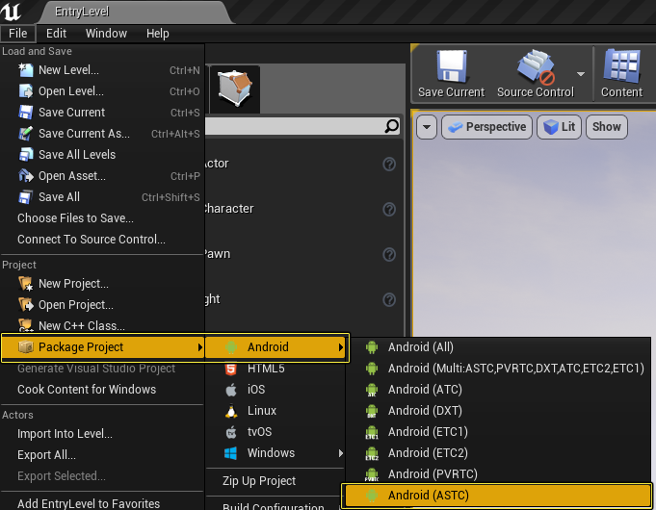
2.Once Android (ASTC) format has been selected, you will be presented with a Windows dialog box. Click the Make New Folder button and name the folder Android_Builds. Once the folder is created, click OK to begin the packaging process.
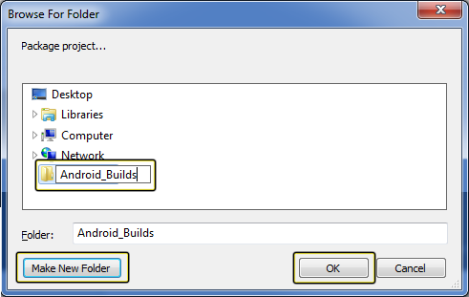
3.While the project is being packaged, a status window is displayed in the lower right-hand corner of the Unreal Editor.
For a more detailed look on what happens during packaging, click the Output Logwindow.
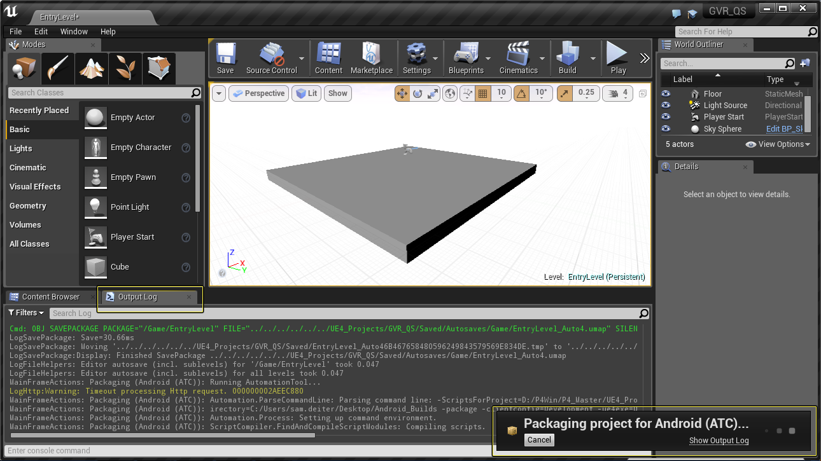
4.Once the project is packaged, open the Android_Builds folder and double-click the Install_GVR_QS_Development-armv7-es2.bat file to install the project to your Android Smartphone.
For this to work, you must make sure that your Android Smartphone is connected to your development PC with a USB cable. If you don't connect your smartphone to your development PC with a USB cable, the project is not installed on the device. 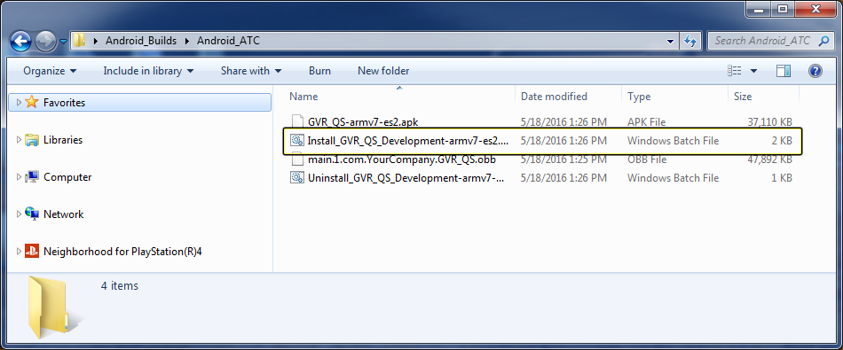

5.Once the .BAT file has been run, a command line window will be displayed showing you the progress of the install. When the install is complete, the command line window will automatically close.

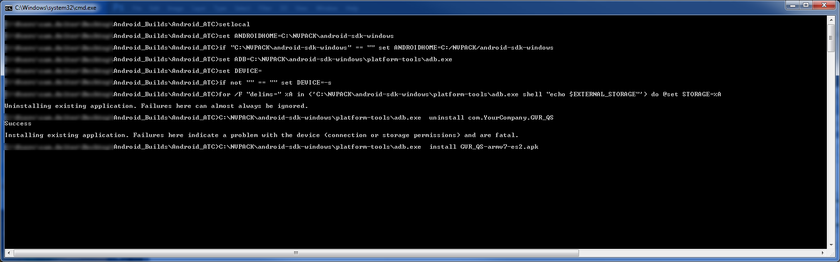

Final result
Congratulations on completing a simple NOLO VR Demo project, from creating, setting up, importing plug-ins, using plug-ins to finally packaging apks

Matters needing attention

1.Set AppKey
A game must acquire an AppKey to run properly with NOLO CV1. An AppKey will be generated automatically when developers apply for their game on NOLO Developer Center.
When the game does not upload NOLO HOME, you can use this public Appkey for development testing.
Public Appkey：4e4f4c4f484f4d457eff82725bc694a5

2.Set Origin

Turn on all NOLO devices, place the headset marker on the ground, press the button on the headset marker. The headset marker’s current position will be the origin in the game. The origin’s coordinates will be saved. This process only needs to be repeated if the Base Station has been moved.

3.Reset Orientation
Upon starting a game, if the forward direction in the game does not point towards Nolo Base Station, or the controller orientation seems a little odd, you may need to reset orientation by doing the following: Put on your headset, face the Nolo Base Station, point both controllers towards the Nolo Base Station, then double click the power button on either controller.

estimate whether the NOLO HOME app has been installed in the Standalone VR headset
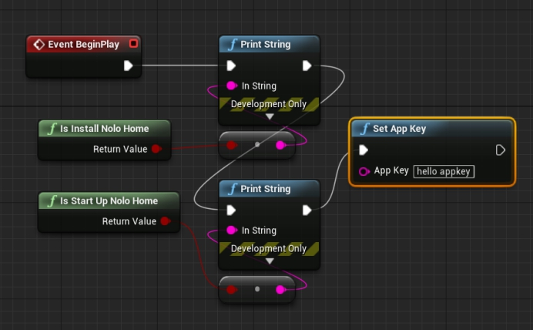
According to IsInstallNoloHome, IsStartUpNoloHome in the above blueprint, estimate whether the NOLO HOME app has been installed in the Standalone VR headset or the NOLO HOME app has been launched. If the NOLO HOME app has not been installed or launched in the standalone VR headset, please pop up a
If you have not installed or started NoloHome, please pop up a 3D UI interface to remind the user.
1:The NOLO HOME needs to be installed before running the game. Please go to the app store, install and launch the NOLO HOME.

2:Failed to launch the NOLO HOME. Please launch the NOLO HOME manually before running the game.

5.NOLO Use Tutorial
https://www.nolovr.com/android-mobilevr?treeid=tutorial_1_1

