SANTOS, MARC GABRIEL R.

2ECEC

DATA WRANGLING HOMEWORK

PROBLEM 1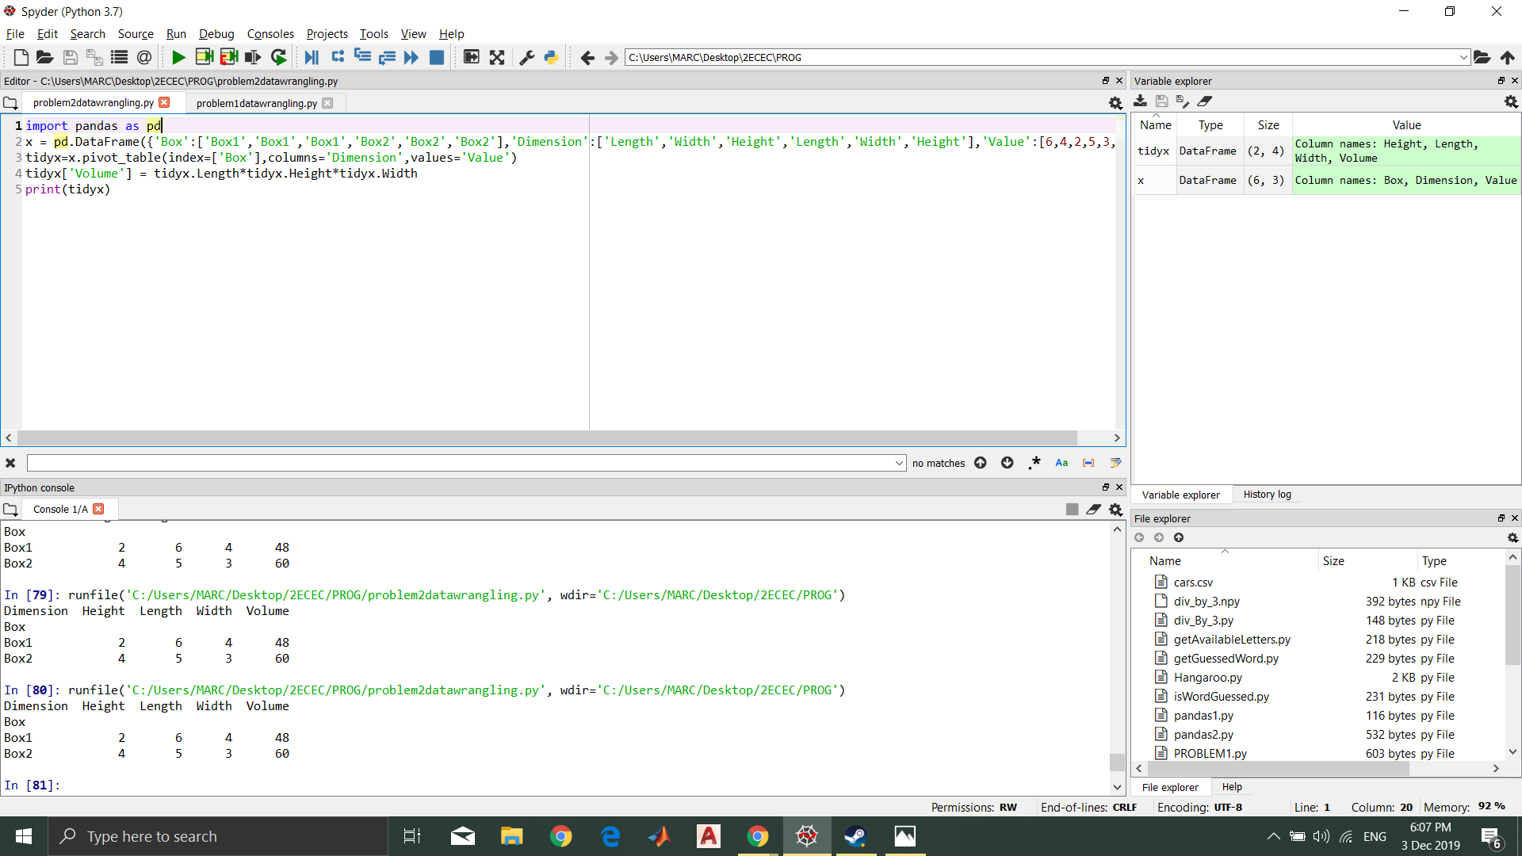

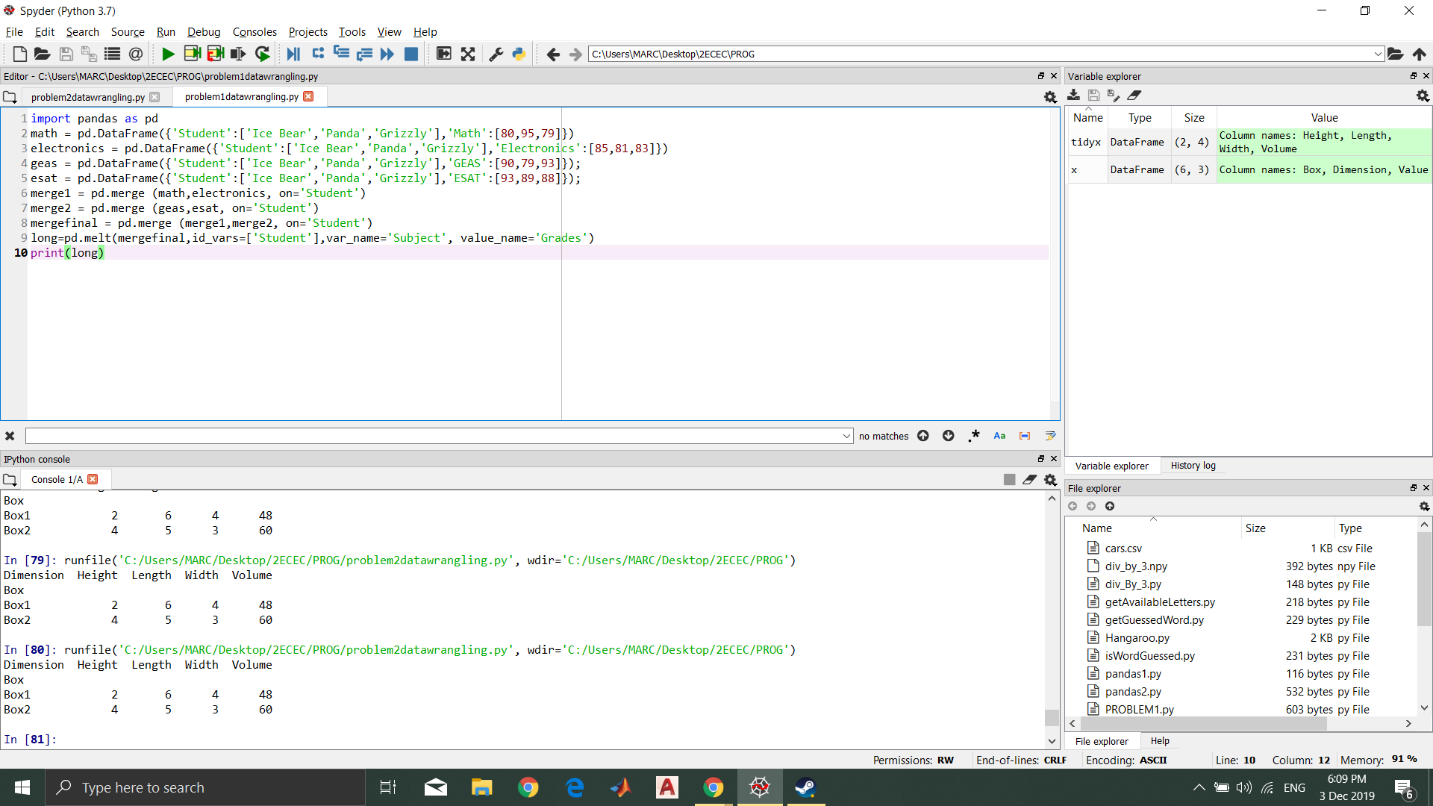

PROBLEM 2