Marc Gabriel R. Santos

Arturo Antonio David C. Tuano

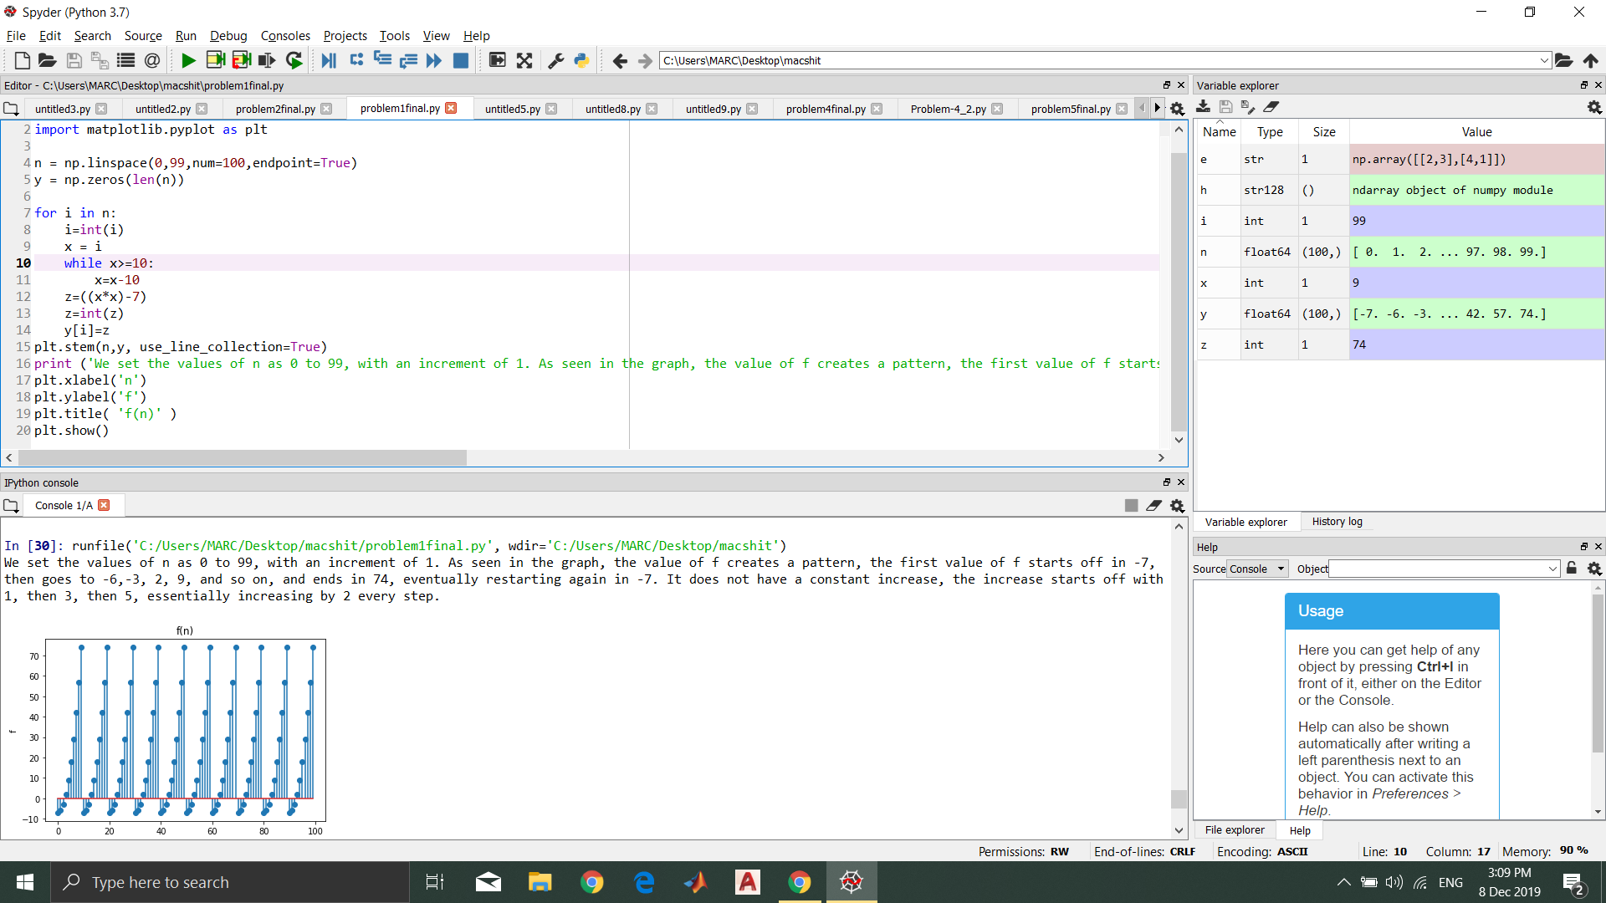

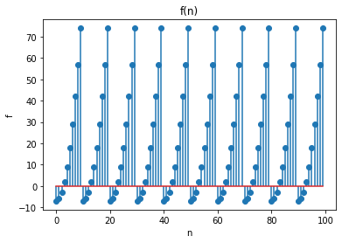

We set the values of n as 0 to 99, with an increment of 1. As seen in the graph, the value of f creates a pattern, the first value of f starts off in -7, then goes to -6,-3, 2, 9, and so on, and ends in 74, eventually restarting again in -7. It does not have a constant increase, the increase starts off with 1, then 3, then 5, essentially increasing by 2 every step.