**Industrial Internship Report on**

**”Project Name”**

**Prepared by**

**[Student name]**

|  |
| --- |
| *Executive Summary* |
| This report provides details of the Industrial Internship provided by upskill Campus and The IoT Academy in collaboration with Industrial Partner UniConverge Technologies Pvt Ltd (UCT).  This internship was focused on a project/problem statement provided by UCT. We had to finish the project including the report in 6 weeks’ time.  My project was (Smart City Traffic Patterns)  This internship gave me a very good opportunity to get exposure to Industrial problems and design/implement solution for that. It was an overall great experience to have this internship. |

**TABLE OF CONTENTS**

1 Preface 3

2 Introduction 4

2.1 About UniConverge Technologies Pvt Ltd 4

2.2 About upskill Campus 8

2.3 Objective 9

2.4 Reference 9

2.5 Glossary 10

3 Problem Statement 11

4 Existing and Proposed solution 12

5 Proposed Design/ Model 13

5.1 High Level Diagram (if applicable) 13

5.2 Low Level Diagram (if applicable) 13

5.3 Interfaces (if applicable) 13

6 Performance Test 14

6.1 Test Plan/ Test Cases 14

6.2 Test Procedure 14

6.3 Performance Outcome 14

7 My learnings 15

8 Future work scope 16

# Preface

Summary of the whole 6 weeks’ work.

About need of relevant Internship in career development.

Brief about Your project/problem statement.

Opportunity given by USC/UCT.

How Program was planned

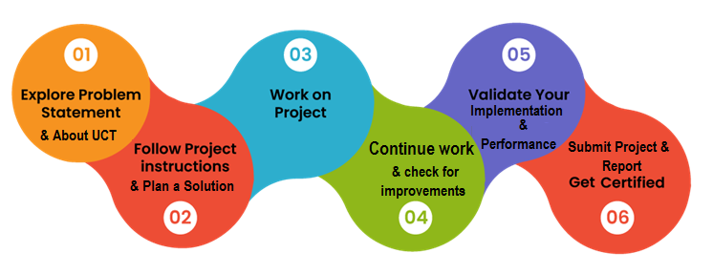

Your Learnings and overall experience.

Thank to all (with names), who have helped you directly or indirectly.

Your message to your juniors and peers.

# Introduction

## About UniConverge Technologies Pvt Ltd

A company established in 2013 and working in Digital Transformation domain and providing Industrial solutions with prime focus on sustainability and RoI.

For developing its products and solutions it is leveraging various**Cutting Edge Technologies e.g. Internet of Things (IoT), Cyber Security, Cloud computing (AWS, Azure), Machine Learning, Communication Technologies (4G/5G/LoRaWAN), Java Full Stack, Python, Front end**etc.



1. UCT IoT Platform **(****)**

**UCT Insight** is an IOT platform designed for quick deployment of IOT applications on the same time providing valuable “insight” for your process/business. It has been built in Java for backend and ReactJS for Front end. It has support for MySQL and various NoSql Databases.

* It enables device connectivity via industry standard IoT protocols - MQTT, CoAP, HTTP, Modbus TCP, OPC UA
* It supports both cloud and on-premises deployments.

It has features to  
• Build Your own dashboard  
• Analytics and Reporting  
• Alert and Notification  
• Integration with third party application(Power BI, SAP, ERP)  
• Rule Engine

 

1. **Smart Factory Platform (****)**

Factory watch is a platform for smart factory needs.

It provides Users/ Factory

* with a scalable solution for their Production and asset monitoring
* OEE and predictive maintenance solution scaling up to digital twin for your assets.
* to unleased the true potential of the data that their machines are generating and helps to identify the KPIs and also improve them.
* A modular architecture that allows users to choose the service that they what to start and then can scale to more complex solutions as per their demands.

Its unique SaaS model helps users to save time, cost and money.

 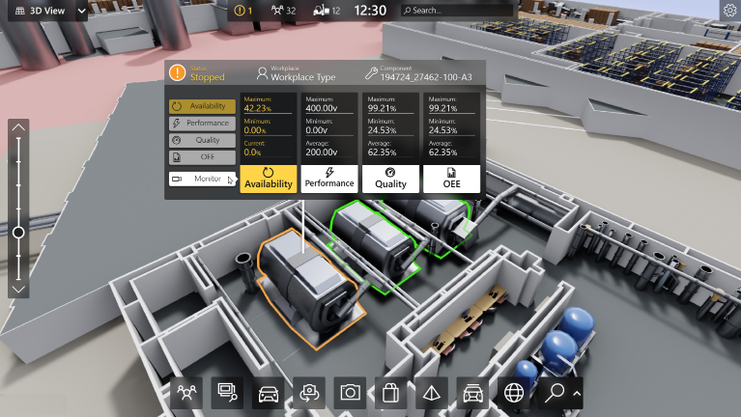

1.  based Solution

UCT is one of the early adopters of LoRAWAN teschnology and providing solution in Agritech, Smart cities, Industrial Monitoring, Smart Street Light, Smart Water/ Gas/ Electricity metering solutions etc.

1. Predictive Maintenance

UCT is providing Industrial Machine health monitoring and Predictive maintenance solution leveraging Embedded system, Industrial IoT and Machine Learning Technologies by finding Remaining useful life time of various Machines used in production process.



## About upskill Campus (USC)

upskill Campus along with The IoT Academy and in association with Uniconverge technologies has facilitated the smooth execution of the complete internship process.

USC is a career development platform that delivers **personalized executive coaching** in a more affordable, scalable and measurable way.



Seeing need of upskilling in self paced manner along-with additional support services e.g. Internship, projects, interaction with Industry experts, Career growth Services

<https://www.upskillcampus.com/>

upSkill Campus aiming to upskill 1 million learners in next 5 year

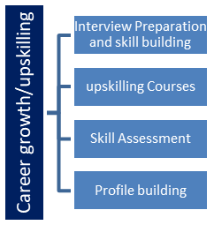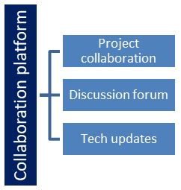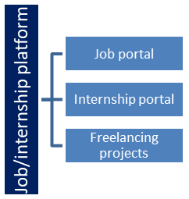

## The IoT Academy

The IoT academy is EdTech Division of UCT that is running long executive certification programs in collaboration with EICT Academy, IITK, IITR and IITG in multiple domains.

## Objectives of this Internship program

The objective for this internship program was to

 ☛ get practical experience of working in the industry.

 ☛ to solve real world problems.

 ☛ to have improved job prospects.

 ☛ to have Improved understanding of our field and its applications.

 ☛ to have Personal growth like better communication and problem solving.

## Reference

[1] https://www.researchgate.net/publication/366408882_SMART_CITY_MANAGEMENT_USING_MACHINE_LEARNING_TECHNIQUES

# Problem Statement

* Traffic congestion: Detection patterns could be used to identify traffic congestion patterns and bottlenecks. This information could then be used to optimize traffic flow and reduce emissions.
* Public safety: Detection patterns could be used to identify potential crime hot spots and other areas where public safety is a concern. This information could then be used to deploy resources more effectively and prevent crime.
* Environmental monitoring: Detection patterns could be used to monitor environmental conditions such as air quality, water quality, and noise levels. This information could then be used to improve environmental sustainability and protect public health.
* Energy efficiency: Detection patterns could be used to identify opportunities for energy savings in buildings, transportation, and other areas. This information could then be used to reduce energy consumption and costs.

# Existing and Proposed solution

Problem: Traffic congestion is a major problem in many cities. It can lead to delays, pollution, and frustration for drivers.

Solution: Smart city detection patterns could be used to identify traffic congestion patterns and bottlenecks. This information could then be used to optimize traffic flow and reduce emissions.

Steps:

1. Define the problem. The first step is to define the problem that you are trying to solve. In this case, the problem is traffic congestion.
2. Collect the data. The next step is to collect data on traffic patterns. This data could be collected from sensors, cameras, or social media.
3. Clean and prepare the data. The data needs to be cleaned and prepared before it can be analyzed. This may involve removing duplicate data, filling in missing data, and transforming the data into a format that is suitable for analysis.
4. Develop the detection patterns. The next step is to develop detection patterns. This may involve using machine learning or other techniques to identify patterns in the data.
5. Test and validate the detection patterns. The detection patterns need to be tested and validated to ensure that they are accurate and reliable.
6. Deploy the detection patterns. Once the detection patterns have been tested and validated, they can be deployed. This means making them available to users so that they can be used to improve traffic flow.
7. Monitor and improve the detection patterns. The detection patterns need to be monitored and improved over time. This is because traffic patterns can change over time, so the detection patterns need to be updated to reflect these changes.

This is just a proposed solution, and the specific steps involved may vary depending on the specific problem. However, these steps provide a general framework for solving traffic congestion problems with smart city detection patterns.

Here are some additional thoughts on the solution:

* The solution should be scalable so that it can be used to handle large amounts of data.
* The solution should be secure so that the data is protected from unauthorized access.
* The solution should be user-friendly so that it can be easily used by city officials and other stakeholders.

The solution is an important part of any project on smart city detection patterns. By carefully planning the solution, you can increase the chances of success for your project.

## Code submission (Github link)

SmartCityTrafficPatterns_Amankumarsingh_usc_utc.html

## Report submission (Github link) :

# Performance Test

There are a number of constraints that need to be kept in mind while making the above project on smart city detection patterns. Some of these constraints include:

* Data availability: The availability of data is a key constraint for any project that involves data analysis. In the case of smart city detection patterns, it is important to have access to large amounts of data from a variety of sources. This data can come from sensors, cameras, social media, and other sources.
* Data quality: The quality of the data is also an important constraint. The data used to create detection patterns must be accurate and reliable. If the data is not of high quality, the detection patterns will not be accurate.
* Computational resources: The creation and use of detection patterns can require significant computational resources. This is especially true for complex detection patterns that involve machine learning and artificial intelligence. It is important to have access to sufficient computational resources in order to create and use detection patterns effectively.
* Privacy and security: The privacy and security of data is a major concern in the context of smart city detection patterns. The data used to create detection patterns can be sensitive, and it is important to protect this data from unauthorized access.
* Cost: The cost of creating and using detection patterns can be a significant constraint. The cost of collecting and processing data, as well as the cost of developing and deploying detection patterns, can be high. It is important to factor in the cost of these activities when planning a project on smart city detection patterns.

Overall, there are a number of constraints that need to be kept in mind while making the above project on smart city detection patterns. These constraints can be challenging to overcome, but they are essential to ensure the success of the project.

Here are some additional thoughts on the constraints of the above project:

* The availability of data can be a challenge in some areas, especially in developing countries.
* The quality of data can also be a challenge, as data from different sources may not be compatible or accurate.
* The computational resources required for creating and using detection patterns can be a challenge for small or resource-constrained organizations.
* The privacy and security of data can be a major concern, especially in the context of sensitive data such as traffic patterns or public safety information.
* The cost of creating and using detection patterns can be a challenge, especially for small or resource-constrained organizations.

Despite these challenges, the potential benefits of smart city detection patterns are significant. By overcoming these challenges, we can use data and technology to improve the efficiency, sustainability, and quality of life in cities.

# My learnings

There are many lessons that can be learned from the above project on smart city detection patterns. Some of these lessons include:

* The importance of data collection and analysis. In order to create effective detection patterns, it is essential to collect and analyze large amounts of data. This data can come from a variety of sources, such as sensors, cameras, and social media.
* The use of machine learning and artificial intelligence. Machine learning and AI can be used to identify complex patterns in data that would be difficult or impossible to identify manually. This can lead to the creation of more sophisticated detection patterns that can provide more accurate insights.
* The importance of collaboration. The development of smart city detection patterns is a complex task that requires the collaboration of experts from a variety of fields, such as data science, computer science, and urban planning.
* The need for continuous improvement. As the technology continues to develop, so too will the need for new and improved detection patterns. It is important to be constantly learning and adapting in order to stay ahead of the curve.

Overall, the above project on smart city detection patterns provides a valuable example of how data and technology can be used to improve the efficiency, sustainability, and quality of life in cities. The lessons learned from this project can be applied to other areas of smart city development, such as traffic management, public safety, and environmental monitoring.

Here are some additional thoughts on the learnings from the above project:

* The importance of having a clear understanding of the problem that you are trying to solve. This will help you to identify the right data sources and to develop effective detection patterns.
* The need to test and validate your detection patterns before deploying them in production. This will help you to ensure that they are accurate and reliable.
* The importance of communicating the benefits of your detection patterns to stakeholders. This will help to ensure that they are adopted and used effectively.

# Future work scope

The future scope of smart city detection patterns is very promising. As the use of data and technology in smart cities continues to grow, there will be an increasing need for ways to analyze and make sense of the vast amounts of data that is being generated. Detection patterns will play a key role in this, by providing a way to identify patterns in data that can be used to improve the efficiency, sustainability, and quality of life in smart cities.

Some of the specific areas where detection patterns are likely to have a major impact in the future include:

* Traffic management: Detection patterns can be used to identify traffic congestion patterns and bottlenecks, which can then be used to optimize traffic flow and reduce emissions.
* Public safety: Detection patterns can be used to identify potential crime hot spots and other areas where public safety is a concern. This information can then be used to deploy resources more effectively and prevent crime.
* Environmental monitoring: Detection patterns can be used to monitor environmental conditions such as air quality, water quality, and noise levels. This information can then be used to improve environmental sustainability and protect public health.
* Energy efficiency: Detection patterns can be used to identify opportunities for energy savings in buildings, transportation, and other areas. This information can then be used to reduce energy consumption and costs.

These are just a few of the many ways that detection patterns are likely to be used in smart cities in the future. As the technology continues to develop, we can expect to see even more innovative and creative applications for detection patterns in the years to come.

Here are some additional thoughts on the future scope of smart city detection patterns:

* As the Internet of Things (IoT) continues to grow, there will be an explosion of new data sources that can be used to create detection patterns. This will open up new opportunities for improving the efficiency, sustainability, and quality of life in smart cities.
* The development of new machine learning and artificial intelligence (AI) algorithms will make it possible to create more sophisticated detection patterns that can identify complex patterns in data. This will lead to even more benefits for smart cities.
* The increasing availability of cloud computing resources will make it easier to store and process large amounts of data, which will be essential for creating and using detection patterns.

Overall, the future scope of smart city detection patterns is very bright. As the technology continues to develop, we can expect to see even more innovative and creative applications for detection patterns in the years to come.