***REGRESSION***

**Introduction**

It is a measurable technique use in money, effective financial planning, and different disciplines that endeavors to decide the strength and character of the connection between one ward variable (for the most part signified by Y) and a progression of different factors (known as free factors).Relapse" comes from "relapse" which thus comes from latin "regressus" - to return (to something). In that sense, the strategy permits "to return" from untidy, difficult to decipher information, to a more clear and more significant model.

*Terminologies Related*

**Dependent Variable**: depends on independent variable . It is also refers as target variable.

**Independent Variable:** The factors which influence the dependent variables or which are use to predict the values of the dependent variables are refers as independent variable, also called as a predictor.

**Outliers:** Outlier is an observation which contains either very low value or very high value in comparison to other observed values. An outlier may affect the result, so it should be avoid.

**Multicollinearity:** If the independent variables are highly inter-relate with each other than other variables, then such condition is called Multicollinearity. It should not be present in the dataset, because it creates problem while ranking the most affecting variable.

**Underfitting and Overfitting:** If our algorithm works well with the training dataset but not well with test dataset, then such problem is Overfitting. And if our algorithm does not perform well even with training dataset, then such problem is underfitting

#### Why to use ?

It helps in the expectation of a constant variable. There are different situations in reality where we really want a few future expectations like weather pattern, deals expectation, showcasing patterns, and so on, for such case we really want some innovation which can make expectations all the more precisely. So for such case we really want it which is a technique and utilized in AI and information science. The following are a few different purposes behind utilizing Relapse investigation:This estimates the relationship between the target and the independent variable.It is use to find the trends in data.It helps to predict real/continuous values.we can confidently determine the most important factor, the least important factor, and how each factor is affecting the other factors.

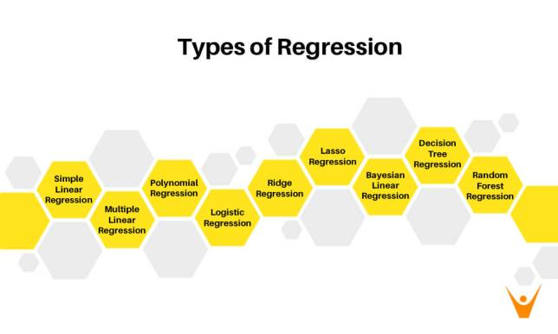

[Type a quote from the document or the summary of an interesting point. You can position the text box anywhere in the document. Use the Drawing Tools tab to change the formatting of the pull quote text box.]

Fig 1

#### Linear Regression

It is a strategy which is utilized for prescient investigation.It shows the straight connection between the free factor (X-hub) and the reliant variable (Y-pivot).In the event that there is just a single info variable (x), such called as straightforward direct relapse. Also, in the event that there is more than one information variable, such straight is called numerous direct relapse.

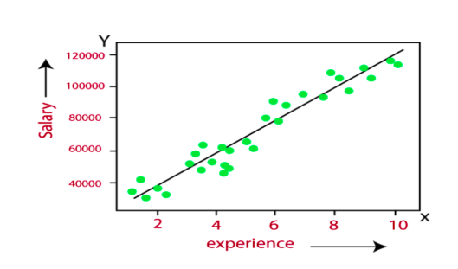The connection between factors in this model can be made sense of utilizing the underneath picture. Here we are foreseeing the compensation of a worker based on the time of involvement

**Fig 2**

**Y= aX+b**

Here, Y = dependent variables (target variables),

X= Independent variables (predictor variables),

a and b are the linear coefficients

Points to keep in mind

Note that this model is more helpless to anomalies consequently; it ought not be utilized in that frame of mind of large size information.

There ought to be a direct connection among free and subordinate factors.

There is just a single free and subordinate variable.

It is a best fit straight line.

#### Multiple linear regression

Basic straight relapse permits an information researcher or information examiner to make forecasts about just a single variable via preparing the model and foreseeing another variable. Likewise, a various relapse model reaches out to a few more than one variable.

**Expression**

yi=β0 +β1​xi1​+β2 x i2 ​+…+βp x ip​+ϵ

where, for i=n observations:

y=dependent variable

x=explanatory variables

β0=y-intercept (constant term)

βp=slope coefficients for each explanatory variable

ϵ=the model’s error term (also known as the residuals)

Focuses to remember:

It shows these highlights multicollinearity, autocorrelation, heteroscedasticity.Multicollinearity builds the fluctuation of the coefficient gauges and makes the assessments exceptionally delicate to minor changes in the model. Thus, the coefficient gauges are unsteady.On account of different free factors, we can go with a forward determination, in reverse disposal, and stepwise methodology for highlight choice.

#### Polynomial Regression

#### This models the non-straight dataset utilizing a direct model.It is like various direct , however it fits a non-straight bend between the worth of x and comparing contingent upsides of y.Assume there is a dataset which comprises of datapoints which are available in a non-straight design, so for such case, direct won't best fit to those . To cover such , we want this.In this, the first elements are move into polynomial highlights of given degree and afterward displayed utilizing a direct model. that implies the information focuses are best fits utilizing polynomial line.

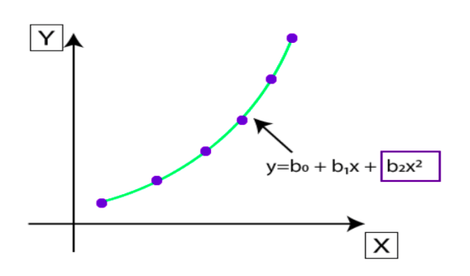

Fig 3

Focuses to remember:

To fit a more serious level polynomial to get a lower mistake, can bring about overfitting. To plot the connections to see the fit and concentration to ensure that the bend fits as indicated by the idea of the issue.

#### Logistic Regression

It is another administer learning calculation which is use to take care of the order issues. In grouping issues, we have subordinate factors in a parallel or discrete configuration like 0 or 1.This calculation works with the straight out factor like 0 or 1, Yes or No, Valid or Misleading, Spam or not spam, and so on.It is a prescient investigation calculation which deals with the idea of likelihood.It is a sort of relapse, yet it is not quite the same as the direct relapse calculation in the term how they are use.This model utilize sigmoid capability or calculated capability which is a complicated expense capability. This sigmoid capability is use in model. The function is:

f(x)= 1/(1+e^-x)

f(x)= Result between the 0 and 1 worth.

x= contribution to the capability

e= base of regular logarithm.

At the point when we give the information values (information) to the capability, it gives the S-bend as follows:

It utilize the idea of limit levels, values over the edge level are round to 1, and values underneath the limit level are round to 0.

#### Ridge Regression

It is one of the most hearty forms of direct in which a limited quantity of predisposition is present so we can get better long haul forecasts.How much predisposition add to the model is alludes as Edge Relapse punishment. We can process this punishment term by duplicating with the lambda to the squared load of every individual highlights.An overall straight or polynomial relapse will fall flat in the event that there is high collinearity between the free factors, so to take care of such issues, Edge relapse can be use to decrease the intricacy of the model. It is likewise alludes as L2 regularization.It assists with tackling the issues assuming we have a bigger number of boundaries than tests.

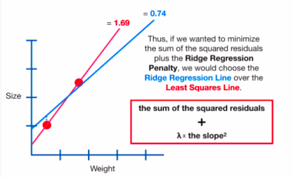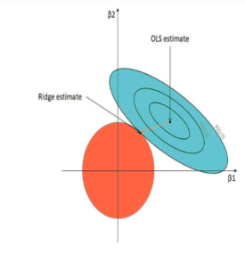

#### Fig 4

#### Lasso Regression

The full type of Rope is the Most un-Outright Shrinkage and Determination Activity. As the name proposes, Tether utilizes the "shrinkage" method in which coefficients are decide , which get shrivel towards the essential issue as the mean.The Rope , in regularization depends on basic models that groups less boundaries. We get a superior understanding of the models because of the shrinkage interaction. The shrinkage cycle likewise empowers the recognizable proof of factors emphatically connected with factors comparing to the objective.This is one more regularization method to lessen the intricacy of the model.It is like the Edge with the exception of that punishment term contains just the outright loads rather than a square of loads.Since it takes outright qualities, consequently, it can recoil the slant to 0, while Edge can shrivel it close to 0.

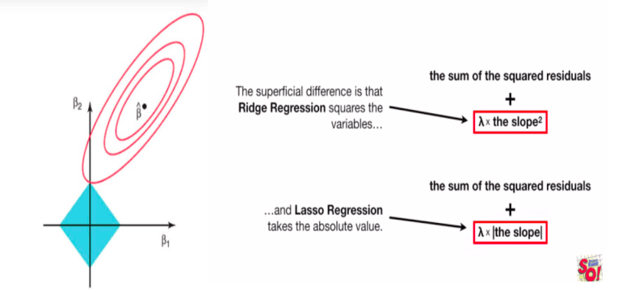This is additionally alludes as L1 regularization.

#### Fig 5

#### Bayesian Linear Regression

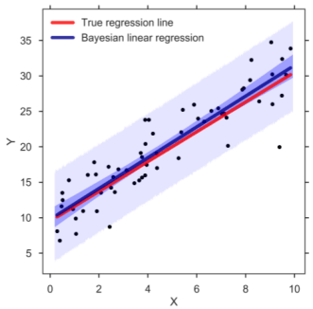this is use to figure out the worth of relapse coefficients. In Bayesian direct , the back dispersion of the highlights is decide as opposed to tracking down the least-squares. Bayesian Straight is a mix of Direct and Edge however is more steady than basic Straight

Fig 6

**Decision Tree Regression**

The choice tree as the name recommends deals with the standard of conditions. It is effective and has solid calculations utilized for prescient investigation. It has primarily credited that incorporate inward hubs, branches, and a terminal hub.

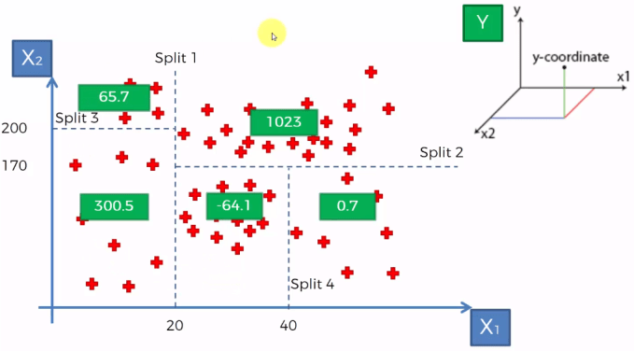Each inner hub holds a "test" on a quality, branches hold the finish of the test and each leaf hub implies the class name. It is utilized for the two groupings as well as relapse which are both directed learning calculations. Choices trees are incredibly sensitive to the data they are ready on little changes to the arrangement set can achieve on a very basic level different tree structures.

Fig 7

#### Random Forest Regression

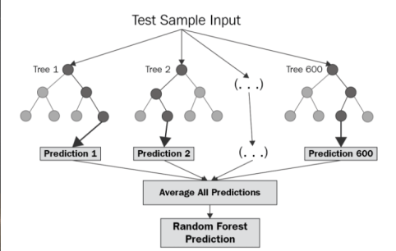Irregular woods, as its name recommends, includes a huge measure of individual choice trees that work collectively or as is commonly said, a group. Each individual choice tree in the irregular woods lets out a class expectation and the class with the most votes is considered as the model's forecast.Arbitrary timberland utilizes this by allowing each individual tree to arbitrarily test from the dataset with substitution, achieving different trees. This is known as bagging.

Fig 8

**How to select the right model?**

Each sort of relapse model performs diversely and the model productivity relies upon the information structure. Various kinds of calculations assist with figuring out which boundaries are essential for making expectations. There are a couple of techniques to perform model choice.Changed R-squared and anticipated R-square: The models with bigger changed and anticipated R-squared values are more effective. These insights can assist you with staying away from the major issue with normal R-squared — it generally increments when you add an autonomous variable. This property can prompt more mind boggling models, which can at times create deceiving results.

Changed R-squared increments when another boundary works on the model. Inferior quality boundaries can diminish model productivity.

Anticipated R-squared is a cross-approval strategy that can likewise diminish the model exactness. Cross-approval segments the information to decide if the model is a nonexclusive model for the dataset.

2. P-values for the autonomous factors: In relapse, more modest p-values than importance level show that the speculation is genuinely huge. "Diminishing the model" is the most common way of remembering every one of the boundaries for the model, and afterward over and over eliminating the term with the most noteworthy non-critical p-esteem until the model contains just huge weighted terms.

3. Stepwise and Best subsets : When we have an enormous measure of free factors and require a variable determination process, these computerized strategies can be exceptionally useful.

### Conclusion

The different types of regression analysis in data science and machine learning discussed in this presentation can be used to build the model depending upon the structure of the training data in order to achieve optimum model accuracy.

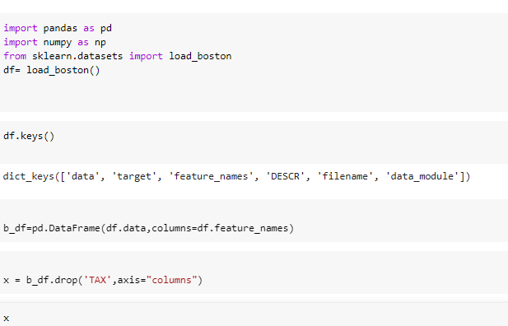CODE:

