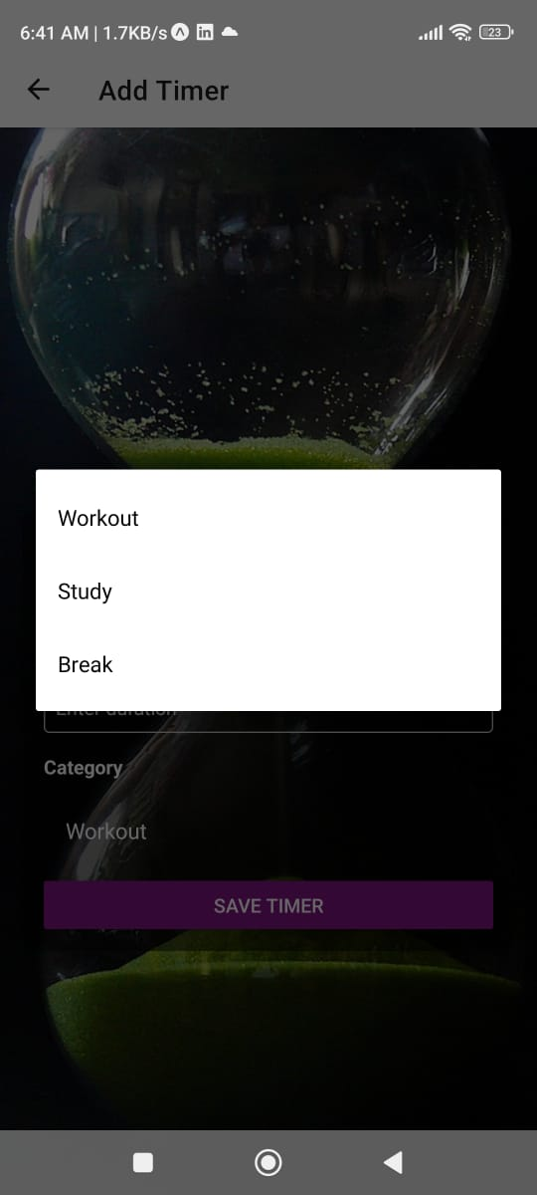

**This React Native application allows users to create, manage, and interact with multiple** **customizable timers. The app uses an image from Pixabay as the background and applies internal styling through StyleSheet.**

**When the app is opened using Expo Go by scanning the QR code, the user is first navigated to the timer creation screen where they can add a timer by providing a name, duration, and category.**

**After adding, timers appear in a scrollable view from top to bottom, animated using the @keyframes concept to give a smooth visual transition.**

**Each timer card includes a progress bar that starts in green and turns red when the remaining time is less than or equal to half the duration.**

**Users can start, pause, and reset individual timers. The application also supports resetting all timers at once .**

**When a timer completes, a congratulatory message is displayed, and the timer’s details including name, category, duration, and current completion time are saved to local storage as part of the history feature.**

**This project demonstrates basic animation, time-based interactivity, local data storage, and UI feedback, all in a mobile-friendly React Native environment.**

