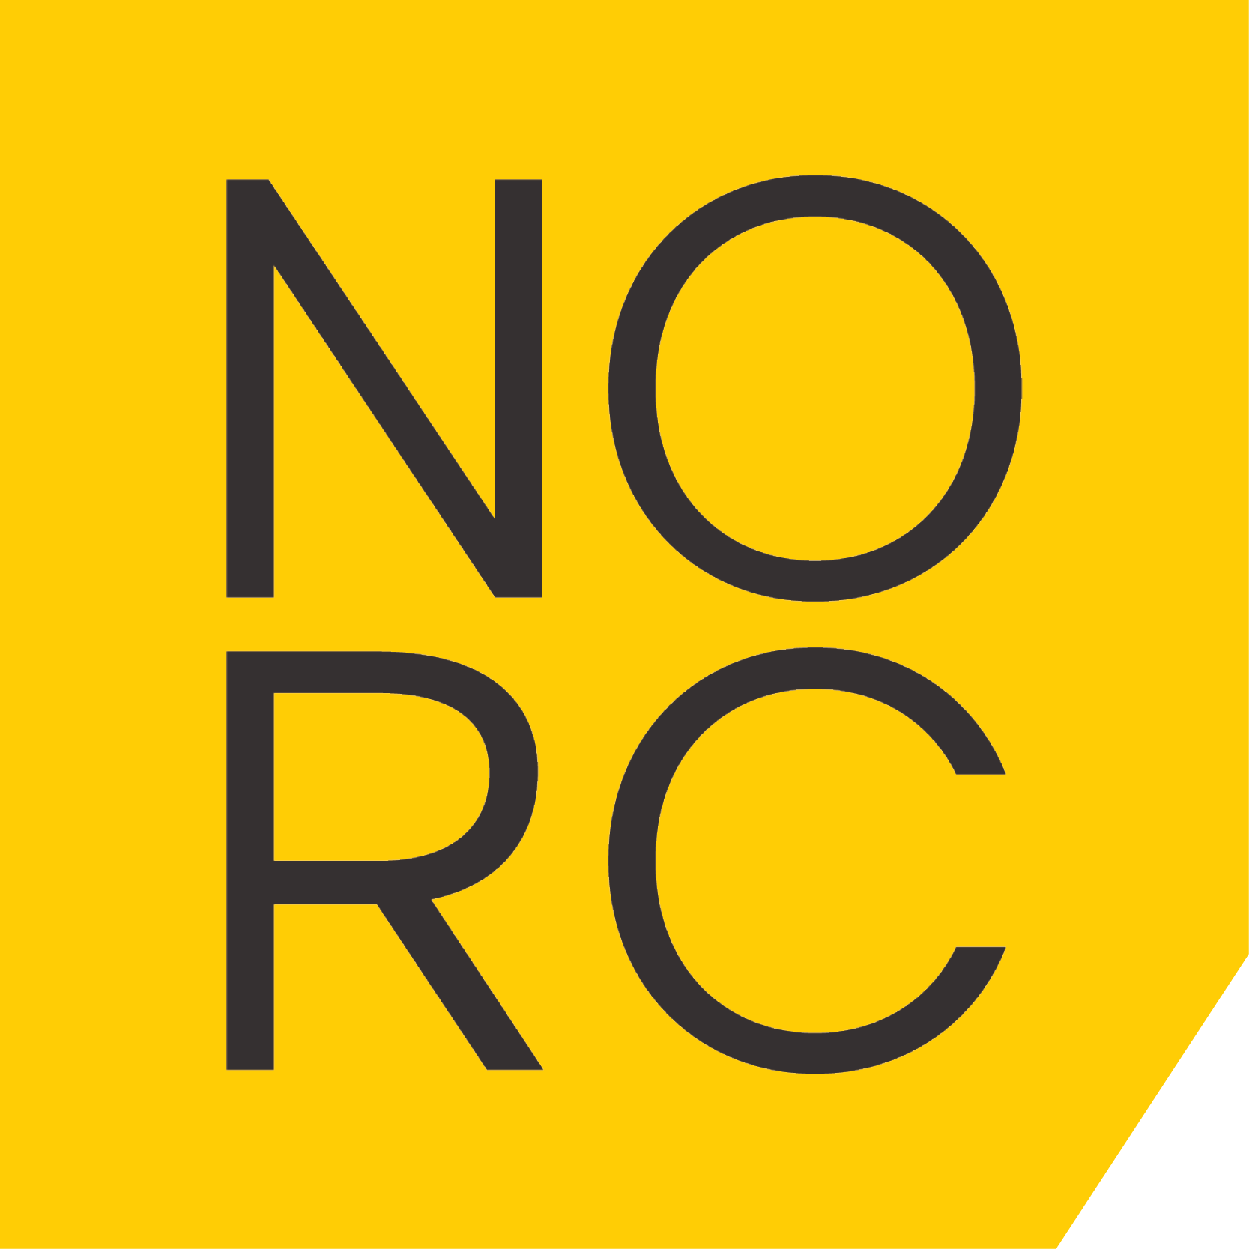 | Nordic  Resilience  Communication | OFFER

Date | Client | Client contact | Project number
2026-05-05 | Team Neusta | Klaudia Kruger / André Conin | 1
Project
Nordic Market Entry & Positioning Partnership
NORC x Safespring x Team Neusta
Team Neusta brings digital scale, engineering depth and transformation capacity.
NORC brings Nordic market understanding, strategic positioning, communication and trust-building.
Together, the ambition is to establish a credible and commercially viable position in the Nordic market.

Engagement Principle
NORC is engaged to shape positioning, market entry and early-stage business development - not as a lead generation or sales execution provider.

Phase 1 - START (90 + 90 days)
Objective:
Establish a clear, credible and testable Nordic market position
Investment:
EUR 4,500 / month (approx. 50,000 SEK)
Duration: 3 + 3 months

Scope
1. Alignment & Market Hypothesis
Define ambition, priority markets and scope
Establish initial market entry hypotheses
2. Nordic Positioning
Develop Nordic value proposition
Messaging hierarchy and narrative
Positioning adapted to Nordic decision logic
3. Focus Areas (2-3 entry points)
Recommended initial focus:
Industrial AI & Digital Transformation
Digital Resilience & Secure Platforms
Public Sector / Critical Infrastructure

Market Assets
Nordic presentation material
Core messaging and meeting narrative
Thought leadership angles

Pilot Outreach (limited)
Testing positioning in selected dialogues
Feedback and iteration

Out of Scope
Full-scale sales execution
Lead generation at scale
Campaign production
Local staffing or operational delivery

Phase 2 - SCALE (3-9 months)
Objective:
Convert positioning into active business opportunities

Scope
Go-to-market execution and prioritisation
Joint offer development (2-3 packaged offers)
Strategic meetings and opportunity shaping
Communication and thought leadership
Sales enablement and refinement
Investment (indicative)
EUR 7,000 - EUR 11,000 / month
Optional success-based component

Phase 3 - SUSTAIN (long-term)
Objective:
Establish a stable and scalable Nordic presence

Scope
Ongoing positioning and communication governance
Strategic account development
Market intelligence and adaptation
Long-term collaboration model
Investment (indicative)
From EUR 10,000 / month

Recommended Approach
We strongly recommend starting with a focused scope (2-3 entry points), rather than introducing the full portfolio, to ensure clarity, relevance and early traction in the Nordic market.

NORC - A Viable Solution
NORC helps organisations build communication resilience in complex environments by aligning strategy, leadership, brand, digital systems, and governance into one coherent operational capability.

Viable Solutions - Nordic Special Operations Company
Viable Solutions translates strategy into operational effect through structures, systems, and capabilities that enable organisations to operate with clarity, speed, and resilience over time.
Läs mer på viablesolutions.se

Contact
Anders Rasmusson
+46(0)707-266 098
contact@norc.agency

