**PRG281 Project User Manual**

**C:\Program Files\Microsoft Office\MEDIA\CAGCAT10\j0285750.wmf**

**PRG281 Group Project**

**Prepared By:** Hendro Opperman 577861

Michael Richter 577302

Arlo Roos 577441

**Contents:**

**1.** **Main Menu** 2

**2.** **Loan Menu** 2

**2.1 Personal & Business Loan** 3

**3.** **Exit Menu** 4

**4.** **Display Menu** 5

# **Main Menu**

*When the program is started the user is prompted for the current prime interest rate. The value entered will be the base interest rate which will later be used in the program by the Personal and Business Loans. The user is required to enter a number, any other entry will cause the program to prompt the interest rate again until a number is entered. When a number is entered the user can press the ENTER key to proceed to the next section.*

# **Loan Menu**

The Second Page of this program consist of 3 options: Personal Loan, Business Loan and Close Program. To Learn more about Close Program go to **3. Exit Menu.** Navigation in this menu requires the use of the UP and DOWN Arrow keys. To apply for a Personal Loan, the Personal Loan Option must be highlighted which the user can then press the ENTER key as shown in Picture A. To apply for a Business Loan, the Business Loan Option *must be highlighted which the user can then press the ENTER key as shown in Picture B. When Loan details are completed, the user will be located to the Loan Menu again. Loan details will be displayed after 5 Loans are completed.*

**Exit MenuLoan Menu***ser can then press the ENTER key as shown in Picture B. When Loan details are completed, the user will be located to the Loan Menu again. Loan details will be displayed after 5 Loans are completed.*

# **Exit MenuLoan Menu**

*The Second Page of this program consist of 3 options: Personal Loan, Business Loan and Close Program. To Learn more about Close Program go to* ***3. Exit Menu.*** *Navigation in this menu requires the use of the UP and DOWN Arrow keys. To apply for a Personal Loan, the Personal Loan Option must be highlighted which the user can then press the ENTER key as shown in Picture A. To apply for a Business Loan, the Business Loan Option must be highlighted wh***Loan Menu***ser can then press the ENTER key as shown in Picture B. When Loan details are completed, the user will be located to the Loan Menu again. Loan details will be displayed after 5 Loans are completed.*

**Exit MenuLoan Menu***ser can then press the ENTER key as shown in Picture B. When Loan details are completed, the user will be located to the Loan Menu again. Loan details will be displayed after 5 Loans are completed.*

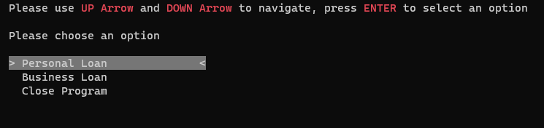

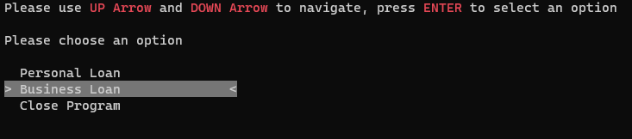**Picture A**

**Picture B**

## **2.1 Personal & Business Loan**

*Upon Entering the* ***Personal or Business Loan Menu****, the user will be prompted for personal information. After the user has entered the required field, the ENTER key can be pressed prompting the next field. Fields required are* ***First Name****,* ***Last Name****,* ***Loan Amount*** *and* ***Loan Term****.*

* ***First*** *and* ***Last Names*** *must only contain Letters, any other entry will prompt the user for the respected field again.*
* ***Loan Amount*** *must only contain a number between 1 and 100 000, any other entry or number outside the required field will prompt the user for the* ***Loan Amount*** *again.*
* ***Loan Term*** *can only be 1, 3 or 5 years, any other number will default the loan term to 1 year and other entries will prompt the* ***Loan Term*** *again.*
* *Example A is if done correctly, Example B is if any of above mistakes were made.*
* **2.1 Personal & Business Loan***y other entry or number outside the required field will prompt the user for the* ***Loan Amount*** *again.*
* ***Loan Term*** *can only be 1, 3 or 5 years, any other number will default the loan term to 1 year and other entries will prompt the* ***Loan Term*** *again.*
* *Example A is if done correctly, Example B is if any of above mistakes were made.*

## **2.1 Personal & Business Loan**

*Upon Entering the* ***Personal or Business Loan Menu****, the user will be prompted for personal information. After the user has entered the required field, the ENTER key can be pressed prompting the next field. Fields required are* ***First Name****,* ***Last Name****,* ***Loan Amount*** *and* ***Loan Term****.*

* ***First*** *and* ***Last Names*** *must only contain Letters, any other entry will prompt the user for the respected field again.*
* ***Loan Amount*** *must only contain a numb***2.1 Personal & Business Loan***y other entry or number outside the required field will prompt the user for the* ***Loan Amount*** *again.*
* ***Loan Term*** *can only be 1, 3 or 5 years, any other number will default the loan term to 1 year and other entries will prompt the* ***Loan Term*** *again.*
* *Example A is if done correctly, Example B is if any of above mistakes were made.*
* **2.1 Personal & Business Loan***y other entry or number outside the required field will prompt the user for the* ***Loan Amount*** *again.*
* ***Loan Term*** *can only be 1, 3 or 5 years, any other number will default the loan term to 1 year and other entries will prompt the* ***Loan Term*** *again.*
* *Example A is if done correctly, Example B is if any of above mistakes were made.*

**Example A**

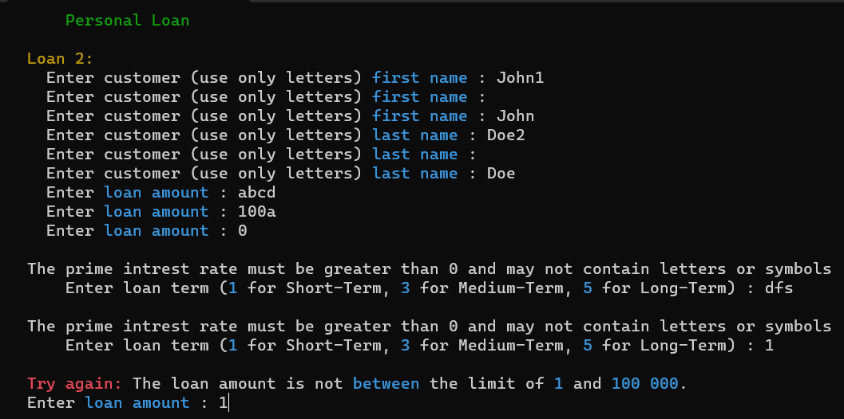

**Example B**

# **Exit Menu**

The Second Page of this program consist of 3 options: Personal Loan, Business Loan and Close Program. To choose the close option, the Close Program option must be highlighted followed up with the ENTER key to close the program. The program will the ask the user if they are sure to close the program which follows with a **YES** or **NO** option. If the user selects **YES**, the program will close, if the user selects **NO**, the program will go back to the **Main Menu.**

**2.1 Personal & Business LoanExit Menu***The user can only exit the program from the* ***Loan Menu*** *OR after the* ***Loan Details*** *are displayed followed with a* ***YES*** *or* ***NO*** *option.*

# **2.1 Personal & Business LoanExit Menu**

*The Second Page of this program consist of 3 options: Personal Loan, Business Loan and Close Program. To choose the close option, the Close Program option must be highlighted followed up with the ENTER key to close the program. The program will the ask the user if they are sure to close the program which follows with a* ***YES*** *or* ***NO*** *option. If the user selects* ***YES****, the program will close, if the user selects* ***NO****, the program will go back to the* ***Mai*Exit Menu***The user can only exit the program from the* ***Loan Menu*** *OR after the* ***Loan Details*** *are displayed followed with a* ***YES*** *or* ***NO*** *option.*

**2.1 Personal & Business LoanExit Menu***The user can only exit the program from the* ***Loan Menu*** *OR after the* ***Loan Details*** *are displayed followed with a* ***YES*** *or* ***NO*** *option.*

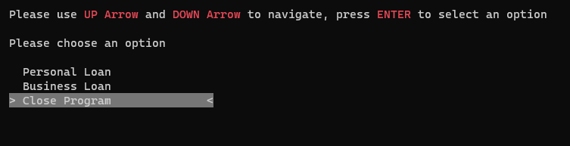

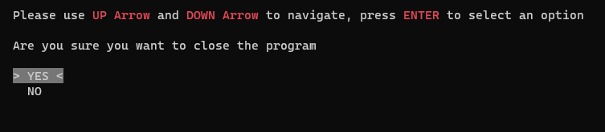**Close Program Option**

# **Exit Menu**

*Sample Text here sample text here sample text here sample text here sample text here sample text here sample text here sample text here sample text here sample text here sample text here sample text here sample text here sample text here sample text here sample text here sample text here sample text here sample text here sample text here sample text here sample text here sample text here sample text here sample text here sample text here sa*

**Exit Menu***re sample text here sample text here sample text here sample text here sample text here sample text here sample text here sample text here sample text here sample text here sample text here sample text here sample text here sample text here.*

**YES/NO Option**

# **Display Menu**

When 5 Loans have been created, all the created Loans will display after the creation of the 5th Loan. Important things to note is that the **Personal Loan** adds **2%** to the **Prime Interest Rate** and a **Business Loan** adds **1%** to the **Prime Interest Rate**.

**Loan 1** Is an example of a **Personal Loan** and **Loan 2** is an example of a **Business Loan**:

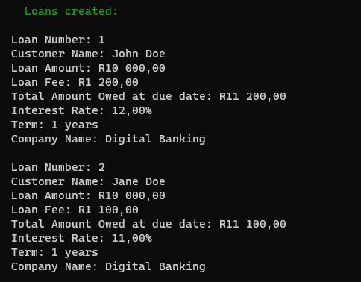

After all the Loans are displayed, the user can then press the ENTER key to prompt a **YES** or **NO** option. The **YES** optionwill take the user back to the **Main Menu**, whilst the **NO** option will exit the program.

