TO ORDER CONSUMABLES FOR CO MONITORS

As of the 1st January 2012, Intermedical Cardio Respiratory handle all UK orders for Bedfont Smokerlyzer.

To order items contact:
Intermedical Customer Services telephone: 01732 522 444

On-line ordering enquiries contact: Sarah Howarth: sarah@intermedical.co.uk
Joanna Finn: joanna@intermedical.co.uk

FOR NHS LOCATIONS already using www.my.supplychain.nhs.uk for their NHS stock ordering
use order code FDD3226 “D-piece” and FDD3681 steribreath mouthpieces

As of February 2014 – Bedfont have changed the mouth pieces, “D” pieces and wipes

Steribreath Mouthpieces for Bedfont Smokerlyzers
Mouthpieces for use with Bedfont piCO+, piCO Simple, piCO baby & Micro Plus Smokerlyzers.
- Each mouthpiece is individually sealed for hygiene
- Environmentally friendly
- New design mouthpiece ensures patient is a good distance from the monitor to ensure that the correct flow rate is blown into the monitor to achieve optimum CO readings
- New D-piece required (see accessories section below)
Product Code: 1420040 Box of 250

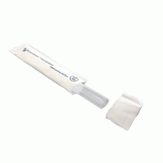

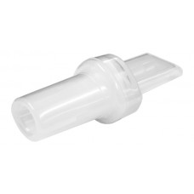

Bedfont Disposable D-Pieces for Steribreath (Pack of 12)
The D-piece incorporates a one-way valve to prevent air being drawn back from the monitor. The breath then passes through an infection control filter, proven to remove and trap >99.9% of airborne bacteria. This system further reduces the risks of cross infection and protects the instrument from contamination.
Product Code: 1420015/2 Box of 12.

Bedfont Alcohol-Free Cleaning Wipes (Pack of 50)
- Cleaning wipes specially designed for the cleaning of all Bedfont devices
- Alcohol free wipes
- Supplied as pack of 50
Product Code: 1420016

CLEANING - IMPORTANT INFORMATION
Bedfont products should only be cleaned by the specially designed alcohol free wipes. Using other branded non-alcohol wipes may damage the device and may void any warranties. Using alcohol wipes will damage the sensor inside the device and will void the warranty

