Họ và tên: Hồ Nguyên Hà . Mã SV: 20it043

Bài Tập Tuần 1

**Ex1:**

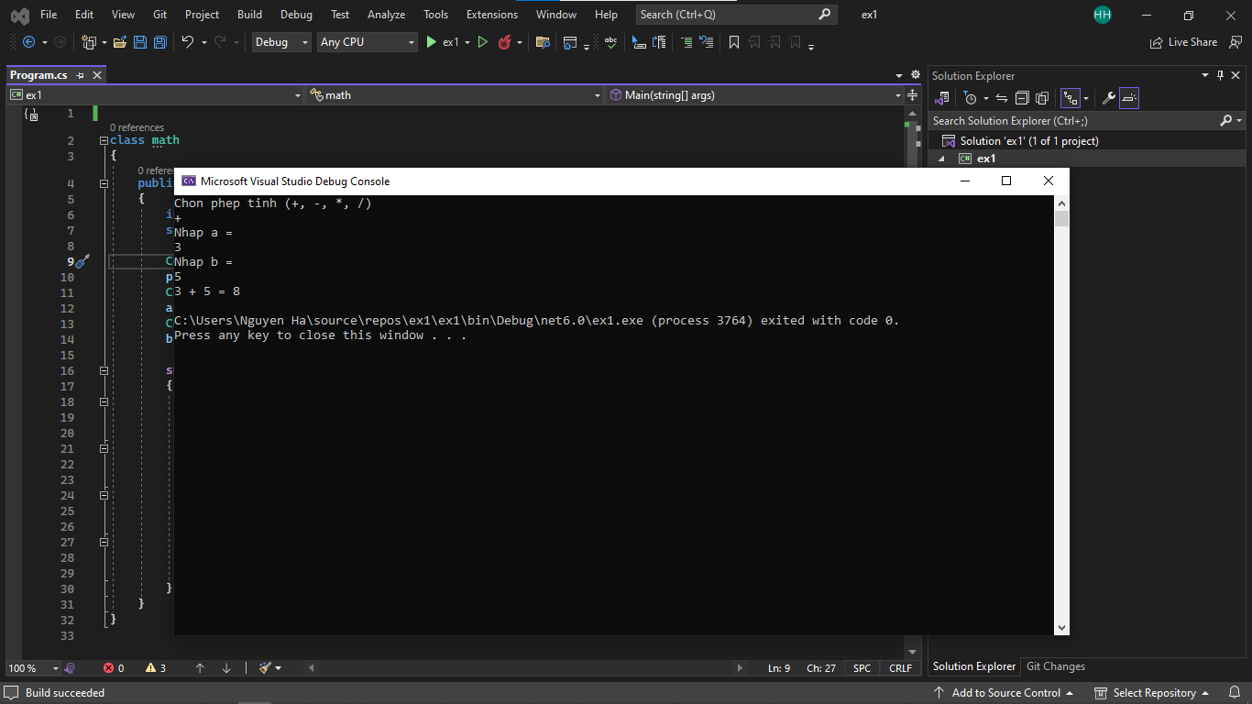

class math

{

public static void Main(string[] args)

{

int a, b;

string p;

Console.WriteLine("Chon phep tinh (+, -, *, /) ");

p = Console.ReadLine();

Console.WriteLine("Nhap a = ");

a = int.Parse(Console.ReadLine());

Console.WriteLine("Nhap b = ");

b = int.Parse(Console.ReadLine());

switch (p)

{

case "+":

Console.WriteLine($"{a} + {b} = {a + b}");

break;

case "-":

Console.WriteLine($"{a} - {b} = {a - b}");

break;

case "*":

Console.WriteLine($"{a} * {b} = {a * b}");

break;

case "/":

Console.WriteLine($"{a} / {b} = {a / b}");

break;

}

}

}

**Ex2:**

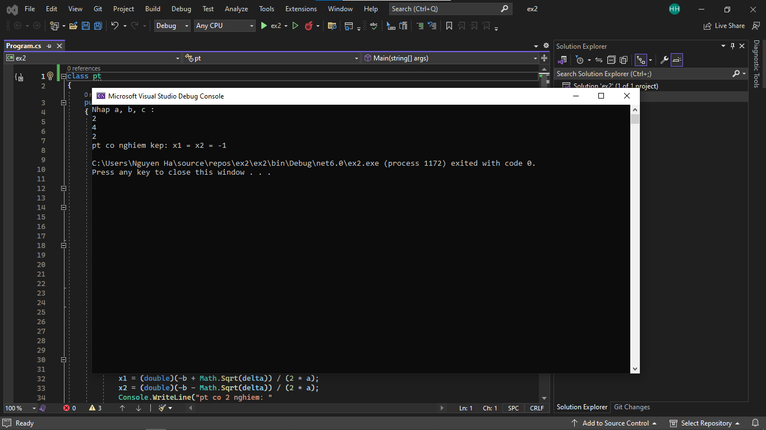

class pt

{

public static void Main(String[] args)

{

int a, b, c;

Console.WriteLine("Nhap a, b, c : ");

a = int.Parse(Console.ReadLine());

b = int.Parse(Console.ReadLine());

c = int.Parse(Console.ReadLine());

if (a == 0)

{

if (b == 0)

{

Console.WriteLine("pt vo nghiem");

}

else

{

Console.WriteLine("pt co 1 nghiem: "

+ "x = " + (-c / b));

}

return;

}

double delta = b * b - 4 * a * c;

double x1;

double x2;

if (delta > 0)

{

x1 = (double)(-b + Math.Sqrt(delta)) / (2 * a);

x2 = (double)(-b - Math.Sqrt(delta)) / (2 * a);

Console.WriteLine("pt co 2 nghiem: "

+ "x1 = " + x1 + " va x2 = " + x2);

}

else if (delta == 0)

{

x1 = -b / (2 * a);

Console.WriteLine("pt co nghiem kep: "

+ "x1 = x2 = " + x1);

}

else

{

Console.WriteLine("pt vo nghiem");

}

}

}

**Ex3:**

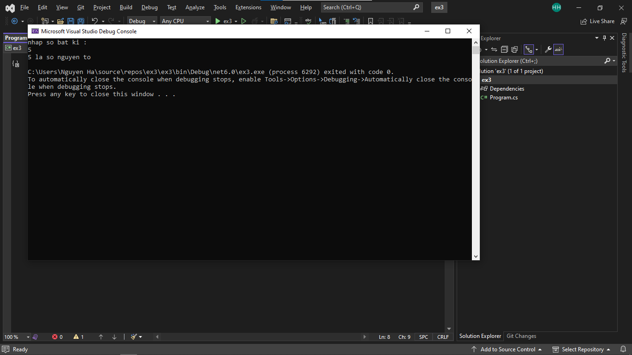

class snt

{

public static void Main(string[] args)

{

int n, c = 0;

Console.WriteLine("nhap so bat ki : ");

n = int.Parse(Console.ReadLine());

for (int i = 2; i <= (n / 2); i++)

{

if ((n % i) == 0)

{

c++;

break;

}

}

if ((c == 0) && (n != 1))

Console.WriteLine(n + " la so nguyen to");

else

Console.WriteLine(n + " khong phai so nguyen to");

}

}

**Ex4:**

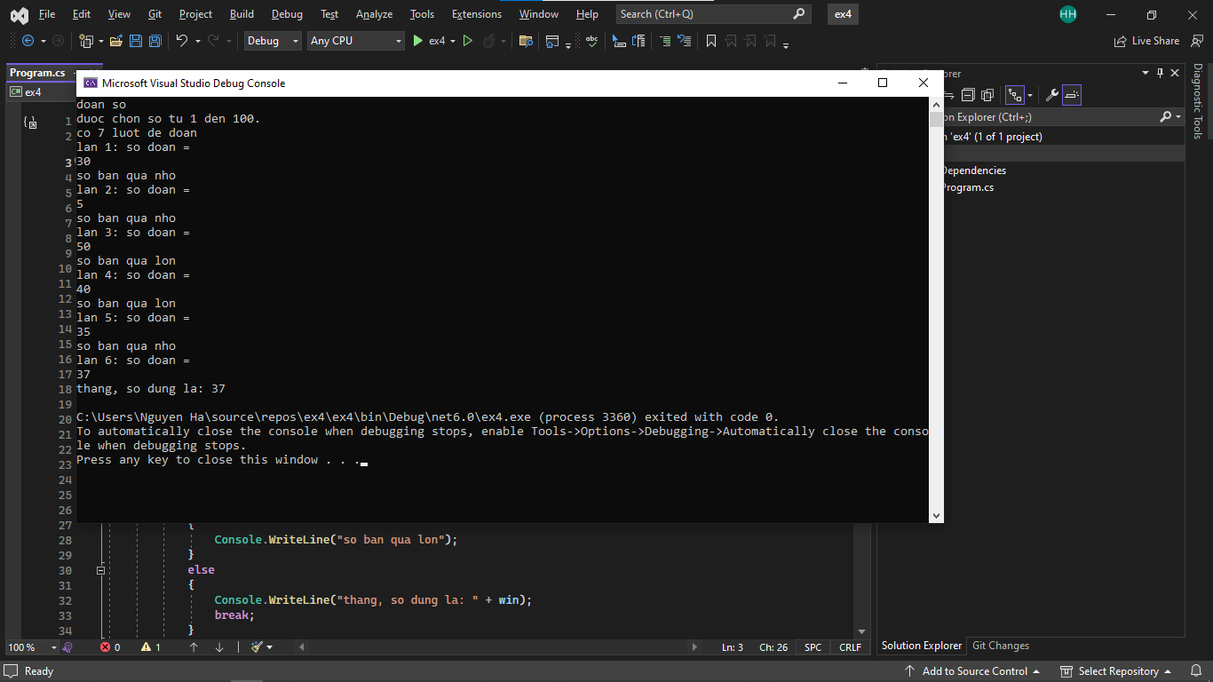

class doan

{

public static void Main(String[] args)

{

Random r = new Random();

int min = 1;

int max = 100;

int win = r.Next(min, max + 1);

int l = 7;

Console.WriteLine("doan so");

Console.WriteLine("duoc chon so tu " + min + " den " + max + ".");

Console.WriteLine("co " + l + " luot de doan");

for (int i = 1; i <= l; i++)

{

Console.WriteLine("lan " + i + ": so doan = ");

int n = int.Parse(Console.ReadLine());

if (n < win)

{

Console.WriteLine("so ban qua nho");

}

else if (n > win)

{

Console.WriteLine("so ban qua lon");

}

else

{

Console.WriteLine("thang, so dung la: " + win);

break;

}

if (i == l)

{

Console.WriteLine("het luot, so dung la: " + win);

}

}

}

}