Họ và tên: Hồ Nguyên Hà . Mã SV: 20it043

Bài Tập Tuần 7

EX 1:

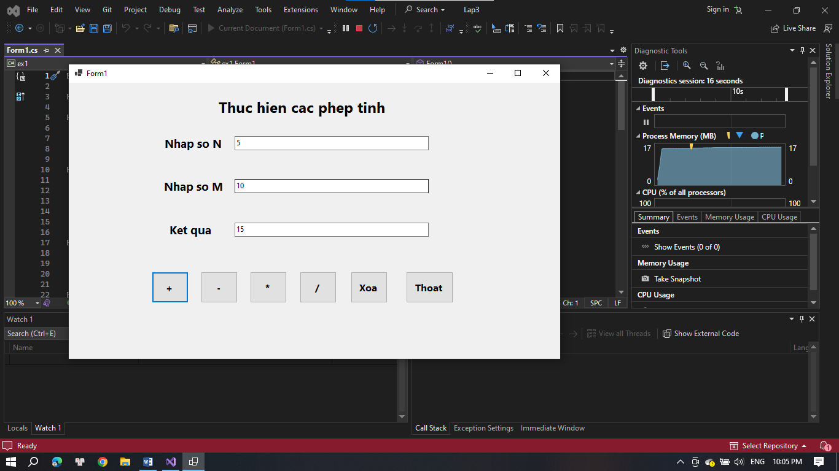

namespace ex1

{

partial class Form1

{

/// <summary>

/// Required designer variable.

/// </summary>

private System.ComponentModel.IContainer components = null;

/// <summary>

/// Clean up any resources being used.

/// </summary>

/// <param name="disposing">true if managed resources should be disposed; otherwise, false.</param>

protected override void Dispose(bool disposing)

{

if (disposing && (components != null))

{

components.Dispose();

}

base.Dispose(disposing);

}

#region Windows Form Designer generated code

/// <summary>

/// Required method for Designer support - do not modify

/// the contents of this method with the code editor.

/// </summary>

private void InitializeComponent()

{

label1 = new Label();

label2 = new Label();

label3 = new Label();

label4 = new Label();

txtSoN = new TextBox();

txtKetqua = new TextBox();

txtSoM = new TextBox();

btnCong = new Button();

btnTru = new Button();

btnNhan = new Button();

btnChia = new Button();

btnXoa = new Button();

btnThoat = new Button();

SuspendLayout();

//

// label1

//

label1.AutoSize = true;

label1.Font = new Font("Segoe UI", 18F, FontStyle.Bold, GraphicsUnit.Point);

label1.Location = new Point(238, 23);

label1.Name = "label1";

label1.Size = new Size(285, 32);

label1.TabIndex = 0;

label1.Text = "Thuc hien cac phep tinh";

//

// label2

//

label2.AutoSize = true;

label2.Font = new Font("Segoe UI", 14.25F, FontStyle.Bold, GraphicsUnit.Point);

label2.Location = new Point(151, 86);

label2.Name = "label2";

label2.Size = new Size(105, 25);

label2.TabIndex = 1;

label2.Text = "Nhap so N";

//

// label3

//

label3.AutoSize = true;

label3.Font = new Font("Segoe UI", 14.25F, FontStyle.Bold, GraphicsUnit.Point);

label3.Location = new Point(150, 156);

label3.Name = "label3";

label3.Size = new Size(108, 25);

label3.TabIndex = 2;

label3.Text = "Nhap so M";

//

// label4

//

label4.AutoSize = true;

label4.Font = new Font("Segoe UI", 14.25F, FontStyle.Bold, GraphicsUnit.Point);

label4.Location = new Point(159, 227);

label4.Name = "label4";

label4.Size = new Size(80, 25);

label4.TabIndex = 3;

label4.Text = "Ket qua";

//

// txtSoN

//

txtSoN.Location = new Point(270, 87);

txtSoN.Name = "txtSoN";

txtSoN.Size = new Size(316, 23);

txtSoN.TabIndex = 4;

//

// txtKetqua

//

txtKetqua.Location = new Point(270, 228);

txtKetqua.Name = "txtKetqua";

txtKetqua.Size = new Size(316, 23);

txtKetqua.TabIndex = 5;

//

// txtSoM

//

txtSoM.Location = new Point(270, 157);

txtSoM.Name = "txtSoM";

txtSoM.Size = new Size(316, 23);

txtSoM.TabIndex = 6;

//

// btnCong

//

btnCong.Font = new Font("Segoe UI", 12F, FontStyle.Bold, GraphicsUnit.Point);

btnCong.Location = new Point(135, 308);

btnCong.Name = "btnCong";

btnCong.Size = new Size(60, 51);

btnCong.TabIndex = 7;

btnCong.Text = "+";

btnCong.UseVisualStyleBackColor = true;

btnCong.Click += btnCong_Click;

//

// btnTru

//

btnTru.Font = new Font("Segoe UI", 12F, FontStyle.Bold, GraphicsUnit.Point);

btnTru.Location = new Point(215, 308);

btnTru.Name = "btnTru";

btnTru.Size = new Size(60, 51);

btnTru.TabIndex = 8;

btnTru.Text = "-";

btnTru.UseVisualStyleBackColor = true;

btnTru.Click += btnTru_Click;

//

// btnNhan

//

btnNhan.Font = new Font("Segoe UI", 12F, FontStyle.Bold, GraphicsUnit.Point);

btnNhan.Location = new Point(295, 308);

btnNhan.Name = "btnNhan";

btnNhan.Size = new Size(60, 51);

btnNhan.TabIndex = 9;

btnNhan.Text = "*";

btnNhan.UseVisualStyleBackColor = true;

btnNhan.Click += btnNhan_Click;

//

// btnChia

//

btnChia.Font = new Font("Segoe UI", 12F, FontStyle.Bold, GraphicsUnit.Point);

btnChia.Location = new Point(376, 308);

btnChia.Name = "btnChia";

btnChia.Size = new Size(60, 51);

btnChia.TabIndex = 10;

btnChia.Text = "/";

btnChia.UseVisualStyleBackColor = true;

btnChia.Click += btnChia_Click;

//

// btnXoa

//

btnXoa.Font = new Font("Segoe UI", 12F, FontStyle.Bold, GraphicsUnit.Point);

btnXoa.Location = new Point(459, 308);

btnXoa.Name = "btnXoa";

btnXoa.Size = new Size(60, 51);

btnXoa.TabIndex = 11;

btnXoa.Text = "Xoa";

btnXoa.UseVisualStyleBackColor = true;

btnXoa.Click += button5_Click;

//

// btnThoat

//

btnThoat.Font = new Font("Segoe UI", 12F, FontStyle.Bold, GraphicsUnit.Point);

btnThoat.Location = new Point(549, 308);

btnThoat.Name = "btnThoat";

btnThoat.Size = new Size(77, 51);

btnThoat.TabIndex = 12;

btnThoat.Text = "Thoat";

btnThoat.UseVisualStyleBackColor = true;

btnThoat.Click += btnThoat_Click;

//

// Form1

//

AutoScaleDimensions = new SizeF(7F, 15F);

AutoScaleMode = AutoScaleMode.Font;

ClientSize = new Size(800, 450);

Controls.Add(btnThoat);

Controls.Add(btnXoa);

Controls.Add(btnChia);

Controls.Add(btnNhan);

Controls.Add(btnTru);

Controls.Add(btnCong);

Controls.Add(txtSoM);

Controls.Add(txtKetqua);

Controls.Add(txtSoN);

Controls.Add(label4);

Controls.Add(label3);

Controls.Add(label2);

Controls.Add(label1);

Name = "Form1";

Text = "Form1";

Load += Form1_Load;

ResumeLayout(false);

PerformLayout();

}

#endregion

private Label label1;

private Label label2;

private Label label3;

private Label label4;

private TextBox txtSoN;

private TextBox txtKetqua;

private TextBox txtSoM;

private Button btnCong;

private Button btnTru;

private Button btnNhan;

private Button btnChia;

private Button btnXoa;

private Button btnThoat;

}

}

namespace ex1

{

public partial class Form1 : Form

{

public Form1()

{

InitializeComponent();

}

private void button5_Click(object sender, EventArgs e)

{

txtSoN.Text = "";

txtSoM.Text = "";

txtKetqua.Text = "";

}

private void Form1_Load(object sender, EventArgs e)

{

}

private void btnCong_Click(object sender, EventArgs e)

{

{

int n = int.Parse(txtSoN.Text);

int m = int.Parse(txtSoM.Text);

int Tong = n + m;

txtKetqua.Text = Tong.ToString();

}

}

private void btnThoat_Click(object sender, EventArgs e)

{

Close();

}

private void btnTru_Click(object sender, EventArgs e)

{

{

int n = int.Parse(txtSoN.Text);

int m = int.Parse(txtSoM.Text);

int Tong = n - m;

txtKetqua.Text = Tong.ToString();

}

}

private void btnNhan_Click(object sender, EventArgs e)

{

{

int n = int.Parse(txtSoN.Text);

int m = int.Parse(txtSoM.Text);

int Tong = n * m;

txtKetqua.Text = Tong.ToString();

}

}

private void btnChia_Click(object sender, EventArgs e)

{

{

int n = int.Parse(txtSoN.Text);

int m = int.Parse(txtSoM.Text);

int Tong = n / m;

txtKetqua.Text = Tong.ToString();

}

}

private void txtSoN_TextChanged(object sender, EventArgs e)

{

}

}

}

EX 2:

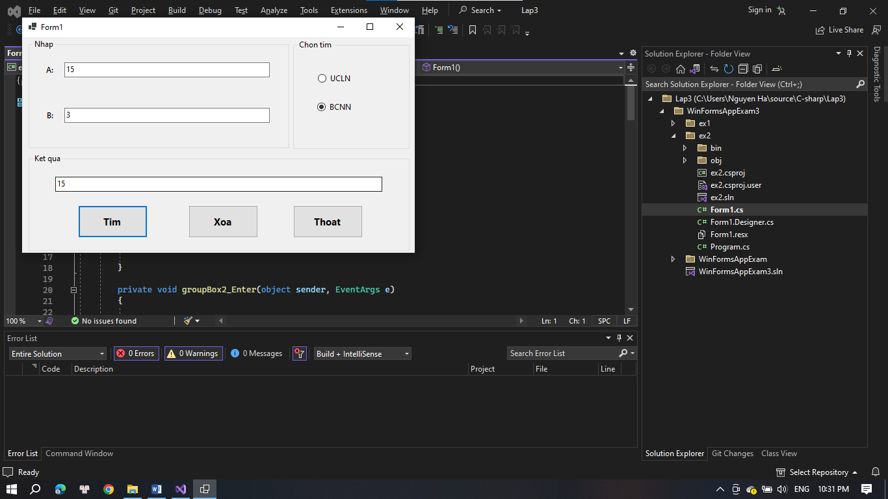

namespace ex2

{

partial class Form1

{

/// <summary>

/// Required designer variable.

/// </summary>

private System.ComponentModel.IContainer components = null;

/// <summary>

/// Clean up any resources being used.

/// </summary>

/// <param name="disposing">true if managed resources should be disposed; otherwise, false.</param>

protected override void Dispose(bool disposing)

{

if (disposing && (components != null))

{

components.Dispose();

}

base.Dispose(disposing);

}

#region Windows Form Designer generated code

/// <summary>

/// Required method for Designer support - do not modify

/// the contents of this method with the code editor.

/// </summary>

private void InitializeComponent()

{

groupBox1 = new GroupBox();

txtB = new TextBox();

txtA = new TextBox();

label2 = new Label();

label1 = new Label();

groupBox2 = new GroupBox();

btnBCNN = new RadioButton();

btnUCLN = new RadioButton();

groupBox3 = new GroupBox();

btnThoat = new Button();

btnXoa = new Button();

btnTim = new Button();

txtKetqua = new TextBox();

groupBox1.SuspendLayout();

groupBox2.SuspendLayout();

groupBox3.SuspendLayout();

SuspendLayout();

//

// groupBox1

//

groupBox1.Controls.Add(txtB);

groupBox1.Controls.Add(txtA);

groupBox1.Controls.Add(label2);

groupBox1.Controls.Add(label1);

groupBox1.Location = new Point(10, 3);

groupBox1.Name = "groupBox1";

groupBox1.Size = new Size(401, 169);

groupBox1.TabIndex = 0;

groupBox1.TabStop = false;

groupBox1.Text = "Nhap";

groupBox1.Enter += groupBox1_Enter;

//

// txtB

//

txtB.Location = new Point(55, 106);

txtB.Name = "txtB";

txtB.Size = new Size(316, 23);

txtB.TabIndex = 3;

//

// txtA

//

txtA.Location = new Point(55, 36);

txtA.Name = "txtA";

txtA.Size = new Size(316, 23);

txtA.TabIndex = 2;

txtA.TextChanged += textBox1_TextChanged;

//

// label2

//

label2.AutoSize = true;

label2.Font = new Font("Segoe UI Semibold", 9F, FontStyle.Bold, GraphicsUnit.Point);

label2.Location = new Point(25, 110);

label2.Name = "label2";

label2.Size = new Size(17, 15);

label2.TabIndex = 1;

label2.Text = "B:";

//

// label1

//

label1.AutoSize = true;

label1.Font = new Font("Segoe UI Semibold", 9F, FontStyle.Bold, GraphicsUnit.Point);

label1.Location = new Point(24, 40);

label1.Name = "label1";

label1.Size = new Size(18, 15);

label1.TabIndex = 0;

label1.Text = "A:";

label1.Click += label1_Click;

//

// groupBox2

//

groupBox2.Controls.Add(btnBCNN);

groupBox2.Controls.Add(btnUCLN);

groupBox2.Location = new Point(417, 4);

groupBox2.Name = "groupBox2";

groupBox2.Size = new Size(179, 169);

groupBox2.TabIndex = 1;

groupBox2.TabStop = false;

groupBox2.Text = "Chon tim";

groupBox2.Enter += groupBox2_Enter;

//

// btnBCNN

//

btnBCNN.AutoSize = true;

btnBCNN.Location = new Point(37, 94);

btnBCNN.Name = "btnBCNN";

btnBCNN.Size = new Size(58, 19);

btnBCNN.TabIndex = 5;

btnBCNN.Text = "BCNN";

btnBCNN.UseVisualStyleBackColor = true;

//

// btnUCLN

//

btnUCLN.AutoSize = true;

btnUCLN.Location = new Point(38, 50);

btnUCLN.Name = "btnUCLN";

btnUCLN.Size = new Size(56, 19);

btnUCLN.TabIndex = 4;

btnUCLN.Text = "UCLN";

btnUCLN.UseVisualStyleBackColor = true;

//

// groupBox3

//

groupBox3.Controls.Add(btnThoat);

groupBox3.Controls.Add(btnXoa);

groupBox3.Controls.Add(btnTim);

groupBox3.Controls.Add(txtKetqua);

groupBox3.Location = new Point(10, 179);

groupBox3.Name = "groupBox3";

groupBox3.Size = new Size(586, 151);

groupBox3.TabIndex = 2;

groupBox3.TabStop = false;

groupBox3.Text = "Ket qua";

groupBox3.Enter += groupBox3_Enter;

//

// btnThoat

//

btnThoat.Font = new Font("Segoe UI", 11.25F, FontStyle.Bold, GraphicsUnit.Point);

btnThoat.Location = new Point(407, 80);

btnThoat.Name = "btnThoat";

btnThoat.Size = new Size(107, 50);

btnThoat.TabIndex = 3;

btnThoat.Text = "Thoat";

btnThoat.UseVisualStyleBackColor = true;

btnThoat.Click += button3_Click;

//

// btnXoa

//

btnXoa.Font = new Font("Segoe UI", 11.25F, FontStyle.Bold, GraphicsUnit.Point);

btnXoa.Location = new Point(246, 80);

btnXoa.Name = "btnXoa";

btnXoa.Size = new Size(107, 50);

btnXoa.TabIndex = 2;

btnXoa.Text = "Xoa";

btnXoa.UseVisualStyleBackColor = true;

btnXoa.Click += btnXoa_Click;

//

// btnTim

//

btnTim.Font = new Font("Segoe UI", 11.25F, FontStyle.Bold, GraphicsUnit.Point);

btnTim.Location = new Point(76, 80);

btnTim.Name = "btnTim";

btnTim.Size = new Size(107, 50);

btnTim.TabIndex = 1;

btnTim.Text = "Tim";

btnTim.UseVisualStyleBackColor = true;

btnTim.Click += button1_Click;

//

// txtKetqua

//

txtKetqua.Location = new Point(41, 36);

txtKetqua.Name = "txtKetqua";

txtKetqua.Size = new Size(503, 23);

txtKetqua.TabIndex = 0;

//

// Form1

//

AutoScaleDimensions = new SizeF(7F, 15F);

AutoScaleMode = AutoScaleMode.Font;

ClientSize = new Size(604, 332);

Controls.Add(groupBox3);

Controls.Add(groupBox2);

Controls.Add(groupBox1);

Name = "Form1";

Text = "Form1";

Load += Form1_Load;

groupBox1.ResumeLayout(false);

groupBox1.PerformLayout();

groupBox2.ResumeLayout(false);

groupBox2.PerformLayout();

groupBox3.ResumeLayout(false);

groupBox3.PerformLayout();

ResumeLayout(false);

}

#endregion

private GroupBox groupBox1;

private GroupBox groupBox2;

private GroupBox groupBox3;

private Label label2;

private Label label1;

private TextBox txtA;

private TextBox txtB;

private Button btnThoat;

private Button btnXoa;

private Button btnTim;

private TextBox txtKetqua;

private RadioButton btnBCNN;

private RadioButton btnUCLN;

}

}

namespace ex2

{

public partial class Form1 : Form

{

public Form1()

{

InitializeComponent();

}

private void Form1_Load(object sender, EventArgs e)

{

}

private void pnNhap_Paint(object sender, PaintEventArgs e)

{

}

private void groupBox2_Enter(object sender, EventArgs e)

{

}

private void groupBox1_Enter(object sender, EventArgs e)

{

}

private void label1_Click(object sender, EventArgs e)

{

}

private void textBox1_TextChanged(object sender, EventArgs e)

{

}

private void groupBox3_Enter(object sender, EventArgs e)

{

}

private void checkBox2_CheckedChanged(object sender, EventArgs e)

{

}

private void checkBox1_CheckedChanged(object sender, EventArgs e)

{

}

private void button1_Click(object sender, EventArgs e)

{

int a, b;

if (int.TryParse(txtA.Text, out a) && int.TryParse(txtB.Text, out b))

{

if (btnUCLN.Checked)

{

int ucln = UCLN(a, b);

txtKetqua.Text = ucln.ToString();

}

else if (btnBCNN.Checked)

{

int bcnn = BCNN(a, b);

txtKetqua.Text = bcnn.ToString();

}

}

else

{

txtKetqua.Text = "Vui lòng nhập số nguyên hợp lệ cho a và b.";

}

}

private void button3_Click(object sender, EventArgs e)

{

Close();

}

private void checkedListBox1_SelectedIndexChanged(object sender, EventArgs e)

{

}

private void btnXoa_Click(object sender, EventArgs e)

{

txtA.Text = "";

txtB.Text = "";

txtKetqua.Text = "";

btnBCNN.Checked = false;

btnUCLN.Checked = false;

}

// Hàm tính UCLN

private int UCLN(int a, int b)

{

while (b != 0)

{

int temp = b;

b = a % b;

a = temp;

}

return a;

}

// Hàm tính BCNN

private int BCNN(int a, int b)

{

return (a * b) / UCLN(a, b);

}

}

}

EX3 EX4:

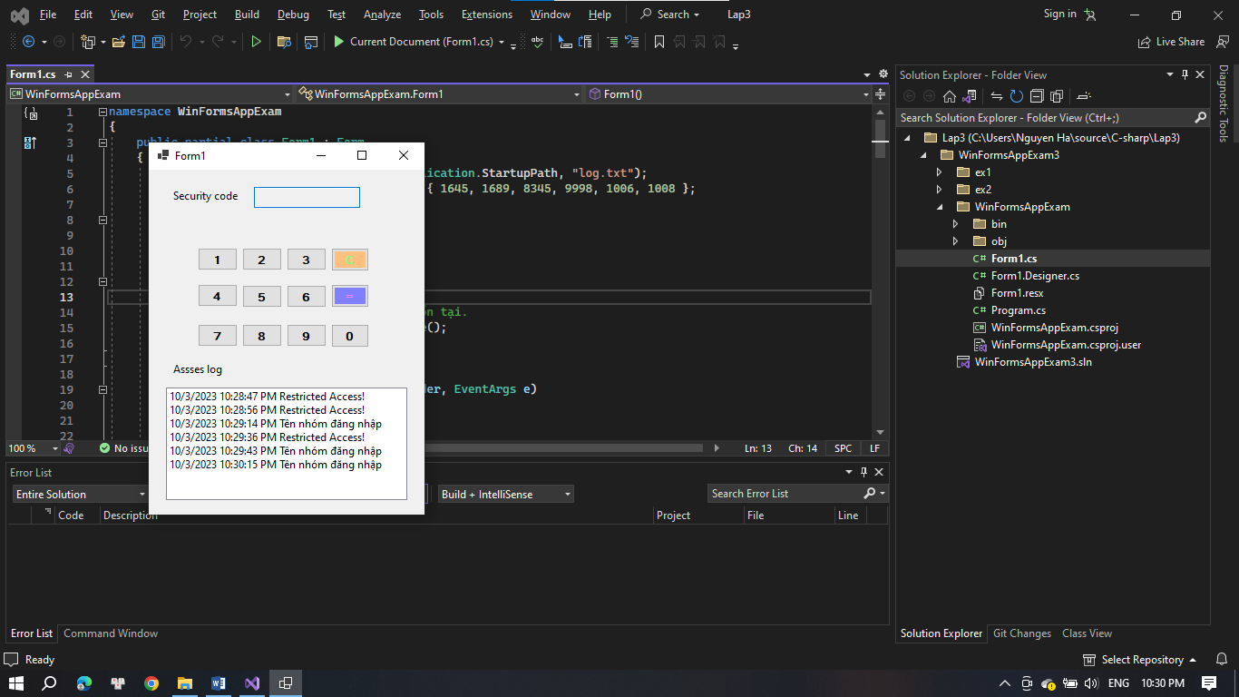

namespace WinFormsAppExam

{

partial class Form1

{

/// <summary>

/// Required designer variable.

/// </summary>

private System.ComponentModel.IContainer components = null;

/// <summary>

/// Clean up any resources being used.

/// </summary>

/// <param name="disposing">true if managed resources should be disposed; otherwise, false.</param>

protected override void Dispose(bool disposing)

{

if (disposing && (components != null))

{

components.Dispose();

}

base.Dispose(disposing);

}

#region Windows Form Designer generated code

/// <summary>

/// Required method for Designer support - do not modify

/// the contents of this method with the code editor.

/// </summary>

private void InitializeComponent()

{

label1 = new Label();

txtSecurityCode = new TextBox();

button1 = new Button();

button2 = new Button();

button3 = new Button();

button6 = new Button();

button5 = new Button();

button4 = new Button();

button8 = new Button();

button9 = new Button();

button7 = new Button();

button0 = new Button();

button = new Button();

buttonC = new Button();

label2 = new Label();

listBoxLog = new ListBox();

SuspendLayout();

//

// label1

//

label1.AutoSize = true;

label1.Location = new Point(28, 28);

label1.Name = "label1";

label1.Size = new Size(98, 20);

label1.TabIndex = 0;

label1.Text = "Security code";

//

// txtSecurityCode

//

txtSecurityCode.AccessibleName = "txtSecurityCode";

txtSecurityCode.Location = new Point(132, 25);

txtSecurityCode.Name = "txtSecurityCode";

txtSecurityCode.PasswordChar = '*';

txtSecurityCode.ReadOnly = true;

txtSecurityCode.Size = new Size(133, 27);

txtSecurityCode.TabIndex = 1;

txtSecurityCode.TextAlign = HorizontalAlignment.Center;

txtSecurityCode.TextChanged += txtSecurityCode_TextChanged;

txtSecurityCode.KeyDown += txtSecurityCode_KeyDown;

//

// button1

//

button1.AccessibleName = "btn1";

button1.Font = new Font("Microsoft Sans Serif", 9F, FontStyle.Bold, GraphicsUnit.Point);

button1.Location = new Point(62, 114);

button1.MaximumSize = new Size(50, 33);

button1.Name = "button1";

button1.Size = new Size(50, 33);

button1.TabIndex = 2;

button1.Text = "1";

button1.UseVisualStyleBackColor = true;

button1.Click += button1_Click;

//

// button2

//

button2.AccessibleName = "btn2";

button2.Font = new Font("Microsoft Sans Serif", 9F, FontStyle.Bold, GraphicsUnit.Point);

button2.Location = new Point(118, 114);

button2.MaximumSize = new Size(50, 33);

button2.Name = "button2";

button2.Size = new Size(50, 33);

button2.TabIndex = 3;

button2.Text = "2";

button2.UseVisualStyleBackColor = true;

button2.Click += button2_Click;

//

// button3

//

button3.AccessibleName = "btn3";

button3.Font = new Font("Microsoft Sans Serif", 9F, FontStyle.Bold, GraphicsUnit.Point);

button3.Location = new Point(174, 114);

button3.MaximumSize = new Size(50, 33);

button3.Name = "button3";

button3.Size = new Size(50, 33);

button3.TabIndex = 4;

button3.Text = "3";

button3.UseVisualStyleBackColor = true;

button3.Click += button3_Click;

//

// button6

//

button6.AccessibleName = "btn6";

button6.Font = new Font("Microsoft Sans Serif", 9F, FontStyle.Bold, GraphicsUnit.Point);

button6.Location = new Point(174, 169);

button6.MaximumSize = new Size(50, 33);

button6.Name = "button6";

button6.Size = new Size(50, 33);

button6.TabIndex = 5;

button6.Text = "6";

button6.UseVisualStyleBackColor = true;

button6.Click += button6_Click;

//

// button5

//

button5.AccessibleName = "btn5";

button5.Font = new Font("Microsoft Sans Serif", 9F, FontStyle.Bold, GraphicsUnit.Point);

button5.Location = new Point(118, 169);

button5.MaximumSize = new Size(50, 33);

button5.Name = "button5";

button5.Size = new Size(50, 33);

button5.TabIndex = 6;

button5.Text = "5";

button5.UseVisualStyleBackColor = true;

button5.Click += button5_Click;

//

// button4

//

button4.AccessibleName = "btn4";

button4.Font = new Font("Microsoft Sans Serif", 9F, FontStyle.Bold, GraphicsUnit.Point);

button4.Location = new Point(62, 168);

button4.MaximumSize = new Size(50, 33);

button4.Name = "button4";

button4.Size = new Size(50, 33);

button4.TabIndex = 7;

button4.Text = "4";

button4.UseVisualStyleBackColor = true;

button4.Click += button4_Click;

//

// button8

//

button8.AccessibleName = "btn8";

button8.Font = new Font("Microsoft Sans Serif", 9F, FontStyle.Bold, GraphicsUnit.Point);

button8.Location = new Point(118, 226);

button8.MaximumSize = new Size(50, 33);

button8.Name = "button8";

button8.Size = new Size(50, 33);

button8.TabIndex = 8;

button8.Text = "8";

button8.UseVisualStyleBackColor = true;

button8.Click += button8_Click;

//

// button9

//

button9.AccessibleName = "btn9";

button9.Font = new Font("Microsoft Sans Serif", 9F, FontStyle.Bold, GraphicsUnit.Point);

button9.Location = new Point(174, 226);

button9.MaximumSize = new Size(50, 33);

button9.Name = "button9";

button9.Size = new Size(50, 33);

button9.TabIndex = 9;

button9.Text = "9";

button9.UseVisualStyleBackColor = true;

button9.Click += button9_Click;

//

// button7

//

button7.AccessibleName = "btn7";

button7.Font = new Font("Microsoft Sans Serif", 9F, FontStyle.Bold, GraphicsUnit.Point);

button7.Location = new Point(62, 226);

button7.MaximumSize = new Size(50, 33);

button7.Name = "button7";

button7.Size = new Size(50, 33);

button7.TabIndex = 10;

button7.Text = "7";

button7.UseVisualStyleBackColor = true;

button7.Click += button7_Click;

//

// button0

//

button0.AccessibleName = "btn0";

button0.Font = new Font("Microsoft Sans Serif", 9F, FontStyle.Bold, GraphicsUnit.Point);

button0.Location = new Point(230, 226);

button0.Name = "button0";

button0.Size = new Size(48, 34);

button0.TabIndex = 11;

button0.Text = "0";

button0.UseVisualStyleBackColor = true;

button0.Click += button0_Click;

//

// button

//

button.AccessibleName = "btn=";

button.BackColor = Color.FromArgb(128, 128, 255);

button.Font = new Font("Microsoft Sans Serif", 9F, FontStyle.Bold, GraphicsUnit.Point);

button.ForeColor = Color.FromArgb(255, 128, 255);

button.Location = new Point(230, 168);

button.Name = "button";

button.Size = new Size(48, 35);

button.TabIndex = 12;

button.Text = "=";

button.UseVisualStyleBackColor = false;

//

// buttonC

//

buttonC.AccessibleName = "btnC";

buttonC.BackColor = Color.FromArgb(255, 192, 128);

buttonC.Font = new Font("Microsoft Sans Serif", 9F, FontStyle.Bold, GraphicsUnit.Point);

buttonC.ForeColor = Color.FromArgb(128, 255, 128);

buttonC.Location = new Point(230, 114);

buttonC.Name = "buttonC";

buttonC.Size = new Size(48, 34);

buttonC.TabIndex = 13;

buttonC.Text = "C";

buttonC.UseVisualStyleBackColor = false;

buttonC.Click += buttonC_Click;

//

// label2

//

label2.AutoSize = true;

label2.Location = new Point(28, 283);

label2.Name = "label2";

label2.Size = new Size(77, 20);

label2.TabIndex = 14;

label2.Text = "Assses log";

//

// listBoxLog

//

listBoxLog.FormattingEnabled = true;

listBoxLog.ItemHeight = 20;

listBoxLog.Location = new Point(22, 320);

listBoxLog.Name = "listBoxLog";

listBoxLog.Size = new Size(304, 164);

listBoxLog.TabIndex = 15;

//

// Form1

//

AutoScaleDimensions = new SizeF(8F, 20F);

AutoScaleMode = AutoScaleMode.Font;

ClientSize = new Size(347, 506);

Controls.Add(listBoxLog);

Controls.Add(label2);

Controls.Add(buttonC);

Controls.Add(button);

Controls.Add(button0);

Controls.Add(button7);

Controls.Add(button9);

Controls.Add(button8);

Controls.Add(button4);

Controls.Add(button5);

Controls.Add(button6);

Controls.Add(button3);

Controls.Add(button2);

Controls.Add(button1);

Controls.Add(txtSecurityCode);

Controls.Add(label1);

Name = "Form1";

Text = "Form1";

Load += Form1_Load;

ResumeLayout(false);

PerformLayout();

}

#endregion

private Label label1;

private TextBox txtSecurityCode;

private Button button1;

private Button button2;

private Button button3;

private Button button6;

private Button button5;

private Button button4;

private Button button8;

private Button button9;

private Button button7;

private Button button0;

private Button button;

private Button buttonC;

private Label label2;

private ListBox listBoxLog;

}

}

namespace WinFormsAppExam

{

public partial class Form1 : Form

{

string logFilePath = Path.Combine(Application.StartupPath, "log.txt");

List<int> accessCodes = new List<int> { 1645, 1689, 8345, 9998, 1006, 1008 };

public Form1()

{

InitializeComponent();

if (!File.Exists(logFilePath))

{

// Tạo tệp log nếu nó không tồn tại.

File.Create(logFilePath).Close();

}

}

private void button1_Click(object sender, EventArgs e)

{

txtSecurityCode.Text += "1";

}

private void button2_Click(object sender, EventArgs e)

{

txtSecurityCode.Text += "2";

}

private void button3_Click(object sender, EventArgs e)

{

txtSecurityCode.Text += "3";

}

private void button4_Click(object sender, EventArgs e)

{

txtSecurityCode.Text += "4";

}

private void button5_Click(object sender, EventArgs e)

{

txtSecurityCode.Text += "5";

}

private void button6_Click(object sender, EventArgs e)

{

txtSecurityCode.Text += "6";

}

private void button7_Click(object sender, EventArgs e)

{

txtSecurityCode.Text += "7";

}

private void button8_Click(object sender, EventArgs e)

{

txtSecurityCode.Text += "8";

}

private void button9_Click(object sender, EventArgs e)

{

txtSecurityCode.Text += "9";

}

private void button0_Click(object sender, EventArgs e)

{

txtSecurityCode.Text += "0";

}

private void buttonC_Click(object sender, EventArgs e)

{

if (txtSecurityCode.Text.Length > 0)

{

txtSecurityCode.Text = txtSecurityCode.Text.Substring(0, txtSecurityCode.Text.Length - 1);

}

}

private void txtSecurityCode_TextChanged(object sender, EventArgs e)

{

if (txtSecurityCode.Text.Length == 4)

{

int enteredCode;

if (int.TryParse(txtSecurityCode.Text, out enteredCode))

{

if (accessCodes.Contains(enteredCode))

{

// Đăng nhập thành công.

listBoxLog.Items.Add($"{DateTime.Now.ToShortDateString()} {DateTime.Now.ToLongTimeString()} Tên nhóm đăng nhập");

}

else

{

// Đăng nhập thất bại.

listBoxLog.Items.Add($"{DateTime.Now.ToShortDateString()} {DateTime.Now.ToLongTimeString()} Restricted Access!");

}

// Xóa nội dung txtSecurityCode.Text sau khi kiểm tra.

txtSecurityCode.Text = "";

}

else

{

// Hiển thị thông báo lỗi nếu mã không hợp lệ.

MessageBox.Show("Mã không hợp lệ", "Lỗi", MessageBoxButtons.OK, MessageBoxIcon.Error);

}

string logEntry = $"{DateTime.Now.ToShortDateString()} {DateTime.Now.ToLongTimeString()} {(accessCodes.Contains(enteredCode) ? "Access granted" : "Access denied")}";

File.AppendAllText(logFilePath, logEntry + Environment.NewLine);

}

}

private void txtSecurityCode_KeyPress(object sender, KeyPressEventArgs e)

{

if (char.IsDigit(e.KeyChar))

{

// Thêm số tương ứng vào txtSecurityCode.

txtSecurityCode.Text += e.KeyChar;

// Ngăn việc ký tự được nhập vào TextBox.

e.Handled = true;

}

}

private void Form1_Load(object sender, EventArgs e)

{

txtSecurityCode.KeyPress += txtSecurityCode_KeyPress;

txtSecurityCode.Focus();

}

private void txtSecurityCode_KeyDown(object sender, KeyEventArgs e)

{

if (e.KeyCode >= Keys.D0 && e.KeyCode <= Keys.D9)

{

// Kiểm tra xem phím được nhấn là một phím số.

// Thêm số tương ứng vào txtSecurityCode.

txtSecurityCode.Text += (char)e.KeyValue;

}

else if (e.KeyCode == Keys.Back && txtSecurityCode.Text.Length > 0)

{

// Xử lý phím Backspace để xóa ký tự cuối cùng nếu có.

txtSecurityCode.Text = txtSecurityCode.Text.Substring(0, txtSecurityCode.Text.Length - 1);

}

// Ngăn việc ký tự được nhập vào TextBox.

e.SuppressKeyPress = true;

}

}

}