**REPORT**

**LAB 1**

**Student name: Hồ Nguyên Hà**

**Student ID: 20IT043**

**Student email: hnha.20it2@vku.udn.vn**

# **Introduction**

* Create a simple flutter mobile app
* Shows a diamond interface and works on android

# **Objectives**

* Know how to use flutter to create application interface

# **Methodology**

* Steps to create the application

1.Working with assets in flutter and the pubspec file

2. add app icon to the ios and android app

# **Results**

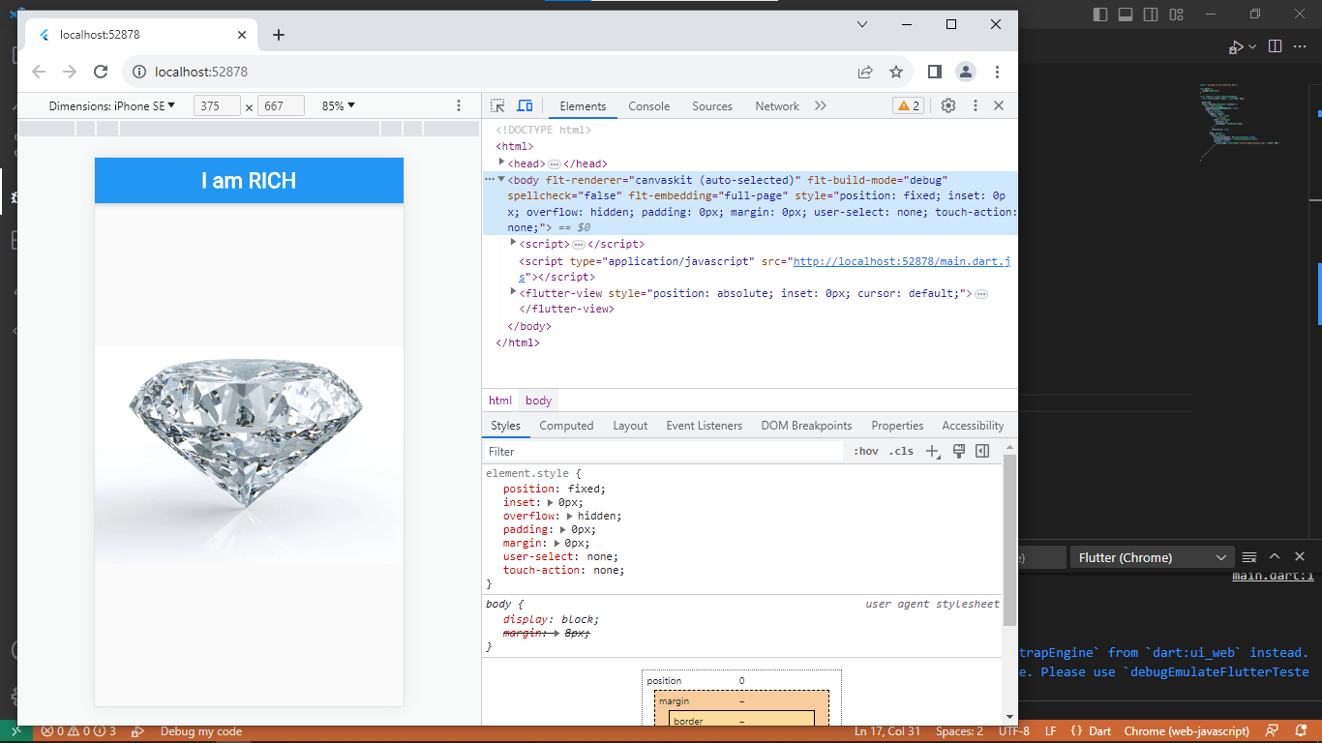

# **Discussion**

* Benefits: Greater reach, Ease of marketing, One for many, Gives a unified look and feel, Uses known technologies, Reduces development costs
* Disadvantage: Different Tools and Languages, User Interactions, Platform Integration, Loss of Flexibility

# **Conclusion**

* Create a mobile application running with flutter and learn how to use it