**REPORT**

**LAB 4**

**Student name: Hồ Nguyên Hà**

**Student ID: 20IT043**

**Student email: hnha.20it2@vku.udn.vn**

# **Introduction**

* This report briefly describes the purpose of the laboratory experiment on the development of the mobile application Magic 8 ball.
* The Magic 8 ball mobile application allows users to create a random dice game.

# **Objectives**

* The objective of the laboratory is to create a mobile application that allows users to create a Magic 8 ball.

# **Methodology**

* The laboratory uses a cross-platform mobile application development method to create the Magic 8 ball application.
* The application is developed using the latest technologies to ensure the best features and performance.

# **Results**

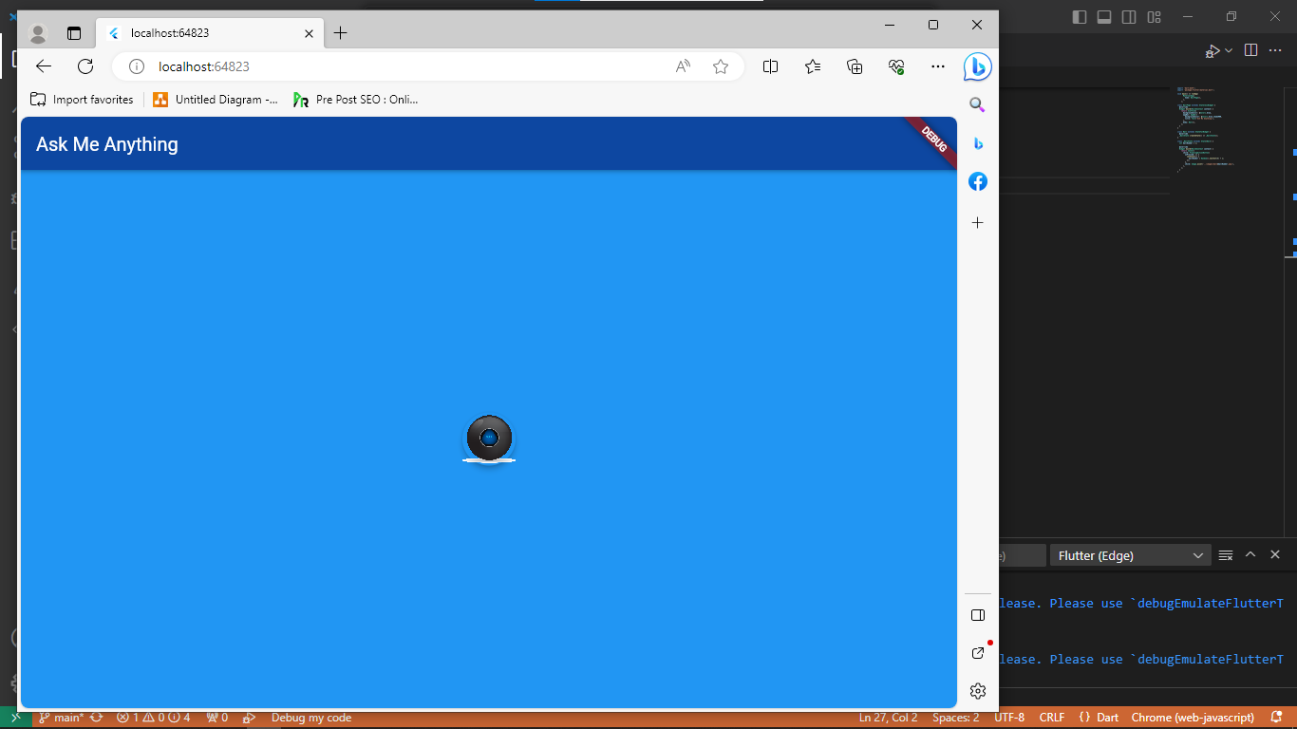

* The experimental results show that the Magic 8 ball application works well and allows users to easily create Magic 8 ball.

# **Discussion**

* The experimental results show that the Magic 8 ball application has achieved the laboratory’s objective.
* The strength of cross-platform mobile application development is that it allows the application to run on multiple platforms, thereby attracting more users. However, the weakness is that development may take more time and effort than developing separately for each platform.

# **Conclusion**

* The laboratory has succeeded in creating a mobile application that allows users to create Magic 8 ball.
* In the future, we can continue to improve and add new features to the Magic 8 ball application to attract more users.