**REPORT**

**LAB 6**

**Student name: Hồ Nguyên Hà**

**Student ID: 20IT043**

**Student email: hnha.20it2@vku.udn.vn**

# **Introduction**

* This report briefly describes the purpose of the laboratory experiment on the development of the mobile application Quizzler.
* The Quizzler mobile application allows users to create a random game with the quizz instrument Quizzler.

# **Objectives**

* The objective of the laboratory is to create a mobile application that allows users to create a Quizzler game.

# **Methodology**

* The laboratory uses a cross-platform mobile application development method to create the Quizzler application.
* The application is developed using the latest technologies to ensure the best features and performance.

# **Results**

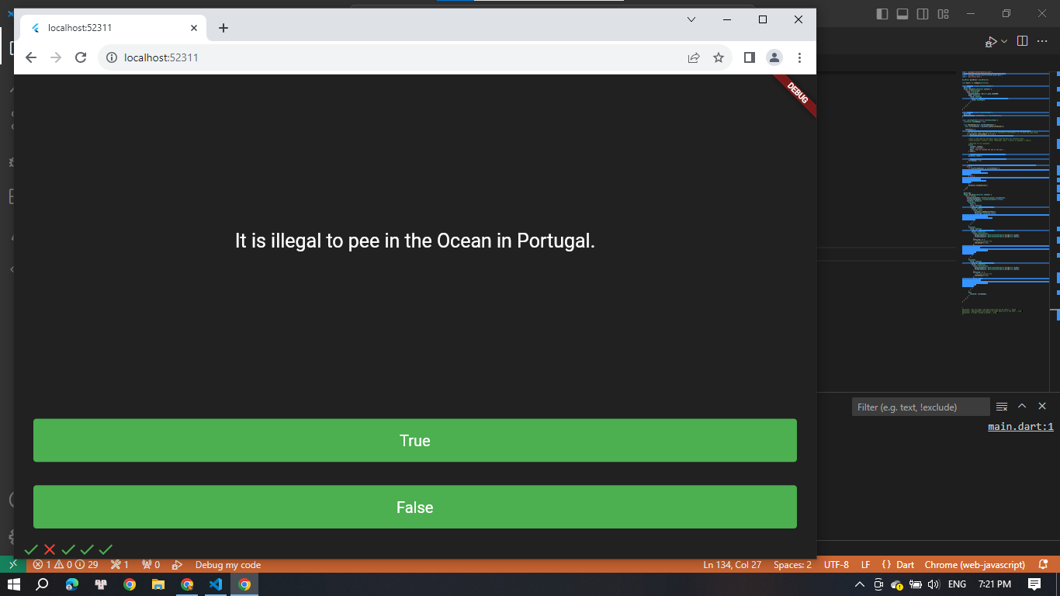

* The experimental results show that the Quizzler application works well and allows users to easily create a Quizzler game.

# **Discussion**

* The experimental results show that the Quizzler application has achieved the laboratory’s objective.
* The strength of cross-platform mobile application development is that it allows the application to run on multiple platforms, thereby attracting more users. However, the weakness is that development may take more time and effort than developing separately for each platform.

# **Conclusion**

* The laboratory has succeeded in creating a mobile application that allows users to create a Quizzler game.
* In the future, we can continue to improve and add new features to the Quizzler application to attract more users.