**TASK 1: Create an array name car with string datatype and save 5 cars names in it and display the car names line by line.**

#include <iostream>

#include <string>

using **namespace** std;

**int** main(){

    string car[5];

    for(**int** i=0; i<=4; i++){

        cout<<"Enter the name of car no  : "<<" -- ";

        cin>>car[i];

    }

    for(**int** i=0; i<=4; i++){

        cout<<endl<<"name of car no : "<<i<<" -- "<<car[i]<<endl;

    }

}

`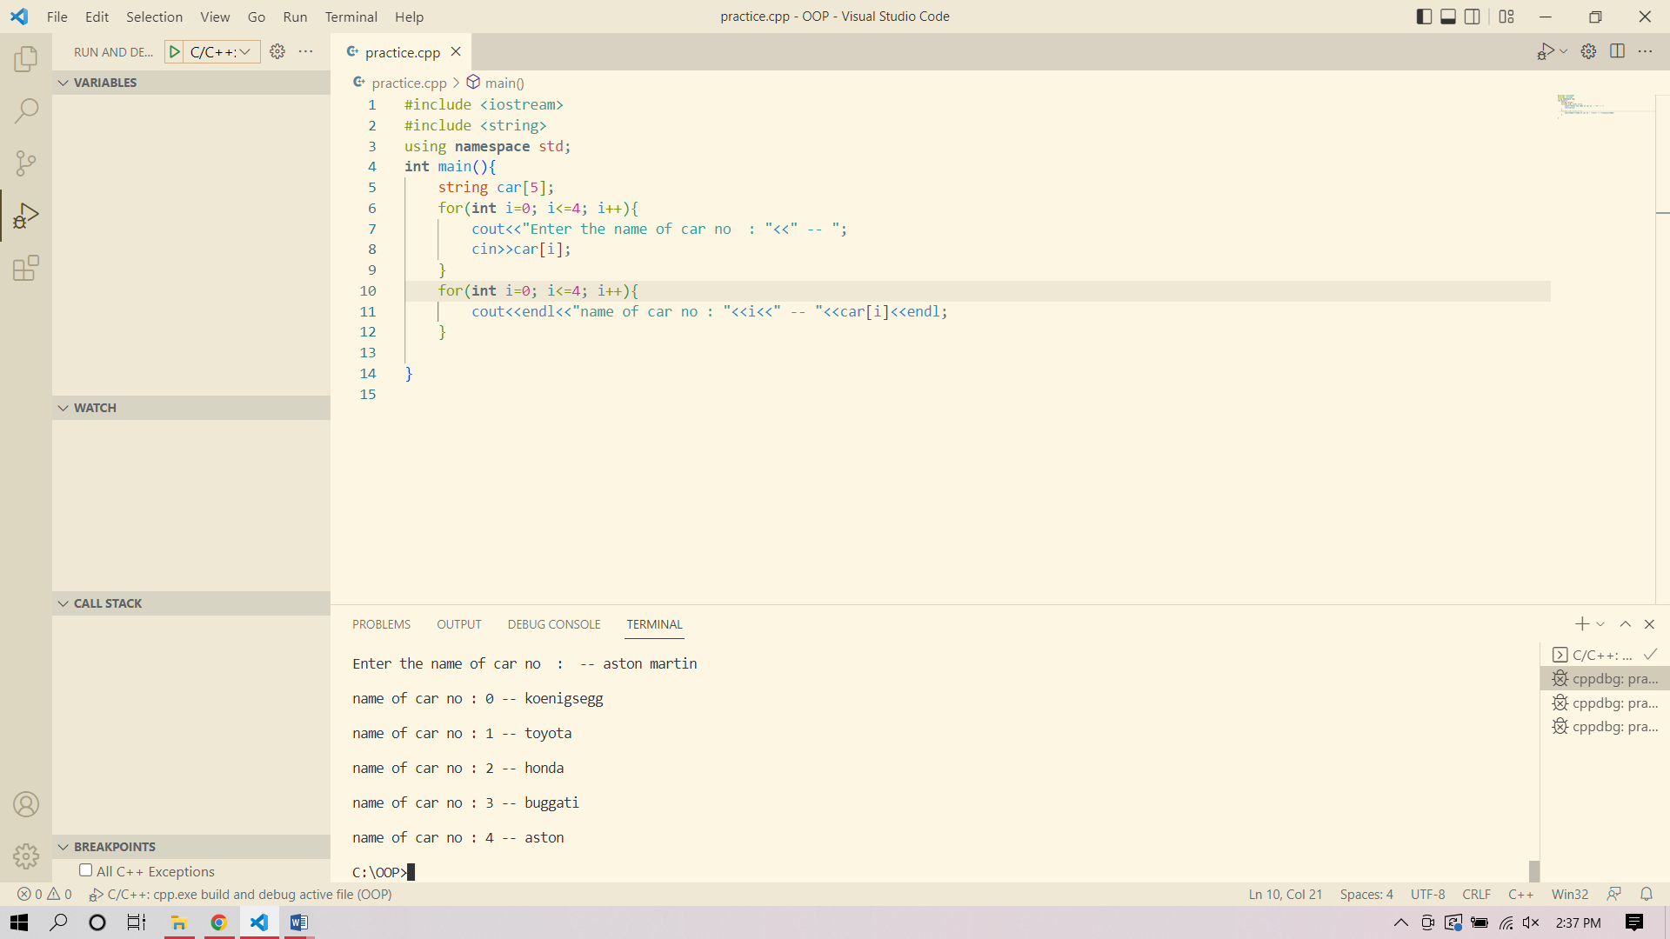

### TASK 2: Create 2D integer array and display 1 to 10 integers in first row and there square in second row.

#include <iostream>

using **namespace** std;

**int** main(){

**int** arr[1][10];

    for(**int** i=0; i<1; i++){

        for(**int** j=0; j<10; j++){

            cout<<"Enter an integer : ";cin>>arr[i][j];cout<<endl;}}

    for(**int** i=0; i<1; i++){

        for(**int** j=0; j<10; j++){

            cout<<arr[i][j]; }}cout<<endl;

    for(**int** i=0; i<1; i++){

        for(**int** j=0; j<10; j++){

            arr[i][j] = arr[i][j]*arr[i][j];cout<<arr[i][j];}}

}

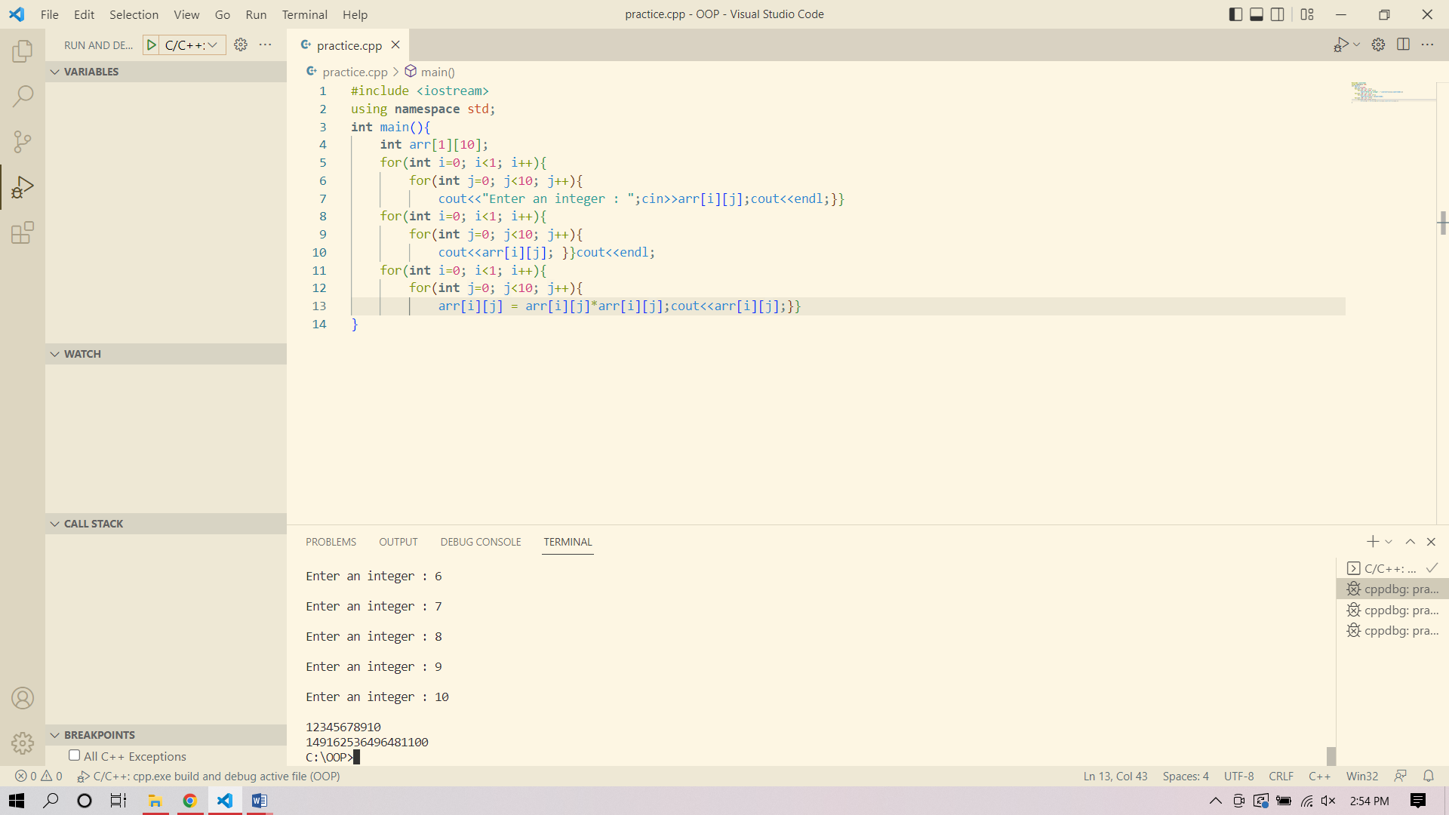

### TASK 3: Run the below codes on compiler and write the outputs.

|  |  |
| --- | --- |
| **CODE** | **OUTPUT** |
| int var1 = 3; int var2 = 24; int var3 = 17;  cout << &var1 << endl; cout << &var2 << endl; cout << &var3 << endl; |  |
| int* ptr; int arr[5];  ptr = &arr[1];  cout << &arr << endl; cout << ptr << endl; cout << ptr-- << endl; cout << --ptr << endl; |  |
| #include <iostream>  using namespace std; |  |

|  |  |
| --- | --- |
| struct Person{}; int main()  {  Person a;  cout<<"Size of Structure a is : " << sizeof(a) << " Bytes";  return 0;  } |  |
| #include <iostream> using namespace std;  struct Person{ int age;  };  int main()  {  Person a;  cout<<"Size of Structure a is : " << sizeof(a) << " Bytes";  return 0;  } |  |
| #include <iostream> using namespace std;  struct Person{ int age; float salary;  };  int main()  {  Person a;  cout<<"Size of Structure a is : " << sizeof(a) << " Bytes";  return 0;  } |  |

**TASK 4: Implement the below tasks.**

* Create a structure “Student” and add two variables in it for storing age and gpa.
* Initialize the variables using hardcoded values.
* Display the outputs.
* Now create **read** and **display** function for reading values from user and showing them on console.

#include <iostream>

using **namespace** std;

**struct** student

{

**int** age = 21;

**float** gpa = 4.00;

**void** read()

    {

        cout<<"Enter the Age: ";

        cin>>age;

        cout<<"Enter the GPA: ";

        cin>>gpa;

    }

**void** display()

    {

        cout<<"Age: "<<age<<endl;

        cout<<"GPA: "<<gpa;

    }

};

**int** main()

{

    student s;

    cout<<s.age<<endl;

    cout<<s.gpa<<endl;

    s.read();

    s.display();

    return 0;

}

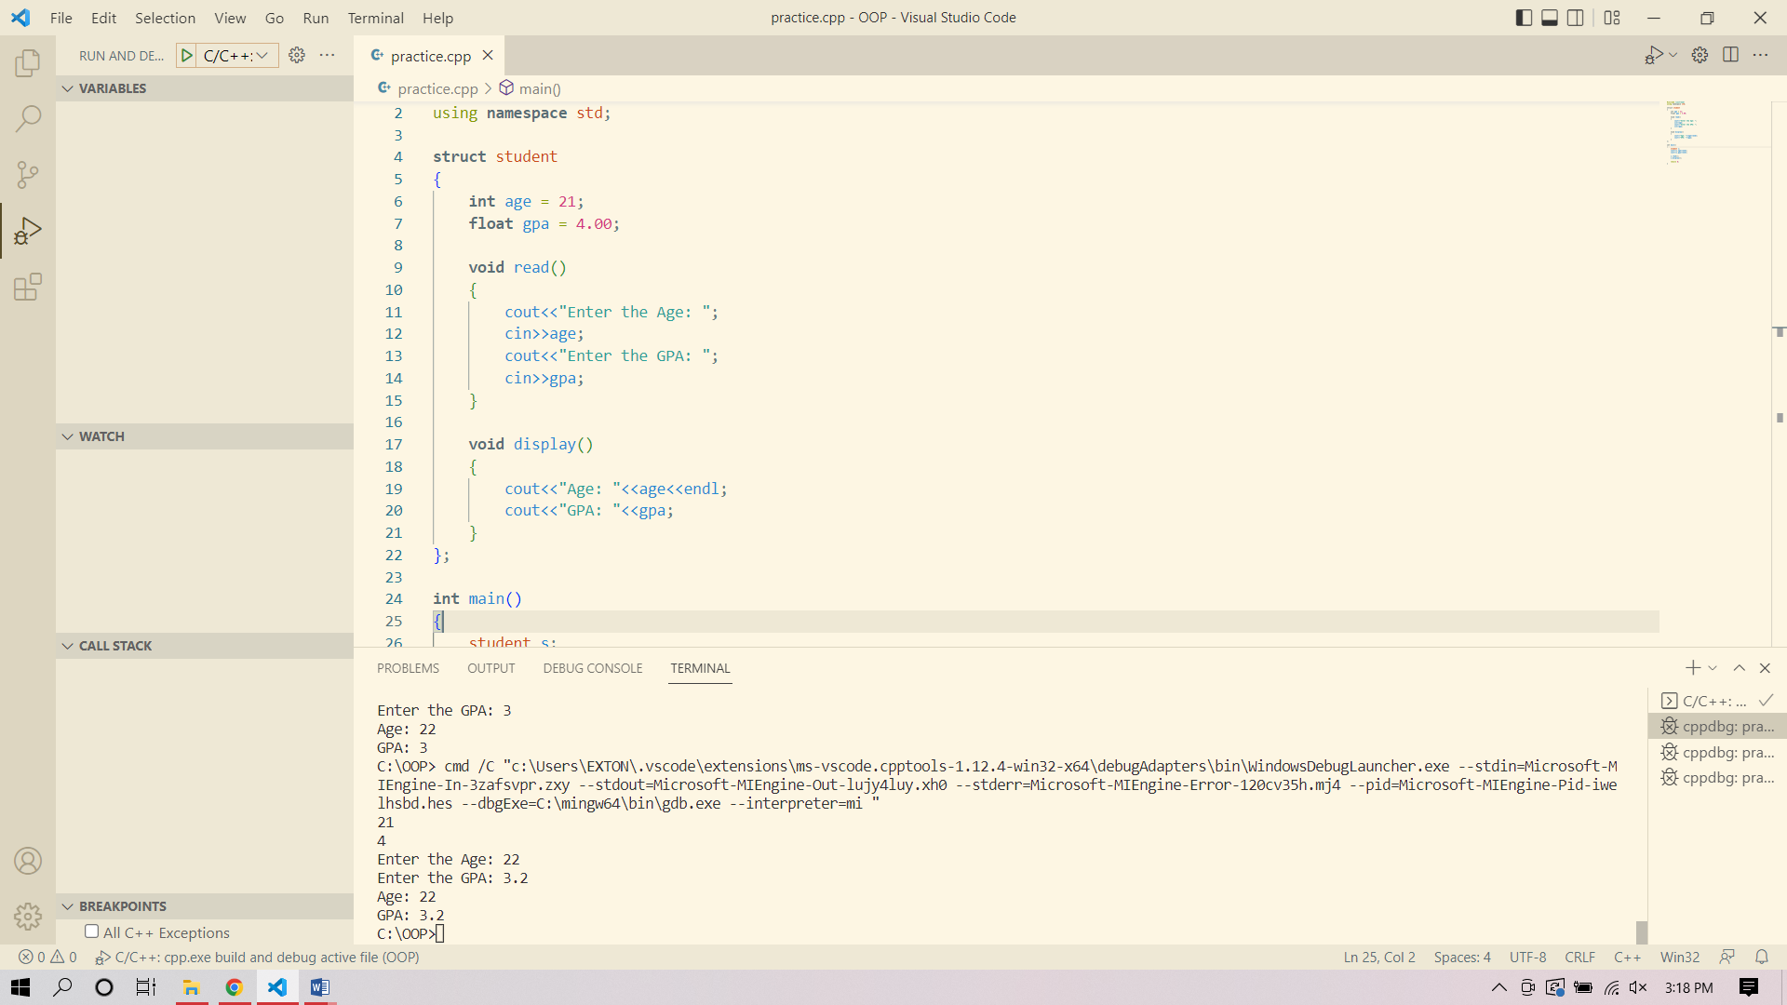

### TASK 5: Implement the below tasks.

* Create a Structure ‘Car’ and declare two variables car1 and car2.
* Add variables for storing car price, car mileage and car model year in structure.
* Create Read and display function to take values and show them on console.

#include <iostream>

using **namespace** std;

**struct** car{

**int** price;

**float** mileage;

**int** model;

};

**void** read(**struct** car **&**car1, **struct** car **&**car2){

    cout<<"Enter car1 price : ";

    cin>>car1.price;cout<<endl;

    cout<<"Enter car1 mileage : ";

    cin>>car1.mileage;cout<<endl;

    cout<<"Enter car1 model : ";

    cin>>car1.model;cout<<endl;

    cout<<"Enter car2 price : ";

    cin>>car2.price;cout<<endl;

    cout<<"Enter car2 mileage : ";

    cin>>car2.mileage;cout<<endl;

    cout<<"Enter car2 model : ";

    cin>>car2.model;cout<<endl;

}

**void** display(**struct** car car1, **struct** car car2){

    cout<<"car1 price : "<<car1.price<<endl;

    cout<<"car1 mileage : "<<car1.mileage<<endl;

    cout<<"car1 model : "<<car1.model<<endl;

    cout<<"car2 price : "<<car2.price<<endl;

    cout<<"car2 mileage : "<<car2.mileage<<endl;

    cout<<"car2 model : "<<car2.model<<endl;

}

**int** main(){

    car car1, car2;

    read(car1, car2);

    display(car1, car2);

}

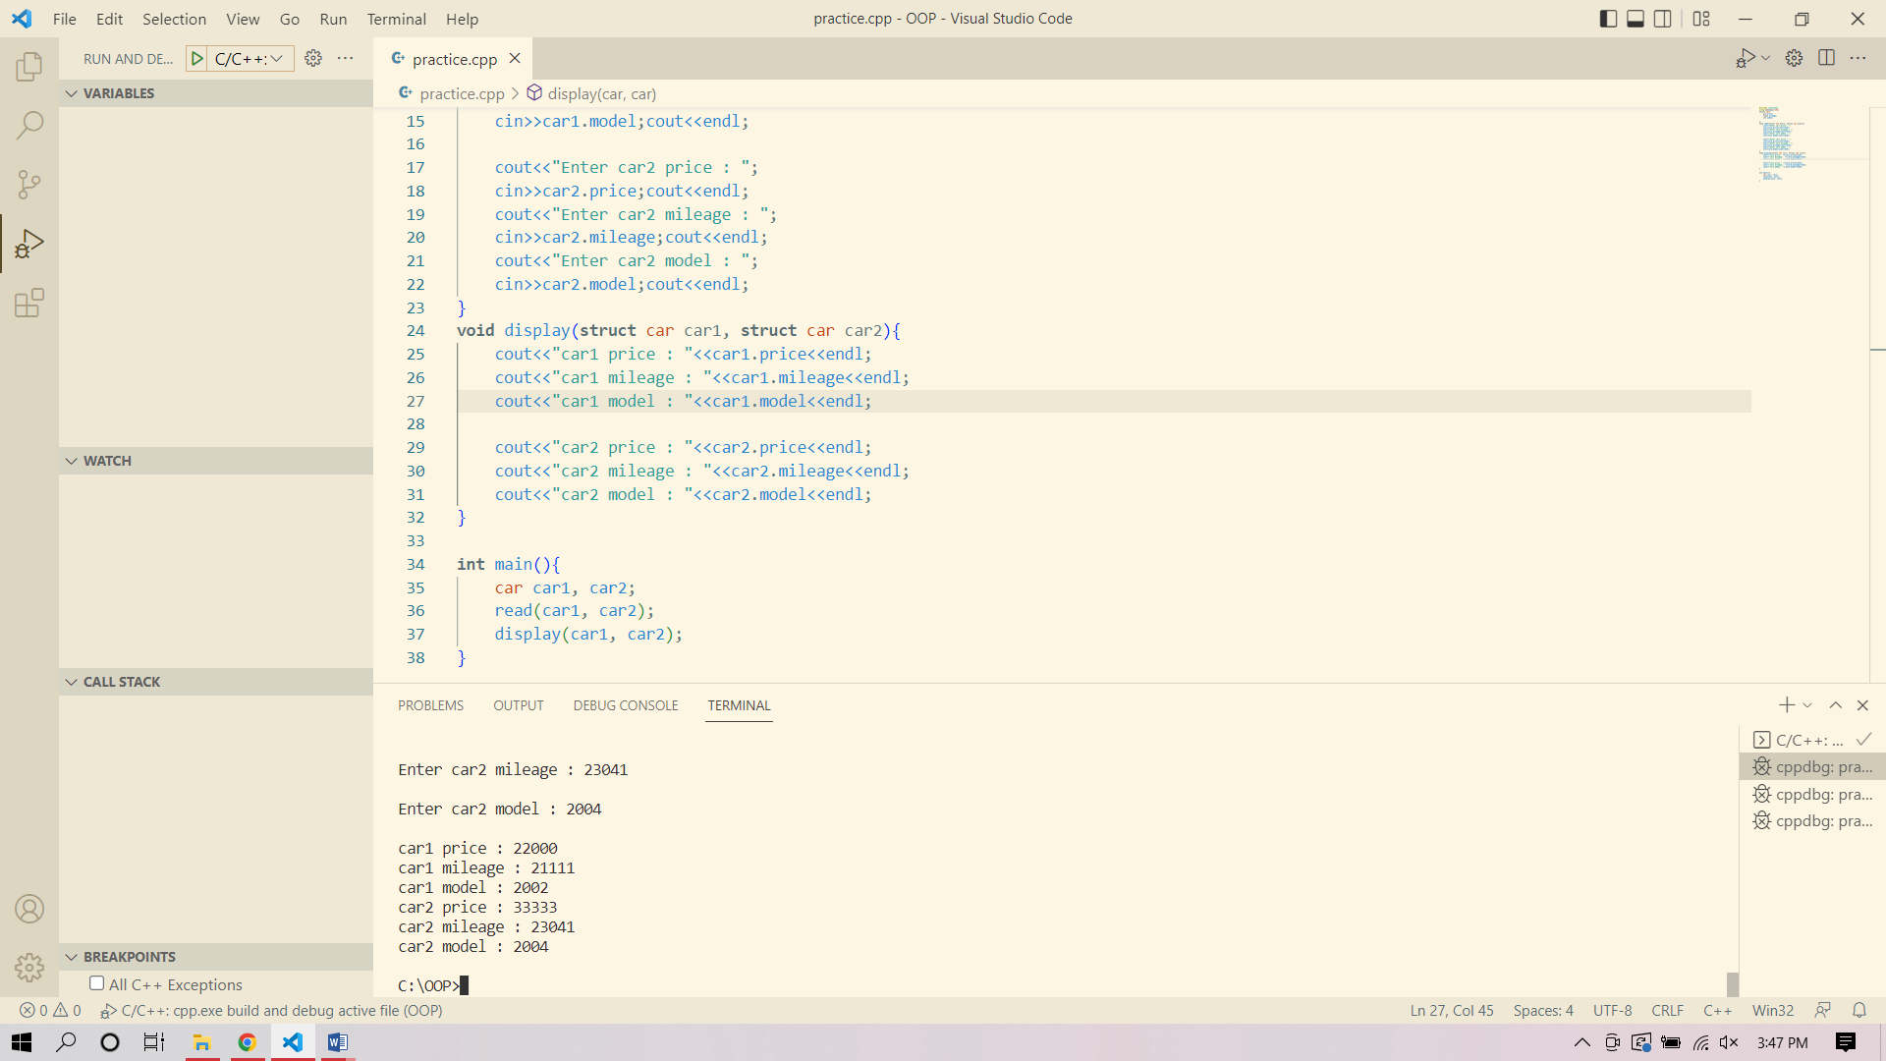

**TASK 6: Implement the below tasks.**

* Create a structure “Fruit” add 3 data members to store information Fruit name, price and quantity.
* Create 5 Fruits with their names and add it price and quantity.
* Create variable Grand_total and show the total cost of fruits (for example: Apple Price is 10 rupees and orange price is 15 and you bought 10 apples and 10 oranges. Grand_Total=250 )

#include <iostream>

using **namespace** std;

**struct** fruit{

    string fruit_name;

**int** fruit_price;

**int** fruit_quantity;

};

**int** main(){

    fruit f[5];

    for(**int** i=0; i<5; i++){

        cout<<"Fruit name : ";

        cin>>f[i].fruit_name;cout<<endl;

        cout<<"Fruit price : ";

        cin>>f[i].fruit_price;cout<<endl;

        cout<<"Fruit quantity (In Kg) : ";

        cin>>f[i].fruit_quantity;cout<<endl;

    }

    cout<<"************************";

**int** grand_total = 0;

    for(**int** i=0; i<5; i++){

        grand_total = grand_total + f[i].fruit_price*f[i].fruit_quantity;

    }

    cout<<"Grand total : "<<grand_total;

}

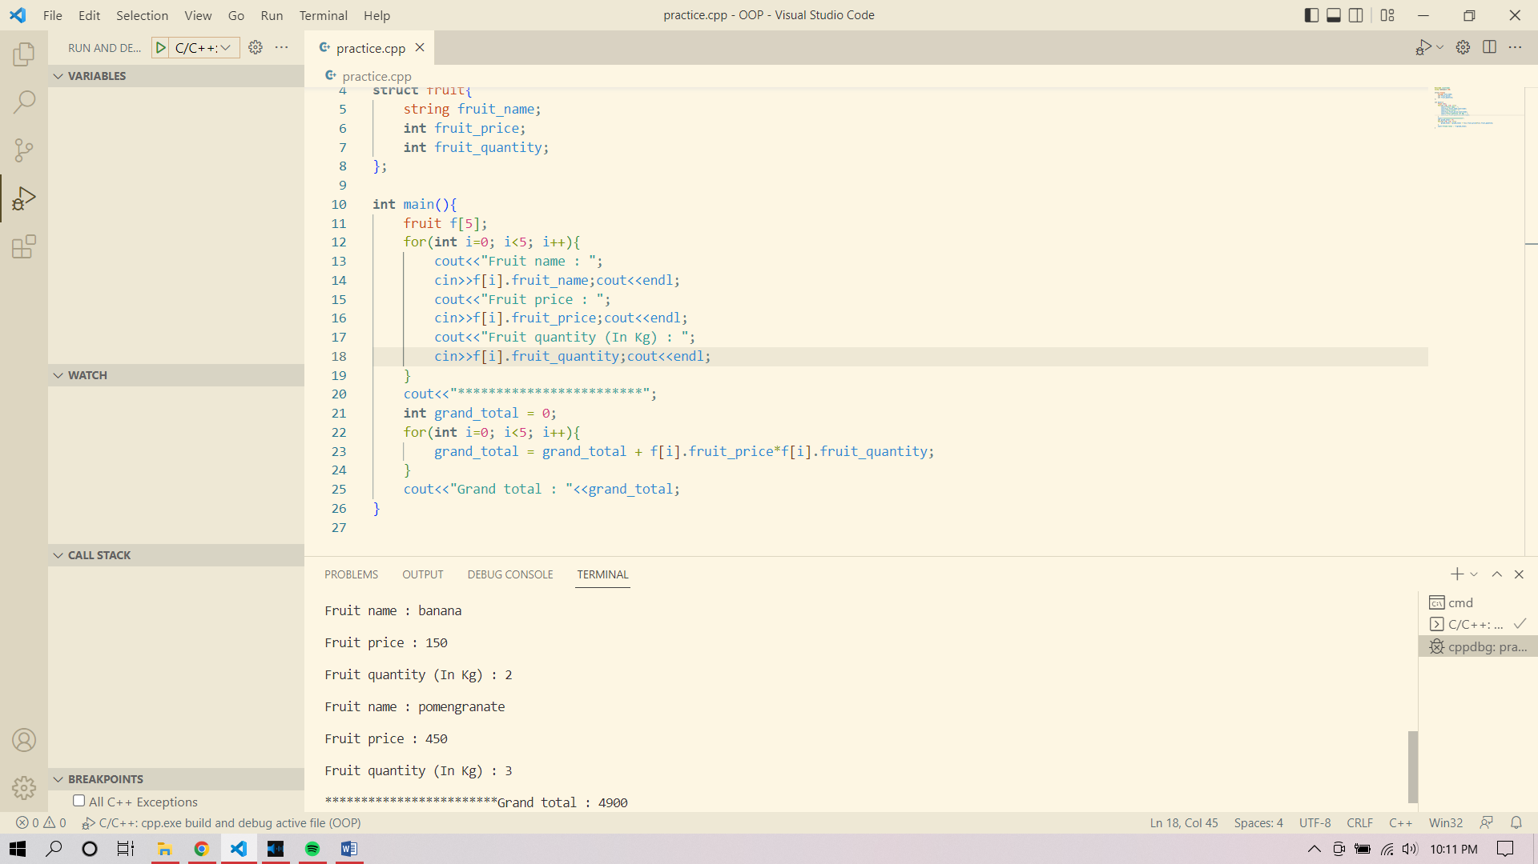

### TASK 7: Implement the below tasks.

* Create a structure “CarForSale” and add four arrays in it for storing Car model, mileage, price demanded and Km covered.
* Initialize the arrays using hardcoded values.
* Input the categories from users and show him the best match of car available for sale.

#include <iostream>

using **namespace** std;

**class** car_for_sale{

**int** car_model[3] = {2018, 2019, 2020};

**int** car_mileage[3] = {22000, 18000, 16000};

**int** car_price_demanded[3] = {3000000, 3300000, 3700000};

**int** car_km[3] = {3000000, 3300000, 3700000};

**int** des_model;

**int** des_mileage;

**int** des_demand;

**int** des_model_available;

**int** curr_model;

**int** curr_mileage;

**int** curr_demand;

**int** i=0;

**int** j=0;

**int** min_mileage = car_mileage[0];

**public:**

**void** read(){

        cout<<"Enter the desired car model --> ";

        cin>>des_model;cout<<endl;

        cout<<"Enter the desired car mileage --> ";

        cin>>des_mileage;cout<<endl;

        cout<<"Enter the desired demand --> ";

        cin>>des_demand;cout<<endl;

    }

**void** processing(){

        while(j<3){

            if(des_model == car_model[j]){

                curr_model = car_model[j];

                break;

            }

            else{

                j++;

            }

            if(j==3){

                cout<<"The car model is not available";

            }

        }

        for(**int** i=0; i<3; i++){

             if(car_mileage[i] < min_mileage){

                min_mileage = car_mileage[i];

            }

            else{

                i++;

            }

            if(i==3){

                cout<<"The car with less or equal mileage not available"<<endl;

            }

        }

                curr_mileage = min_mileage;

        while(i<3){

             if(car_price_demanded[i] <= des_demand){

                curr_demand=car_price_demanded[i];

                break;

            }

            else{

                i++;

            }

            if(i==3){

                cout<<"The car with the specified amount is not available"<<endl;

            }

        }

    }

**void** display(){

        if(curr_model>0&&car_mileage>0&&car_price_demanded>0){

            cout<<endl<<"************************************"<<endl;

            cout<<"--The car specs are--"<<endl;

            cout<<"Car model --> "<<curr_model<<endl;

            cout<<"Car mileage --> "<<curr_mileage<<endl;

            cout<<"Car demand --> "<<curr_demand<<endl;

        }

        else{

            cout<<"No cars with the specifed specs available right now.";

        }

    }

};

**int** main(){

    car_for_sale car;

    car.read();

    car.processing();

    car.display();

}

