TASK # 1: Write a Program using structure Rectangle using (Length and width variables in  
structure) and create functions area () and perimeter (). Get values of Length and Width at  
runtime. Display Results using Display()

#include <iostream>

using **namespace** std;

**struct** rectangle{

**int** length;

**int** width;

**int** area_sol;

**int** peri_sol;

**void** read(){

        cout<<"ENTER THE LENGTH : ";cin>>length;cout<<endl;

        cout<<"ENTER THE WIDTH : ";cin>>width;cout<<endl;

    }

**void** area(){

        area_sol = length*width;

    }

**void** perimeter(){

        peri_sol = 2*length + 2*width;

    }

**void** display(){

        cout<<"THE AREA IS : "<<area_sol<<endl;

        cout<<"PERIMETER IS : "<<peri_sol<<endl;

    }

};

**int** main(){

    rectangle r;

    r.read();

    r.area();

    r.perimeter();

    r.display();

}

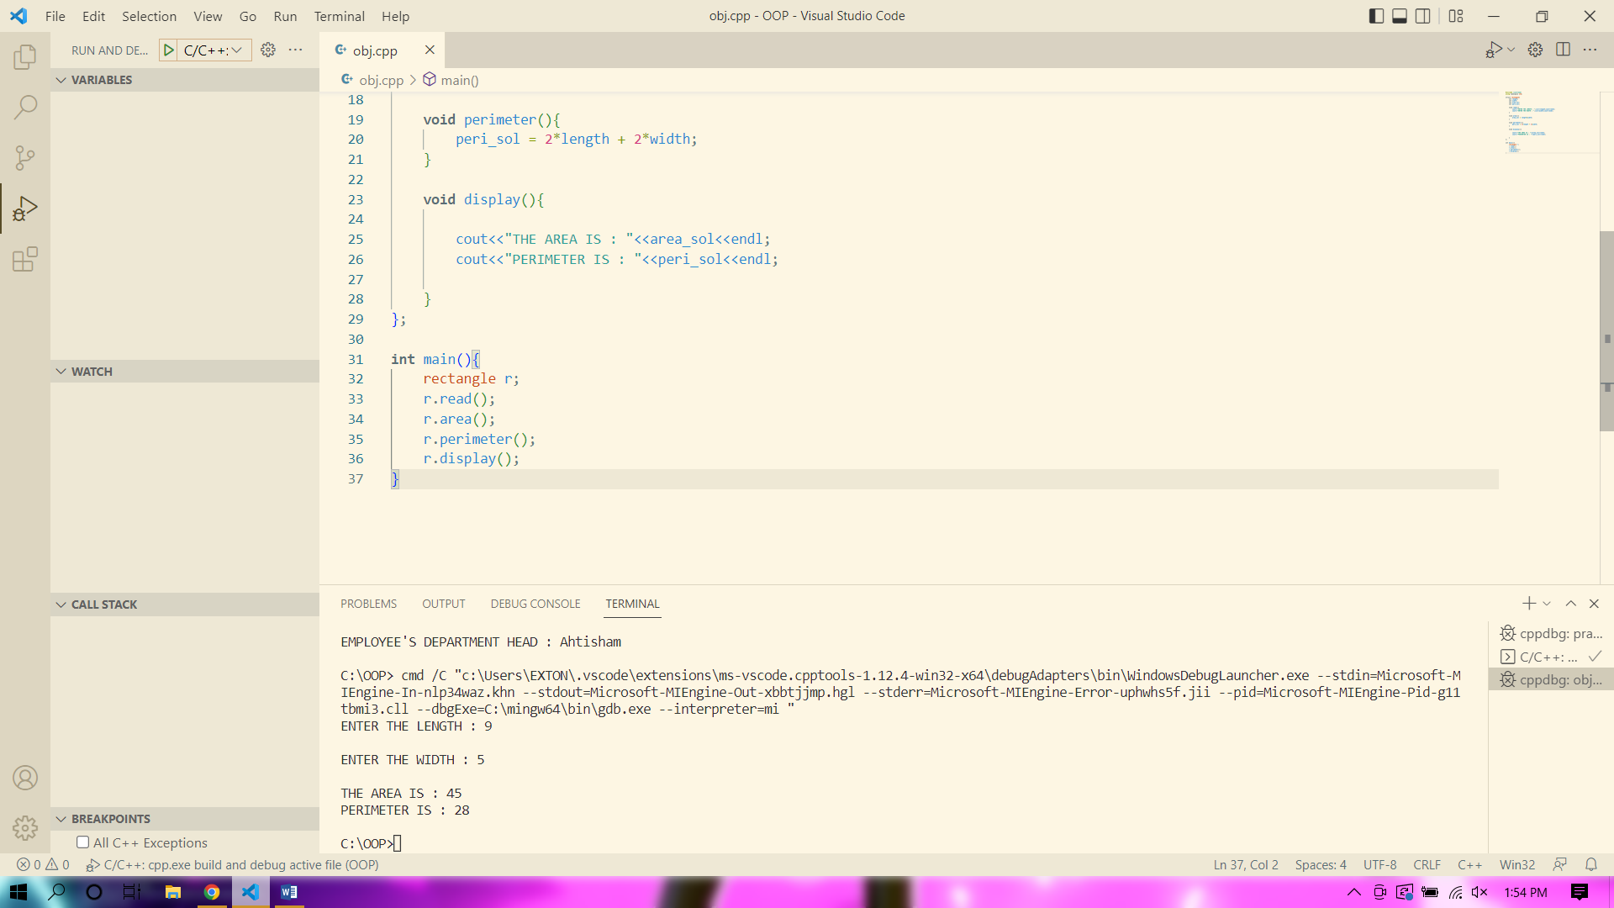

TASK # 2: Write a Program using structure Circle have member variable Radius. Create  
member functions in the structure to get area and circumference of circle. Get Value from  
users.

#include <iostream>

using **namespace** std;

**struct** circle{

**float** radius;

**float** area_sol;

**float** pie = 3.14;

**float** circum;

**void** read(){

        cout<<"ENTER THE RADIUS : ";cin>>radius;cout<<endl;

    }

**void** area(){

        area_sol = pie*(radius)*(radius);

    }

**void** circumference(){

        circum = 2*pie*radius;

    }

**void** display(){

        cout<<"RADIUS : "<<radius<<endl;

        cout<<"CIRCUMFERENCE : "<<circum<<endl;

        cout<<"AREA IS : "<<area_sol<<endl;

    }

};

**int** main(){

    circle c;

    c.read();

    c.area();

    c.circumference();

    c.display();

}

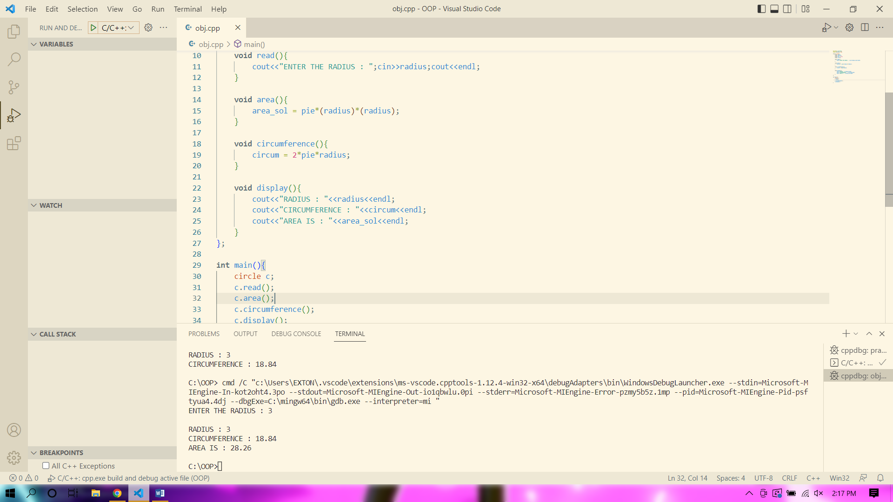

TASK # 3: Create a Structure Movie (Variables: Name, Year, rating). Create object of  
movie.Create Pointer object of movie. The pointer of movie pointing the object of movie.  
Give values to the movie object and Print the Movie object value using Point2

#include <iostream>

using **namespace** std;

**struct** movie{

    string name;

**int** year;

**float** rating;

**void** read(){

        cout<<"ENTER THE MOVIE NAME : ";cin>>name;cout<<endl;

        cout<<"ENTER THE MOVIE RELEASE YEAR : ";cin>>year;cout<<endl;

        cout<<"ENTER THE RATING : ";cin>>rating;cout<<endl;

    }

**void** display(){

        cout<<"NAME : "<<name<<endl;

        cout<<"RELEASE YEAR : "<<year<<endl;

        cout<<"RATING : "<<rating<<endl;

    }

};

**int** main(){

    movie m_main;

    movie *p;

    p = &m_main;

    p->read();

    p->display();

}

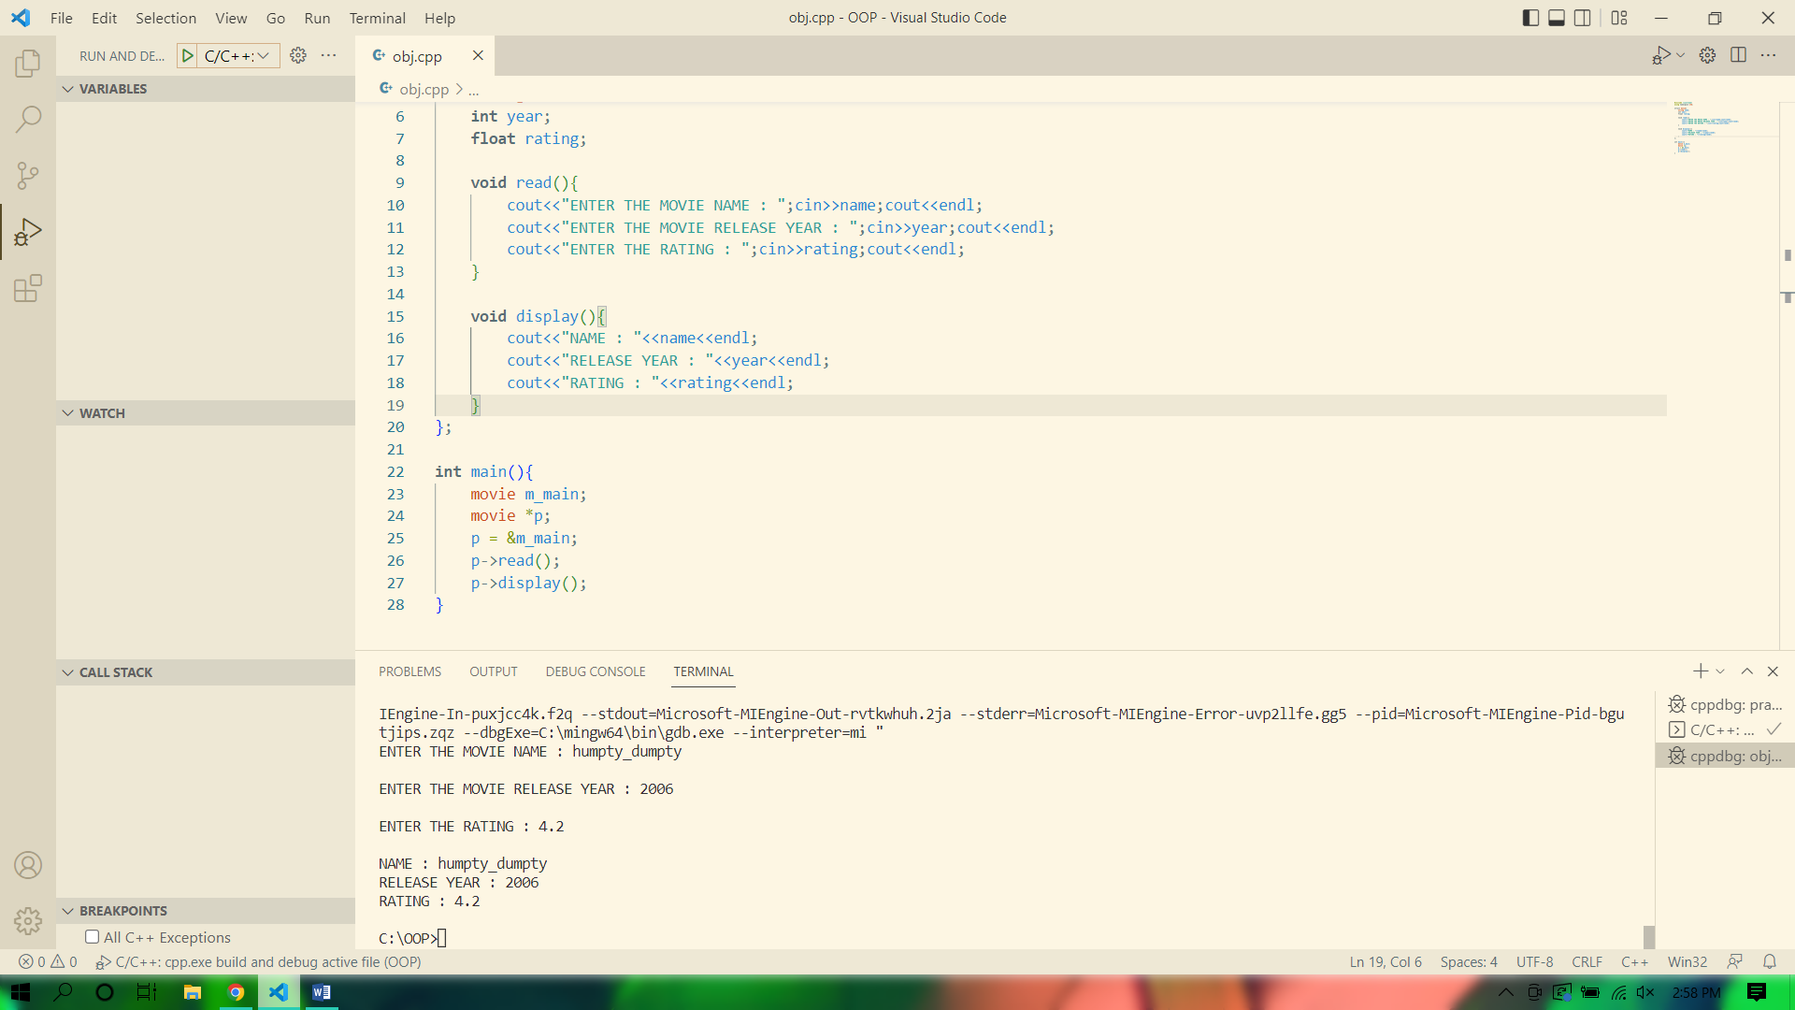

TASK # 4: Create a structure Place (Variable: Name, LocatedCountry), Create a structure  
Person (Variables: name, age, FavouritePlace). Favourite Place is the object of Place  
Structure. Get and Display Person information using member functions. And Getfunction()  
get values at run time. (Hint: Nested

#include <iostream>

using **namespace** std;

**struct** person{

    string name;

**int** age;

    string fav_place;

};

**struct** place{

    string name;

    string located_country;

    person p1;

**void** getfun(){

        cout<<"ENTER THE NAME : ";cin>>p1.name;cout<<endl;

        cout<<"ENTER THE AGE : ";cin>>p1.age;cout<<endl;

        cout<<"ENTER THE FAV PLACE : ";cin>>p1.fav_place;cout<<endl;

        cout<<"ENTER THE PLACE NAME : ";cin>>name;cout<<endl;

        cout<<"ENTER THE LOCATED COUNTRY : ";cin>>located_country;cout<<endl;

    }

**void** display(){

        cout<<"NAME : "<<p1.name<<endl;

        cout<<"AGE : "<<p1.age<<endl;

        cout<<"FAVOURITE PLACE : "<<p1.fav_place<<endl;

        cout<<"PLACE NAME : "<<name<<endl;

        cout<<"LOCATED COUNTRY : "<<located_country<<endl;

    }

};

**int** main(){

    place pl;

    pl.getfun();

    pl.display();

}

