TASK # 1  
• Create a Class “StudentInfo”   
• Read Student Information such as name, roll number, section  
• Input the categories from users and showthe student information

#include <iostream>

using **namespace** std;

**class** student_info{

**private:**

    string name;

**int** roll_number;

    string sec;

**public:**

**void** read(){

        cout<<"ENTER THE NAME : ";cin>>name;cout<<endl;

        cout<<"ENTER THE ROLL NUMBER : ";cin>>roll_number;cout<<endl;

        cout<<"ENTER THE SECTION : ";cin>>sec;cout<<endl;

    }

**void** display(){

        cout<<"******************************"<<endl;

        cout<<"NAME : "<<name<<endl;

        cout<<"ROLL NUMBER : "<<roll_number<<endl;

        cout<<"SECTION : "<<sec<<endl;

    }

};

**int** main(){

    student_info s;

    s.read();

    s.display();

}

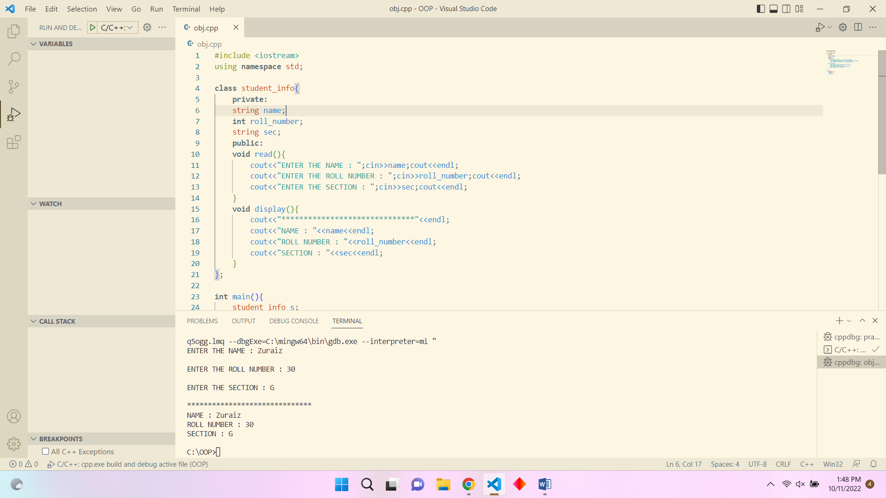

TASK # 2  
Create a class called fraction. Its two members of type int should be called num and denum.   
Write a program that prompts the user to enter to fractions and then computes and displays the   
sum of the fractions entered by user as a fraction.

#include <iostream>

#include <math.h>

using **namespace** std;

**class** fraction{

**private:**

**int** num, denum;

**int** de1, de2;

**int** numerator;

**int** denominator;

**float** sum;

**public:**

**void** read(){

        cout<<"ENTER FIRST FRACTION : ";cin>>num;cout<<endl;

        cout<<"/";cin>>de1;cout<<endl;

        cout<<"ENTER SECOND FRACTION : ";cin>>denum;cout<<endl;

        cout<<"/";cin>>de2;cout<<endl;

    }

**void** calc(){

        numerator = (num*de2)+(denum*de1);

        denominator = (de1*de2);

    }

**void** display(){

        cout<<"SUM IS : "<<numerator<<"/"<<denominator<<endl;

    }

};

**int** main(){

    fraction f;

    f.read();

    f.calc();

    f.display();

}

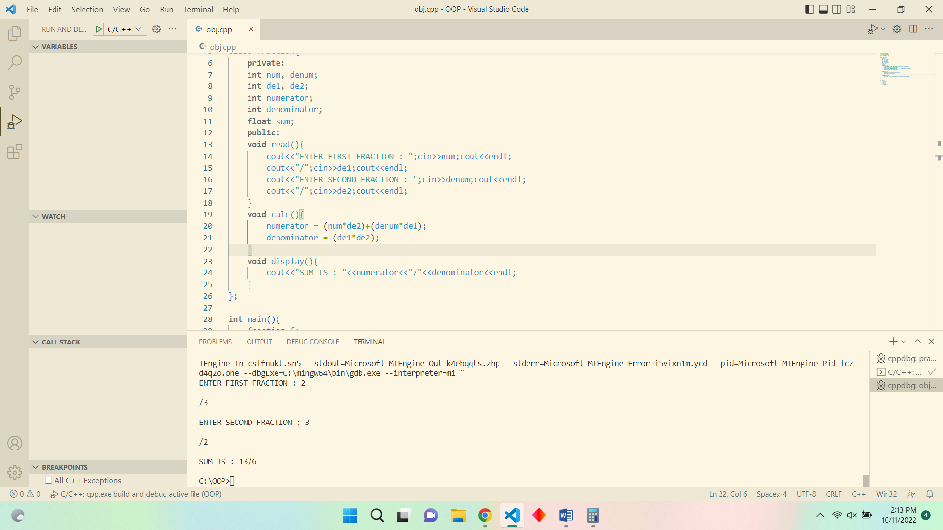

TASK # 3  
Create a class of Phone directory with following data members  
λ Name  
λ ID  
λ Address  
λ Phone_Num  
1. Add data of at least 5 persons using Add_contact_info function and pointer

2. Use a remove Function to take an ID from user and remove the data of matching ID from   
array.  
3. Display the data before and after removing the person

#include <iostream>

using **namespace** std;

**class** phone_directory{

**public:**

    string name;

**int** id;

    string address;

**int** phone_num;

**void** add_contact_info(){

        cout<<"NAME : ";cin>>name;cout<<endl;

        cout<<"ID : ";cin>>id;cout<<endl;

        cout<<"ADDRESS : ";cin>>address;cout<<endl;

        cout<<"PHONE NUMBER : ";cin>>phone_num;cout<<endl;

    }

**void** display(){

        cout<<"NAME IS : "<<name<<endl;

        cout<<"ID IS : "<<id<<endl;

        cout<<"ADDRESS IS : "<<address<<endl;

        cout<<"PHONE NUMBER IS : "<<phone_num<<endl;

    }

**void** display_removed(){

        cout<<"NAME IS : "<<name<<endl;

        cout<<"ID IS : "<<id<<endl;

        cout<<"ADDRESS IS : "<<address<<endl;

        cout<<"PHONE NUMBER IS : "<<phone_num<<endl;

}

};

**void** remove(phone_directory **\***p, **int** id_passed, phone_directory **\***c){

**int** j=0;

    for(**int** i = 0;i<2; i++){

        if(p[i].id != id_passed){

            c[j] = p[i];

            j++;

        }

    }

}

**int** main(){

    phone_directory *p = new phone_directory[2];

    for(**int** i=0;i<2;i++){

        p[i].add_contact_info();

    }

    phone_directory *c = new phone_directory[1];

**int** rem;

    cout<<"ENTER THE ID YOU WANT TO REMOVE : ";cin>>rem;cout<<endl;

    remove(p, rem, c);

    for(**int** i = 0;i<1;i++){

        c[i].display_removed();

    }

}

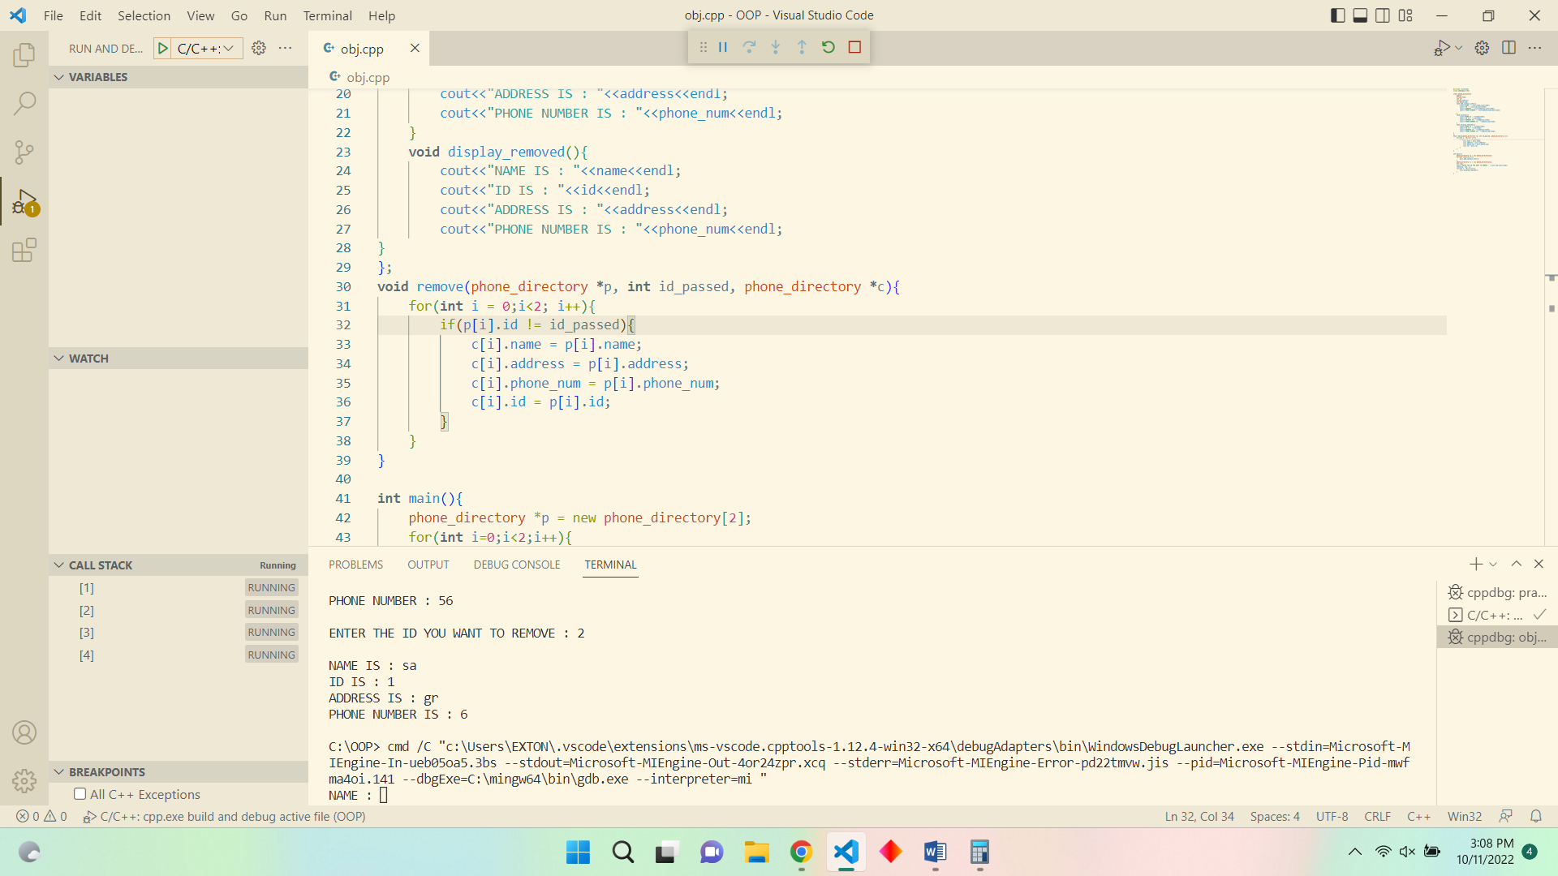

TASK # 4  
Create a class Employee (Variables: Name, joining date , salary). Create another class dept.   
create a nested relation between classes. In the function main(), an object of the class Employee   
and class dept is defined. Then the functions getdata() and putdata() are called using the variable   
obj.

#include <iostream>

using **namespace** std;

**class** employee{

**public:**

    string name;

**int** joining_date;

**int** salary;

**void** read_emp(){

    }

};

**class** dept{

**public:**

    string department_name;

    employee e1;

**void** get_data(){

        cout<<"ENTER DEPT NAME : ";cin>>department_name;cout<<endl;

        cout<<"ENTER EMPLOYEE NAME : ";cin>>e1.name;cout<<endl;

        cout<<"ENTER JOINING DATE : ";cin>>e1.joining_date;

        cout<<"ENTER THE SALARY : ";cin>>e1.salary;cout<<endl;

    }

**void** put_data(){

        cout<<"DEPT NAME : "<<department_name<<endl;

        cout<<"EMPLOYEE NAME : "<<e1.name<<endl;

        cout<<"JOINING DATE : "<<e1.joining_date<<endl;

        cout<<"SALARY : "<<e1.salary<<endl;

    }

};

**int** main(){

    dept obj;

    obj.get_data();

    obj.put_data();

}

