Lab Task

Task # 1  
Create a simple queue with five nodes containing data {3, 8, 5, 9, and 16}.  
Task # 2  
Create a function which prints the queue in reverse manner.

#include <iostream>

using namespace std;

class node {

public:

int data;

node* next;

};

node* front = NULL;

node* back = NULL;

node* top_temp = NULL;

class list {

public:

node* create_node() {

node* newnode = new node;

return newnode;

}

void read_data() {

node* newnode = create_node();

cout << "ENTER THE DATA : ";

cin >> newnode->data; cout << endl;

enqueue(newnode);

system("CLS");

}

node* find_front() {

node* temp = back;

if (temp == NULL) {

return NULL;

}

else {

while (temp->next != NULL) {

temp = temp->next;

}

return temp;

}

}

void enqueue(node* newnode) {

node* temp_front = find_front();

if (front == NULL) {

front = newnode;

back = front;

front->next = back;

back->next = NULL;

}

else {

back->next = newnode;

back = newnode;

back->next = NULL;

}

}

void dequeue() {

//node* find_sec = find_sec_in_queue();

if (front == NULL) {

cout << "THE LIST IS EMPTY" << endl;

}

else if (front->next == NULL) {

delete(front);

back = NULL;

front = NULL;

}

else {

node* temp = front;

front = front->next;

delete(temp);

}

}

node* find_sec_in_queue() {

node* temp_front = find_front();

if (temp_front == NULL) {

return NULL;

}

else if (back->next == NULL) {

return back;

}

else {

node* temp = back;

while (temp->next->next != NULL) {

temp = temp->next;

}

return temp;

}

}

void ins_stack(int inp) {

node* newnode = create_node();

newnode->data = inp;

if (top_temp == NULL) {

top_temp = newnode;

top_temp->next = NULL;

}

else {

newnode->next = top_temp;

top_temp = newnode;

}

}

void display_original() {

node* temp_front = find_front();

if (temp_front == NULL) {

cout << "THE LIST IS EMPTY" << endl;

}

else {

node* temp = front;

while (temp != NULL) {

cout << temp->data << endl;

temp = temp->next;

}

}

system("pause");

system("CLS");

}

void display_reverse() {

node* temp_front = find_front();

if (temp_front == NULL) {

cout << "THE LIST IS EMPTY" << endl;

}

else {

node* temp = front;

while (temp != NULL) {

ins_stack(temp->data);

temp = temp->next;

}

node* temp_disp_stack = top_temp;

while (temp_disp_stack != NULL) {

cout << temp_disp_stack->data << endl;

temp_disp_stack = temp_disp_stack->next;

}

top_temp = NULL;

}

system("pause");

system("CLS");

}

bool is_empty() {

node* temp_front = find_front();

if (temp_front == NULL) {

return 1;

}

else {

return 0;

}

}

};

int main() {

list l;

int option;

while (1) {

cout << "ENTER 1 TO INSERT IN QUEUE" << endl;

cout << "ENTER 2 TO DISPLAY IN ORDER" << endl;

cout << "ENTER 3 TO DEQUEUE" << endl;

cout << "ENTER 4 TO CHECK IF QUEUE IS EMPTY" << endl;

cout << "ENTER 5 TO DISPLAY IN REVERSE" << endl;

cout << "ENTER 6 TO EXIT THE PROGRAM" << endl;

cin >> option; cout << endl;

switch (option) {

case 1:

{

system("CLS");

l.read_data();

break;

}

case 2:

{

system("CLS");

l.display_original();

break;

}

case 3:

{

system("CLS");

l.dequeue();

break;

}

case 4:

{

system("CLS");

if (l.is_empty()) {

cout << "THE LIST IS EMPTY" << endl;

}

else {

cout << "THE LIST IS NOT EMPTY" << endl;

}

break;

}

case 5:

{

system("CLS");

l.display_reverse();

break;

}

case 6:

{

exit(0);

break;

}

}

}

}

OUTPUT:

STANDARD DISPLAY:

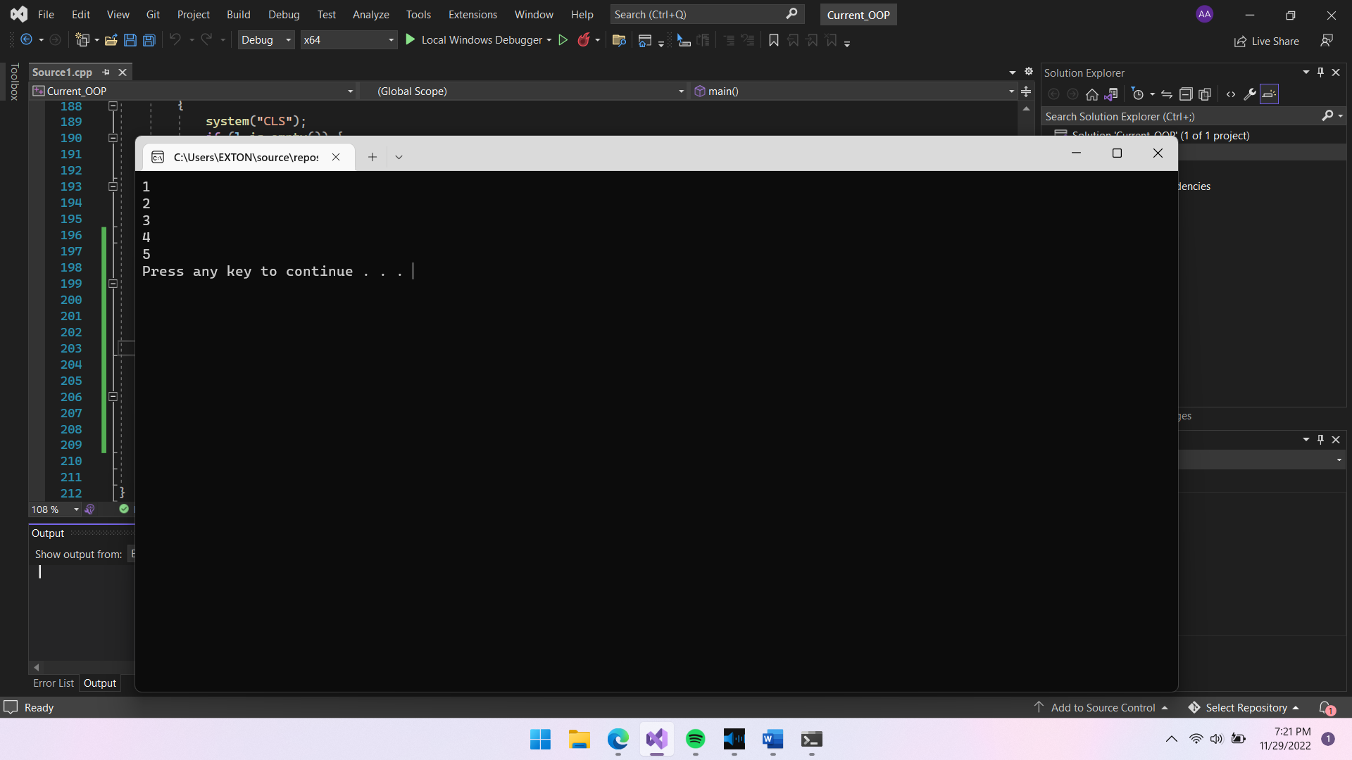

REVERSE DISPLAY:

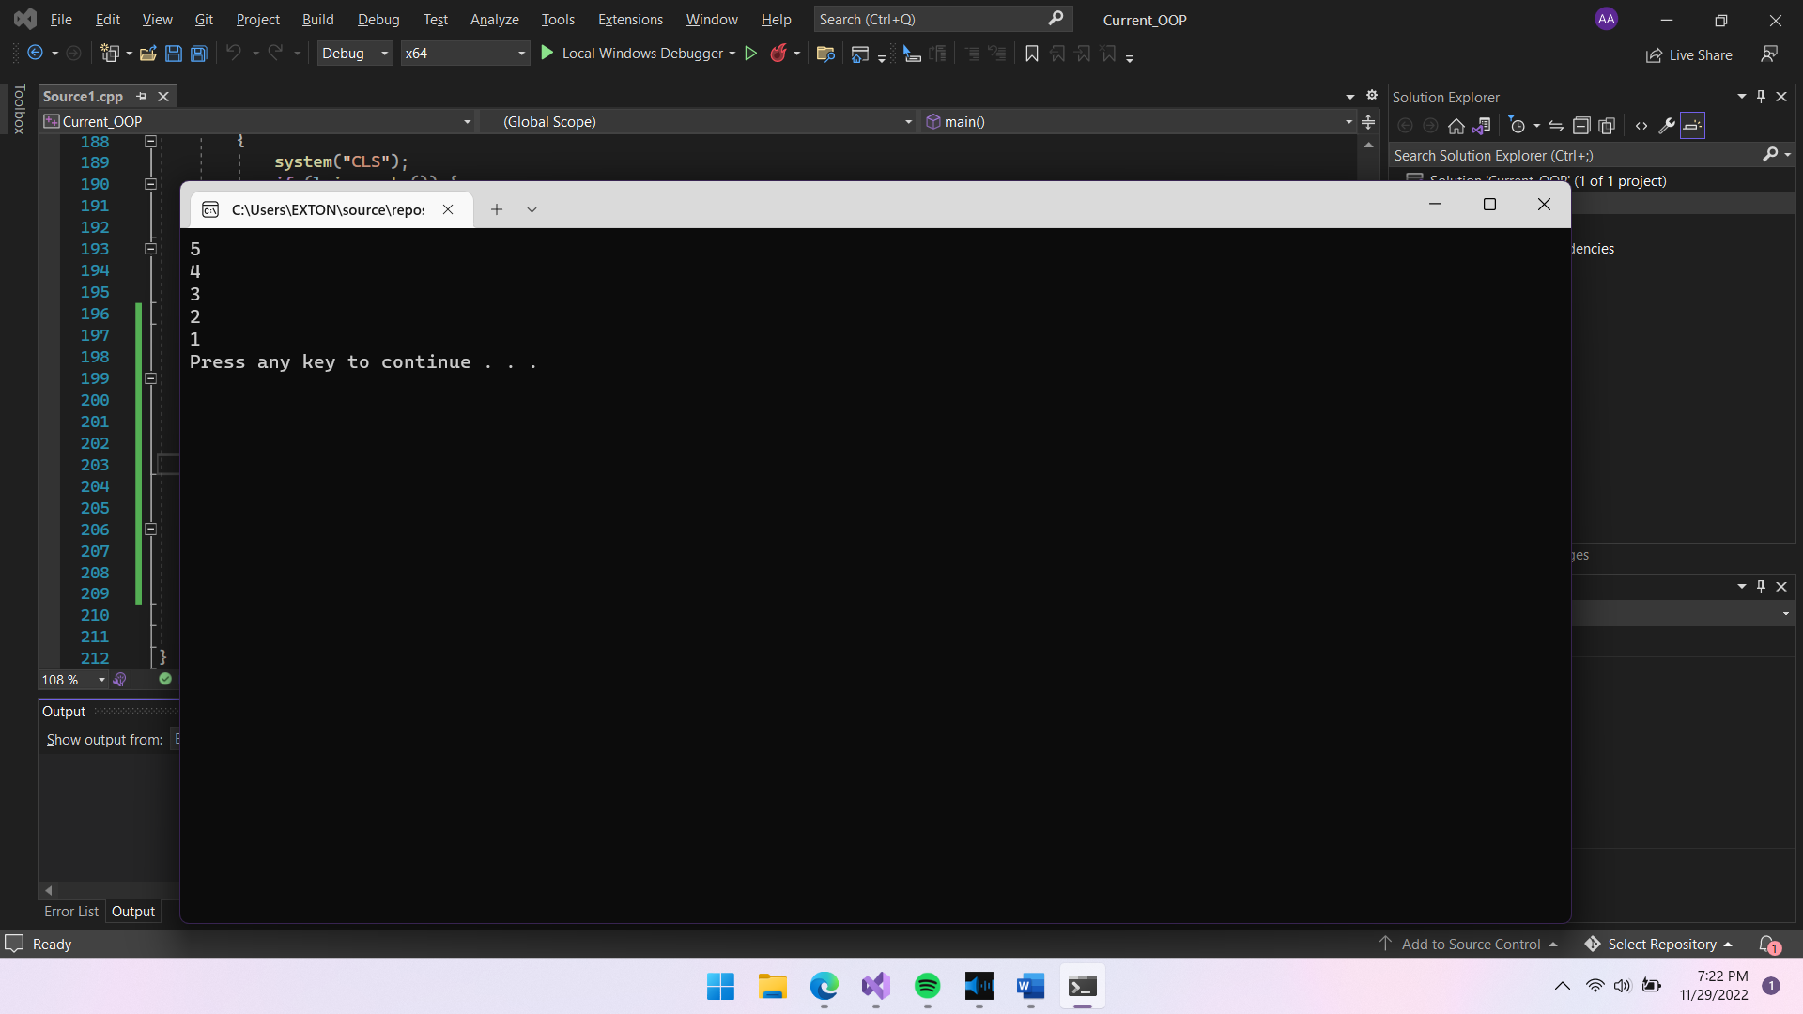

DEQUEUE:

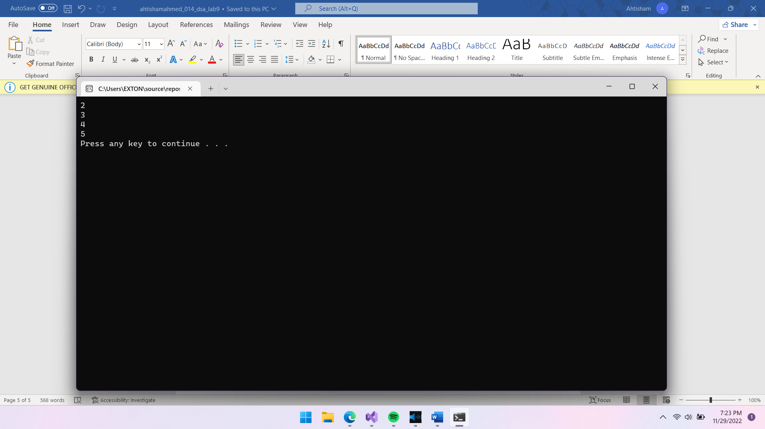

Task # 2  
Create a new project having two interfaces one for Queue using Array and the   
other one is for Queue using Link List. User will choose the one he/she   
wants to use.

#include <iostream>

using namespace std;

class node {

public:

int data;

node* next;

};

node* front = NULL;

node* back = NULL;

node* top_temp = NULL;

class list {

public:

node* create_node() {

node* newnode = new node;

return newnode;

}

void read_data() {

node* newnode = create_node();

cout << "ENTER THE DATA : ";

cin >> newnode->data; cout << endl;

enqueue(newnode);

system("CLS");

}

node* find_front() {

node* temp = back;

if (temp == NULL) {

return NULL;

}

else {

while (temp->next != NULL) {

temp = temp->next;

}

return temp;

}

}

void enqueue(node* newnode) {

node* temp_front = find_front();

if (front == NULL) {

front = newnode;

back = front;

front->next = back;

back->next = NULL;

}

else {

back->next = newnode;

back = newnode;

back->next = NULL;

}

}

void dequeue() {

//node* find_sec = find_sec_in_queue();

if (front == NULL) {

cout << "THE LIST IS EMPTY" << endl;

}

else if (front->next == NULL) {

delete(front);

back = NULL;

front = NULL;

}

else {

node* temp = front;

front = front->next;

delete(temp);

}

}

node* find_sec_in_queue() {

node* temp_front = find_front();

if (temp_front == NULL) {

return NULL;

}

else if (back->next == NULL) {

return back;

}

else {

node* temp = back;

while (temp->next->next != NULL) {

temp = temp->next;

}

return temp;

}

}

void display_original() {

node* temp_front = find_front();

if (temp_front == NULL) {

cout << "THE LIST IS EMPTY" << endl;

}

else {

node* temp = front;

while (temp != NULL) {

cout << temp->data << endl;

temp = temp->next;

}

}

system("pause");

system("CLS");

}

void ins_stack(int inp) {

node* newnode = create_node();

newnode->data = inp;

if (top_temp == NULL) {

top_temp = newnode;

top_temp->next = NULL;

}

else {

newnode->next = top_temp;

top_temp = newnode;

}

}

void display_reverse() {

node* temp_front = find_front();

if (temp_front == NULL) {

cout << "THE LIST IS EMPTY" << endl;

}

else {

node* temp = front;

while (temp != NULL) {

ins_stack(temp->data);

temp = temp->next;

}

node* temp_disp_stack = top_temp;

while (temp_disp_stack != NULL) {

cout << temp_disp_stack->data << endl;

temp_disp_stack = temp_disp_stack->next;

}

top_temp = NULL;

}

system("pause");

system("CLS");

}

bool is_empty() {

node* temp_front = find_front();

if (temp_front == NULL) {

return 1;

}

else {

return 0;

}

}

};

//A R R A Y

class list_array {

public:

static int front_arr;

static int back_arr;

int read_data() {

int i;

cout << "ENTER THE DATA : "; cin >> i; cout << endl;

return i;

}

void insert(int* arr, int data_inp, int size_arr) {

if (back_arr == size_arr || back_arr == size_arr - 1) {

cout << "QUEUE OVERFLOW" << endl;

}

else if (front_arr == -1) {

front_arr++;

back_arr++;

arr[back_arr] = data_inp;

}

else if (front_arr > 0) {

back_arr++;

arr[back_arr] = data_inp;

}

else {

int traverse = 0;

while (traverse != back_arr) {

traverse++;

}

arr[traverse + 1] = data_inp;

back_arr++;

}

}

void display(int* arr) {

int traverse = front_arr;

while (traverse != back_arr + 1) {

cout << arr[traverse] << endl;

traverse++;

}

}

void dequeue(int* arr) {

if (front_arr == -1) {

cout << "Queue Underflow" << endl;

}

else if (front_arr == back_arr) {

front_arr = -1;

back_arr = -1;

}

else {

front_arr++;

}

}

};

int list_array::front_arr = -1;

int list_array::back_arr = -1;

int main() {

list l; list_array l_a;

int option;

int arr[10];

int size = sizeof(arr) / sizeof(arr[0]);

while (1) {

cout << "ENTER 1 TO IMPLEMENT QUEUE USING LINKED LIST" << endl;

cout << "ENTER 2 TO IMPLEMENT QUEUE USING ARRAY" << endl;

cin >> option; cout << endl;

switch (option) {

case 1:

{

int opt;

cout << "ENTER 1 TO INSERT IN QUEUE" << endl;

cout << "ENTER 2 TO DISPLAY IN ORDER" << endl;

cout << "ENTER 3 TO DEQUEUE" << endl;

cout << "ENTER 4 TO CHECK IF QUEUE IS EMPTY" << endl;

cout << "ENTER 5 TO DISPLAY IN REVERSE" << endl;

cin >> opt;

switch (opt) {

case 1:

{

system("CLS");

l.read_data();

break;

}

case 2:

{

system("CLS");

l.display_original();

break;

}

case 3:

{

system("CLS");

l.dequeue();

break;

}

case 4:

{

system("CLS");

if (l.is_empty()) {

cout << "THE LIST IS EMPTY" << endl;

}

else {

cout << "THE LIST IS NOT EMPTY" << endl;

}

break;

}

case 5:

{

system("CLS");

l.display_reverse();

break;

}

}

break;

}

//array

case 2:

{

int opt;

cout << "ENTER 1 TO INSERT IN QUEUE" << endl;

cout << "ENTER 2 TO DISPLAY IN ORDER" << endl;

cout << "ENTER 3 TO DEQUEUE" << endl;

cin >> opt; cout << endl;

switch (opt) {

case 1:

{

system("CLS");

int inp = l_a.read_data();

l_a.insert(arr, inp, size);

break;

}

case 2:

{

system("CLS");

l_a.display(arr);

break;

}

case 3:

{

system("CLS");

l_a.dequeue(arr);

break;

}

}

break;

}

}

}

}

MENU:

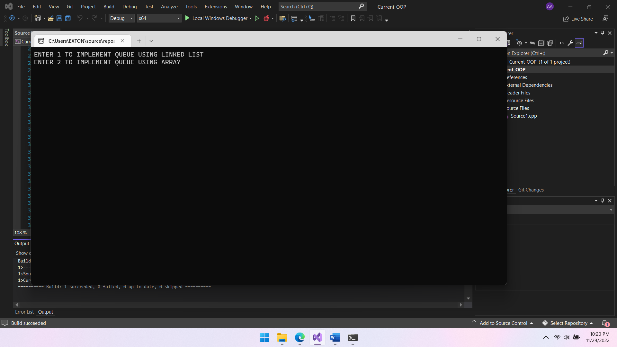

QUEUE AFTER INSERTION: [ARRAY]

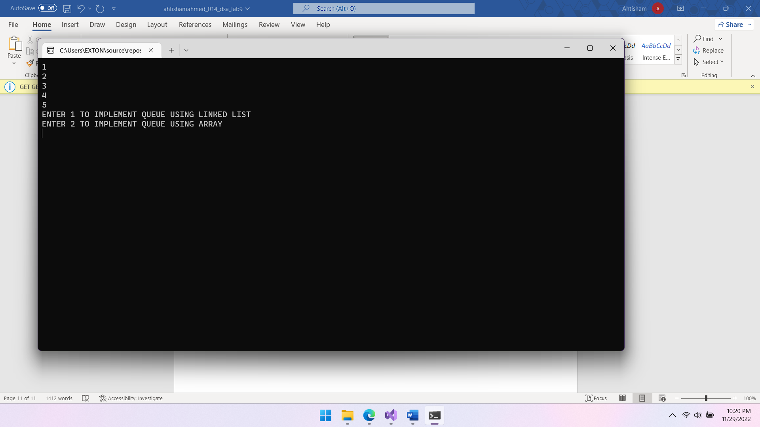

QUEUE AFTER DEQUEUE: [ARRAY]

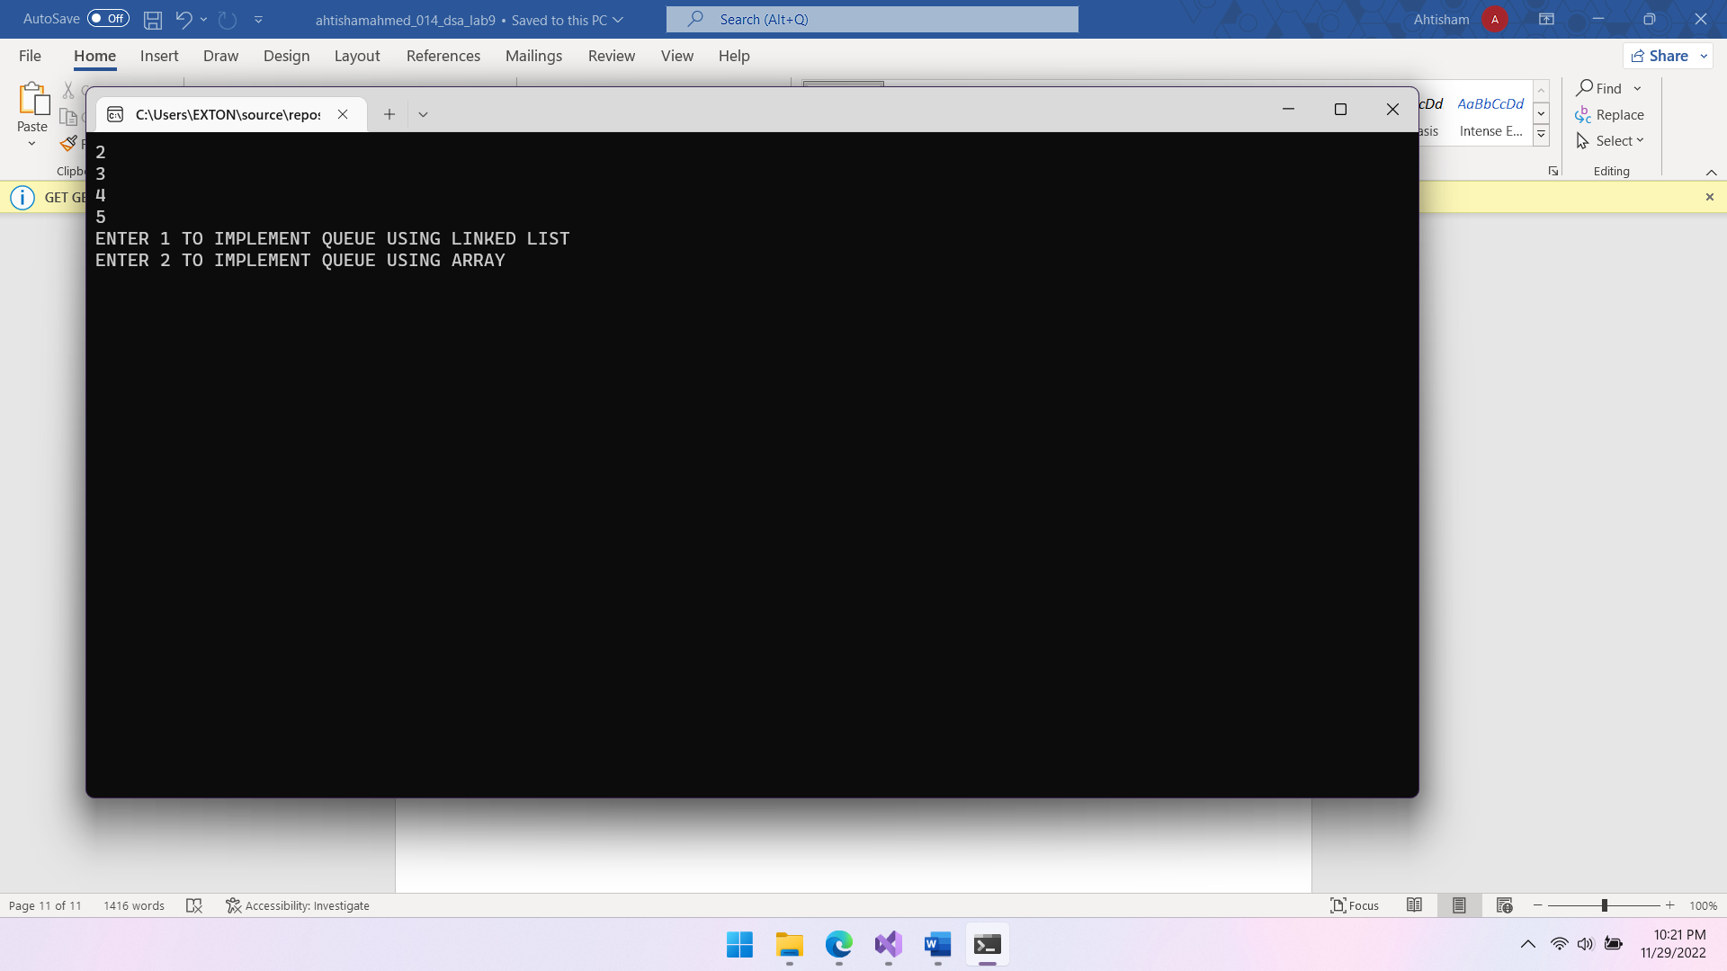

**********LINKED LIST IS THE SAME AS PREVIOUS QUESTION*************

Home Task  
A palindrome is a string that reads the same forwards as backwards. Using only a fixed number   
of stacks and queues, write a code to determine if a string is a palindrome. Assume that the string   
is read from standard input one character at a time. The code should output true or false as   
appropriate.

#include <iostream>

using namespace std;

class stack_arr {

public:

static int front;

static int back;

void read(char* arr, int size) {

char inp;

cout << "Enter the character : "; cin >> inp; cout << endl;

if (front == -1) {

front++;

back++;

arr[front] = inp;

}

else if (front == back) {

back++;

arr[back] = inp;

}

else if(back<size) {

back++;

arr[back] = inp;

}

else if (back >= size) {

cout << "QUEUE OVERLOADED" << endl;

}

}

bool check(char* arr, int size) {

int first = 0;

int i = back;

int second = back;

while (first != second) {

if (arr[first] != arr[second]) {

return 0;

}

else {

return 1;

}

first++;

second--;

}

}

void display(char* arr) {

int i = 0;

while (i != back+1) {

cout << arr[i] << endl;

i++;

}

}

};

int stack_arr::front = -1;

int stack_arr::back = -1;

int main() {

char arr[20];

stack_arr l;

int opt;

int size = sizeof(arr) / sizeof(arr[0]);

while (1) {

cout << "ENTER 1 TO INPUT A CHARACTER" << endl;

cout << "ENTER 2 TO CHECK IF THE DATA IN QUEUE IS A PLAINDROME" << endl;

cout << "ENTER 3 TO DISPLAY" << endl;

cin >> opt; cout << endl;

switch (opt) {

case 1:

{

l.read(arr, size);

cout << l.back << endl;

break;

}

case 2:

{

if (l.check(arr, 20)) {

cout << "PALINDROME" << endl;

}

else {

cout << "NOT A PALINDROME" << endl;

}

break;

}

case 3:

{

l.display(arr);

break;

}

}

}

}

INPUT:

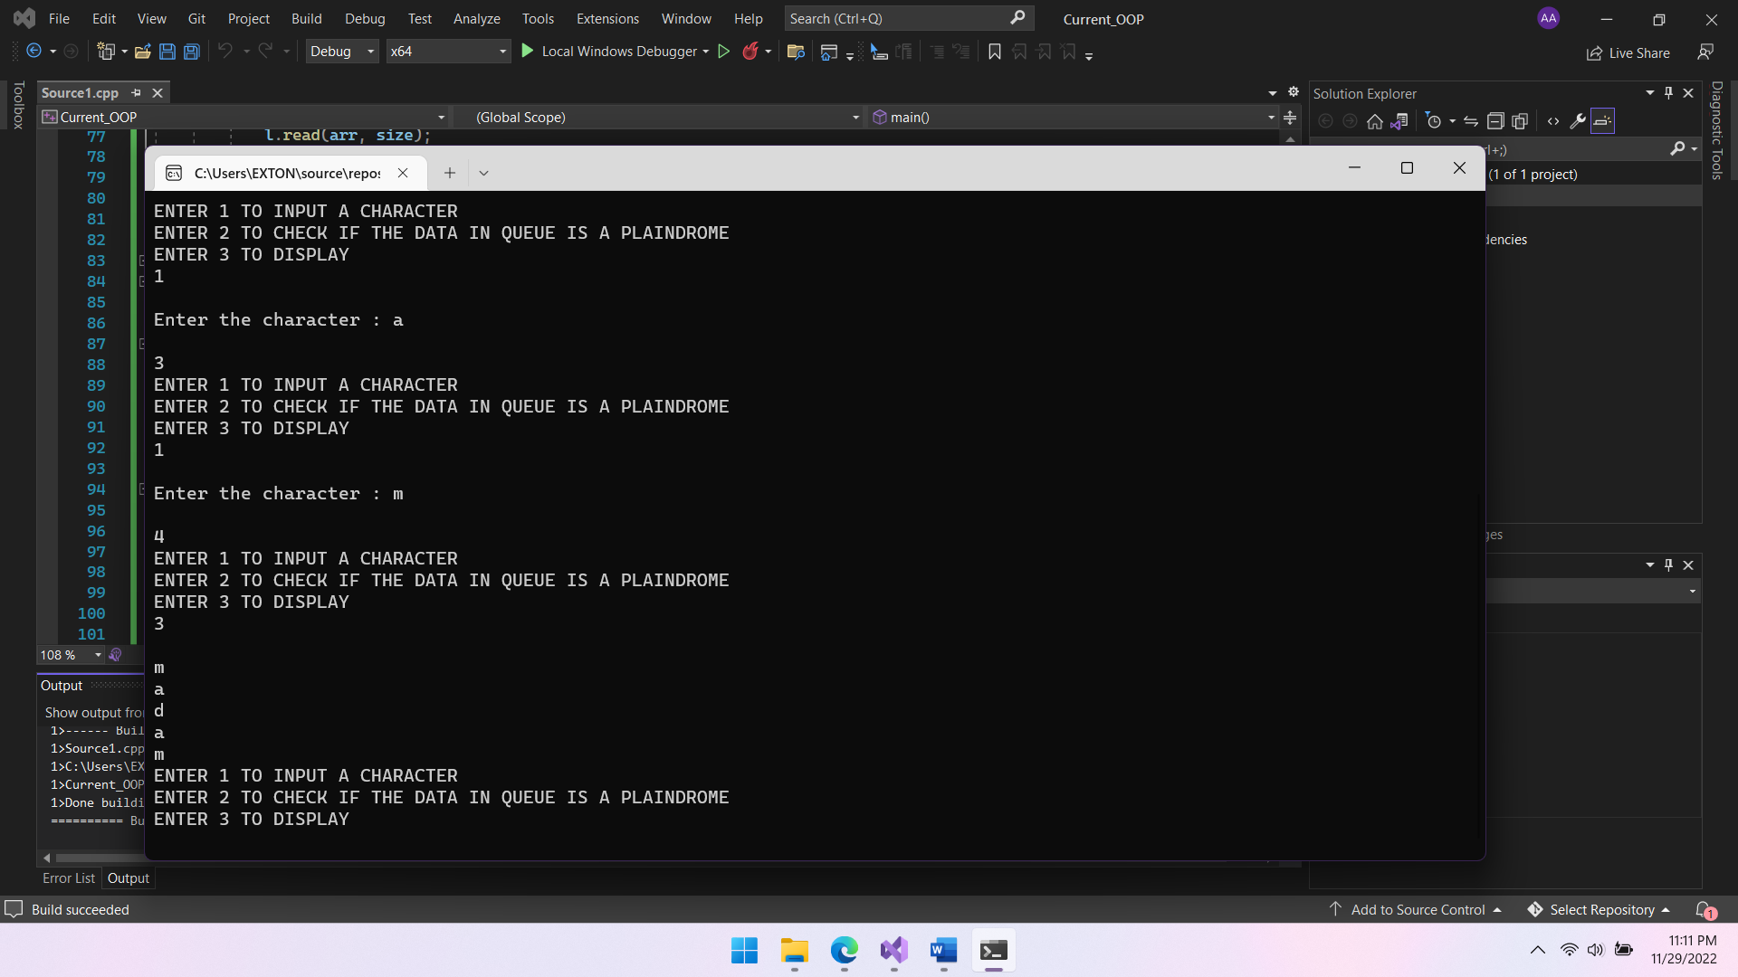

OUTPUT:

