1. Write program to Implement a stack using   
   a. singly linked list.

#include <iostream>

using namespace std;

class node {

public:

node* next;

int roll;

};

node* top = NULL;

class list {

public:

node* create_node() {

node* newnode = new node;

return newnode;

}

void read_data(node* newnode) {

cout << "ENTER THE ROLL NO : "; cin >> newnode->roll; cout << endl;

}

void push(node* newnode) {

if (top == NULL) {

top = newnode;

top->next = NULL;

}

else {

newnode->next = top;

top = newnode;

}

}

void pop() {

if (top == NULL) {

cout << "THE LIST IS EMPTY" << endl;

}

else {

node* temp = top;

top = top->next;

delete(temp);

}

}

bool is_empty() {

if (top == NULL) {

return true;

}

else {

return false;

}

}

void display() {

if (top == NULL) {

cout << "THE LIST IS EMPTY" << endl;

}

else {

node* temp = top;

while (temp != NULL) {

cout << temp->roll; cout << endl;

temp = temp->next;

}

}

}

};

int main() {

int opt; list l;

while (1) {

cout << "ENTER 1 TO PUSH" << endl;

cout << "ENTER 2 TO POP" << endl;

cout << "ENTER 3 TO DISPLAY" << endl;

cin >> opt; cout << endl;

switch (opt) {

case 1:

{

node* newnode = l.create_node();

l.read_data(newnode);

l.push(newnode);

break;

}

case 2:

{

l.pop();

break;

}

case 3:

{

l.display();

break;

}

}

}

}

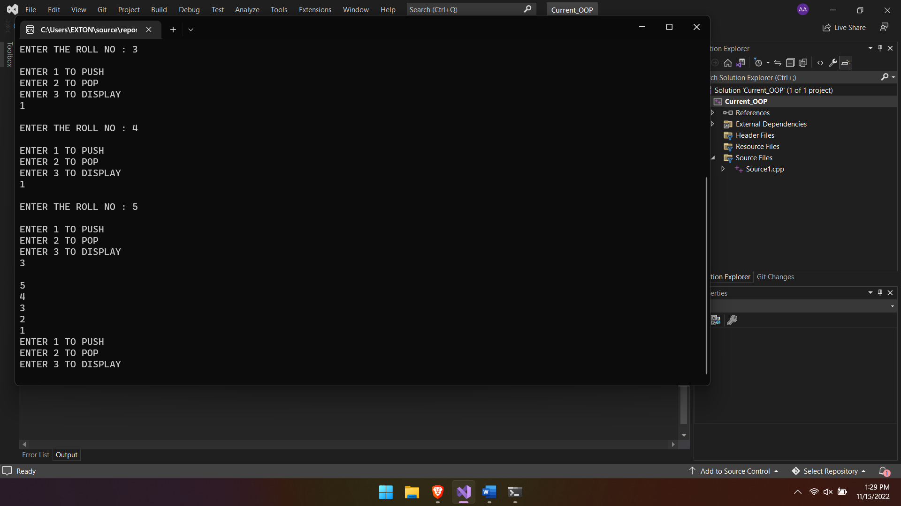

2. Sort the stack using another temporary stack.  
Like if values in Stack S and in Stack T at the start are:

//push done

//pop done

//initial push done

#include <iostream>

using namespace std;

class node {

public:

node* next;

int data;

};

node* top_final;

node* top_1; //temp

node* top_2; //temp

node* create_node() {

node* newnode = new node;

return newnode;

}

void push_top_1(int i) {

node* newnode = create_node();

newnode->data = i;

if (top_1 == NULL) {

top_1 = newnode;

top_1->next = NULL;

}

else {

newnode->next = top_1;

top_1 = newnode;

}

}

void push_top_2(int i) {

node* newnode = create_node();

newnode->data = i;

if (top_2 == NULL) {

top_2 = newnode;

top_2->next = NULL;

}

else {

newnode->next = top_2;

top_2 = newnode;

}

}

void push_top_final(int i) {

node* newnode = create_node();

newnode->data = i;

if (top_final == NULL) {

top_final = newnode;

top_final->next = NULL;

}

else {

newnode->next = top_final;

top_final = newnode;

}

}

void pop_top_1() {

if (top_1 == NULL) {

top_1 = NULL;

cout << "" << endl;

}

else {

node* temp_top_1 = top_1;

top_1 = NULL;

}

}

void pop_top_2() {

if (top_2 == NULL) {

top_2 = NULL;

cout << "" << endl;

}

else {

node* temp_top_2 = top_2;

top_2 = NULL;

}

}

//IMPORTANT

bool status_temp_1() {

if (top_1 == NULL) {

return 1;

}

else {

return 0;

}

}

bool status_temp_2() {

if (top_2 == NULL) {

return 1;

}

else {

return 0;

}

}

void ascend() {

//temp stack no 1

if (top_1 == NULL) {

node* temp_top_2 = top_2;

node* min_node = top_2;

int min_data_2 = top_2->data;

while (temp_top_2 != NULL) {

if (min_data_2 > temp_top_2->data) {

min_data_2 = temp_top_2->data;

min_node = temp_top_2;

}

else {

temp_top_2 = temp_top_2->next;

}

}

push_top_final(min_data_2); //pushes min value to final

node* temp_top = top_2;

while (temp_top->next != NULL) {

if (temp_top == min_node) {

node* temp_del = temp_top;

temp_top = temp_top->next;

}

else {

push_top_1(temp_top->data);

node* temp_pop = temp_top;

temp_top = temp_top->next;

pop_top_2();

}

}

if (temp_top->next == NULL) {

if (temp_top == min_node) {

node* temp_del = temp_top;

temp_top = temp_top->next;

pop_top_2();

}

else {

push_top_1(temp_top->data);

pop_top_2();

}

}

}

//temp stack no 2

else if (top_2 == NULL) {

node* temp_top_1 = top_1;

node* min_node = top_1;

int min_data_1 = top_1->data;

while (temp_top_1 != NULL) {

if (min_data_1 > temp_top_1->data) {

min_data_1 = temp_top_1->data;

min_node = temp_top_1;

}

else {

temp_top_1 = temp_top_1->next;

}

}

push_top_final(min_data_1); //pushes min value to final

node* temp_top = top_1;

while (temp_top->next != NULL) {

if (temp_top == min_node) {

node* temp_del = temp_top;

temp_top = temp_top->next;

delete(temp_del);

}

else {

push_top_2(temp_top->data);

node* temp_pop = temp_top;

temp_top = temp_top->next;

pop_top_1();

}

}

if (temp_top->next == NULL) {

if (temp_top == min_node) {

node* temp_del = temp_top;

temp_top = temp_top->next;

pop_top_1();

}

else {

push_top_2(temp_top->data);

pop_top_1();

}

}

}

}

void display_final() {

node* temp_final = top_final;

while (temp_final != NULL) {

cout << temp_final->data << endl;

temp_final = temp_final->next;

}

}

int main() {

//initial values

push_top_1(1);

push_top_1(5);

push_top_1(2);

push_top_1(8);

push_top_1(9);

//ascend

int count = 5;

int i = 0;

while (i<5) {

ascend();

i++;

}

display_final();

}

INITIAL INPUT:

1

5

2

8

9

OUTPUT:

