PROJECT PROPOSAL
LinguaQuest
A Listening Skills Adventure App for Grade 7

Subject Area | Listening Comprehension
Target Users | Grade 7 Students (12-13 years old)
Platform | Android Mobile Application
Connectivity | Offline (Main Quest) + Online (Multiplayer)
Theme | Pirate Adventure / Quest
Prepared by | Mark Andrei A. Condino
Date | March 14, 2026

1. Project Background and Rationale

Research highlights a significant challenge among Grade 7 learners: listening comprehension difficulties stemming from unfamiliar vocabulary, rapid speech delivery, complex sentence structures, and emotional factors such as nervousness and worry. Compounding this, many students stop processing entirely upon encountering unfamiliar words, revealing a lack of effective listening strategies.

These four failure points are the direct foundation of LinguaQuest's design. Each one maps to a specific mechanic:

- Unfamiliar vocabulary and the habit of stopping: in both Main Quest and Abandon Ship, audio plays once and cannot be paused, stopped, or replayed. Students are forced to push through unfamiliar words rather than shutting down, which directly trains the strategy of continuing to listen even when something is unclear.
- Rapid speech delivery: audio clips are designed at natural conversational pace with no artificial slowing. Students must adapt to real-world speech rhythm rather than classroom-adjusted audio.
- Complex sentence structures: questions target specific buried details within longer, multi-clause clips. Students must hold the full structure of what they heard in working memory while identifying the correct detail.
- Nervousness and worry: the Abandon Ship mode introduces productive pressure through visible shared ship health and a 45-second group voting window. Wrong answers damage the crew's ship collectively — no individual is ever named or exposed. Because the answer is a majority vote, no single student carries the weight of a wrong answer alone. This design distinguishes between the harmful anxiety that shuts down learning and the manageable challenge that builds resilience under real listening conditions.

LinguaQuest addresses these gaps head-on through a gamified, adventure-driven Android application designed to build and sustain listening competency in a way that feels engaging rather than academic.

2. Story Narrative

2.1 Premise
Note: the story narrative below applies to character mode (optional paid add-on). In the default minimal mode, the app uses plain instructional text with no narrative framing. All listening content and questions are identical across both modes.

In the ancient Listening Sea, a legendary treasure called the Alingawngaw ("The Great Echo") has been lost for centuries. This treasure, said to be a mystical crystal conch shell, holds the power to understand any language, decode any message, and communicate across all realms. It was shattered into fragments by the treacherous storm-sorcerer Ingay, scattering the pieces across seven cursed islands.

The student plays as a young pirate apprentice named Dagat, newly recruited into the crew of Captain Salita, a legendary but aging pirate captain whose voice has been stolen by Ingay as punishment for coming too close to the treasure. Captain Salita can only communicate through written notes and whispered maps, and needs Dagat to be her ears and voice as they sail together to recover the shards of the Alingawngaw.

2.2 Main Characters
LinguaQuest ships in two UI modes. The base app uses a minimal interface with no character illustrations and is completely free. Character mode — featuring Dagat, Captain Salita, and Ingay as flat 2D cartoon illustrations — is an optional paid add-on unlockable per student or school-wide through the admin panel. Both modes deliver 100 percent identical audio content, comprehension questions, feedback, and badges. The character layer is a narrative wrapper only, never a functional requirement.

Minimal mode (default, free): plain interface with no character art. Map view shows island names only. Quest prompts appear as direct instructional text. Island introductions show a plain skill focus and difficulty notice. Player is represented by a simple anonymous sailor icon. All core features fully functional.

Character mode (optional paid add-on): full illustrated UI with Dagat, Captain Salita, and Ingay. All character art uses flat 2D illustration with bold outlines and vibrant colors, optimized for mobile screen rendering. Quest prompts delivered in character voice through animated text bubbles. Dagat is a customizable avatar with selectable hat, outfit, and skin tone. Unlocked as a single one-time purchase per student or as a school-wide license. Teachers can set character mode as the class default from the admin panel.

Character | Role | Description
Dagat | Player Character | A curious, eager pirate apprentice. Customizable avatar (hat, outfit, skin tone). Only appears in character mode (paid add-on). In the default minimal mode, replaced by a simple anonymous sailor icon. Dagat's visual progression mirrors the student's listening progress when character mode is active.
Captain Salita | Mentor / Quest Giver | Wise, weathered captain whose voice was stolen. Communicates through animated text bubbles. Displayed as a 2D illustrated portrait. Only appears in character mode (paid add-on). In the default minimal mode, all quest prompts appear as plain instructional text with no portrait.
Ingay | Antagonist | The storm-sorcerer who thrives in noise and misunderstanding. Appears at the start of each island as a static illustrated warning screen. Only appears in character mode (paid add-on). In the default minimal mode, island introductions show a plain skill focus and difficulty notice instead.
Island Locals | NPC Quest Characters | Each island has a unique NPC (e.g., a merchant, a lighthouse keeper, a storyteller) who delivers the listening audio. Represented as static portrait illustrations per island.

2.3 World and Setting
The Listening Sea is a hand-drawn style 2D map rendered as an interactive screen in the app. The map contains seven islands, each representing a listening skill theme:

Island | Name | Listening Skill Focus
1 | Isla ng Salita (Island of Words) | Vocabulary in context
2 | Isla ng Bilis (Island of Speed) | Rapid speech comprehension
3 | Isla ng Diwa (Island of Meaning) | Main idea and details
4 | Isla ng Damdamin (Island of Feeling) | Emotional tone and inference
5 | Isla ng Tanong (Island of Questions) | Listening for specific information
6 | Isla ng Kwento (Island of Stories) | Narrative comprehension
7 | Isla ng Alingawngaw (The Final Isle) | Full integration challenge

2.4 Technical Stack
LinguaQuest is built using React Native with NativeWind (Tailwind CSS for React Native), enabling a consistent, responsive UI across Android devices.

- Framework: React Native (cross-platform mobile development)
- Styling: NativeWind (Tailwind CSS utility classes for React Native)
- Map and Pin Interface: React Native custom canvas or react-native-maps with custom overlay components
- Audio Playback: react-native-track-player or expo-av for NPC dialogue and listening challenge audio
- Animations: React Native Animated API or Lottie for React Native (badge and certificate animations)
- Offline Storage: AsyncStorage or SQLite via expo-sqlite for local quest state and cached data
- Authentication and Online Features: Firebase or Supabase for user login and real-time multiplayer
- Navigation: React Navigation for screen routing and dashboard/quest/multiplayer flow

3. Project Objectives

- Improve Grade 7 listening comprehension skills through structured, gamified exercises.
- Motivate sustained engagement using a pirate-themed adventure narrative, milestone badges, and a progressive quest structure.
- Develop effective listening strategies by providing hints, real-time feedback, reflective post-quest inputs, and checkpoint reviews.
- Support inclusive learning through both offline (Main Quest) and online (Multiplayer) modes.
- Reduce performance anxiety by removing individual scoring entirely in favor of collective milestone-based progress and shared badge achievements.

4. Target Users

The primary users of LinguaQuest are Grade 7 students aged 12-13 years old. The app is designed to accommodate varying connectivity situations, making it accessible to learners regardless of internet availability. Secondary users include teachers who can monitor student progress through the admin panel, reviewing milestone achievements, badge completion, and session accuracy data per student.

5. Core Features and Functionality

5.1 Main Quest Mode (Offline)
The Main Quest is the core single-player experience, fully available offline. It uses an interactive map-based interface where students navigate a pirate-themed world:

- Interactive Map with Pins
  - The game world is displayed as a pirate-themed map with location pins scattered across it.
  - Each pin represents a listening challenge or quest stop. Tapping a pin opens the challenge.
  - Visuals tied to each pin serve as objectives or output previews, giving students context before they engage.
- Quest Challenges
  - Students listen to audio clips and respond to comprehension questions at each pin.
  - Challenges are organized progressively, building vocabulary and strategy over time.
- Checkpoints
  - Periodic checkpoint stops consolidate learning from previous pins before the student advances.
  - Checkpoints recap errors made and highlight correct strategies applied.

5.2 Multiplayer Mode - Abandon Ship (Online)
Abandon Ship is LinguaQuest's multiplayer mode. Up to 6 players form a crew aboard a pirate ship with 5 parts: Hull, Mast, Sails, Anchor, and Rudder. Each part starts at 25 percent health. The crew must repair all parts to 100 percent before running out of rounds. Each round contains 5 audio clips and 5 questions. The core mechanic: the crew votes together on every answer. There are no individual submissions. Majority vote is the crew's answer. Correct vote repairs the chosen part by 25 percent. Wrong vote damages it by 25 percent.

There is no impostor. There are no roles. The enemy is the audio and the question difficulty. Because answering is a collective vote, no student is ever singled out for a wrong answer. The debate that happens during the 45-second voting window is the learning itself — students must recall what they heard, defend their interpretation, and convince their crew. This design is directly grounded in research identifying nervousness and individual shame as primary causes of comprehension failure. The pressure in Abandon Ship is always shared, never personal.

5.2A Ship health system
- The ship has 5 parts: Hull, Mast, Sails, Anchor, and Rudder. Each part starts at 25 percent health at the beginning of every session.
- The crew's goal is to repair all 5 parts to 100 percent health before the session ends.
- Each round has 5 audio clips and 5 questions. The crew votes on which part to repair at the start of each round. All 5 questions that round contribute toward repairing that chosen part.
- Correct crew vote: repairs the chosen part by 25 percent.
- Wrong crew vote: damages the chosen part by 25 percent. One wrong vote undoes one correct vote's repair. The crew is fighting both audio difficulty and their own disagreements simultaneously.
- If a part reaches 0 percent health, the ship sinks immediately and the session ends. The crew loses.
- If the crew fully repairs the chosen part before the 5th question of a round, remaining questions automatically shift focus to the next most damaged part. Health carries over between rounds and is never reset.
- If the crew does not fully repair the chosen part within 5 questions, they vote at the start of the next round whether to continue repairing it or move to another part. The current health percentage is preserved either way.

5.2B Audio playback — no control, no mercy
- When a round starts, the audio clip plays automatically and simultaneously on all devices. There is no countdown warning before it starts.
- Players cannot pause, stop, or replay the audio under any circumstances. Once it plays, it is gone. This directly addresses the research finding that students stop their listening process when encountering unfamiliar words — in Abandon Ship, stopping is not an option.
- The moment the clip ends, the question and 4 answer choices appear immediately on every device. A 45-second discussion and voting timer starts instantly.
- During the 45 seconds, players discuss the question out loud (face to face) or via pre-set chat options (remote). Each player taps their chosen answer on their own screen. The crew's vote locks when the timer runs out or all players have submitted.
- Majority wins. If tied, the answer submitted by the most players in the shortest average time wins. The result — correct or wrong — is revealed simultaneously to all players and ship health updates immediately.
- 45 seconds is intentionally chosen: long enough for 2 to 3 players to make their case and reach a genuine group decision, short enough that the clock is always a presence. Productive urgency without individual panic.

5.2C What makes it hard
- Hard questions, not hard mechanics: difficulty comes entirely from the audio and question design. Questions target the least obvious detail in the clip — a specific word, number, name, or implication buried in the middle of a 30-second clip. All four answer choices are things actually said in the audio. Students must recall exactly which detail was asked about and defend that recall to their crew.
- Disagreement is the challenge: because the crew votes together, the real difficulty is reaching consensus under time pressure. Two players may have heard different things. The 45-second window forces negotiation, not just recall.
- Collective stakes: the ship health is visible to everyone the entire session. A wrong crew vote hurts everyone equally. The stakes feel real without the shame of individual failure.

5.2D Repair part vote
- At the start of each round, all ship parts and their current health percentages are shown on a shared screen. The crew votes on which part to repair this round. Majority vote wins. If tied, the most damaged part is selected automatically.
- After the repair vote is locked, the first audio clip plays immediately with no warning. The repair vote is the only moment of crew control before the listening begins.

5.2E Win and lose conditions
- Crew wins if at least 3 out of 5 ship parts are Fully Intact by the end of round 5. Half-Fixed parts do not count toward the win condition.
- Crew loses if they cannot reach 3 Fully Intact parts by end of round 5, or if all 5 parts drop to Broken before round 5 ends. If all 5 break, the ship sinks immediately and the session ends early.
- The crew must balance strategy each round: push to fix a new Broken part, or sacrifice a round to fully complete a Half-Fixed one. Leaving too many parts Half-Fixed risks falling short of the 3 fully fixed threshold even if the ship is still afloat.
- End screen shows the crew's collective accuracy per round, part health changes per round, and which questions caused the most damage. Each player's individual accuracy is shown only on their own private summary screen, never to the group.

5.2F Example scenario
Players: Anna, Ben, Carlo, Diana, Enzo. 5 players, face to face, one device each. Session start: all 5 ship parts at 25 percent health. Round 1 begins.

Step 1 — Repair vote: all 5 parts show 25 percent on the ship diagram. The crew votes which part to repair first. 4 out of 5 vote Hull. The screen locks: Repairing Hull this round. Hull is at 25 percent. They need to push it to 100 percent across the 5 questions this round.

Step 2 — Question 1 of 5, audio auto-plays: no warning, no countdown. A 30-second clip of a merchant describing his cargo route plays on all 5 devices simultaneously. The room goes quiet. The question targets a detail buried 12 seconds in — the second port the merchant stopped at. All four answer choices are port names actually mentioned in the clip.

Step 3 — Question and voting: clip ends, question appears on all screens at the same moment with 4 answer choices. 45-second timer starts.

The room erupts. Anna says she heard Porto Salvo. Ben says no, it was Isla Bilis, he is sure. Carlo agrees with Anna. Diana is unsure. Enzo sides with Ben. The debate is happening out loud, from memory, with a clock ticking.

Votes submitted: Anna — Porto Salvo. Ben — Isla Bilis. Carlo — Porto Salvo. Diana — Porto Salvo. Enzo — Isla Bilis. Majority: 3 votes Porto Salvo, 2 votes Isla Bilis. The crew's answer is Porto Salvo.

Result: Porto Salvo is correct. The Hull repairs from 25 to 50 percent. The ship creaks but holds. Ben and Enzo are visibly annoyed — they were overruled. Anna tells them to listen harder next clip.

Question 2 of 5 plays immediately. Same flow — auto-play, instant question, 45 seconds to debate and vote. Each question is harder than the last. The details get more buried. The choices get more plausible. By Question 4, the crew is arguing seriously because they genuinely disagree about what they heard. That is the whole point.

If the Hull hits 100 percent before Question 5, the remaining questions shift to the next most damaged part automatically. If the Hull hits 0 percent at any point, the ship sinks immediately. No second chances. The crew lives and dies by their collective recall and their ability to convince each other under pressure.

5.2G Access and session settings
- Multiplayer is locked when the device is offline. An in-app prompt notifies the student and redirects to the dashboard.
- Students must be logged in to join or create a room. Guest accounts are redirected to the login screen.
- Room codes allow classmates to join a private session. Teachers can generate codes from the admin panel.
- Room size: 4 to 6 players. Default 5 rounds per session, configurable by the host up to 7 rounds.
- Face-to-face and remote play are both supported. Face-to-face players share a room code and use individual devices.

5.3 Feedback and Learning Support for Main Quest
Feature | Description
Hint System | Students struggling with a challenge can request contextual hints that guide without revealing the answer, reinforcing strategy over guessing.
Real-Time Error Display | After each answer, students immediately see what was wrong and what the correct response is with an explanation.
Post-Quest Reflection | After completing a quest, students are prompted to reflect: What went wrong? What could have been done better? This builds metacognitive listening skills.
Overall Error Summary | A comprehensive recap at the end of each session shows all errors alongside correct answers for review.

5.4 Progression and Motivation System
LinguaQuest replaces traditional scoring with a milestone and badge system designed to celebrate effort and growth rather than numeric performance.

Quest badges
- First Steps: awarded upon completing the first island.
- Sharp Ear: awarded for achieving 100 percent accuracy on any island.
- Never Lost: awarded for completing an island without using a single hint.
- Ship Saver: awarded for being on the winning crew 3 times across separate Abandon Ship sessions.
- The Captain: awarded upon completing all 7 islands of the Listening Sea.
- Island badges for each of the 7 islands, showing the island name and its listening skill focus.

Abandon Ship badges
- Unsinkable: complete a full session with the ship losing zero parts — all 5 reach 100 percent health.
- Unanimous: the crew achieves a unanimous correct vote on every question in a single round.
- True Crew: the crew wins a full session without a single wrong vote across all 5 rounds.
- Comeback: the crew repairs a part that was at 0 percent risk in the final round.

Certificates
- Upon completing a full island arc, students receive an animated digital certificate naming their username (minimal mode) or character name Dagat (character mode), the island completed, and the listening skill mastered.
- A Grand Certificate (Island Conqueror) is awarded upon completing all 7 islands. This is the app's highest milestone and triggers a full-screen animated celebration sequence.

No traditional scores
- Numeric scores do not appear anywhere in the student-facing interface. Progress is shown only as badges earned, islands cleared, and milestones reached. This reduces performance anxiety and shifts focus to learning growth.

5.5 Onboarding and Accessibility
- Tutorial Mode: A simple, interactive tutorial walks new users through the app before their first quest, covering navigation, how to answer, using hints, and understanding feedback.
- Progressive Difficulty: listening clips and questions are organized by island difficulty level, starting with shorter, slower-paced clips on early islands and increasing in length, pace, and sentence complexity toward island 7.
- Visual-First Design: All challenges are accompanied by visual cues and illustrated pirate-world environments to aid comprehension and engagement.
- Character Mode (optional paid add-on): the default app ships in minimal mode — plain instructional UI with no character art. Character mode, featuring Dagat, Captain Salita, and Ingay as flat 2D illustrated assets, is a one-time paid unlock available per student or school-wide. Teachers can activate it as the class default from the admin panel. Both modes deliver 100 percent identical audio content, questions, feedback, and badges.

6. Technical Architecture Overview

Component | Details
Platform | Android (React Native + NativeWind / Tailwind)
Offline Capability | Main Quest fully functional without internet; data cached locally
Online Features | Multiplayer mode requires active internet connection
Authentication | Login required for online/multiplayer access; guest mode limited to Main Quest
Content System | Manually authored listening content with structured Q&A and island formats defined in Sections 10 and 11
Animations | Animated badge and certificate delivery upon milestones
Access Control | Multiplayer locked with redirect prompt when user is offline or not logged in

7. User Flow Summary

The diagram below maps the complete user journey through LinguaQuest, from first launch to badge completion, for both Main Quest and Multiplayer paths.

7.1 Shared Entry Flow
- App launch triggers a new user check.
  - New users complete the Tutorial before reaching the dashboard.
  - Returning users go directly to Login then the dashboard.

7.2 Main Quest Flow (Offline)
- Student opens the pirate map and taps a pin.
- A quest popup introduces the challenge. In minimal mode (default) this is plain instructional text. In character mode (paid add-on) it is delivered by Captain Salita through an animated text bubble.
- The listening audio plays. Student answers comprehension questions.
  - Hint is available on after 1 minute of no response
- Correct and incorrect answers are shown immediately with explanations.
- At checkpoint pins, a recap of all errors so far is displayed.
- After all pins on an island are cleared, the post-quest reflection screen appears.
  - Student inputs what went wrong and what they would do differently.
- An animated badge or certificate is awarded. The next island unlocks on the map.

7.3 Multiplayer Flow - Abandon Ship (Online)
- Student taps Multiplayer. App checks internet connection and login status.
  - If offline: locked prompt shown, redirect to dashboard.
  - If not logged in: redirect to login screen.
- Student joins a room via room code or creates one. Waiting lobby shows all connected players (4 to 6).
- Host starts the session. Ship is shown with all 5 parts at 25 percent health.

Each round:
- Crew votes which ship part to repair this round. Majority wins.
- First audio clip plays automatically on all devices simultaneously. No pause, no replay.
- Question appears immediately when clip ends. 45-second discussion and voting timer starts.
- Players discuss out loud (face to face) or via pre-set chat (remote). Each player taps their vote.
- Majority vote is the crew's answer. Correct = chosen part +25% health. Wrong = chosen part -25% health.
- Result shown immediately. Ship health updates. Next clip plays after brief transition.
- Round continues for all 5 questions. If a part hits 100% before question 5, remaining questions shift to next damaged part.
- If any part hits 0% at any point, the ship sinks and the session ends immediately.

End of session:
- Crew wins if all 5 parts reach 100 percent health before the session ends.
- Crew loses if any part reaches 0 percent health.
- Final screen shows crew collective accuracy per round, part health history, and which questions caused the most damage.
- Badges awarded based on ship outcome and crew voting performance.

7A. Admin Panel and Functions

LinguaQuest includes a web-based admin panel accessible only to authorized teachers and administrators. The admin panel is separate from the student-facing mobile app and is accessed via browser.

7A.1 Admin Roles
Role | Access Level
Teacher / Admin | Full access to all features: content, users, analytics, and system settings.  Can view student progress, manage class rosters, create rooms, and submit content for review. Cannot publish content without super admin approval.

7A.2 Admin Functions
Function | Description
Content Management | Add, edit, or remove islands, pins, audio scripts, questions, choices, answers, hints, and explanations. Uses the Q&A format defined in Section 10. Published content goes live on next app sync.
Story Management | Update story text, NPC dialogues, island descriptions, character bios, and shard names. Uses the Story Input format from Section 11.
User Management | View all registered student accounts. Reset passwords, deactivate accounts, assign students to class groups, and manage teacher accounts.
Progress and Analytics | View per-student progress: islands completed, pins cleared, error frequency by skill, hint usage rate, and badge milestones. Exportable as CSV.
Progress Reports | View and export per-student accuracy data, badge milestones, session completion rates, and island progress. Exportable as CSV per class or school-wide.
Badge and Certificate Control | Create or edit badge designs and milestone thresholds. Configure which actions trigger certificate generation (e.g. completing all 7 islands).
Content Moderation | Review and approve post-quest reflection inputs submitted by students. Flag or hide inappropriate responses. Reflection data is anonymized in analytics exports.
System Settings | Configure app-wide settings: max players per room, round count per Abandon Ship session, voting window duration (default 45 seconds), and offline sync frequency.

8. Expected Outcomes and Success Metrics

Outcome | Indicator
Improved listening comprehension | Increased accuracy in post-quest challenge responses
Higher student motivation | Session completion rate and badge/milestone achievement rate
Better use of listening strategies | Reduction in hint usage over time per student
Reflective learning behavior | Completion and quality of post-quest reflection inputs
Peer engagement and competition | Active multiplayer participation rate

9. Conclusion

LinguaQuest is a purposefully designed Android application that transforms Grade 7 listening comprehension practice from a passive, often anxiety-inducing academic exercise into an active, story-driven adventure. By combining research-backed instructional strategies — immediate corrective feedback, metacognitive reflection, and progressive listening challenges — with engaging game mechanics like pirate maps, animated badges, cooperative multiplayer, and milestone-based progression, LinguaQuest addresses both the cognitive and motivational barriers that impede student listening development.

The dual-mode structure, offline for independent Main Quest play and online for the Abandon Ship multiplayer mode, ensures accessibility and flexibility for learners regardless of connectivity, while robust access control keeps the experience seamless and secure.

LinguaQuest is not just a learning tool. It is a language adventure.

10. Question and Answer Content Format

To submit listening challenge content for a quest pin, use the plain text format below. Send each challenge as a separate message or document section. The development team will encode these into the app.

10.1 Format Fields
Field | Description
ISLAND: | Which island this belongs to (1-7 or island name)
PIN: | Pin number on the map (e.g. Pin 1, Pin 2)
AUDIO_SCRIPT: | Full text that will be read aloud as the listening clip
QUESTION: | The comprehension question the student must answer
CHOICES: | A, B, C, D options (leave blank for open-ended)
ANSWER: | The correct answer letter (A/B/C/D) or expected response for open-ended
EXPLANATION: | Why the answer is correct, shown to the student after answering
HINT: | A clue shown if the student requests help (do not give away the answer)

10.2 Sample Q&A Entry
Copy this block exactly. Repeat for each question. Separate multiple questions on the same pin with a blank line.

ISLAND: 1 - Isla ng Salita
PIN: 2

AUDIO_SCRIPT: "Listen carefully! The merchant said: I have sold trinkets in every
port from Batangas to Borneo. My most prized item is a compass that never
lies. Sailors call it the Truthfinder."

QUESTION: What does the merchant call his most prized item?

CHOICES:
A. The Stargazer
B. The Truthfinder
C. The Navigator
D. The Compass Rose

ANSWER: B

EXPLANATION: The merchant said sailors call it the Truthfinder.
Listening for specific names and labels is the key skill here.

HINT: Focus on what the sailors themselves call it, not just what it is.

You may include more than one QUESTION block per pin. Just repeat the QUESTION, CHOICES, ANSWER, EXPLANATION, and HINT fields below the same ISLAND and PIN header.

11. Story and Island Input Format

Use this format to write or customize the story, island descriptions, or NPC dialogue. Send the completed text to the development team. Leave any field blank if unsure.

11.1 Story Overview Format
Field | Description
STORY_TITLE: | The name of the full story or adventure arc
PREMISE: | 1 to 3 sentence summary of what the story is about
HERO_NAME: | Name of the player character
HERO_DESCRIPTION: | Appearance, personality, and background
MENTOR_NAME: | Name of the guide or mentor NPC
MENTOR_DESCRIPTION: | Who they are and how they communicate with the hero
VILLAIN_NAME: | Name of the antagonist
VILLAIN_DESCRIPTION: | What makes them a threat and how they appear in the game
WORLD_NAME: | The name of the game world or sea
WORLD_DESCRIPTION: | Brief description of the setting and atmosphere

11.2 Island Format
Repeat this block for each island (up to 7). You do not need to fill all 7 at once.

--- ISLAND START ---

ISLAND_NUMBER: 1
ISLAND_NAME: Isla ng Salita
ISLAND_SKILL_FOCUS: Vocabulary in context
ISLAND_DESCRIPTION:
A bustling port island where traders from all over shout their wares.
Dagat must learn the meaning of words from context.

NPC_NAME: Tindera (the Market Keeper)
NPC_DIALOGUE_INTRO:
"Ay, young sailor! You look lost. Listen well or you will be cheated!"

NPC_DIALOGUE_SUCCESS:
"Ha! You have sharp ears. Take this shard and sail on, young one."

NPC_DIALOGUE_FAIL:
"Hmm. Listen again, and this time, pay attention to the whole sentence."

SHARD_ITEM_NAME: The Merchant's Echo
SHARD_DESCRIPTION:
A tiny shard that hums with the sounds of a marketplace.

--- ISLAND END ---

Copy the ISLAND START to ISLAND END block and fill it in for each island. Leave any NPC dialogues or shard descriptions blank if you want the development team to draft them.

11.3 Sample Story Overview
STORY_TITLE: The Quest for the Alingawngaw

PREMISE:
A legendary conch shell that grants the power to understand any language
was shattered by the storm sorcerer Ingay. Dagat, a young pirate
apprentice, must sail the Listening Sea to recover all seven shards.

HERO_NAME: Dagat
HERO_DESCRIPTION:
A 13-year-old pirate apprentice. Brave, curious, and kind. Wears a green
jacket and a black tricorn hat with a gold band.

MENTOR_NAME: Captain Salita
MENTOR_DESCRIPTION:
A weathered captain whose voice was stolen by Ingay. Communicates only
through written scrolls and animated text bubbles on screen.

VILLAIN_NAME: Ingay
VILLAIN_DESCRIPTION:
A grey-faced storm sorcerer who thrives in noise and misunderstanding.
Appears as a warning screen at the start of each new island.

WORLD_NAME: The Listening Sea
WORLD_DESCRIPTION:
A vast hand-drawn pirate world made up of 7 cursed islands. Each island
has its own atmosphere, NPC, and listening challenge theme.

"Every great quest begins with a single word."
LinguaQuest Development Team

UI MOCKUPS AND DIAGRAMS
MAIN QUEST
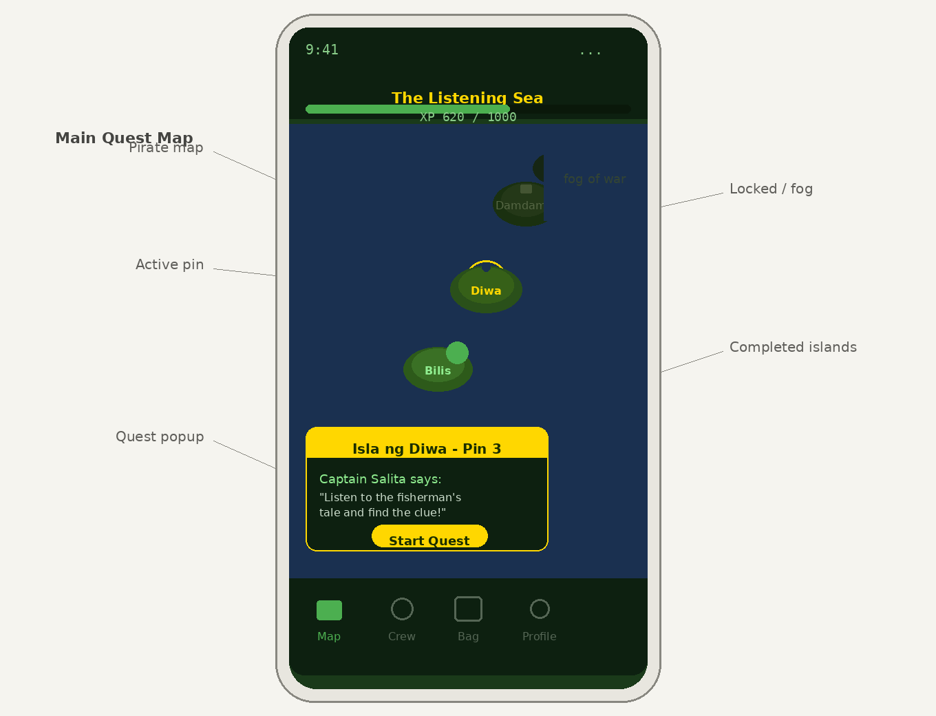

MULTIPLAYER
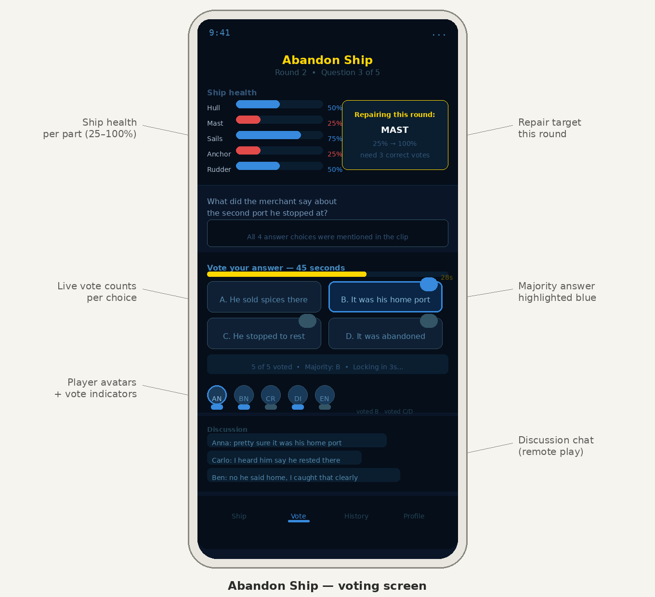

USER FLOW
