READVENTURE
A Story-Based Gamified Reading Application for Grade 7 Learners
Project Proposal

I. Project Overview
Readventure is a story-based gamified reading application designed to help Grade 7 learners improve their decoding, fluency, and comprehension through level-based and mission-based reading tasks. Learners take the role of a Readventurer whose goal is to restore a silent village by completing reading missions.
Each mission is structured to strengthen reading from word recognition to oral reading fluency and finally to text understanding, allowing learners to develop foundational and higher-level reading skills in a guided and engaging environment.

II. Rationale
The application is grounded in the findings of a needs assessment that identified decoding, fluency, and comprehension as priority skill areas among Grade 7 learners. The reading assessment revealed that learners are not at the same level — some are independent readers, some are at the instructional level, some are at the frustration level, and some are classified as non-readers. Readventure responds to this diversity through adaptive difficulty, differentiated mission delivery, and level-based placement.
The app retains the original strengths of the Readventure concept, including the village restoration narrative, Android student application, adaptive difficulty engine, collaborative room, rewards and badges, read-aloud support, progress tracking, and four reading levels. Its instructional focus is now aligned with the remedial reading syllabus.

III. Project Objectives
The application aims to:
- Strengthen Grade 7 learners' decoding skills through structured word-level tasks.
- Improve oral reading fluency through repeated and guided reading activities.
- Develop comprehension skills through meaning-based tasks connected to reading passages.
- Provide adaptive and differentiated reading experiences based on individual learner readiness.
- Promote learner engagement through gamification, narrative, and collaborative features.

IV. Target Users
User Group | Role in the Application
Grade 7 Learners | Primary users; complete reading missions and restore the village through the Android app.

V. App Navigation
The application uses a five-tab bottom navigation bar that persists across all screens. The Home tab is the default entry point after placement and serves as the main game mode selection screen. From there, learners can tap directly into Story Mode or Multiplayer Mode without going through the village map first.

Tab | Label | Function
🏠 | Home | Main screen showing both game modes (Story and Multiplayer) with quick-access buttons and current progress summary.
🗺️ | Story | Goes directly to the Village Map for the single-player Story Mode campaign.
⚔️ | Multi | Opens the Multiplayer Mode hub showing Reading Race and Squad Restore options and recent match history.
📊 | Progress | Opens the Student Dashboard with skill breakdown, mission history, and multiplayer record.
🎖️ | Badges | Shows all earned and locked badges with unlock conditions.

The Home screen displays both game mode cards side by side. The Story Mode card shows the learner's current zone and village restoration progress. The Multiplayer Mode card shows the two sub-modes and links to recent match history. This ensures that both modes are always visible and accessible from the moment the learner opens the app.

VI. Game Modes
Readventure is built around two distinct game modes: Story Mode and Multiplayer Mode. Both modes share the same village world, XP system, badges, and adaptive difficulty engine. Learners access both modes from the Village Map after completing the initial placement activity.

Game Mode | Type | Description
Story Mode | Single Player | The main narrative campaign. Learners restore the silent village by completing zone-based reading missions solo.
Multiplayer Mode | 2–4 Players | A separate competitive and cooperative mode with two sub-modes: Reading Race and Squad Restore.

Game Mode 1: Story Mode (Single Player)
Story Mode is the primary game mode and the core of the Readventure experience. It is a single-player narrative campaign where the learner takes the role of a Readventurer working to restore a silent village. All instructional content, mission sequences, syllabus alignment, and adaptive support are delivered through Story Mode.

1. Placement and Reading Level Assignment
When the learner opens the application, the first step is a short placement activity that identifies the learner's reading level. The purpose of the placement is to determine the amount of support the learner needs in decoding, fluency, and comprehension. Based on the result, the learner is assigned to one of four reading levels.

Level | Reading Level
Level 1 | Non-Reader
Level 2 | Beginning Reader
Level 3 | Developing Reader
Level 4 | Fluent Reader

2. Village Map as the Main Progress Screen
After placement, the learner enters the Village Map, which serves as the main game screen. The village is divided into zones, and each zone contains a set of reading missions. Learners may progress through missions based on readiness and completed tasks. The village gradually restores as the learner completes reading tasks successfully.
3. Mission Structure
Each mission follows the same three-part reading sequence:

Mission Part | Focus Area | Key Tasks
Part A | Decoding | Identifying vowel sounds and consonant clusters; applying syllabication; decoding unfamiliar and multisyllabic words; practicing correct pronunciation.
Part B | Fluency | Reading phrases or short passages; observing punctuation marks; applying proper pauses and phrasing; improving smoothness through guided or repeated reading.
Part C | Comprehension | Identifying the main idea; locating supporting details; arranging events in sequence; answering literal and simple inferential questions.

This mission flow reflects the learning relationship in the syllabus: learners first decode words accurately, then read more smoothly, and then understand the text more effectively.
4. Adaptive Difficulty per Learner
The Adaptive Difficulty Engine is a core component of the application. All learners may work within the same village world, but each learner receives a version of the task suited to their reading level. The app adjusts the difficulty and support according to the learner's progress. This makes the syllabus more implementable because the syllabus provides the reading content while the app provides the differentiated delivery.
5. Reading Task Screen
The Reading Task Screen is the core instructional screen in the application. It presents:
- The word or text to be read
- Interactive support for difficult words
- Audio or read-aloud assistance
- Comprehension questions connected to the same text
This is where the learner completes each mission in sequence: decoding, fluency, and comprehension.
6. Word Support Features
The app includes Word Spark and Village Wordbook as support tools for both decoding and comprehension. When a learner encounters a difficult word, the app may provide pronunciation audio, visual support, a simple meaning, and sentence context.
7. Collaborative Room
In group missions, learners work at the same time but on their own level-appropriate tasks. All members must complete their own mission parts before the shared village updates. This preserves the collaborative and accountability-based feature of the original concept while still respecting different reading levels.
8. Support for Struggling Learners
When a learner struggles with a task, the app activates its support system: after repeated incorrect attempts, the learner receives a simpler version with more hints and audio support; when a learner becomes inactive, the app gives a gentle prompt. This is especially important for learners at the frustration and non-reader levels who need more foundational support.
9. Culminating In-App Performance
The culminating mission serves as the digital version of the Integrated Oral Reading Assessment. In this final mission, the learner decodes selected unfamiliar and multisyllabic words, reads a short passage orally with fluency support, answers comprehension questions based on the same passage, and restores a major part of the village as a final achievement.

VII. Student Dashboard
The Student Dashboard is a dedicated section within the Android app that gives learners a personal view of their own progress, skills, and multiplayer record. It is accessible at any time from the bottom navigation bar under the Progress tab. The dashboard is entirely student-facing — there is no external access. All data displayed is generated from the learner's own mission activity and performance.

1. Overview Tab
The Overview tab is the main dashboard screen. It displays:
- Learner name, current reading level, and XP progress bar toward the next level.
- Three summary stat cards showing total missions completed, current daily streak, and total badges earned.
- Skill breakdown bars showing individual percentage scores for Decoding, Fluency, and Comprehension.
- Village restoration progress bar with zone status indicators.
- Recent activity feed showing the last three mission or multiplayer results with XP earned.

2. Skill Detail Tab
The Skill Detail tab provides a deeper breakdown of the learner's performance across all three reading skill areas:
- Each skill area (Decoding, Fluency, Comprehension) has its own card with a progress bar, a percentage score, and a rating label such as Good, Fair, or Developing.
- Each card lists the specific sub-skills within that area and marks them as passed or still developing, for example: vowel sounds passed, consonant clusters still developing.
- The adaptive engine uses this data to flag the learner's weakest sub-skills and prioritize them in upcoming missions.
- A full mission history log shows every mission attempt with its result — Passed, Retried, or In Progress.

3. Multiplayer Stats Tab
The Multiplayer Stats tab tracks the learner's full competitive and cooperative record:
- Summary cards for total races played, races won, and squad missions completed.
- Reading Race history listing each match, placement, opponents, finish time, and XP earned.
- Squad Restore history listing each squad mission, the learner's assigned role, outcome, and XP earned.
- A personalized insight card generated from the learner's multiplayer data, for example identifying which mission part they finish fastest and which is slowing them down in races.

Dashboard Tab | Key Information Displayed
Overview | Level, XP progress, stat cards, skill bars, village progress, recent activity
Skill Detail | Per-skill progress, sub-skill status, adaptive focus flags, mission history log
Multiplayer Stats | Race record, squad record, role history, XP earned, personalized insight
Badges | All earned and locked badges with unlock conditions

VIII. Multiplayer Game Mode
Game Mode 2: Multiplayer Mode
Multiplayer Mode is a separate game mode accessible from the Village Map. It does not replace Story Mode — learners must still complete solo missions to progress through zones and restore the village. Multiplayer Mode serves as an additional engagement layer that reinforces the same reading skills through real-time social play. All XP, badges, and village restoration earned in Multiplayer Mode carry over to the main game.

Readventure includes a dedicated Multiplayer Mode that operates as a separate game mode from the solo mission path. Multiplayer missions are accessible from the Village Map and contribute XP, badges, and village restoration progress to the same main game. The mode features two distinct sub-modes: Reading Race and Squad Restore.

Sub-mode 1: Reading Race (Competitive)
Reading Race is a competitive real-time mode where two to four players race through the same mission simultaneously. Each player receives their own adaptive version of the mission, ensuring the race remains fair across reading levels. All players must complete Part A, Part B, and Part C in sequence. The first player to correctly finish all three parts wins and earns the highest XP reward. Incorrect answers trigger a hint and retry without a time penalty, but are flagged on the leaderboard. Live progress bars allow each learner to see how rivals are progressing in real time.

Reading Race | Details
Players | 2 to 4 players per match
Mission | Same mission for all; adaptive version per reading level
Structure | Part A then Part B then Part C in sequence; all parts required
Win condition | First to correctly complete all three parts
Wrong answers | Hint and retry triggered; no time penalty but flagged on leaderboard
XP reward | Scaled by placement: 1st = 30 XP, 2nd = 20 XP, 3rd = 10 XP

Sub-mode 2: Squad Restore (Cooperative)
Squad Restore is a cooperative mode for exactly three players. Instead of competing, the squad divides the mission by part: one player handles Part A (Decoding), one handles Part B (Fluency), and one handles Part C (Comprehension). Roles are assigned based on each learner's current skill gaps. All three players work simultaneously, but there is a dependency chain: Part B unlocks only after Part A is passed, and Part C unlocks only after Part B is passed. If a player fails their part, they receive a simplified version with additional hints and must retry. The village section is restored only when all three players complete their assigned parts correctly. XP is shared equally across the squad.

Squad Restore | Details
Players | Exactly 3 players per squad
Roles | Player A = Decoding · Player B = Fluency · Player C = Comprehension
Role assignment | Based on each learner's current skill gaps identified by the adaptive engine
Dependency chain | B unlocks after A passes; C unlocks after B passes
Fail condition | Failed part triggers simplified retry with hints; squad waits
Win condition | All 3 parts completed correctly by all 3 players
XP reward | Equal XP shared across all squad members

Shared Multiplayer Features
Both multiplayer sub-modes share the following features:
- Lobby system with room codes for inviting classmates or auto-matching.
- Adaptive difficulty — every player receives a version of the mission suited to their reading level.
- Real-time squad progress visibility so learners are aware of their team's status.
- Post-game results screen showing XP earned, village progress, and option to rematch or return to the village map.
- All multiplayer XP and village restoration progress feeds back into the main solo game.

IX. Alignment with the Remedial Reading Syllabus
The application directly supports all finalized learning episodes in the remedial reading syllabus.

Week | Learning Episode | App Feature / Mission Part
1 | Sound and Pattern Recognition for Decoding | Mission Part A – Decoding (vowel sounds, consonant clusters, sound patterns)
2 | Syllabication and Word Attack Skills | Mission Part A – Decoding (syllable parts, multisyllabic word breaking)
3–4 | Oral Reading Accuracy | Mission Part A & B – Decoding and Fluency (accurate and smooth reading)
5 | Guided and Repeated Reading for Fluency | Mission Part B – Fluency (pacing, phrasing, smooth and confident reading)
6 | Vocabulary Support and Main Idea Development | Mission Part C – Comprehension + Word Spark & Village Wordbook features
7 | Sequencing and Guided Comprehension Response | Mission Part C – Comprehension (sequencing, literal and inferential questions)
Final | Integrated Oral Reading Assessment | Culminating In-App Performance Mission

X. Key Application Features
Feature | Description
Village Restoration Narrative | Story-driven gameplay where learners restore a silent village by completing reading missions.
Android Student Application | Mobile app accessible to Grade 7 learners on Android devices.
Four Reading Levels | Placement-based system assigning learners to Non-Reader, Beginning, Developing, or Fluent Reader levels.
Adaptive Difficulty Engine | Automatically adjusts task difficulty and support based on learner performance and progress.
Three-Part Mission Structure | Every mission follows Part A (Decoding), Part B (Fluency), and Part C (Comprehension).
Word Spark & Village Wordbook | In-app vocabulary tools providing pronunciation audio, visual support, simple meanings, and sentence context.
Read-Aloud Support | Audio assistance integrated into the reading task screen to support learners with difficult words or passages.
Collaborative Room | Group missions where learners work on level-appropriate tasks simultaneously.
Multiplayer — Reading Race | Competitive real-time mode where 2–4 players race through the same mission, each with their own adaptive version.
Multiplayer — Squad Restore | Cooperative mode for 3 players, each owning one mission part (Decoding, Fluency, or Comprehension) with a dependency chain.
Rewards and Badges | Gamified recognition system to motivate learners and celebrate reading milestones.
Progress Tracking | In-app learner progress indicators tracking decoding, fluency, and comprehension performance.
Struggling Learner Support | Simplified task versions with additional hints and audio support for learners who need more foundational assistance.
Student Dashboard | In-app personal progress view showing skill scores, XP, village progress, mission history, and multiplayer record.

XI. Platform and Technical Specifications
Component | Details
Student Platform | Android Mobile Application
Target Device | Android smartphones and tablets
Connectivity | Online for mission sync; offline mode available for core reading tasks
Audio Support | Integrated text-to-speech and pre-recorded pronunciation audio
Adaptive Engine | Rule-based difficulty adjustment with learner performance tracking
Multiplayer | Real-time room-based play; requires active internet connection

XII. Expected Outcomes
Upon completion of the application and the reading program, learners are expected to:
- Demonstrate improved accuracy in decoding unfamiliar and multisyllabic words.
- Show measurable improvement in oral reading fluency in terms of pacing, phrasing, and smoothness.
- Correctly identify main ideas, supporting details, and sequence of events from reading passages.
- Answer both literal and simple inferential comprehension questions with greater accuracy.
- Progress from their initial reading level toward the next level based on mission completion and assessment results.

XIII. Conclusion
Readventure is a student-centered, syllabus-aligned reading application that makes remedial reading instruction more engaging, adaptive, and accessible. By combining a compelling village restoration narrative with a structured three-part mission system, the application supports Grade 7 learners in building the foundational reading skills they need to become more accurate, fluent, and competent readers.
The application serves as a differentiated delivery tool that brings the remedial reading program to life in a format that is responsive to the varied needs and reading levels of Grade 7 learners.

MOCKUPS AND DIAGRAMS
Screens 1–3: Onboarding → Placement → Level Assignment.
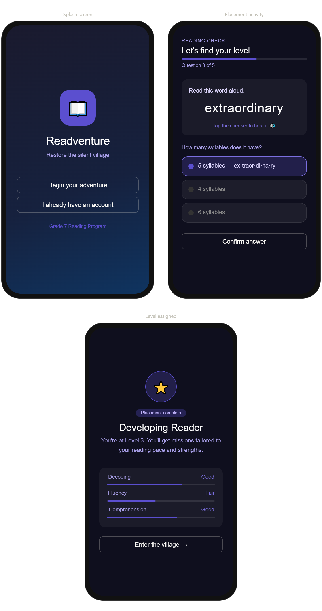

Screens 4–6: Village Map → Mission Select → Reading Task
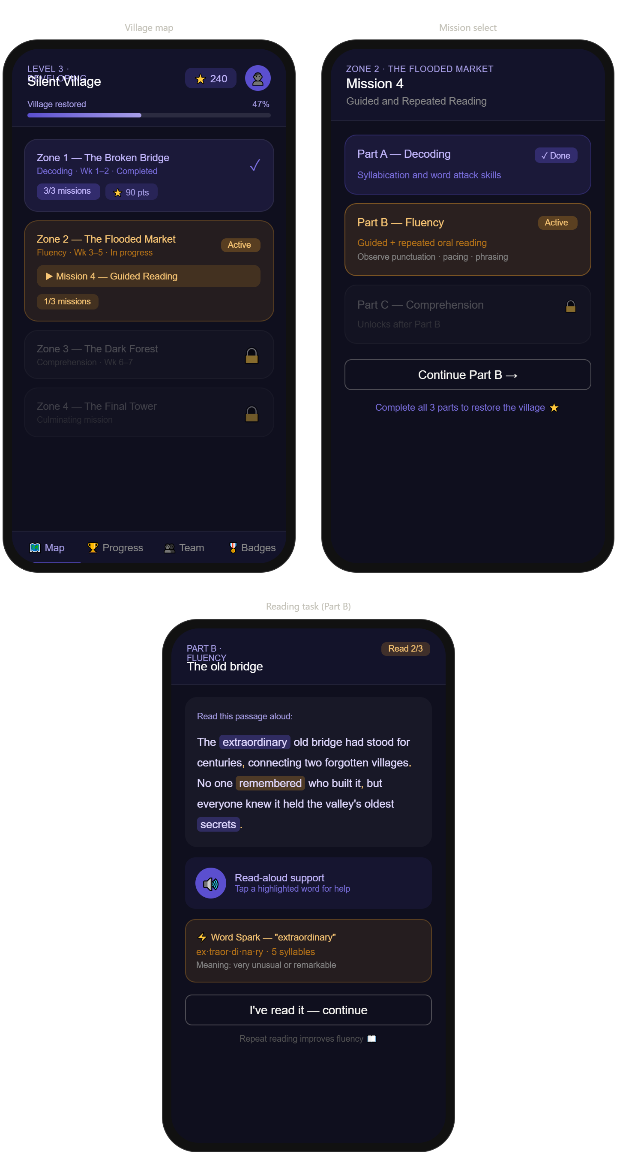

PROGRESS VIEW
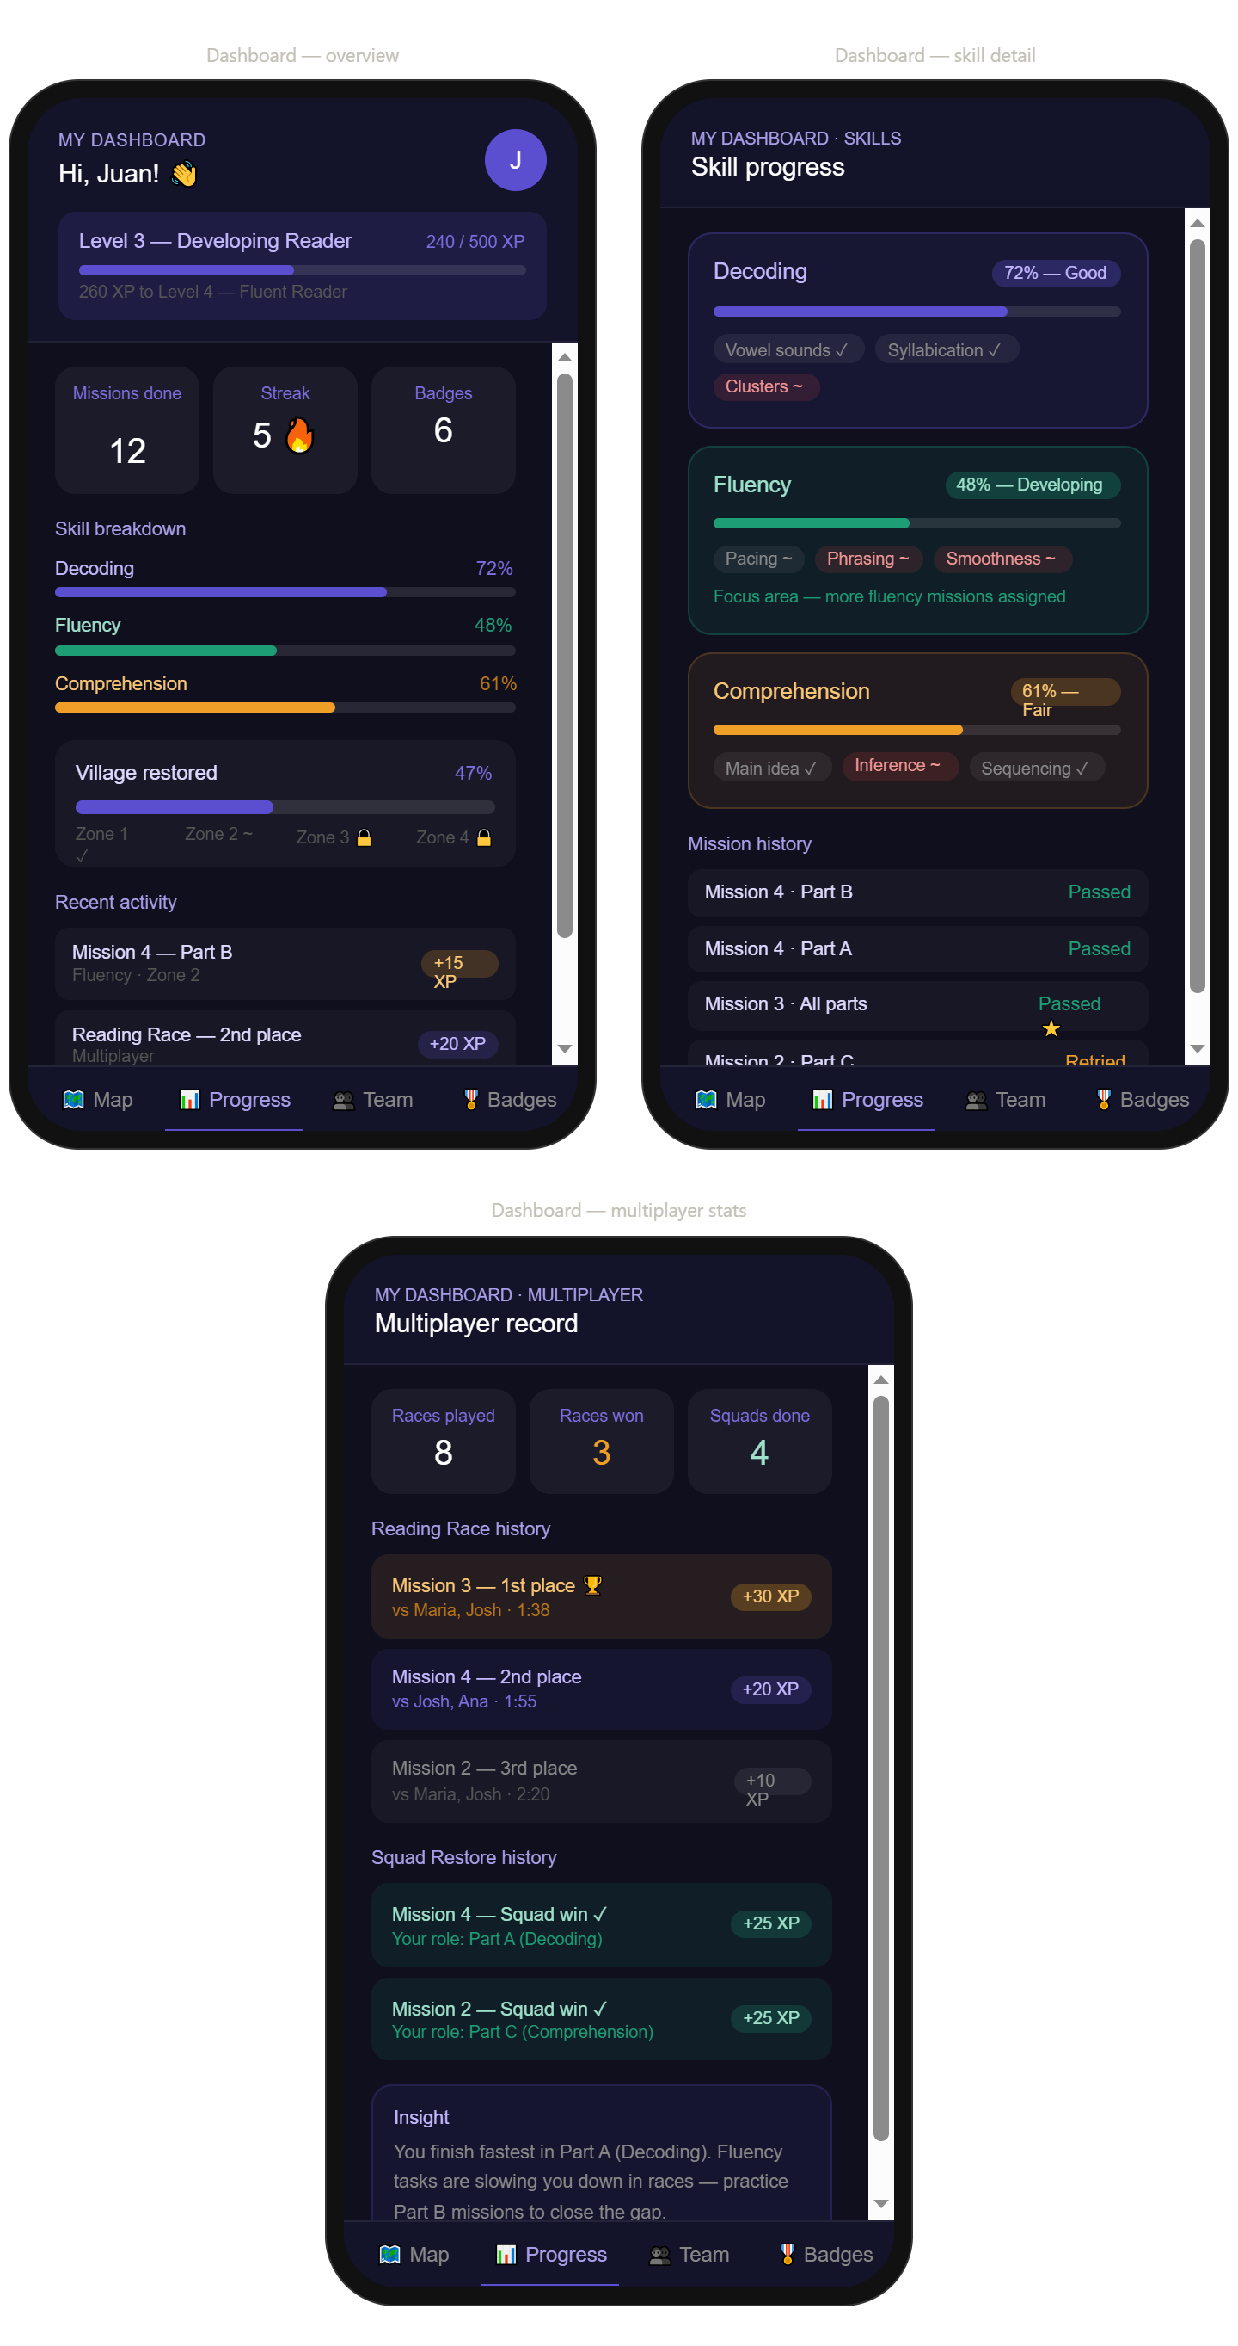

Multiplayer Mode
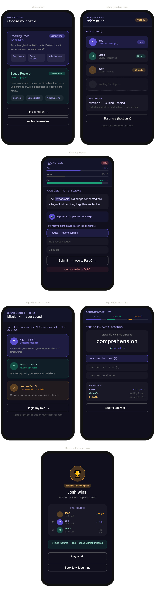

USER FLOW
