Intrusion Detection System
A Hybrid IDS with SIEM-Style Dashboard for Network Threat Detection and Analysis

Project Report
Submitted in partial fulfilment of the requirements for the B.Tech CSE

Department of Emerging Technology (ET)
CEC-CGC Landran
2026

Developed By
Sumit Kumar
2337896

Table of Contents
Sr. no | Context | Page
1 | Introduction
2 | Background and Fundamentals
3 | System Architecture
4 | Literature Survey
5 | Detection Methodology
6 | Packet Capture and Traffic Analysis
7 | Alert Generation and Incident Handling
8 | SIEM Dashboard Design
9 | MITRE ATT&CK Framework Integration
10 | Real-Time Communication
11 | Implementation Details
12 | Cross-Platform Compatibility
13 | Results and Analysis
14 | Security Considerations
15 | Advantages and Uniqueness of the System
16 | Limitations
17 | Future Enhancements
18 | Applications of the System
19 | Conclusion
20 | References
21 | Appendix

Abstract
Intrusion Detection Systems (IDS) play a critical role in modern cybersecurity by monitoring network traffic and identifying malicious activities. With the rapid growth of network-based attacks, traditional security mechanisms such as firewalls are no longer sufficient on their own. This project presents the design and implementation of a Hybrid Intrusion Detection System with a SIEM-style Dashboard that combines signature-based detection and anomaly-based analysis to detect network intrusions effectively.
The proposed system supports offline PCAP analysis on Windows and real-time live packet capture on Linux, ensuring cross-platform compatibility. Network packets are captured and analyzed using Scapy, processed through a detection engine, and correlated into alerts. Detected threats are mapped to the MITRE ATT&CK framework to provide contextual understanding of attacks, including tactics, techniques, and recommended mitigations.
A modern, web-based dashboard built using HTML, Tailwind CSS, JavaScript, and ECharts visualizes alerts, severity levels, traffic trends, incidents, and attack chains in real time. The backend API and WebSocket services are implemented using FastAPI, enabling low-latency alert delivery and scalable communication.
The system aims to provide a practical, educational, and extensible IDS platform suitable for learning, research, and future enhancements in network security monitoring.

1. Introduction
1.1 Overview of Intrusion Detection Systems (IDS)
With the rapid growth of computer networks and internet-based services, securing network infrastructure has become a critical challenge. Modern networks face a wide range of cyber threats such as port scanning, denial-of-service attacks, unauthorized access attempts, and abnormal traffic behaviour. Traditional security mechanisms like firewalls and access control lists are not sufficient to detect all forms of malicious activity, especially sophisticated or unknown attacks.
An Intrusion Detection System (IDS) is a security mechanism designed to monitor network traffic or system activities in order to detect suspicious behaviour, policy violations, or potential cyber-attacks. Unlike firewalls, which primarily prevent unauthorized access, an IDS focuses on detecting intrusions that bypass preventive controls. IDS solutions analyze network packets, traffic patterns, and system behaviour to identify attacks in real time or through offline analysis.
IDS systems play a crucial role in modern cybersecurity by acting as an early warning mechanism, enabling administrators and security analysts to respond to threats before they cause significant damage.
1.2 Need for Intrusion Detection Systems
The increasing complexity of cyber-attacks has made it difficult for organizations to rely solely on perimeter-based security. Attackers often exploit legitimate network behaviour, making malicious traffic difficult to distinguish from normal traffic. Some key reasons for the need of IDS include:
- Continuous monitoring of network traffic
- Detection of attacks that bypass firewalls
- Identification of insider threats
- Early detection of abnormal or suspicious behaviour
- Support for incident response and forensic analysis
In academic environments, enterprises, and security operation centers (SOC), IDS systems are essential for understanding network behaviour and improving overall security posture.
1.3 Types of Intrusion Detection Systems
Intrusion Detection Systems are generally classified based on their detection methodology:
- Signature-Based IDS
Detects attacks by matching network traffic against predefined patterns or signatures of known attacks. This method is highly effective for known threats but cannot detect new or unknown attacks.
- Anomaly-Based IDS
Detects intrusions by identifying deviations from normal network behaviour. This approach can detect zero-day or unknown attacks but may generate false positives.
Modern IDS solutions increasingly adopt a hybrid approach, combining both signature-based and anomaly-based techniques to improve detection accuracy.
1.4 Motivation for the Project
Despite the availability of commercial IDS and SIEM solutions, many of them are complex, expensive, and difficult to understand for students and beginners in cybersecurity. There is a need for a system that:
- Clearly demonstrates how IDS works internally
- Supports both offline and real-time analysis
- Provides meaningful visualizations for detected threats
- Integrates industry-standard frameworks like MITRE ATT&CK
- Is modular, extensible, and suitable for academic research
This project was motivated by the goal of building a practical, educational, and scalable Intrusion Detection System that bridges the gap between theoretical IDS concepts and real-world security monitoring systems.
1.5 Objectives of the Project
The main objectives of this project are:
- To design and implement a hybrid Intrusion Detection System
- To analyze network traffic using both PCAP files and live packet capture
- To detect malicious activities using signature-based and anomaly-based methods
- To generate structured alerts with severity classification
- To visualize detected threats through a SIEM-style interactive dashboard
- To map detected attacks to the MITRE ATT&CK framework
1.6 Scope of the Project
The scope of this project includes:
- Network traffic analysis at the packet level
- Offline analysis of PCAP files captured using tools like Wireshark
- Real-time packet capture in Linux environments
- Detection of common network attacks such as scanning and denial-of-service patterns
- Alert generation and incident correlation
- Real-time visualization using a web-based dashboard
The project focuses on detection and monitoring, not automated attack prevention. It is designed primarily for educational, research, and analytical purposes, making it suitable for academic demonstration and further enhancement.

2. Background and Fundamentals
2.1 Network Security Overview
Network security refers to the set of policies, practices, and technologies designed to protect network infrastructure, data, and services from unauthorized access, misuse, modification, or disruption. As modern networks handle sensitive data and critical services, they have become prime targets for cyber attackers.
Network security involves multiple layers of defense, including firewalls, access control mechanisms, encryption, monitoring tools, and intrusion detection systems. Each layer addresses specific security challenges, but no single mechanism can provide complete protection on its own.
In real-world environments, attacks often appear as normal traffic at the packet level. Therefore, monitoring and analyzing traffic behaviour is essential for identifying malicious activities that evade traditional defences.
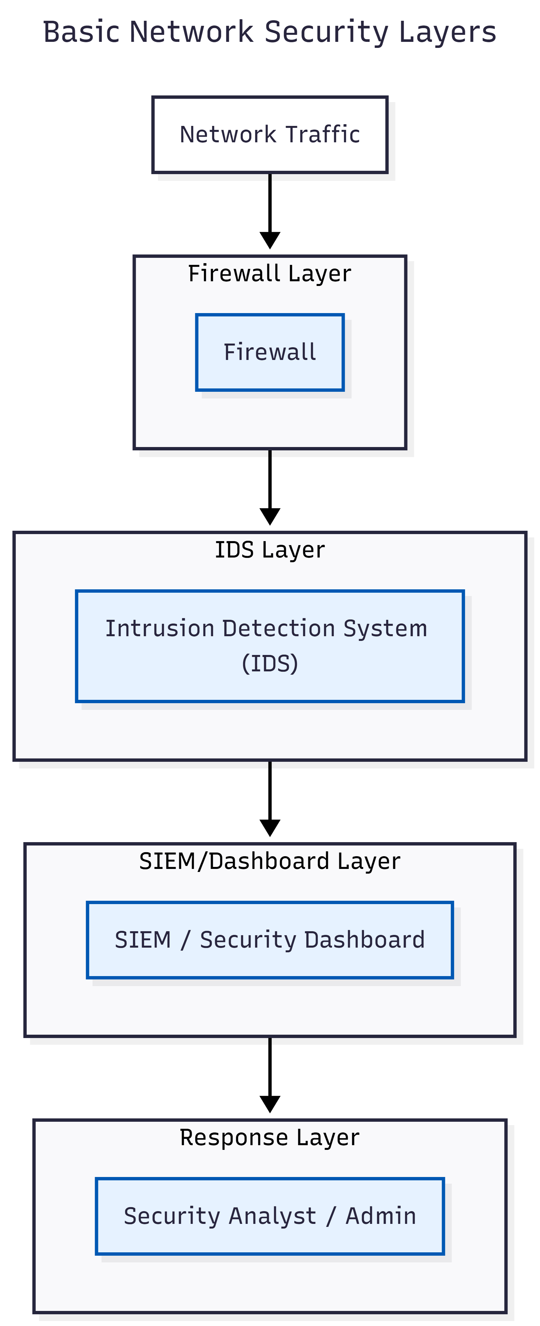
2.2 Common Cyber-attacks in Networks
Modern cyber-attacks target both network services and system resources. Some common attacks relevant to this project include:
- Port Scanning:
Attackers scan multiple ports on a target system to discover open services that can be exploited.
- Denial of Service (DoS):
Attackers flood a target with excessive traffic, exhausting system or network resources and disrupting availability.
- Suspicious Traffic Patterns:
Abnormally high packet rates, unusual packet sizes, or unexpected protocol usage may indicate malicious intent.
These attack types often leave identifiable patterns in network traffic, making them suitable for detection using packet-level analysis.
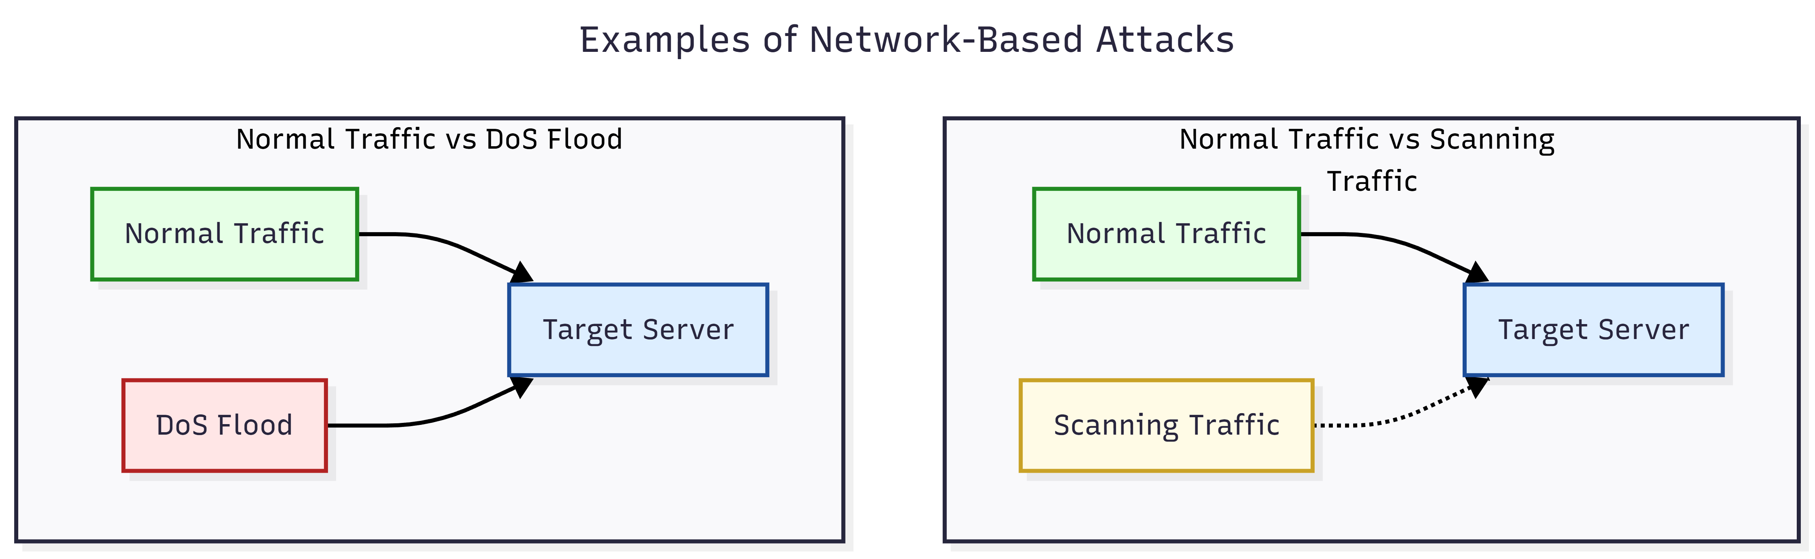
2.3 Need for Intrusion Detection Beyond Firewalls
Firewalls are designed to allow or block traffic based on predefined rules such as IP addresses, ports, and protocols. While effective as a first line of defense, firewalls have several limitations:
- They cannot detect attacks using allowed ports
- They do not analyze traffic behaviour deeply
- They cannot identify unknown or zero-day attacks
- They lack visibility into traffic patterns over time
Intrusion Detection Systems complement firewalls by continuously monitoring network traffic and analyzing behaviour to detect suspicious or malicious activities. IDS systems provide visibility, alerts, and insights that are critical for effective security monitoring.

2.4 Signature-Based Intrusion Detection
Signature-based intrusion detection works by comparing observed network traffic against a database of known attack patterns or signatures. Each signature represents a specific attack behaviour.
Advantages:
- High accuracy for known attacks
- Low false-positive rate
- Easy to understand and implement
Limitations:
- Cannot detect unknown or zero-day attacks
- Requires regular signature updates
In this project, signature-based detection is used to identify known attack behaviours such as scanning patterns and traffic floods using predefined rules.
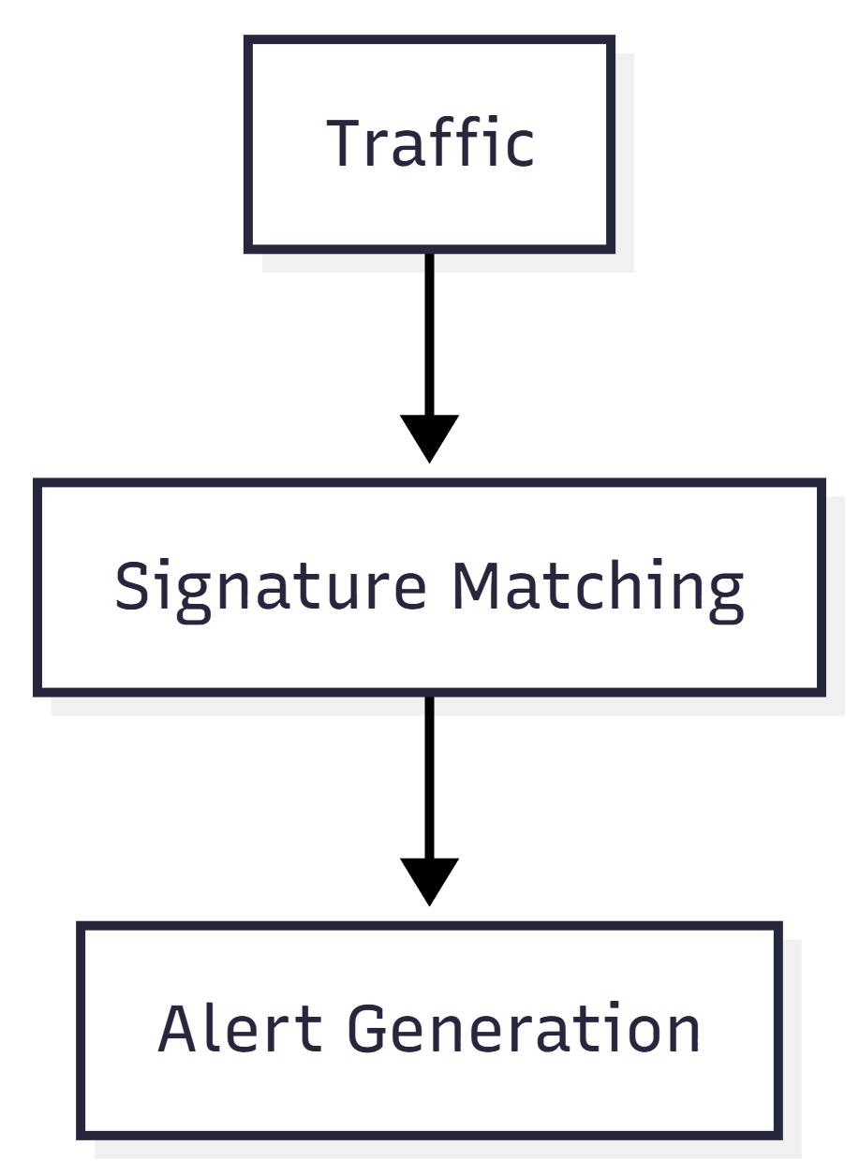
2.5 Anomaly-Based Intrusion Detection
Anomaly-based intrusion detection identifies intrusions by detecting deviations from normal network behaviour. Instead of relying on known signatures, it builds a model of expected traffic patterns and flags abnormal behaviour.
Advantages:
- Can detect unknown attacks
- Effective against novel or evolving threats
Limitations:
- May generate false positives
- Requires careful tuning of thresholds or models
In this project, anomaly-based detection complements signature-based detection by identifying unusual traffic patterns such as abnormal packet rates or unexpected traffic behaviour.
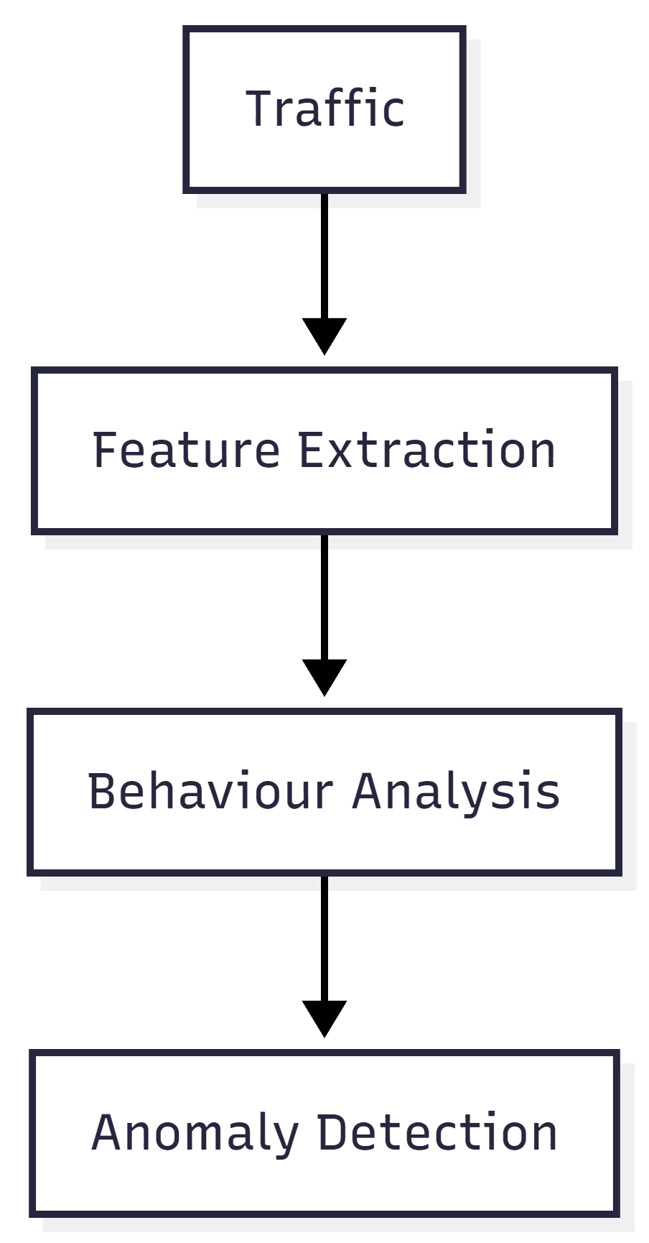
2.6 Hybrid Intrusion Detection Approach
Relying on a single detection technique can result in missed attacks or excessive false alerts. To overcome these limitations, modern IDS solutions adopt a hybrid detection approach that combines both signature-based and anomaly-based methods.
The hybrid approach offers:
- Accurate detection of known attacks
- Ability to identify unknown threats
- Improved reliability and reduced false positives
This project implements a hybrid IDS architecture where both detection methods operate together to analyze traffic and generate alerts.
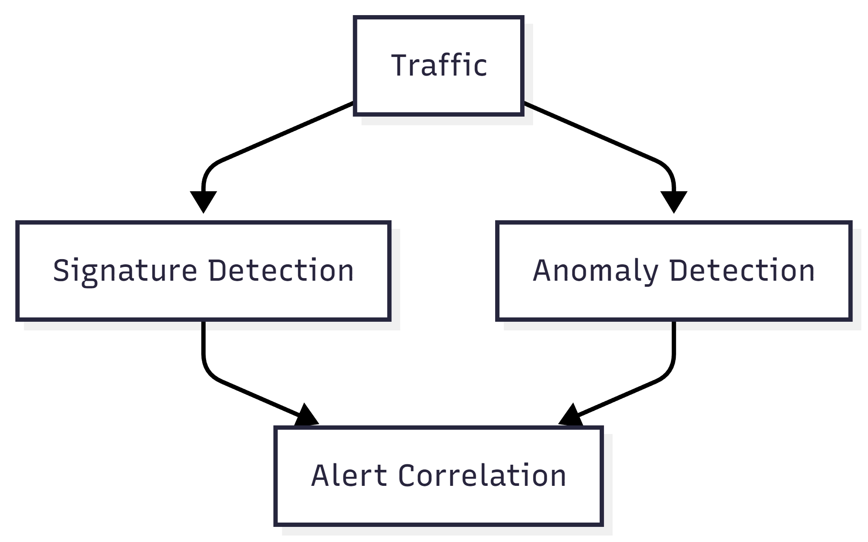
2.7 Role of SIEM in Modern Security Monitoring
A Security Information and Event Management (SIEM) system collects, analyzes, and visualizes security alerts generated by different monitoring tools. SIEM dashboards help security analysts understand the security posture of a network in real time.
Key functions of a SIEM system include:
- Centralized alert visualization
- Severity classification
- Incident correlation
- Historical analysis
- Threat intelligence integration
In this project, a SIEM-style dashboard is implemented to display alerts, trends, incidents, and MITRE ATT&CK mappings in an interactive and user-friendly manner.
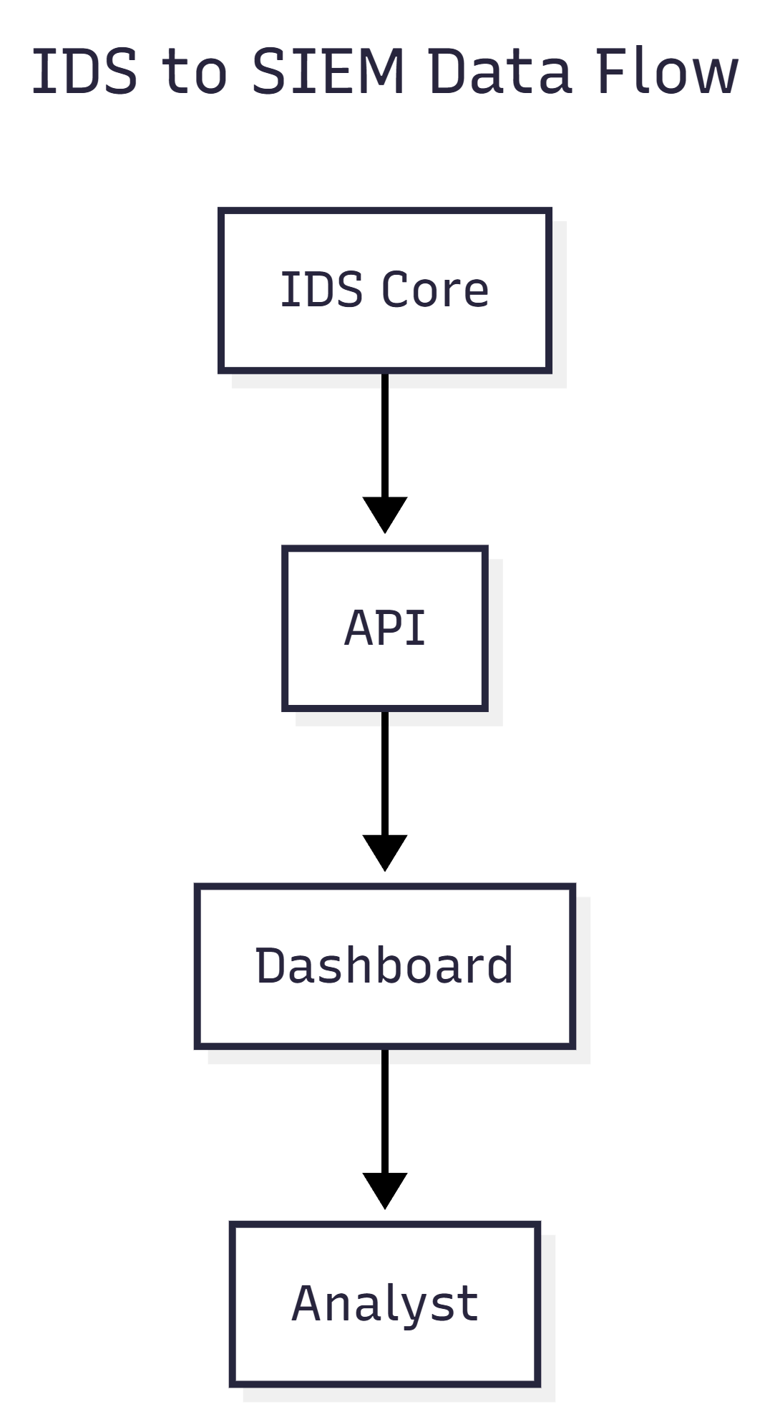
3. Literature Survey
A literature survey is an essential part of any research-oriented project, as it provides an understanding of existing systems, techniques, and research work related to the problem domain. This section reviews prior work on Intrusion Detection Systems (IDS), highlighting commonly used approaches, their advantages, limitations, and the research gaps that motivated the development of this project.
3.1 Traditional Intrusion Detection Systems
Early IDS implementations primarily relied on rule-based mechanisms and static pattern matching. These systems were designed to detect well-known attack signatures by comparing incoming network traffic against predefined rules.
Such systems were effective in controlled environments but struggled with evolving attack techniques. As networks grew in size and complexity, traditional IDS solutions faced challenges in scalability, adaptability, and detection accuracy.
3.2 Signature-Based Intrusion Detection Systems
Signature-based IDS is one of the most widely used detection approaches in both academic research and commercial security products. Well-known tools such as Snort and Suricata rely heavily on signature-based detection.
Key characteristics:
- Uses predefined attack signatures
- Detects known attack patterns efficiently
- Low false-positive rate
Limitations identified in literature:
- Inability to detect zero-day attacks
- Requires continuous signature updates
- Limited adaptability to new attack behaviours
Research indicates that while signature-based IDS is reliable for known threats, it is insufficient as a standalone solution in modern threat environments.
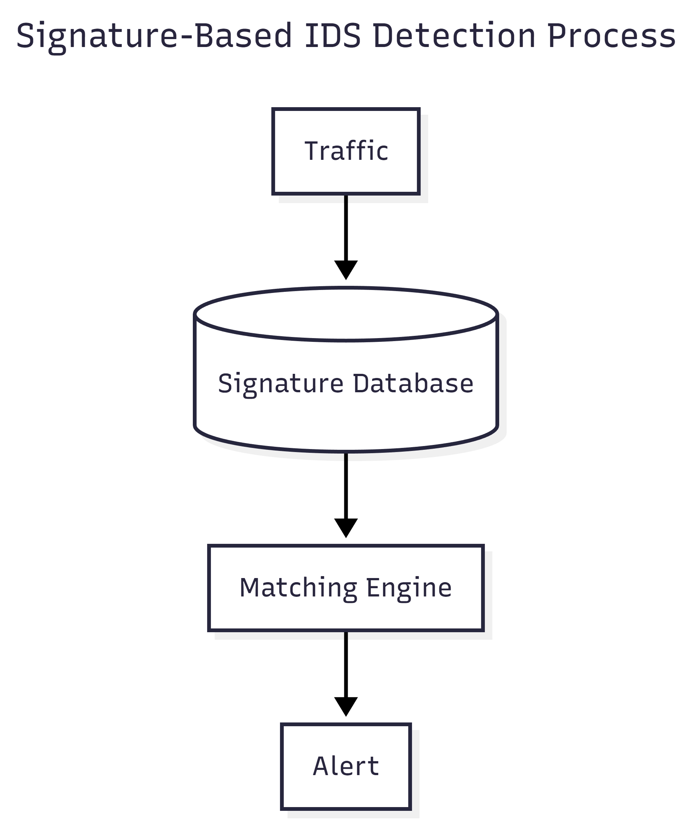
3.3 Anomaly-Based Intrusion Detection Systems
Anomaly-based IDS focuses on identifying deviations from normal behaviour rather than matching known patterns. These systems typically rely on statistical models or machine learning techniques to learn baseline network behaviour.
Advantages highlighted in research:
- Ability to detect unknown and zero-day attacks
- Adaptive to changing network conditions
Challenges identified:
- Higher false-positive rates
- Requirement for training data
- Complexity in tuning detection thresholds
Studies suggest that anomaly-based IDS is powerful but must be carefully designed to avoid alert fatigue caused by excessive false alarms.
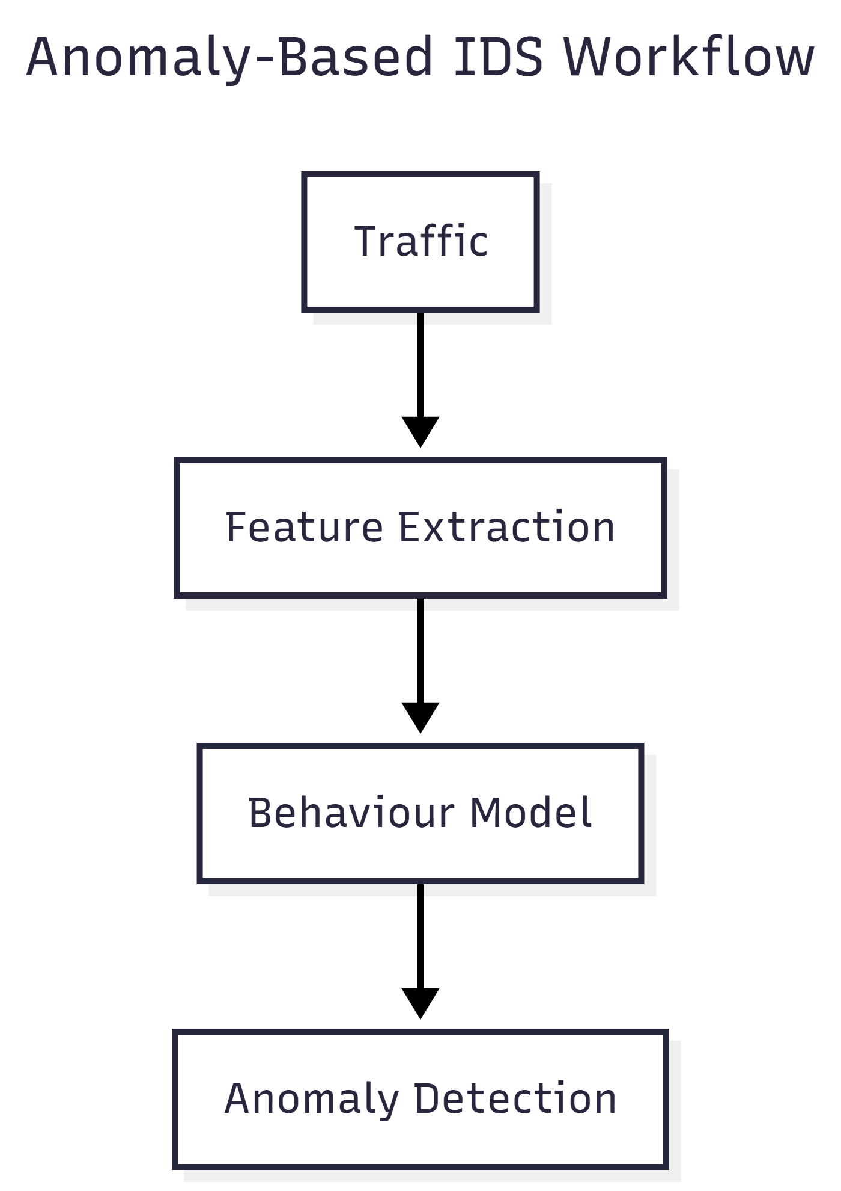
3.4 Hybrid Intrusion Detection Systems
Recent research emphasizes the effectiveness of hybrid IDS architectures that combine both signature-based and anomaly-based techniques. Hybrid systems aim to leverage the strengths of both approaches while mitigating their individual limitations.
Benefits discussed in literature:
- Improved detection accuracy
- Balanced false-positive and false-negative rates
- Better adaptability to evolving threats
Hybrid IDS models are increasingly adopted in modern security frameworks, especially in enterprise and SOC environments.
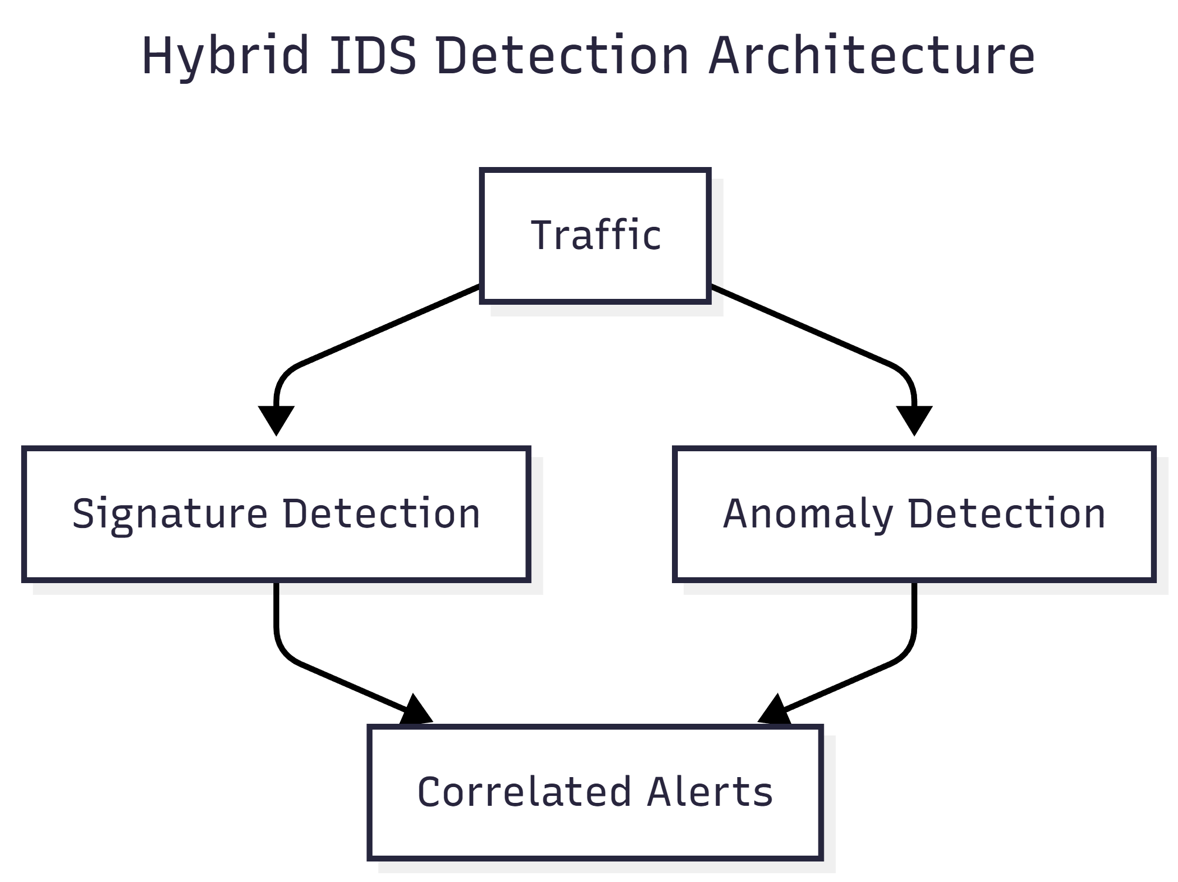
3.5 SIEM and Security Visualization Platforms
Security Information and Event Management (SIEM) systems aggregate alerts from multiple security tools and present them through centralized dashboards. Research highlights the importance of visualization in security monitoring, as it improves situational awareness and reduces response time.
Key features of SIEM platforms identified in literature include:
- Centralized alert management
- Real-time visualization
- Incident correlation
- Historical analysis
However, many commercial SIEM solutions are complex and expensive, limiting their accessibility for educational and research purposes.
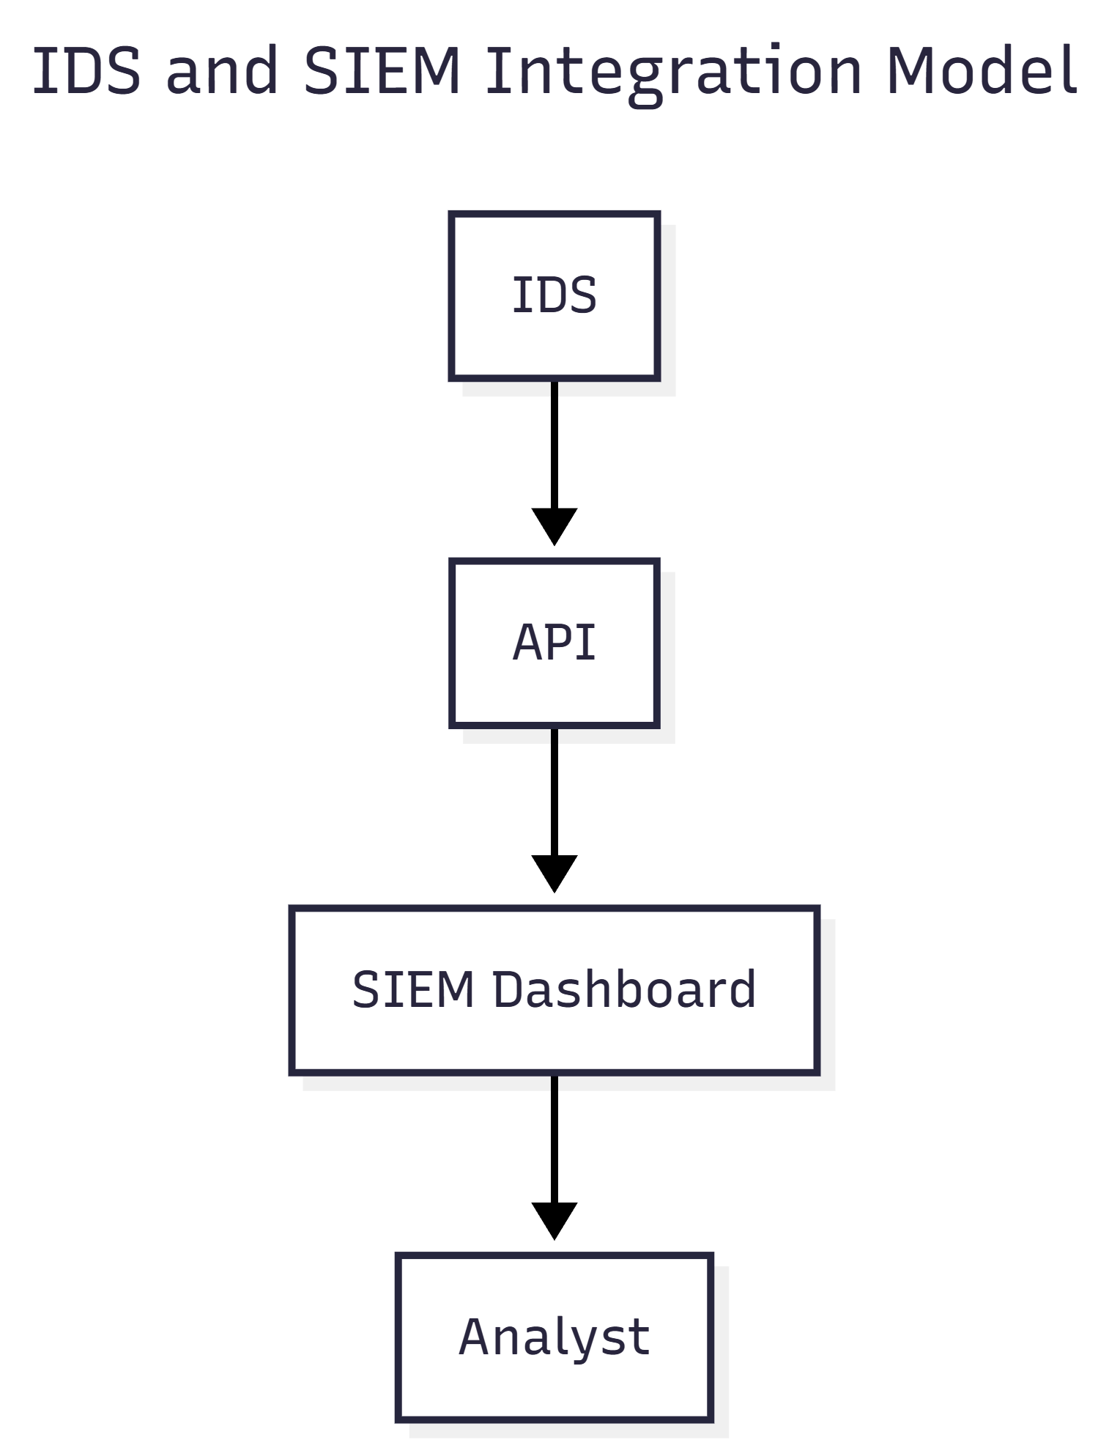
3.6 MITRE ATT&CK Framework in IDS Research
The MITRE ATT&CK framework has become a standard reference model in cybersecurity research for classifying adversary behaviour. Recent studies emphasize integrating MITRE ATT&CK into IDS and SIEM systems to improve attack context and understanding.
Research findings show that:
- MITRE mapping enhances alert interpretability
- It helps analysts understand attacker intent
- It supports structured mitigation planning
This integration is particularly valuable in educational IDS systems, where learning attacker behaviour is as important as detection itself.
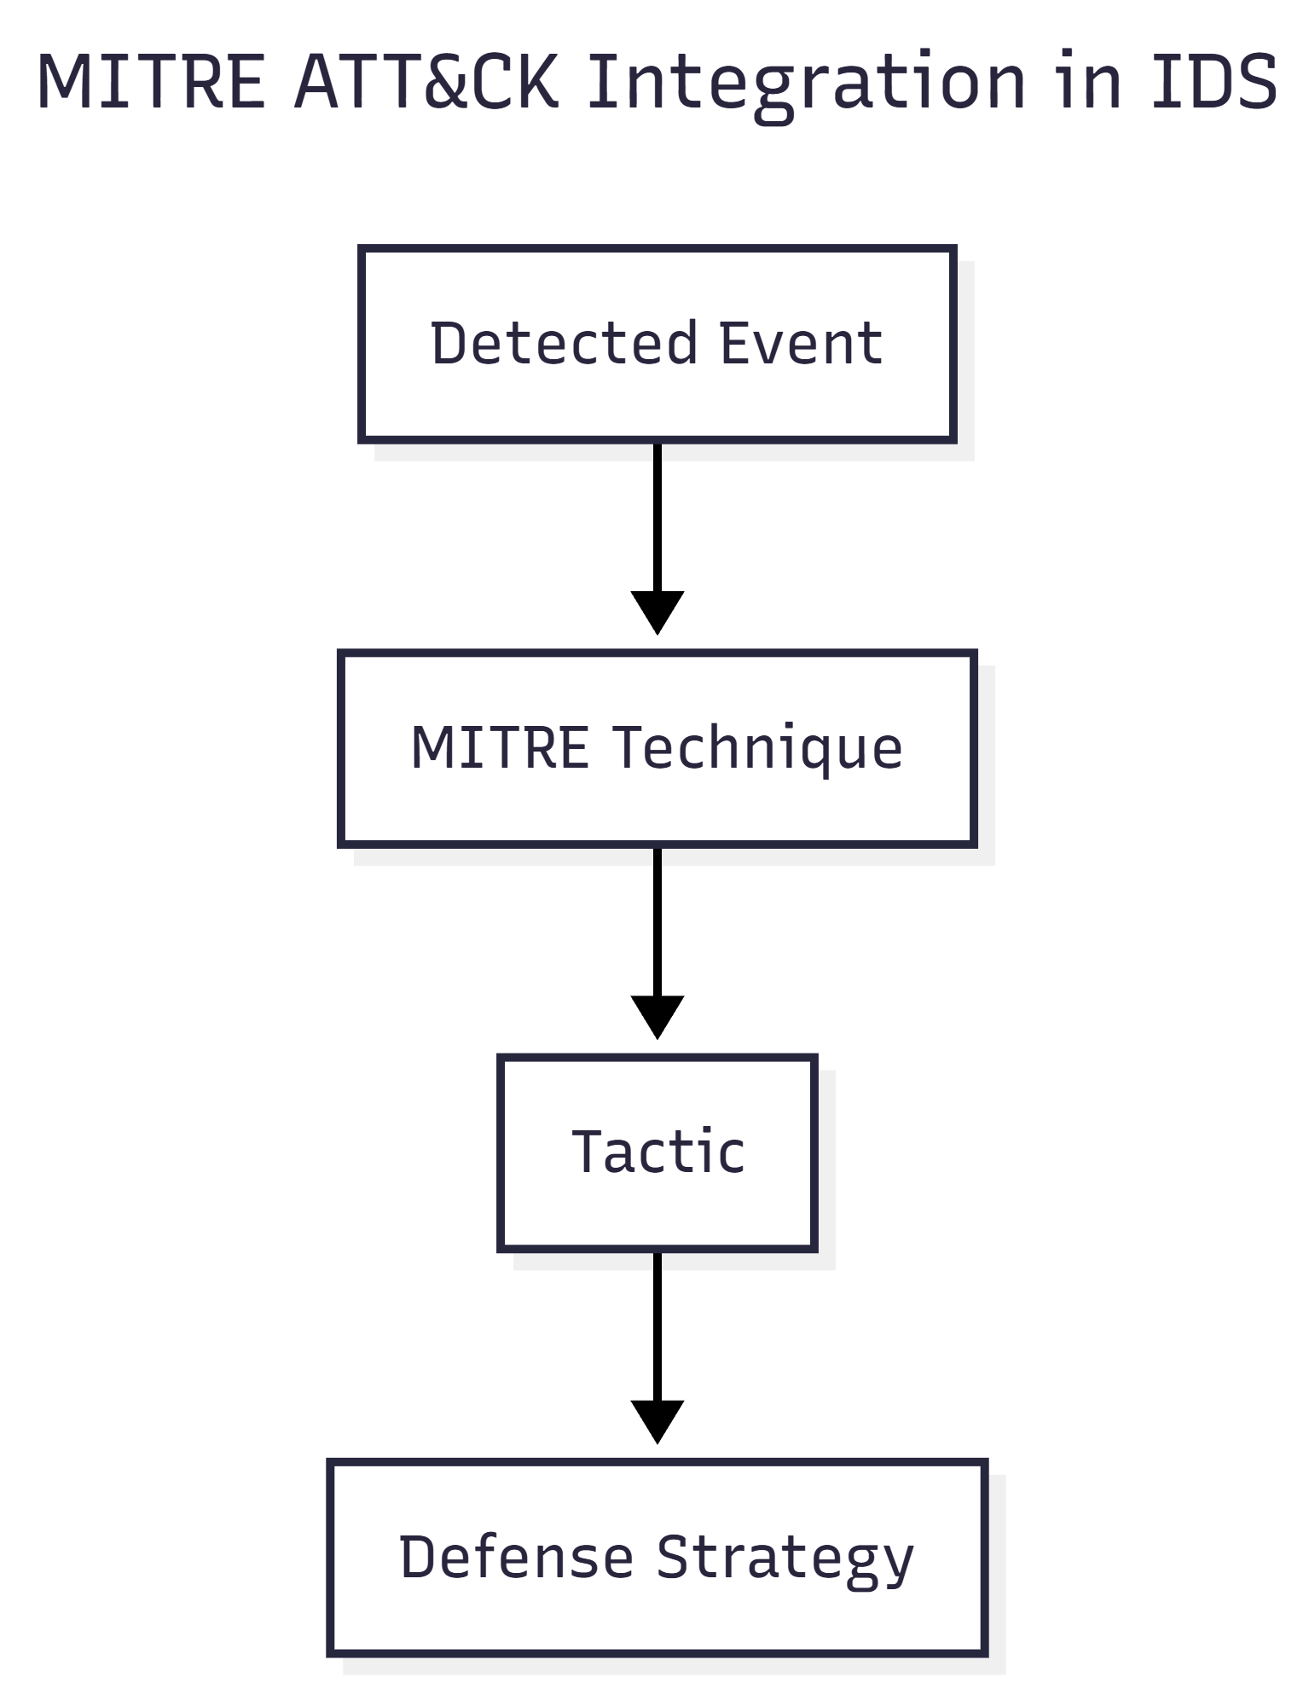
4. System Architecture
This section describes the architectural design of the Intrusion Detection System, explaining how different components interact to capture network traffic, analyze it, detect intrusions, and present the results through a dashboard. The architecture is designed to be modular, scalable, and easy to extend for future enhancements.
4.1 Overall System Architecture
The system follows a layered architecture consisting of traffic capture, analysis, detection, alerting, backend services, and frontend visualization. Network traffic flows through these layers sequentially, ensuring clear separation of responsibilities between components.
At a high level, the system operates as follows:
- Network packets are captured either from PCAP files or live interfaces.
- Captured packets are analyzed to extract meaningful features.
- Detection logic evaluates traffic using hybrid detection techniques.
- Alerts are generated and sent to a backend service.
- The frontend dashboard visualizes alerts, incidents, and analytics in real time.
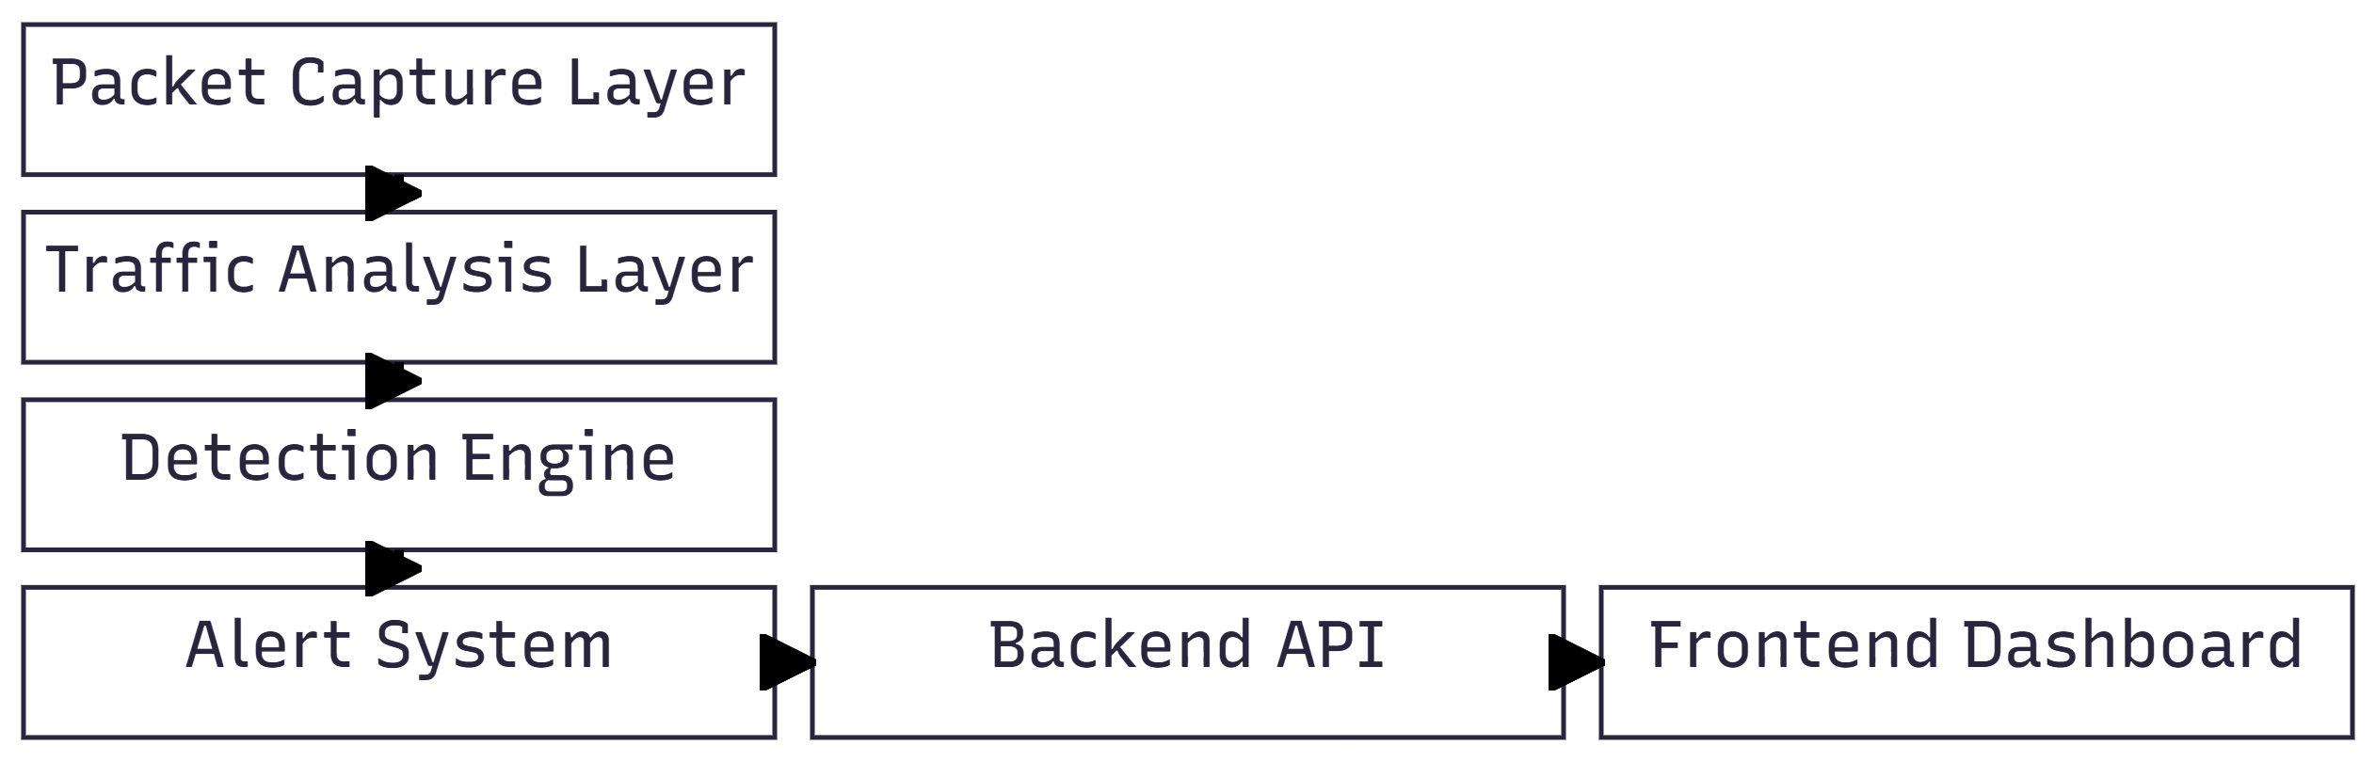
4.2 Component-Wise Description
The system is composed of the following major components:
- Packet Capture Module:
Responsible for acquiring network traffic either from PCAP files (offline mode) or directly from network interfaces (live mode).
- Traffic Analysis Module:
Processes captured packets and extracts relevant features such as IP addresses, ports, packet size, and timing information.
- Detection Engine:
Implements hybrid intrusion detection using both signature-based rules and anomaly-based logic to identify malicious behaviour.
- Alert System:
Generates structured alerts, assigns severity levels, and forwards alerts to the backend API.
- Backend API:
Acts as a central communication layer that stores and serves alerts to the frontend and supports real-time updates.
- Frontend Dashboard:
Provides an interactive SIEM-style interface for visualizing alerts, incidents, analytics, and MITRE ATT&CK mappings.
Each component operates independently, allowing the system to be easily modified or extended.
4.3 Data Flow Diagram
The data flow within the system follows a clear and sequential path:
- Network traffic enters the system through packet capture.
- Captured packets are forwarded to the traffic analysis module.
- Extracted features are evaluated by the detection engine.
- Detected threats generate alerts.
- Alerts are sent to the backend API.
- The frontend retrieves alerts and updates the dashboard.
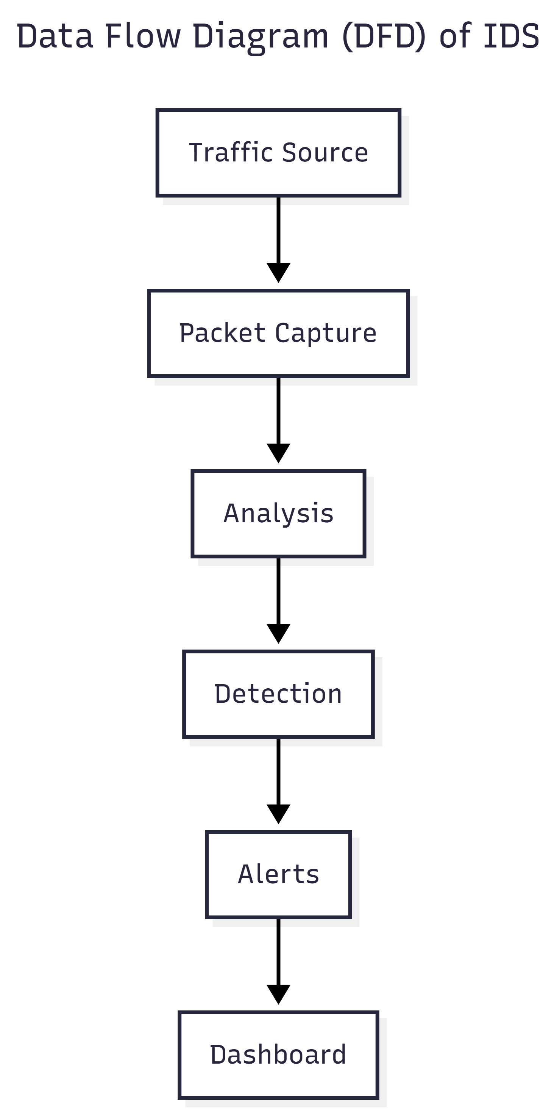
4.4 Communication Between Modules
Modules communicate using well-defined interfaces to ensure loose coupling:
- Internal modules communicate through function calls and data structures.
- Alerts are transmitted to the backend using HTTP requests.
- Real-time updates are delivered using WebSockets.
- The frontend fetches alert data via REST APIs.
This communication design improves reliability and allows individual components to evolve without affecting the entire system.
4.5 Backend–Frontend Interaction
The backend is implemented using FastAPI and serves as the bridge between the IDS core and the dashboard. It exposes endpoints for:
- Retrieving detected alerts
- Streaming real-time alerts via WebSockets
- Supporting dashboard updates
The frontend interacts with the backend to:
- Display real-time metrics
- Render charts and tables
- Show alert and incident details
- Provide user interaction for analysis
This separation ensures scalability and supports future migration to more advanced frontend frameworks or distributed deployments.
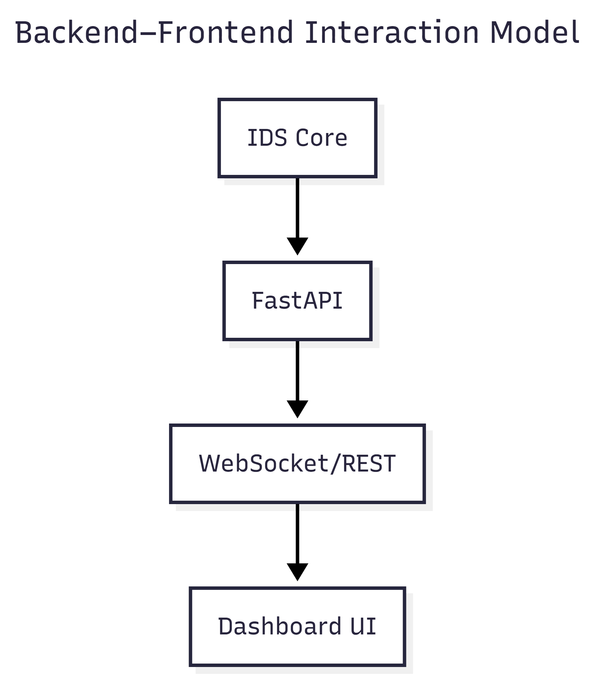
5. Detection Methodology
This section explains the detection approach used in the Intrusion Detection System, focusing on how network traffic is evaluated to identify malicious behaviour. The system adopts a hybrid methodology to improve accuracy and reliability.
5.1 Hybrid Detection Approach
The project implements a hybrid intrusion detection methodology that combines both signature-based and anomaly-based detection techniques. This approach ensures that the system can accurately detect known attacks while also identifying previously unseen or abnormal traffic behaviour.
By running both detection techniques in parallel, the system reduces false negatives and improves overall detection effectiveness. Alerts generated from different methods are correlated before being forwarded to the alert system.
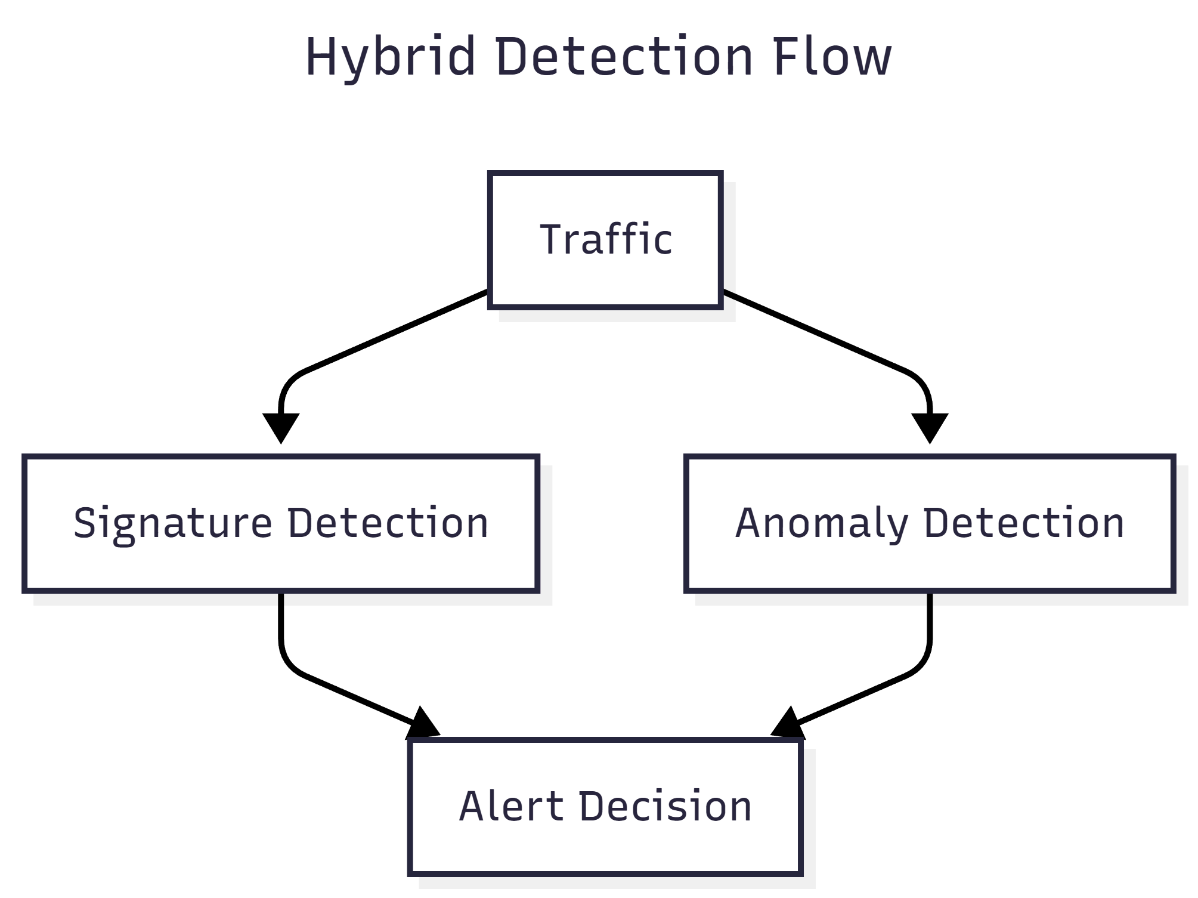
5.2 Signature-Based Detection Logic
Signature-based detection relies on predefined rules that represent known attack patterns. Each incoming packet or flow is evaluated against these rules to determine whether it matches characteristics of known attacks such as scanning or flooding behaviour.
This method provides fast and reliable detection for known threats and ensures a low false-positive rate. In this project, rule-based logic is used to detect specific malicious behaviours commonly observed in network attacks.
5.3 Anomaly-Based Detection Logic
Anomaly-based detection focuses on identifying deviations from normal network behaviour. Traffic features such as packet rate, byte rate, and timing are analyzed to detect unusual patterns that may indicate malicious activity.
This method allows the system to identify unknown or emerging threats that do not match existing signatures. It enhances the adaptability of the IDS and strengthens detection coverage.
5.4 Thresholds and Rule Evaluation
Detection decisions are based on predefined thresholds and evaluation criteria. These thresholds define acceptable limits for traffic behaviour, such as packet frequency or traffic volume.
If observed values exceed defined thresholds or match known attack conditions, the system flags the activity as suspicious. Threshold-based evaluation ensures consistent and explainable detection behaviour.
5.5 Packet-Level Analysis
The detection methodology operates at the packet level, allowing detailed inspection of network traffic. Each packet is analyzed for attributes such as source and destination addresses, ports, size, and protocol-specific information.
Packet-level analysis enables fine-grained detection and supports accurate feature extraction, which is essential for both signature-based and anomaly-based detection processes.
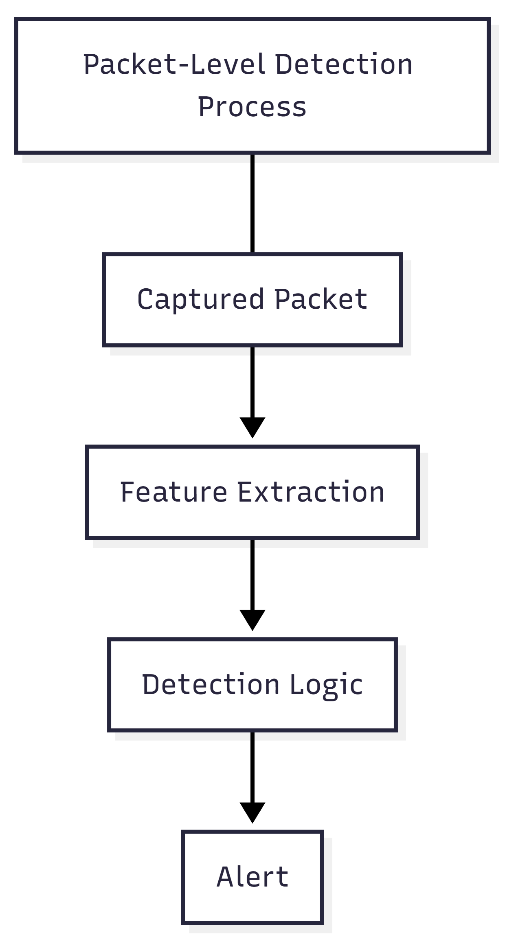
6. Packet Capture and Traffic Analysis
This section describes how network traffic is captured and analyzed within the system. Packet capture and traffic analysis form the foundation of the IDS, as all detection logic depends on accurate and reliable packet-level data.
6.1 PCAP File Analysis
The system supports offline traffic analysis using PCAP (Packet Capture) files. PCAP files are commonly generated using tools such as Wireshark and contain recorded network traffic.
In this project, PCAP analysis allows the IDS to:
- Operate on Windows systems without requiring raw socket access
- Analyze previously captured traffic for attack patterns
- Reproduce and study attacks for testing and evaluation
Each packet from the PCAP file is processed sequentially and passed through the traffic analysis and detection pipeline, enabling controlled and repeatable intrusion analysis.
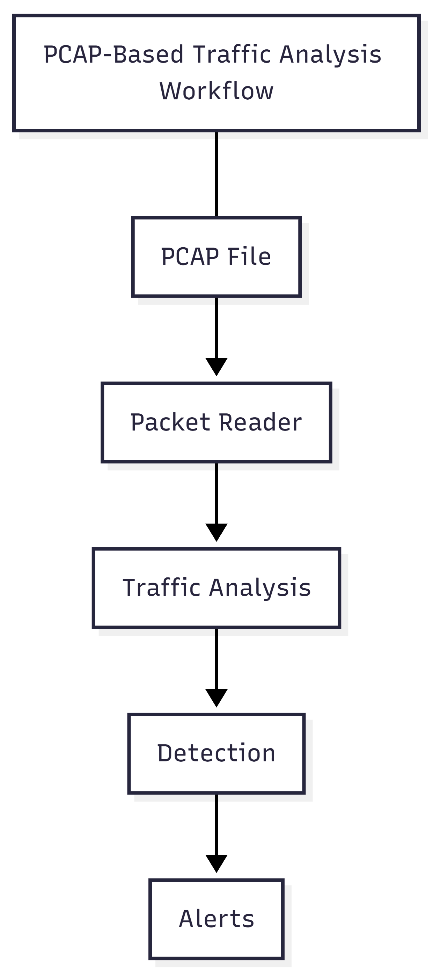
6.2 Live Packet Capture
For real-time intrusion detection, the system supports live packet capture on Linux-based environments. Live capture allows the IDS to monitor network interfaces directly and analyze traffic as it flows through the network.
This mode enables:
- Real-time attack detection
- Continuous network monitoring
- Immediate alert generation for suspicious activity
Live packet capture is handled through a dedicated capture module that feeds packets into the analysis pipeline without disrupting system performance.
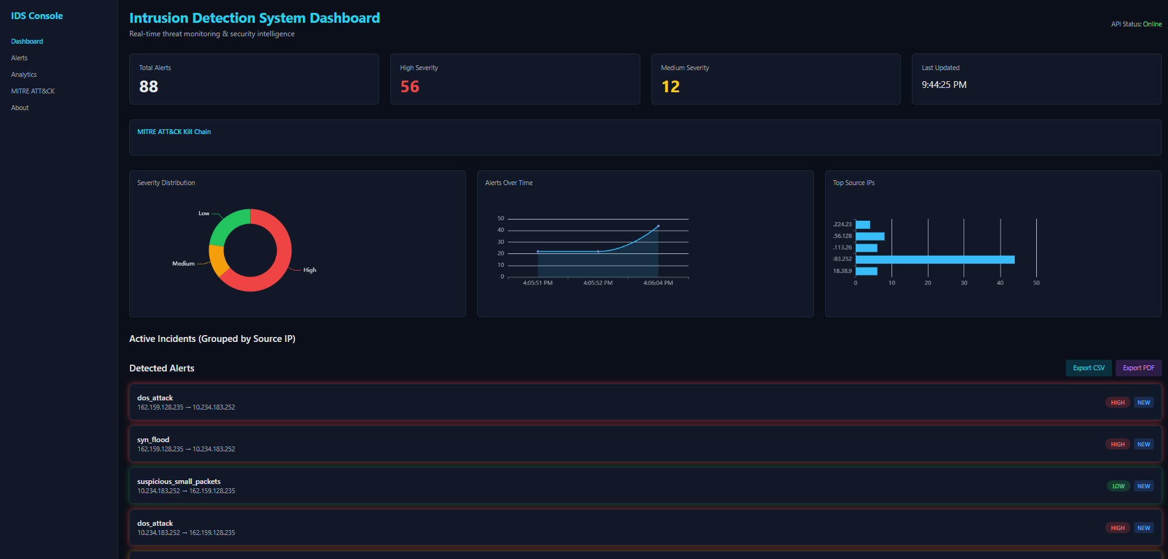
6.3 Feature Extraction
Once packets are captured, relevant features are extracted to support detection logic. Feature extraction converts raw packet data into structured information suitable for analysis.
Extracted features include:
- Source and destination IP addresses
- Source and destination ports
- Packet size
- Packet rate and timing information
- Protocol-specific attributes
These features are essential for identifying traffic patterns and evaluating both signature-based and anomaly-based detection rules.
6.4 Traffic Behaviour Modeling
Traffic behaviour modeling involves analyzing extracted features over time to understand normal and abnormal network behaviour. By observing traffic trends, the system can distinguish between legitimate usage and suspicious activity.
This modeling supports:
- Detection of abnormal traffic bursts
- Identification of scanning behaviour
- Recognition of unusual communication patterns
Traffic behaviour modeling enhances detection accuracy and provides meaningful context for alert generation.
6.5 Protocol Analysis
The system performs protocol-level analysis to interpret packet contents correctly. By identifying protocol-specific fields, such as TCP flags, the IDS gains deeper insight into the nature of network communication.
Protocol analysis helps:
- Identify suspicious connection attempts
- Detect misuse of standard protocols
- Improve the accuracy of packet-level inspection
This low-level analysis strengthens the overall detection capability and ensures precise identification of malicious behaviour.
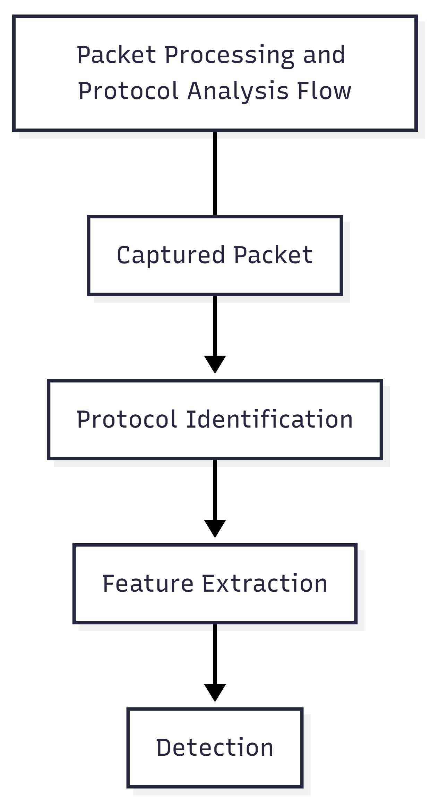
7. Alert Generation and Incident Handling
This section explains how detected threats are converted into structured alerts and how multiple alerts are correlated into incidents for effective security analysis.
7.1 Alert Structure and Format
When suspicious or malicious activity is detected, the system generates a structured alert containing relevant security information. Each alert includes:
- Timestamp of detection
- Attack name
- Severity level (Low, Medium, High)
- MITRE ATT&CK technique (if applicable)
- Source and destination network details
- Traffic and packet-related attributes
This structured format ensures alerts are easy to process, visualize, and store, and it supports further analysis and reporting.
Detection Result → Alert Structuring → Alert Output
Alert Generation Process
7.2 Severity Classification
Alerts are classified into severity levels based on the potential impact and risk of the detected activity:
- Low Severity: Minor anomalies or suspicious behaviour with limited risk
- Medium Severity: Potential attack behaviour requiring investigation
- High Severity: Critical threats that may cause service disruption or compromise
Severity classification helps prioritize alerts and allows analysts to focus on the most critical threats first.
7.3 Alert Lifecycle (New, Investigating, Resolved)
Each alert follows a defined lifecycle to support proper incident response:
- New: Alert has been detected and requires attention
- Investigating: Alert is under analysis by the user or analyst
- Resolved: Alert has been addressed or determined to be benign
The alert lifecycle improves tracking and ensures systematic handling of security events.
New → Investigating → Resolved
Alert Lifecycle Flow
7.4 Incident Correlation and Grouping
Multiple related alerts are grouped into incidents based on common attributes such as source IP address. Incident correlation helps identify coordinated or repeated attack attempts originating from the same source.
Incident grouping provides:
- Better visibility of attack patterns
- Reduced alert noise
- Simplified investigation process
This approach allows analysts to focus on broader attack campaigns rather than individual alerts.
Multiple Alerts → Correlation Logic → Incident
Incident Correlation Model
7.5 Logging and Alert Persistence
All alerts are logged for future reference and analysis. Logging ensures that security events can be reviewed during audits, investigations, or forensic analysis.
Alert persistence allows:
- Historical analysis of attacks
- Trend identification
- Report generation for documentation and compliance
This capability strengthens the reliability and usefulness of the IDS as a monitoring and analysis tool.

8. SIEM Dashboard Design
This section describes the design and functionality of the SIEM-style dashboard used to visualize alerts, incidents, and network security analytics generated by the IDS.
8.1 Dashboard Overview
The dashboard serves as the primary interface between the user and the IDS. It provides a centralized view of detected security events, enabling users to monitor network activity, analyze threats, and understand attack behaviour in real time.
The dashboard is designed to resemble a Security Operations Center (SOC) interface, focusing on clarity, usability, and actionable information.
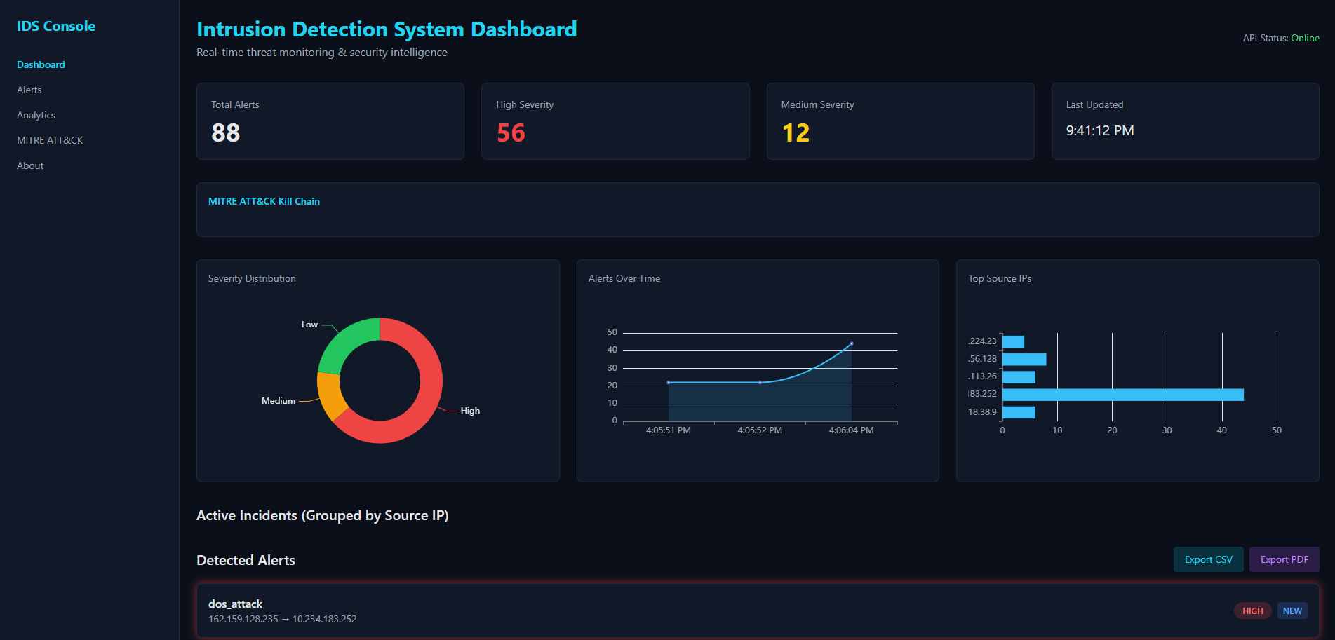
8.2 Real-Time Visualization
The dashboard supports real-time visualization of alerts using backend communication mechanisms. As new alerts are generated, the dashboard updates dynamically without requiring manual page refresh.
Real-time visualization ensures:
- Immediate awareness of ongoing attacks
- Faster response to security incidents
- Continuous monitoring of network activity
8.3 Severity Metrics
Severity metrics provide a high-level summary of detected threats. The dashboard displays the total number of alerts along with a breakdown by severity level.
These metrics help users quickly assess the overall security posture of the network and identify critical threats that require immediate attention.
8.4 Charts and Graphs
Graphical visualizations are used to represent security data in an intuitive manner. The dashboard includes multiple charts to display:
- Severity distribution of alerts
- Alerts over time
- Top source IP addresses involved in attacks
Charts enable users to identify trends, patterns, and anomalies in network traffic.
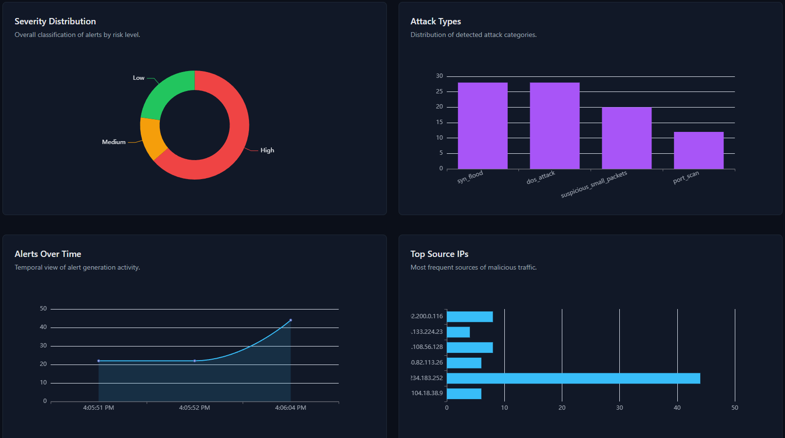
8.5 Incident Tables and Filtering
The dashboard provides structured tables for displaying alerts and incidents. Users can view detailed alert information and filter data based on severity, source, or attack type.
Incident tables group related alerts together, reducing clutter and helping users focus on meaningful security events.
8.6 User Interaction Features
Interactive features enhance usability and analysis capabilities. These include:
- Expandable alert views for detailed inspection
- Modal windows for in-depth alert and incident information
- Export options for reports in CSV and PDF formats
These features allow users to investigate threats, document findings, and share results effectively.
9. MITRE ATT&CK Framework Integration
This section explains how the MITRE ATT&CK framework is integrated into the IDS to provide contextual intelligence, attack understanding, and defensive guidance.
9.1 Introduction to MITRE ATT&CK
MITRE ATT&CK is a globally recognized knowledge base that categorizes adversary behaviour into tactics and techniques based on real-world attack observations. It provides a structured way to understand how attackers operate across different stages of an attack.
By integrating MITRE ATT&CK, the IDS moves beyond simple alert generation and provides meaningful context about detected threats.
9.2 Mapping Detected Attacks to MITRE Techniques
Each detected attack in the system is mapped to a corresponding MITRE ATT&CK technique whenever applicable. This mapping associates alerts with standardized identifiers, allowing consistent classification of attack behaviour.
MITRE mapping helps users understand:
- What type of attack was detected
- The attacker’s objective
- The stage of the attack lifecycle

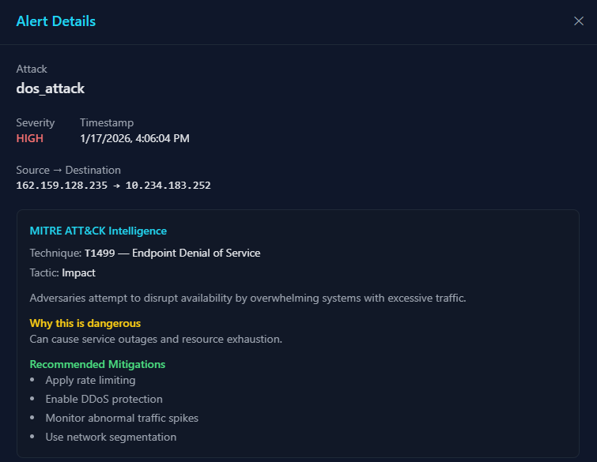

9.3 Kill Chain Visualization
The dashboard visually represents the MITRE ATT&CK kill chain to show where the detected attack fits within the broader attack lifecycle. Highlighting the active tactic helps users understand the progression and potential next steps of an attack.
Kill chain visualization improves situational awareness and supports better decision-making during incident response.
Reconnaissance → Initial Access → Execution → Command & Control → Impact
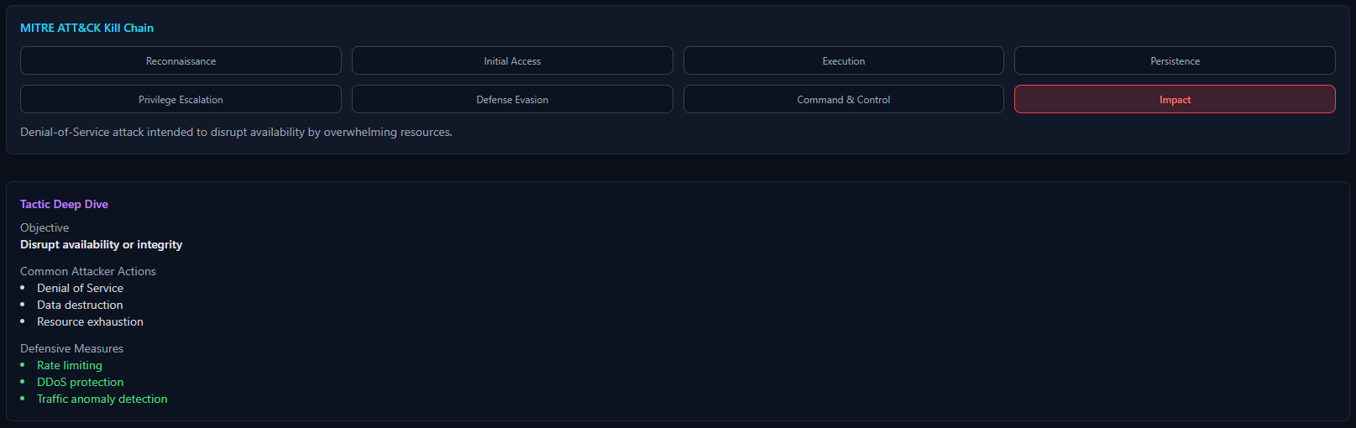
9.4 Attack Explanation and Context
For each mapped MITRE technique, the system provides descriptive information explaining how the attack works and why it is dangerous. This contextual information transforms raw alerts into actionable intelligence.
Attack explanations are particularly useful in academic and learning environments, helping users understand the reasoning behind detection events.
9.5 Mitigation Strategies and Defensive Guidance
Along with attack explanations, the system presents recommended mitigation strategies based on MITRE ATT&CK guidance. These defensive measures help users understand how similar attacks can be prevented or minimized in real-world environments.
Providing mitigation guidance makes the IDS not only a detection tool but also a learning and decision-support system.
Detected Attack → MITRE Mapping → Mitigation Guidance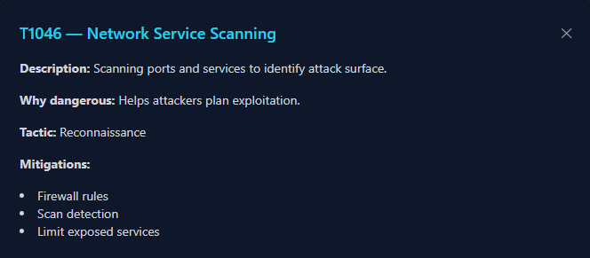
Detection to Mitigation Flow
10. Real-Time Communication
This section explains how real-time communication is implemented in the system to ensure immediate alert delivery and live dashboard updates.
10.1 FastAPI Backend
The backend of the system is implemented using FastAPI, which provides a lightweight and high-performance framework for building APIs. FastAPI acts as the central communication layer between the IDS core and the frontend dashboard.
The backend is responsible for:
- Receiving alerts from the IDS core
- Storing and managing alert data
- Serving alert data to the frontend
- Supporting real-time communication mechanisms
FastAPI enables efficient handling of concurrent requests and supports asynchronous operations, making it suitable for real-time security monitoring systems.
10.2 WebSocket Implementation
To support real-time alert streaming, the system uses WebSockets. Unlike traditional HTTP requests, WebSockets allow persistent two-way communication between the server and the client.
When a new alert is generated:
- The backend immediately pushes the alert to connected dashboard clients
- The dashboard updates metrics, charts, and tables dynamically
WebSockets eliminate the need for frequent polling and ensure low-latency alert delivery.
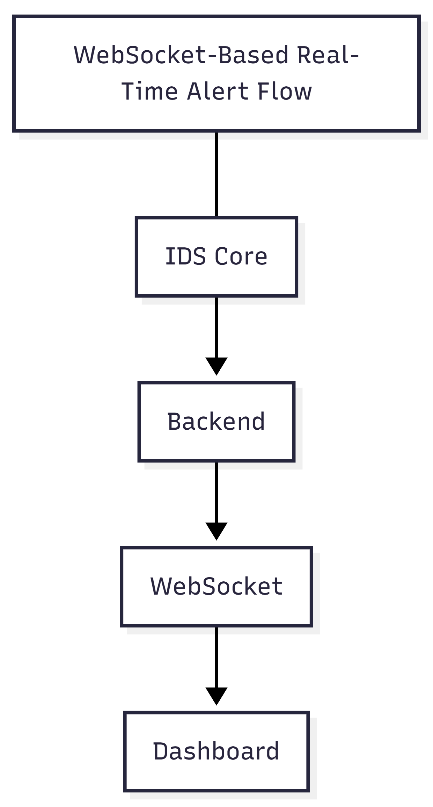
10.3 Live Alert Streaming
Live alert streaming ensures that detected threats appear on the dashboard as soon as they occur. This capability is critical for real-time intrusion detection and rapid incident response.
Live streaming enables:
- Immediate visibility of attacks
- Continuous dashboard updates
- Real-time incident tracking
This feature enhances the responsiveness and effectiveness of the IDS.
10.4 Frontend Data Synchronization
The frontend maintains synchronization with the backend by combining WebSocket-based updates with API-based data retrieval. This approach ensures data consistency even if temporary communication interruptions occur.
Frontend synchronization ensures:
- Accurate alert counts
- Consistent visualization state
- Reliable recovery after disconnections
This design improves system robustness and user experience.

11. Implementation Details
This section describes the technical implementation of the Intrusion Detection System, including the technologies used and how different parts of the system are implemented and organized.
11.1 Technology Stack
The project is implemented using modern, widely adopted technologies to ensure performance, scalability, and ease of development:
- Python: Core IDS logic, packet analysis, detection engine
- Scapy: Packet parsing and network traffic handling
- FastAPI: Backend API and real-time communication
- WebSockets: Live alert streaming
- HTML, Tailwind CSS, JavaScript: Frontend dashboard
- ECharts: Data visualization and analytics
- Wireshark (PCAP): Traffic capture for offline analysis
This technology stack allows seamless integration between detection logic and visualization.
11.2 Backend Implementation
The backend handles alert ingestion, storage, and distribution. It exposes REST endpoints for fetching alerts and WebSocket endpoints for real-time updates.
Key backend responsibilities include:
- Receiving structured alerts from the IDS core
- Managing alert data lifecycle
- Broadcasting alerts to connected clients
- Serving dashboard data efficiently
The backend is designed to be lightweight and scalable, supporting future enhancements such as persistent databases or authentication.
11.3 Frontend Implementation
The frontend provides a SIEM-style interface for monitoring and analysis. It is implemented using HTML, Tailwind CSS, and JavaScript to ensure responsiveness and modern UI design.
Frontend features include:
- Real-time alert updates
- Interactive charts and graphs
- Expandable alert and incident views
- MITRE ATT&CK visualization and explanations
- Export of incident reports
The frontend is decoupled from the backend, allowing independent evolution.
11.4 API Design
The system uses a clean API design to ensure clear communication between components. APIs are used to:
- Retrieve alert data
- Stream alerts in real time
- Support dashboard synchronization
This design ensures modularity and simplifies integration with other systems if required.
11.5 Folder Structure Explanation
The project follows a modular folder structure to improve readability, maintainability, and scalability. Core IDS logic, backend services, and frontend UI are separated into distinct directories.
This structure enables:
- Easy addition of new detection modules
- Independent frontend and backend development
- Clear separation of concerns
The organized folder structure supports long-term project maintenance and expansion.

12. Cross-Platform Compatibility
This section explains how the Intrusion Detection System is designed to operate across different operating systems while maintaining consistent detection and analysis capabilities.
12.1 Windows-Based PCAP Analysis
On Windows systems, direct live packet capture using raw sockets is often restricted due to operating system limitations. To address this, the IDS supports offline analysis using PCAP files.
In this mode:
- Network traffic is captured using tools such as Wireshark
- PCAP files are provided as input to the IDS
- Packets are processed sequentially for analysis and detection
This approach allows Windows users to fully utilize the IDS for testing, learning, and forensic analysis without requiring special kernel-level permissions.
12.2 Linux Live Traffic Monitoring
Linux environments provide native support for raw socket access, enabling real-time packet capture. In this mode, the IDS directly monitors a specified network interface and analyzes traffic as it flows through the system.
Live traffic monitoring enables:
- Continuous network surveillance
- Immediate detection of attacks
- Real-time alert generation and visualization
This mode is suitable for deployment in controlled lab environments and advanced security setups.
12.3 System Requirements
The system requires a standard development environment with support for Python and networking libraries. Key requirements include:
- Python runtime environment
- Network packet capture permissions (for live mode)
- Web browser for dashboard access
These minimal requirements make the IDS accessible across different platforms.
12.4 Deployment Considerations
The IDS is designed to be deployed flexibly depending on the operating system and use case. Users can choose between offline PCAP analysis or live monitoring based on system capabilities.
This flexibility ensures:
- Ease of testing and demonstration
- Compatibility with academic environments
- Adaptability to different deployment scenarios

13. Results and Analysis
This section presents the observed results obtained from testing and running the Intrusion Detection System and analyzes its performance and effectiveness.
13.1 Detection Accuracy
The IDS successfully detects known attack patterns using signature-based detection and identifies abnormal traffic behaviour using anomaly-based logic. During PCAP-based testing and simulated traffic scenarios, the system consistently flagged suspicious activities such as scanning and traffic bursts.
The hybrid detection approach improves accuracy by ensuring that known attacks are reliably detected while still allowing identification of abnormal behaviour that may not match predefined signatures.
13.2 Performance Evaluation
The system demonstrates efficient performance during both offline and live analysis. Packet processing and detection operations are lightweight and do not introduce significant delay.
Key performance observations include:
- Smooth processing of PCAP files without packet loss
- Stable real-time monitoring during live capture
- Responsive dashboard updates via WebSockets
These results indicate that the system is suitable for real-time monitoring in small to medium-scale environments.
13.3 Alert Analysis
Generated alerts are structured, informative, and enriched with contextual information such as severity levels and MITRE ATT&CK mappings. Alerts provide sufficient detail for understanding the nature and potential impact of detected threats.
Severity classification enables prioritization of alerts, allowing users to focus on critical events while still retaining visibility into lower-risk activities.
13.4 Dashboard Effectiveness
The SIEM-style dashboard effectively visualizes security data using metrics, charts, tables, and interactive components. Real-time updates ensure that users remain informed about ongoing network activity.
Dashboard features such as incident grouping, expandable alert views, and filtering improve usability and reduce alert fatigue, making analysis more efficient.
13.5 Sample Attack Detection Results
During testing, the IDS successfully detected:
- Repeated connection attempts indicative of scanning behaviour
- Abnormal traffic patterns associated with denial-of-service activity
- Multiple alerts grouped into a single incident based on source IP
These results validate the correctness of the detection logic and demonstrate the practical usefulness of the system for intrusion monitoring and analysis.

14. Security Considerations
This section discusses important security aspects related to the design, deployment, and usage of the Intrusion Detection System.
14.1 API Security
The backend API acts as a central point for receiving and serving alert data. While the current implementation focuses on functionality and learning objectives, API security is an important consideration.
Key aspects include:
- Controlled access to alert endpoints
- Protection against unauthorized data access
- Prevention of misuse of alert submission endpoints
In production environments, authentication, authorization, and rate limiting would be essential to secure the API.
14.2 Data Handling
The IDS processes sensitive network information such as IP addresses, ports, and traffic characteristics. Proper handling of this data is necessary to maintain privacy and integrity.
Considerations include:
- Secure transmission of alert data
- Avoidance of unnecessary data exposure
- Safe storage of logs and alerts
The project ensures structured and minimal data handling suitable for monitoring and analysis purposes.
14.3 Risks and Limitations
As with any detection system, the IDS has inherent risks and limitations:
- Possibility of false positives in anomaly-based detection
- Inability to detect all attack types
- Dependence on detection thresholds and rules
These limitations are acknowledged, and the system is designed to minimize their impact through hybrid detection and alert correlation.
14.4 Safe Usage of IDS Systems
Intrusion Detection Systems should be used responsibly and ethically. This project is intended for:
- Educational use
- Controlled testing environments
- Authorized network monitoring
The system should not be deployed on networks without proper permission, and users must follow applicable laws and policies regarding network monitoring.

15. Advantages and Uniqueness of the System
This section highlights the key advantages of the proposed Intrusion Detection System and explains what makes it unique compared to conventional IDS implementations.
15.1 Key Advantages
The system offers several advantages that enhance its effectiveness and usability:
- Hybrid detection improves accuracy by combining signature-based and anomaly-based techniques
- Real-time monitoring enables immediate visibility of threats
- Structured alerts simplify analysis and investigation
- Cross-platform support allows usage on both Windows and Linux systems
- Modular design makes the system easy to understand and extend
These advantages make the system suitable for academic, research, and learning-oriented environments.
15.2 Unique Features
The project includes several features that distinguish it from basic IDS implementations:
- Integration of MITRE ATT&CK framework for contextual threat intelligence
- SIEM-style interactive dashboard for visualization and analysis
- Incident correlation and grouping to reduce alert noise
- Real-time alert streaming using WebSockets
- Exportable incident reports in CSV and PDF formats
These features elevate the system beyond simple intrusion detection and make it a comprehensive monitoring solution.
15.3 Comparison with Existing Solutions
Compared to traditional IDS tools, this system emphasizes clarity, visualization, and educational value. While many existing solutions focus primarily on detection, this project provides additional insights through analytics, attack mapping, and incident correlation.
The system balances functionality and simplicity, making it accessible to users who are learning cybersecurity concepts while still demonstrating real-world IDS principles.
15.4 SOC-Oriented Design Benefits
The dashboard and alert handling workflow are inspired by Security Operations Center (SOC) practices. This design approach helps users understand how real-world security teams monitor and respond to threats.
SOC-oriented features include:
- Centralized alert visualization
- Severity-based prioritization
- Incident-based analysis
- Contextual threat intelligence
This design improves both usability and learning effectiveness.

16. Limitations
This section discusses the limitations of the Intrusion Detection System, acknowledging areas where the current implementation has constraints.
16.1 Current System Constraints
The system is designed primarily for educational and research purposes, which introduces certain constraints. It is optimized for small to medium-scale network environments rather than large enterprise deployments.
The detection logic focuses on specific traffic behaviours and does not cover all possible attack vectors.
16.2 Performance Limitations
While the system performs efficiently in testing environments, performance may degrade when handling extremely high traffic volumes. Packet processing and analysis are performed at the application level, which may limit scalability under heavy network loads.
Additionally, real-time visualization performance depends on the number of alerts and active WebSocket connections.
16.3 Detection Challenges
Anomaly-based detection may generate false positives if traffic patterns change significantly. Signature-based detection relies on predefined rules, limiting its ability to detect completely unknown attack patterns.
Detection accuracy is influenced by threshold selection and traffic characteristics, requiring careful tuning for different environments.

17. Future Enhancements
This section outlines potential improvements and extensions that can be added to the system in future work to enhance its capabilities and scalability.
17.1 Machine Learning Integration
Future versions of the IDS can incorporate advanced machine learning models to improve anomaly detection accuracy. Learning-based models can adapt dynamically to evolving network behaviour and reduce false positives.
Machine learning integration would enable:
- Automated behaviour modeling
- Improved detection of complex attacks
- Adaptive threshold tuning
17.2 Advanced Correlation
Alert correlation can be extended beyond source IP grouping to include time-based, protocol-based, and multi-stage attack correlations. Advanced correlation techniques would help identify sophisticated attack campaigns spanning multiple phases.
This enhancement would further reduce alert noise and improve incident clarity.
17.3 Threat Intelligence Feeds
Integration with external threat intelligence feeds can enrich alerts with information such as known malicious IPs, domains, or attack indicators. This would improve detection confidence and provide additional context for analysis.
Threat intelligence integration would strengthen situational awareness.
17.4 Cloud Deployment
Deploying the IDS in cloud environments would allow scalable monitoring of distributed systems. Cloud deployment can support containerization, load balancing, and centralized monitoring across multiple network segments.
This enhancement would make the system suitable for enterprise-level environments.
17.5 Enterprise Scalability
Future work can focus on improving scalability through optimized packet processing, persistent storage, and distributed architectures. These improvements would enable the IDS to handle higher traffic volumes and support multiple users.
Enterprise scalability enhancements would prepare the system for real-world deployment scenarios.

18. Applications of the System
This section describes practical scenarios where the Intrusion Detection System can be effectively applied.
18.1 Educational Institutions
The system is highly suitable for academic environments, where students can learn practical concepts of network security and intrusion detection. It allows hands-on experimentation with PCAP analysis, live traffic monitoring, and attack visualization.
Educational institutions can use the system for:
- Cybersecurity laboratories
- IDS and SIEM demonstrations
- Research and learning projects
18.2 Enterprises
Small and medium-sized enterprises can use the system to monitor network traffic and detect suspicious activities. The SIEM-style dashboard provides visibility into security events and helps organizations understand potential threats within their networks.
The system can support basic security monitoring and awareness in enterprise environments.
18.3 SOC Environments
The system’s design is inspired by Security Operations Center (SOC) workflows. Features such as alert severity classification, incident grouping, and real-time visualization align with SOC monitoring practices.
This makes the system useful for training SOC analysts and understanding real-world security monitoring processes.
18.4 Research and Learning Use Cases
Researchers and learners can use the system to study attack behaviour, analyze traffic patterns, and experiment with detection techniques. The modular architecture allows easy extension for testing new detection algorithms or visualization methods.
The system provides a flexible platform for cybersecurity research and experimentation.

19. Conclusion
This section summarizes the work carried out in the project, highlights key achievements, and reflects on the overall outcomes.
19.1 Summary of Work
This project presented the design and implementation of a Hybrid Intrusion Detection System capable of analyzing network traffic and detecting malicious activities. The system combines signature-based and anomaly-based detection techniques to improve accuracy and reliability.
The IDS supports both offline PCAP-based analysis and real-time live traffic monitoring, enabling flexible deployment across different operating systems.
19.2 Achievements
The major achievements of this project include:
- Successful implementation of hybrid intrusion detection logic
- Real-time alert generation and visualization
- SIEM-style interactive dashboard with analytics and incident handling
- Integration of MITRE ATT&CK framework for attack intelligence
- Cross-platform operation on Windows and Linux
These achievements demonstrate the effectiveness of the system in detecting and analyzing network threats.
19.3 Learning Outcomes
Through this project, significant practical knowledge was gained in areas such as:
- Network packet analysis
- Intrusion detection methodologies
- Backend and frontend integration
- Real-time communication using WebSockets
- Security visualization and incident analysis
The project helped bridge the gap between theoretical cybersecurity concepts and real-world implementations.
19.4 Final Remarks
The developed Intrusion Detection System provides a strong foundation for further research and enhancement. While the current implementation focuses on detection and analysis, the modular architecture allows future expansion into advanced security monitoring solutions.
Overall, this project successfully demonstrates the principles of intrusion detection and security monitoring in a clear, practical, and extensible manner.

20. References
This section lists the technical standards, tools, frameworks, and learning resources that were referred to during the design and development of the Intrusion Detection System.
20.1 Technical Standards and Frameworks
- MITRE ATT&CK Framework
Used for attack classification, kill-chain mapping, and threat intelligence representation.
- TCP/IP Networking Standards (RFCs)
Referenced for understanding packet structure, protocols, and traffic behaviour.
20.2 Tools and Technologies
- Scapy (Python Library)
Used for packet parsing, manipulation, and analysis.
- FastAPI
Used for building a high-performance backend API for alert handling and real-time communication.
- WebSockets
Used for real-time alert streaming between backend and frontend.
- HTML, Tailwind CSS, JavaScript
Used for building an interactive and responsive SIEM-style dashboard.
- ECharts
Used for data visualization including charts and traffic analytics.
20.3 Learning Resources
- Official documentation of Scapy, FastAPI, and WebSockets
- MITRE ATT&CK official knowledge base
- Cybersecurity research papers and IDS-related academic resources
- Network security textbooks and online technical articles
These resources supported the theoretical understanding and practical implementation of the project.

21. Appendix
21.1System Requirements
Software Requirements
- Python 3.10 or higher
- Node.js (for frontend build with Tailwind CSS)
- npm
- Wireshark (for PCAP capture on Windows)
- Linux OS (for live packet capture)
Python Libraries
- scapy
- fastapi
- uvicorn
- requests
22.2 Backend Command:
1) Start FastAPI Backend:
uvicorn backend.app:app –reload
2) Verifyx API status:
http://127.0.0.1:8000/
3) Expected Output:
{
"message": "IDS Backend API is running",
"status": "OK"
}
  - IDS Execution Commands:

1) PCAP Mode (Windows):
python src/main.py
2) PCAP file location:
data/pcaps/sample.pcap
3) Live Mode (Linux):
ids = IntrusionDetectionSystem(mode="live")
ids.run_live_mode()
  - Frontend Commands:
1) Install Dependencies:
npm install
2) Build Tailwind CSS:
npx tailwindcss -i ./src/input.css -o ./public/output.css --watch
3) Open Dashboard:
frontend/public/dashboard.html
  - WebSocket Configuration:
- WebSocket Endpoint:
ws://127.0.0.1:8000/ws/alerts
- Used for:
- Live alert streaming
- Real-time dashboard updates
  - Sample Alert Output:
{
"timestamp": "2026-01-12T10:24:32Z",
"attack_name": "Network Service Scanning",
"severity": "medium",
"mitre_technique": "T1046",
"source": {
"ip": "10.0.0.1",
"port": 1234
},
"destination": {
"ip": "192.168.1.10",
"port": 80
}
}
  - All Screenshots of Working IDS:
  - Main Dashboard
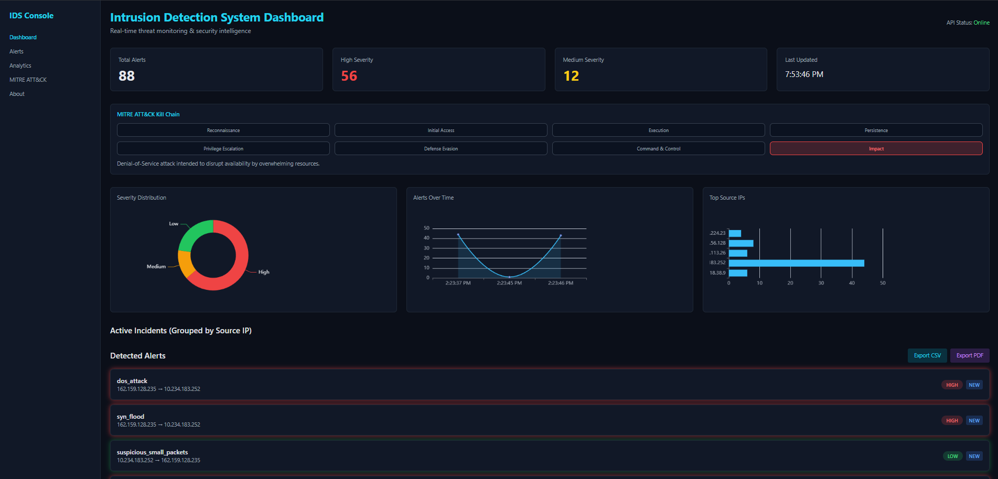

  - MITRE ATT&CK Kill Chain in Dashboard

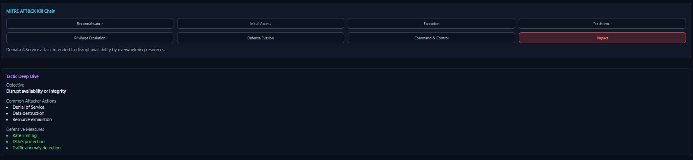
  - Analytics of Alert Data (Donut Graph, Curve Graph, Bar Graph):
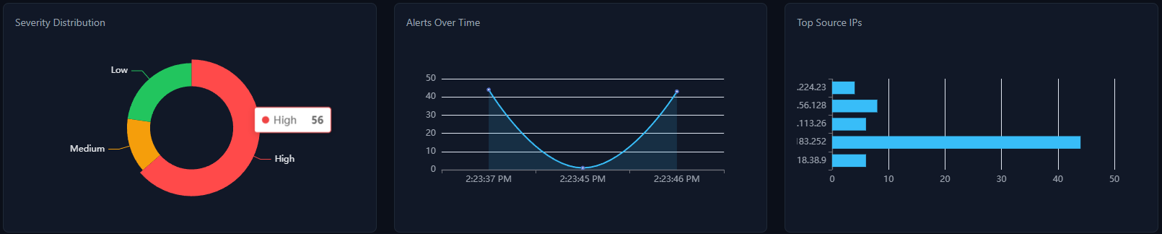
  - Alert Detail Modal (click on any alert from the detected alert and whole info about that alert with Attack, Severity, Timestamp, Source and Destination IP shows and MITRE ATT&CK Intelligence, Packet Traffic Analysis and Alert Life Cycle Shows too for more in-detail Intel)
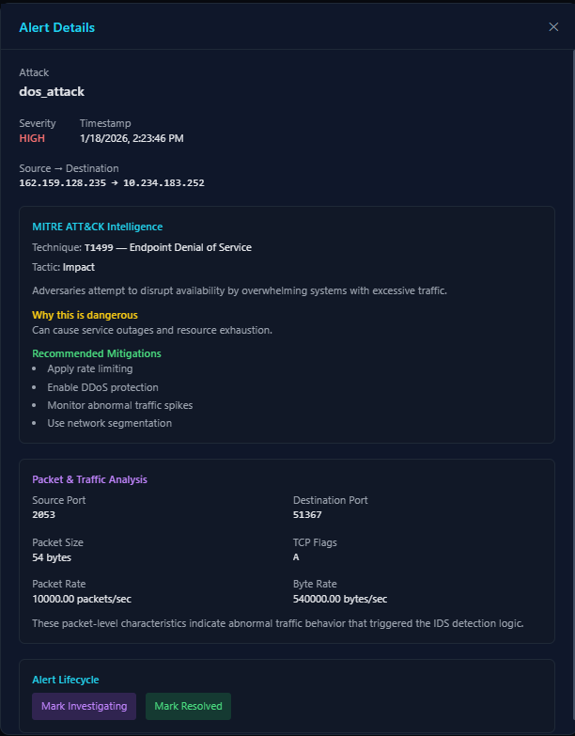

  - Now Alert Page where all Detected Alerts shows:
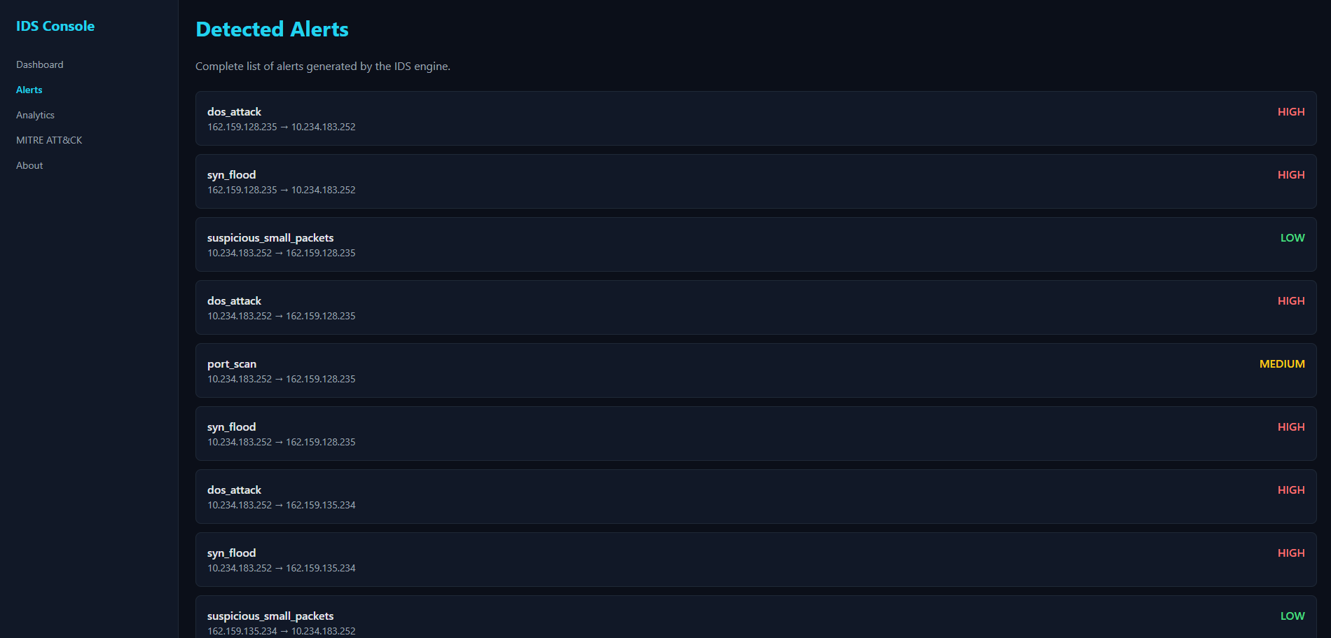
  - Move to next page Analytics where all the Security Analytics shows in graphs:
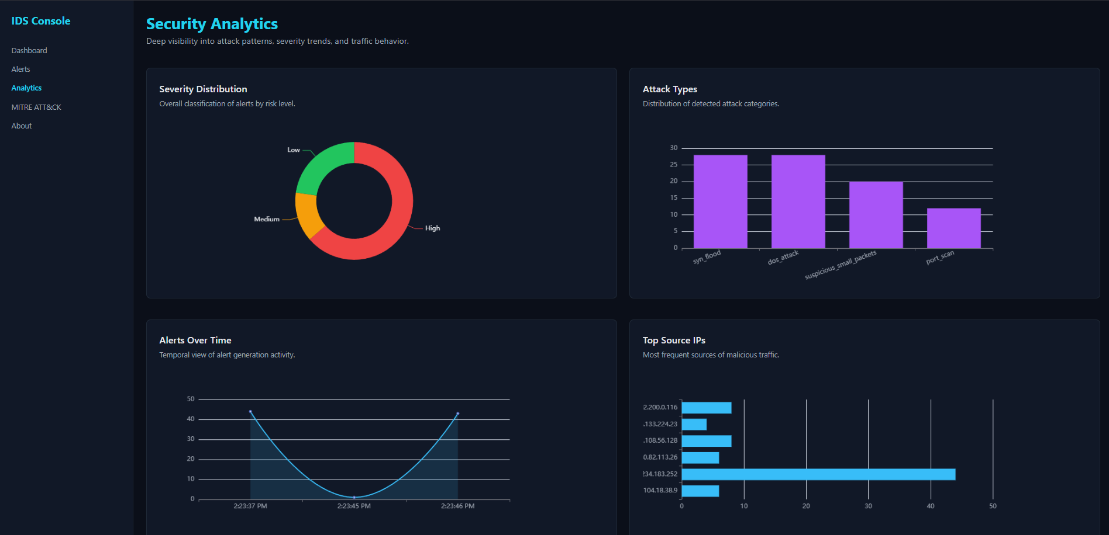
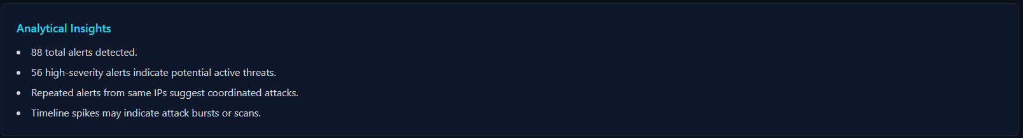

  - Now move to MITRE ATT&CK Intelligence page where all kill chain overview of attack shows and however the technique frequency and tactic of severity visually show:
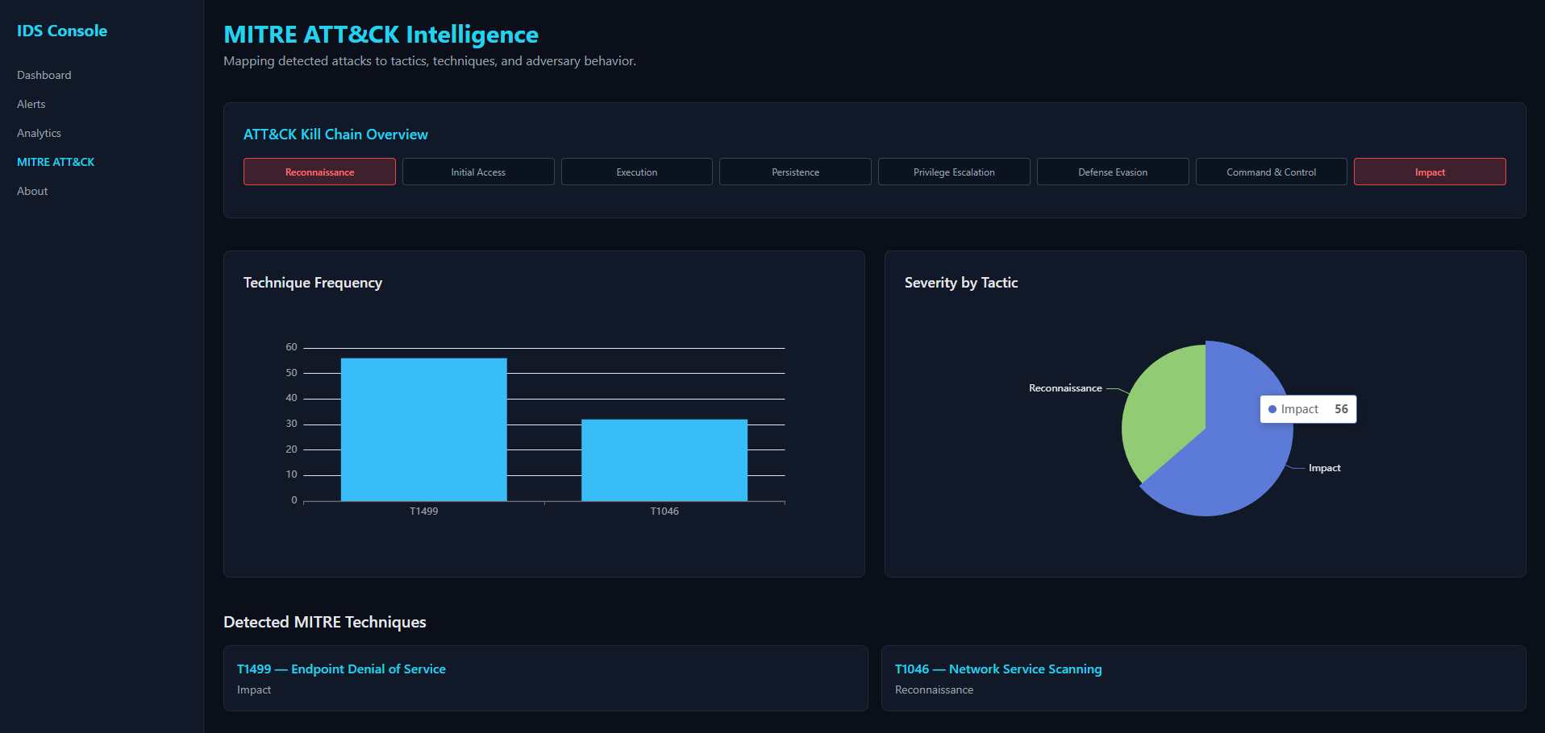
  - In same page you can also see Detected MITRE Technique which can be further open in Modal to see detail about it with Mitigations
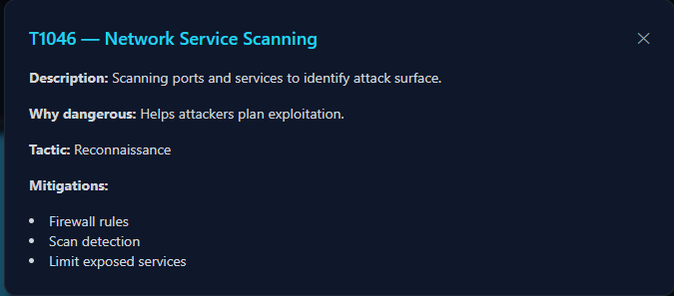
  - You can also Export either CSV or PDF file of alerts in your system:

  - Now move in About page Just what this Project is and why its matter and system architecture and Tech Stack of project and Developer (Sumit) mention
