

MobileDOAS v6.3

Software Manual
Optical Remote Sensing Group,
Department of Radio and Space Sciences,
Chalmers University of Technology,
Göteborg, Sweden

Last updated 2020-03-03

Santiago Arellano
Chalmers University Optical Remote Sensing Group
santiago.arellano@chalmers.se

Christoph Kern
USGS Volcano Disaster Assistance Program
ckern@usgs.gov

Diana Norgaard
USGS Volcano Disaster Assistance Program
dnorgaard@usgs.gov

Table of Contents
MobileDOAS v6.3 1
Software Manual 1
1. Overview 6
1.1 Required Devices 6
1.2 Computer Requirements 6
1.2.1 High DPI Displays 7
1.3 Software Installation 8
1.3.1 Java 8 8
1.3.2 OmniDriver 9
1.3.3 Spectrometer Driver 9
1.3.4 GPS Driver 12
1.3.5 MobileDOAS 12
1.4 Execution 13
2. Configuration 13
2.1 Spectrometer 13
2.2 GPS 15
2.3 Evaluation 16
2.3.1 Fit Window 17
2.3.2 Fit Parameters 17
2.3.3 Misc 17
2.3.4 References 17
3. Performing Flux Measurements Using MobileDOAS 20
3.1 Collecting Spectra 20
3.1.1 STEP 1 - Verify Configurations 20
3.1.2 STEP 2 - Initial Setting 20
3.1.3 STEP 3 - Start Data Collection 20
3.2 Real-Time Results 21
3.2.1 The Main Window 21
3.2.2 Real-time route Graph 22
3.2.3 Spectrum Fit Window 22
3.2.4 Column Error 22
4. Flux Calculation 22
4.1 Flux Formula 22
4.2 Real-time Flux 23
4.3 Calculating Flux From File 23
4.3.1 STEP 1 – Set Wind Parameters and Source Coordinate 23
4.3.2 STEP 2 – Delete Bad Points 24
4.3.3 STEP 3 – Calculate Flux 26
4.4 Importing a Modeled Wind Field 27
5. Re-Evaluation of Spectra 28
5.1 STEP 1 – Selecting the Evaluation Log 28
5.1.1 Dark Spectra 29
5.1.2 Saturated Spectra 30
5.1.3 Wavelength Range 30
5.2 STEP 2 – The Sky Spectrum 30
5.3 STEP 3 – The Fit Window 31
5.3.1 Storing Fit Window Settings 32
5.4 STEP 4 – Re-Evaluating 32
5.5 Scripting the Re-Evaluation (Advanced) 34
6. Other Measurement Modes 35
6.1 Viewing Spectra Directly From the Spectrometer 35
6.2 Viewing Spectra From a Directory 36
7. Other Functions 37
7.1 Viewing Collected Spectra 37
7.2 The Route Dialog 38
7.2.1 View Options 39
7.2.2 Zoom 39
7.2.3 Distance and Bearing Calculation 40
7.2.4 Landmarks 40
7.3 Exporting Evaluated Results to Google Earth 40
7.4 Testing the GPS Connection 41
7.5 Plot Setting 41
7.6 Pause and Exit 41
8. File Formats 42
8.1 Parameters 42
8.1.1 Intensity Section 42
8.1.2 GPS Section 43
8.1.3 The Offset section 43
8.1.4 The Fit Window Section 44
8.2 Example of Configuration File 45
9. Reference File 46
10. Spectrum File 46
11. Evaluation Log File 46
11.1 Example of Evaluation Log File 46
12. Flux Calculation File 47
12.1 Sample Content of Flux Calculation File 48
13. File Format to Import Modeled Wind-Field 48
13.1 Example of a Small Wind-Field Data File 49
14. Troubleshooting 49

Overview
The software MobileDOAS described in this user manual is a software package developed by Chalmers University of Technology in Sweden as an easy to use software package for performing gas flux measurements using the mobile DOAS technique.
The software is tested with the following spectrometers from Ocean Optics Inc.:
- S2000
- USB2000+
- USB2000
- USB4000
- HR2000
- HR4000

Required Devices
Table 1 Required Devices
Spectrometer | Collect Spectra
GPS receiver (with USB interface) | Record GPS time and GPS coordinates
USB cable | Communication with and power to spectrometer
Fiber and telescope | Connected to the spectrometer to expand the visible scope
Laptop or desktop computer | Run the program to collect data from spectrometer and GPS receiver
Before running the software, please make sure that the equipment is properly connected to the computer.

Computer Requirements
CPU | Pentium III 550 MHz or higher
Memory | 128 MB or more
Operating system | Windows XP, Windows 7, or Windows 10
Screen Resolution | 1024 by 768 pixels or better

High DPI Displays
MobileDOAS dialog windows may not display properly on a high DPI display. In this case, you can override high DPI scaling behavior in the application’s Properties->Compatibility settings:
- Right Click on MobileDOAS.exe (or MobileDOAS_x64.exe)
- Select Properties
- Select Compatibility tab
- Check the box next to ‘Override high DPI scaling behavior.’
- Select ‘System’ in drop down under ‘Scaling performed by:’
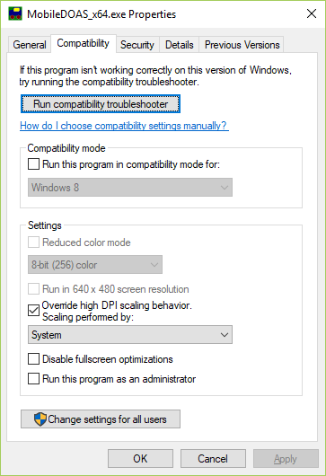
Figure 1 Disabling high DPI scaling behavior

Software Installation
MobileDOAS does not have an installer but require other programs to be installed as a pre-requisite for use: Java 8, Ocean Optic’s OmniDriver, spectrometer driver, and GPS driver. Install either the 32 or 64-bit versions of the software depending on your OS (you can only install 32-bit on 32-bit OS) and the version of MobileDOAS you want to run.

Java 8
Java is a commonly used software so your PC may already have it installed. Look under C:\Program Files\Java for 64-bit installation (or C:\Program Files (x86)\Java for 32-bit installation). You should see jre1.8.0_xxx or jdk1.8.0_xxx in the directory. If you do, Java is already installed on your PC. If you do not have Java installed on your PC download the JRE from Oracle website (http://www.oracle.com/technetwork/java/javase/downloads/jre8-downloads-2133155.html) and install.
MobileDOAS has not been tested with Java 6 or Java 7 but it may work with these older versions also.

OmniDriver
If OmniDriver is not provided download from Ocean Optics website (https://oceanoptics.com/support/software-downloads/#omnidriver) and double click on it to run it. Select all default options when prompted by installer. License to use the OmniDriver is not required unless you are planning to do software development against it. You should now have an Ocean Optics/OmniDriver directory (e.g. C:\Program Files (x86)\Ocean Optics\OmniDriver).
If you see the error message “Error running RegAsm64.exe … : Program ended with an error exit code.” – then you are missing the .NET framework on your computer. You can download the installer for .NET 4.0 from the Ocean Optics OmniDriver download page under Miscellaneous Tools and Utilities.)

Spectrometer Driver
After installing OmniDriver, connect your spectrometer to the computer. Then go to Control Panel -> Device Manager. Look for your spectrometer under “Ocean Optics USB Devices”. It is also possible that your computer does not recognize the device and it will be under “Other devices” as an “Unknown device”
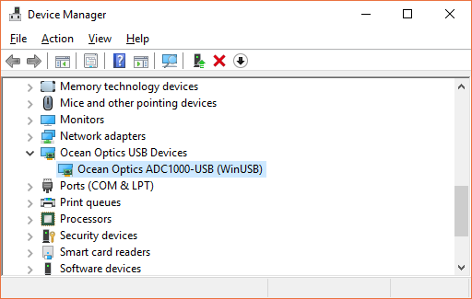
Figure 2 Ocean Optics spectrometer in Device Manager
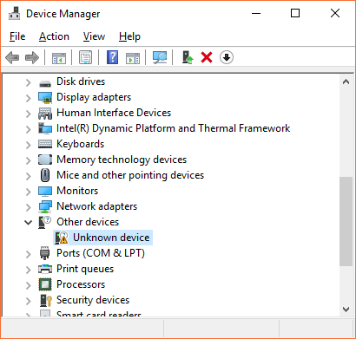
Figure 3 Spectrometer listed as "Unknown device"
Right click on the spectrometer name (or “Unknown device” depending on the case) and select either “Install Driver” or “Update Driver”.
Select the second, “Browse my computer for driver software” option.
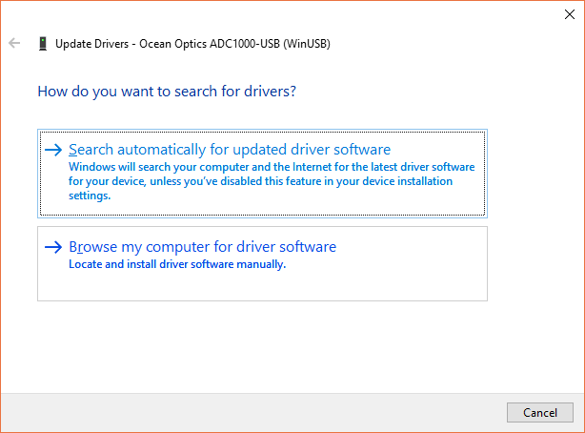
Figure 4 Update spectrometer driver
Enter C:\Program Files\Ocean Optics\OmniDriver\winusb_driver in box under “Search for drivers in this location:”. Then click Next.
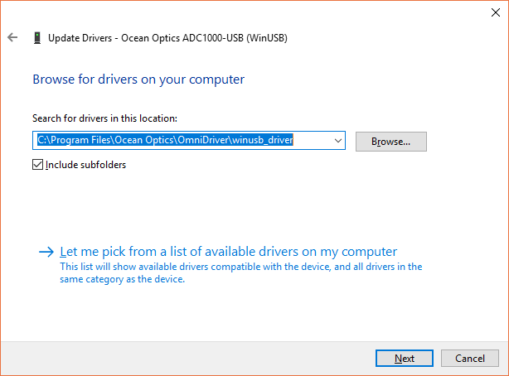
Figure 5 Install/update Ocean Optics driver

GPS Driver
The GPS that uses PL2303 driver, it can be found at http://prolificusa.com/pl-2303hx-drivers/ under Drivers & Softwares. Click on the ‘Download’ link next to “Windows Driver Installer Setup Program”, unzip the file, and follow the instructions in How To Install USB Driver.pdf.
It is also suggested that users install the GPSinfo program by running the GPSInfoSetup.exe found in the “GPSInfo Utility For Windows” folder. You can use this program to see if your GPS driver was successfully installed and that your GPS is working.
MobileDOAS supports NMEA 0183 protocol for GPS data output.

MobileDOAS
Create a directory, e.g. C:\\MobileDOAS, and place the MobileDOAS executable (i.e. MobileDOAS.exe or MobileDOAS_x64.exe) in it. If there is a configuration file from previous version of MobileDOAS, i.e. cfg.xml, copy it into this directory also.

Execution
Click the MobileDOAS.exe to start the 32-bit version of the program.
Click the MobileDOAS_x64.exe to start the 64-bit version of the program.

Configuration
MobileDOAS must be configured prior to collecting Spectra. Select menu “Configuration → Operation Setting” or click on the toolbar to open the Configuration Dialog. If cfg.xml exists in the working directory, the configuration dialog will read the existing configurations and allow the user to edit them. If cfg.xml does not exist, then it will warn the user that one does not exist. The software will have to be configured through the dialog.
The dialog contains three tabs:
- Spectrometer – Configure spectrometer connection and exposure time of spectra.
- GPS – Configure GPS port and baud rate.
- Evaluation – Configure how to evaluate the collected spectra.
When you are done configuring the settings, press the button “Save” to store the settings to cfg.xml or press “Cancel” to close the dialog without writing anything to file.

Spectrometer
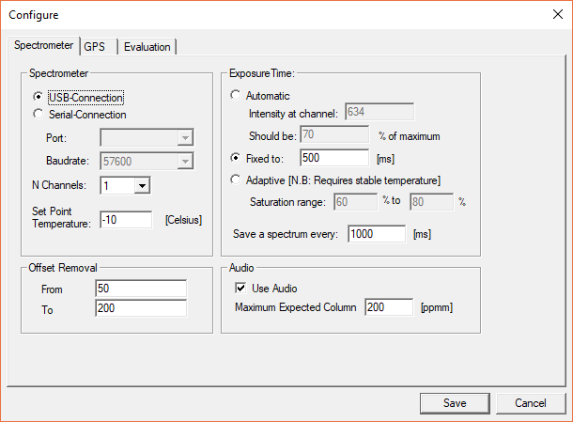
Figure 6 Spectrometer tab of Configuration Dialog
This page is divided into the following groups:
- Spectrometer Setting – Choose “USB” if an USB-cable is used for communicating with the spectrometer. If the serial port is used, select the correct COM port and baud rate for the spectrometer. Then select the number of channels that you wish to use on the spectrometer. If the spectrometer supports it (e.g. QE65000), you can also specify the set point for the CCD temperature.
- Exposure Time – It is possible to set the exposure time manually or let the program calculate it automatically from the received level of light.
- Automatic (recommended) If this is set, then the exposure time will be calculated when the sky spectrum is collected, in the beginning of the measurement. This exposure time will then be used for every collected spectrum in the measurement. The calculation is based on the values in the two edit boxes. The first specifies pixel on the spectrometer’s detector where the light-level will be measured. The second is the desired saturation ratio at that pixel.
- Fixed You can also manually set the exposure time to use in the measurement. This exposure time will be used for every collected spectrum in the measurement.
- Adaptive (advanced users only): It is also possible to let the software calculate the optimal exposure time for each spectrum in the measurement. This gives better quality spectra but requires a stable temperature of the spectrometer. Notice that when selecting adaptive exposure time, the program will start the measurement by collecting a dark-current and offset spectrum – which can take 5 to 10 minutes.
- Offset Removal. The software calculates and subtracts an offset from each spectrum with the purpose of reducing stray light and compensate for a changing offset. These values should be a range of pixels which you know should be dark (i.e. covering wavelengths where there really is not supposed to be any light). If you are using a S2000 or USB2000 spectrometer covering the wavelength range 280 to 420nm then these values should be 50 and 200.
- Audio. To make it easier to make measurements alone, the software can play a sound for each measured column with increasing pitch (or volume if pitch is not supported by audio device) for high measured gas columns. The value to enter under ‘Maximum expected column’ is the maximum value that you expect to have in a measurement. Measured values at this column or higher will be played at the maximum pitch or volume.

GPS

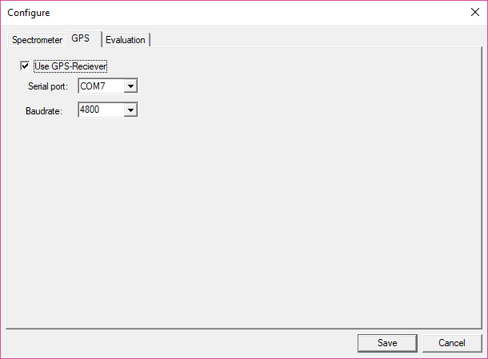
Figure 7 GPS tab of Configuration Dialog
If you use GPS receiver, the checkbox of “Use GPS Receiver” should be clicked. The COM port and baud rate (usually 4800 bps) should be chosen according to the GPS receiver. Note: if the GPS is not used then no flux can be calculated from the measurement!
If you are unsure of how to configure the GPS, go to “Control->Test the GPS” menu item. It will tell you the COM port and baud rate if one is connected:
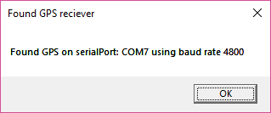
Figure 8 Pop-up from GPS test

Evaluation
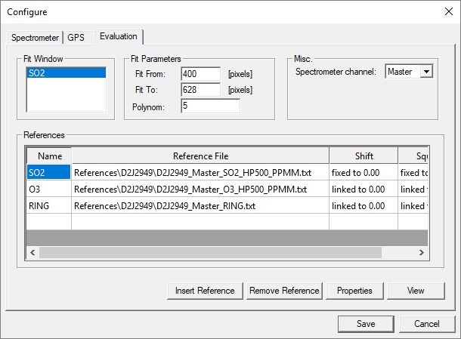
Figure 9 Evaluation tab of Configuration Dialog
In this tab you will select the parameters for the evaluation of the measured spectra.

Fit Window
The Fit Window box lists the real-time DOAS analysis routines that are configured. Typically, only a single DOAS analysis for evaluating SO2 will be configured, and this box will only have one entry. This analysis will be performed on each spectrum as it is acquired, and the results will be displayed by the software as the measurements are taken. If desired, additional DOAS analyses can be set up by right-clicking in the box and selecting ‘Insert’. For example, an analysis for bromine monoxide (BrO) could be configured that would then also run in real-time as the data is acquired.

Fit Parameters
You should first specify the range of pixels to use for the evaluation, this is done in the two edit boxes ‘Fit From’ and ‘Fit To’.

Misc
Currently it is not possible to specify separate evaluation parameters for more than one channel. Users should leave this as the default value of ‘Master’.

References
To derive gas column densities from the measured spectra, the absorption cross-sections of various trace gases are fit to the differential optical depth acquired during the measurement. Here, the reference absorption cross-sections that will be used in the fit are listed.
Each reference cross-section is specified by a separate file. The reference files are simple ASCII files that either have a *.txt or a *.xs extension. Each file must contain the same number of lines as the spectrometer has pixels. The file can have one or two columns separated by a tab. If the file has only one column, the number in that column lists the differential absorption cross-section of the respective trace gas in units of –2.5e15 cm²/molecule at the wavelength of the corresponding spectrometer pixel. If the file has two columns, the first column lists the wavelength of the respective pixel in nm, while the second column lists the differential absorption cross-section.
The supplied absorption cross-sections must be prepared individually for each spectrometer and take into account the spectrometer’s instrument line shape and optical resolution. This is typically done by convolving a high-resolution absorption cross-section with the instrument line shape, which is in turn determined by measuring a mercury vapor lamp. This process is somewhat complex, and if you are uncertain of which reference file to use, ask the supplier of your mobile DOAS system.
In order for the evaluation to work, at least one reference file must be specified. If you have not specified any reference files (that is; you don’t see anything in the box with references) then press the ‘Insert Reference’ button in the lower part of the page. This will open a dialog that makes it possible to select a reference file to use. If you wish to change the setup, then select the reference file you wish to remove in the list and press the button ‘Remove reference’. You can specify any number of references that you wish in the list of references but only the fit result of the first one will be shown on the screen when making a measurement.
To see the options for a reference, select the reference in the list and press the ‘Properties’ button. This will show the dialog seen in Figure 10. It is here possible to change how the given reference file will be used in the fitting. For example, you can specify a constant or variable shift and/or squeeze of the reference in wavelength space.
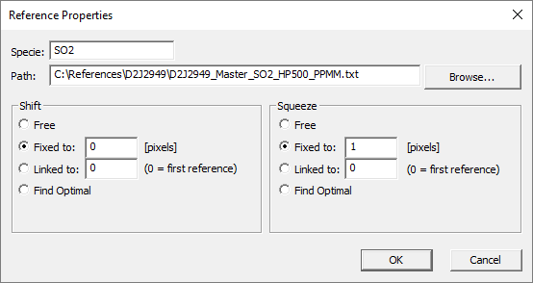
Figure 10 Reference Properties dialog

You can check the reference files that you have specified by pressing the button ‘View’, this will open the reference file window. In this window you can see the size of the reference files over the range of pixels specified by “Fit From” and “Fit To”. If you don’t see any red line in the graph, then you should check your reference files.
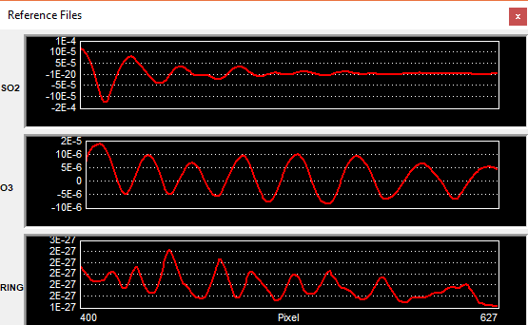
Figure 11 Reference File view window
Click “Save” to save the new configuration or “Cancel” to close the dialog without saving anything.

Performing Flux Measurements Using MobileDOAS
To perform a flux-measurement using MobileDOAS ensure that the equipment listed in section 1.1 is connected to a computer running MS Windows and has been configured as described in section 2.

Collecting Spectra

STEP 1 - Verify Configurations
Prior to each collection, double check the configurations previously created through the Configuration Dialog (see section 2.)

STEP 2 - Initial Setting
After checking the configurations; set wind speed, wind direction, and base name for the measurement in the main window. The wind speed and the wind direction parameters are used by the real-time calculation of flux. So if you are not sure about the wind speed and the wind direction, you can leave them as the default values.
The base name is the name you give to the measurement and is used when saving the spectra.

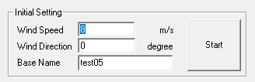
Figure 12 Initial setting in the main window

STEP 3 - Start Data Collection
Click button “Start” (shown in Figure 12) or click in the toolbar to start data collection.
You can also start data collection by clicking menu “Control → Start Traverse”.
When the data collection starts, the program tests the connections to determine if the spectrometer and GPS are connected to the computer. The software creates a folder with the name of the current date (taken from the computer’s time) inside which all measurements will be stored, with one sub-folder for each measurement performed.
The measurement starts with setting the exposure time of the spectrometer and the telescope must therefore in the beginning be pointing to the zenith. Once the exposure time is set, the number of exposures to add before storing one spectrum is calculated based on the desired time-resolution and the calculated exposure time. The dark-current of the spectrometer detector is then measured at the set exposure time; to do this the entrance of the telescope must be covered. When the dark-spectrum is measured, the program measures one “sky” spectrum, which is also sometimes referred to as Fraunhofer-reference or control spectrum. This is the reference spectrum to which all the evaluated column values will be relative, hence if this spectrum contains pollutants such as SO2 then the evaluated column values can be negative.
Each measured spectrum after the sky-spectrum is evaluated, using the dark and the sky measurements and the result is shown in the main-window and also appended to the evaluation log file in the output folder. The measured spectra, including the sky and the dark spectra, are also stored in the output – folder. The program stores the collected spectra as STD-files and it creates one evaluation log containing the results of the evaluations.

Real-Time Results
To make sure that the data-collection runs as it should, the MobileDOAS program shows running information which makes it possible to inspect the collection of data.

The Main Window
The main-plot in the main-window shows the evaluated columns of the last measured spectrum (by default as red columns), the intensity of the last spectrum (by default as white squares) and the last spectrum measured (by default as a green line for the master-channel of the spectrometer and as a red line for the slave-channel of the spectrometer, if one exists).
In the lower part of the main-window, additional information about the collected spectra is shown. The ‘Spectrometer Information’ – panel shows the following information about the last measured spectrum
- The exposure time, in milliseconds
- The evaluated column and the column error, in ppmm
- The shift used in the evaluation, normally 0
- The number of spectra measured and saved so far
- The number of exposures which are co-added in the last measurement
- The squeeze used in the evaluation, normally 1
The ‘GPS-Information’ – panel shows the following information about the last reading from the GPS-receiver:
- GPS-time in UTC
- Latitude in degrees
- Longitude in degrees
- # Satellites – the number of satellites that can be seen by the GPS-receiver. A minimum of three is required for the calculation of latitude and longitude.
If the GPS – receiver loses the connection with the satellites, the ‘GPS-Information’ - panel will give a warning by turning red.

Real-time route Graph
The real-time route graph can be opened from the menu in the main window through the menu option ‘View -> Real-time Route’. If there is a GPS-receiver connected to system, then the real-time route window shows the location of the so-far collected spectra in a latitude-longitude plot.

Spectrum Fit Window
The Spectrum-fit window can be opened from the menu in the main-window through ‘View -> Spectrum Fit’. The spectrum-fit window shows the last differentiated measured spectrum together with a scaled cross-section provided from the given reference-file. This can be used to visually inspect the quality of the DOAS fit.

Column Error
The error bars of the retrieved columns can be shown in the real-time graph. The menu option ‘View -> Column Error’ toggles the error bars on or off. The graph will be updated when the next spectrum is collected.

Flux Calculation

Flux Formula
The flux is calculated using the measured gas columns, the spatial distance between two sample points, the wind speed and the wind direction. The formula is:
Flux = column * distance * wind speed* wind factor
The wind factor is calculated by the travel direction and the wind direction:
Wind factor = cos(travel angle– wind angle+ 3π/2).
The flux can be calculated in two ways, either in real-time directly from the measurement or off-line after the measurement has been done. The real-time calculation does not allow for any inspection of the data used and should only be used to give an indication of the size of the flux.

Real-time Flux
During the measurement you can check the real-time flux. Select the menu option “Control -> Realtime Flux”, the flux value will be shown. The real-time flux calculation uses the raw column values and the wind speed and wind direction that was given when the measurement started.

Calculating Flux From File
After the measurement is finished you can calculate the flux using the post flux calculation dialog in MobileDOAS. click on the menu “Analysis -> Calculate Flux From File” or click on the button on the toolbar to open the “Post Flux Calculation” dialog.

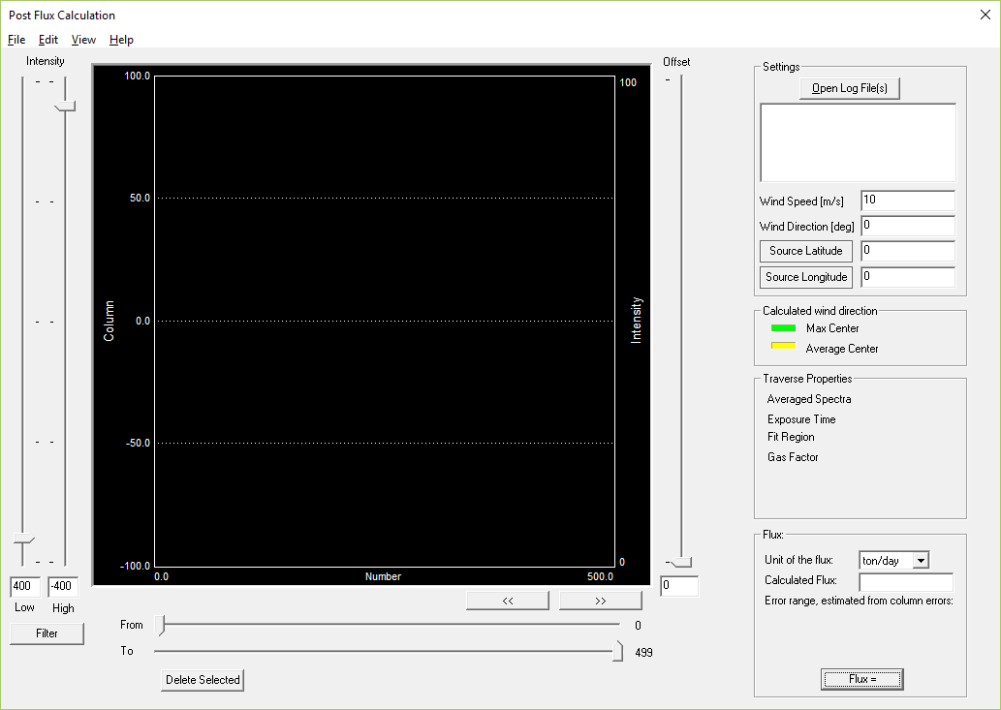
Figure 13 Post Flux Calculation dialog

STEP 1 – Set Wind Parameters and Source Coordinate
First open the evaluation log file from the measurement you want to process by pressing the button “Open Log File(s)” in the upper right corner of the dialog. The program will now read the data in the evaluation log file and show some data on the screen.
In the small list-box just below the “Open Log File(s)” button you can see which log files are currently opened and select which one to process. The main graph in the dialog shows the columns from the currently selected measurement. Notice that when a measurement has been evaluated with several references (e.g. SO2 and O3) then this will be listed as two or more evaluation logs – each one starting with the name of the trace gas. Make sure that you select the trace gas you wish to calculate the flux for!
To calculate a flux, you need to fill in the wind speed and wind direction (in degrees) at the time of the measurement in the white boxes below the evaluation log list.
MobileDOAS can also calculate a wind direction for you. If you wish use this feature, then you need to supply the latitude and longitude of the source. The wind direction is then calculated as the direction of the line directly from the source to the point where the center of the gas plume is found.
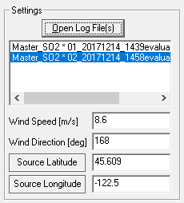
Figure 14 Post Flux Calculation Wind Settings
Note: There is one line for every reference that was included in the evaluation of the spectra. Be sure to select the specie you wish to calculate the flux for.
The wind speed and wind direction can also be imported from a text-file, see section 4.4.

STEP 2 – Delete Bad Points
Check the column plot to see whether there are any “bad points”. The “bad points” are spectra with very low or very high intensity and are usually caused by trees or buildings which are blocking the light to your telescope during the measurement or by bright clouds sending too much light into the telescope. In below example, several measurements have very low intensity caused by trees blocking the light. The intensity of each spectrum are plotted as white squares and the error in the derived gas columns.

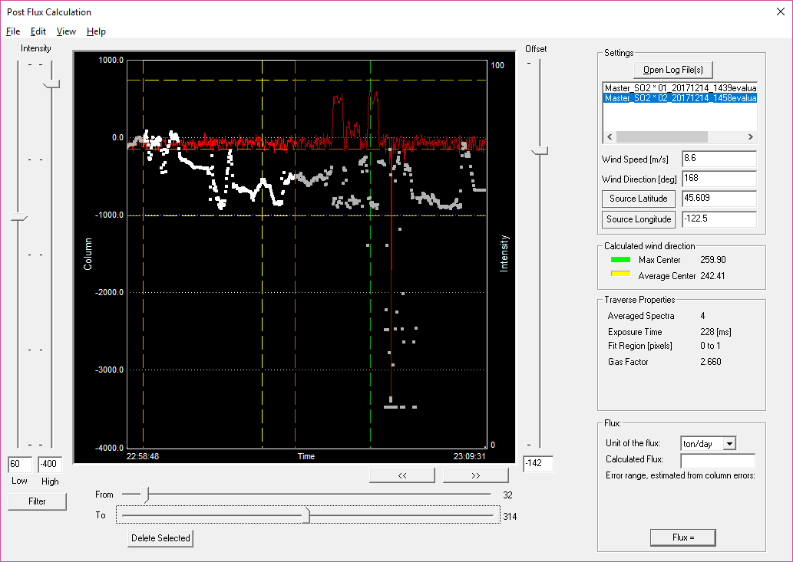
Figure 15 Example of readings with bad measurements
If you cannot see the white squares use the menu-item ‘View -> Show Intensity’ or right-click on the graph and select ‘Show Intensity’ to show the white squares. You can also see the error of each derived gas column in the plot by selecting ‘View -> Show Column Error’ or right clicking in the graph and selecting ‘Show Column Error’.
A “bad point” can be either a very low or very high concentration value, which introduces very large errors into the flux calculation.
The “bad points” can be deleted in two ways:
- By index: Use the “From” and “To” sliders to enclose the location of the “bad point”, note that points which are not in the selected range will be grayed out. The indices at which the ‘From’ and ‘To’ sliders are pointing is shown to the right of each slider. Clicking the button “Delete Selected” will delete the points between the two sliders.
- By intensity: Use the “Intensity” sliders on the left hand side of the window to define a limit on the intensity of the spectra. When you click the “Filter” button all measurements with intensity lower and higher than the defined thresholds will be deleted and a message box will inform you of the number of points deleted.
Below image shows the data from Figure 15 after deleting bad points and filtering on intensity.
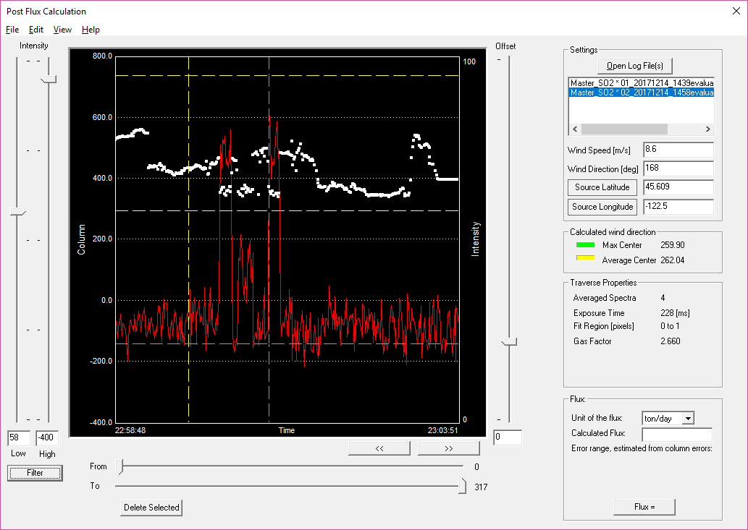
Figure 16 After deleting points

STEP 3 – Calculate Flux
Move “From” and “To” sliders to enclose the scope where you want to calculate flux. If the traverse is very long, not all measurements will be shown in the plot. You can then move the plot using the buttons. Move the “Offset” slider to set the column offset for flux calculation. Usually the offset value can be set to the lowest column value. Select the unit you want to have the flux in then click the button “Flux = ” to get the flux result. After the calculation the program generates a log file called fluxCalculation.txt which locates in the same place with the evaluation log file.

Importing a Modeled Wind Field
In cases where the traverse extends over a larger area a modeled wind field can give a more accurate result. The modeled wind fields can provide a different wind speed and wind direction for each measurement point. To import the result from a model, first open the evaluation log for which the flux shall be calculated in the post-flux dialog. Then select ‘Edit -> Import Wind field’ from the menu. This will open the ‘Include Wind Field’ dialog below.

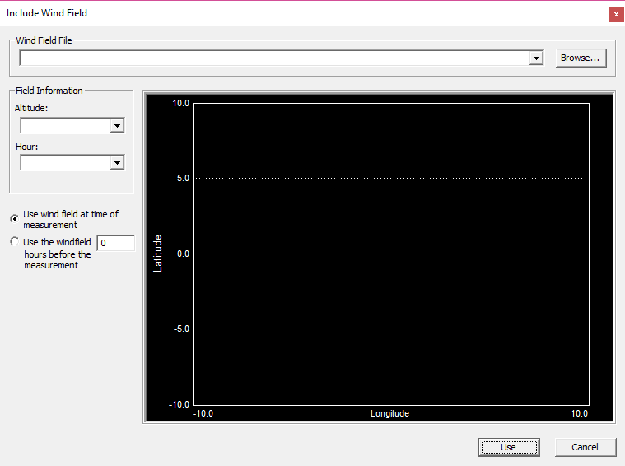
Figure 17 Include Wind Field dialog
The text-file containing the modeling can be selected by pressing the ‘Browse’ – button. If the file contains data for several altitudes and times, then the two combo-boxes in the left side of the dialog will contain all altitudes and hours for which the data is valid. Selecting a combination of one altitude and one hour will display the wind-field in the graph in the ‘Include Wind field’ dialog. The wind field is displayed as lines pointing to the direction in which the wind comes from and the relative length of each line shows the strength of the wind at that point compared to the other points. Finally, pressing the ‘Use’ button in the lower part of the dialog will import the data from the wind-field to the currently selected evaluation log.
Note:
- Only the data for the altitude selected in the ‘Altitude’ combo-box will be used.
- The time of the measurement will be compared to the time of the data points in the wind field and the correct time will be chosen automatically.
- If a measurement point does not exactly correspond to any point in the wind field file then the closest point will be selected.
- The time-stamp for each wind data-point can only be an integer hour. Measurements made in between two integer hours will be interpolated in time. E.g. for a measurement made at 13:25 the wind field will be a linear interpolation between the wind-field at 13:00 and at 14:00.
For a detailed description of the format of the files that can be imported, see section 13.

Re-Evaluation of Spectra
If the real-time evaluation of the spectra was not adequately good, the spectra can be evaluated again by using the spectrum ReEvaluation module of MobileDOAS. There are many options for how to re-evaluate a measurement. The options are organized into tabs in the ReEvaluation dialog. For most re-evaluations, the values already filled in when the dialog is opened are ok.
The ReEvaluation-dialog is reached by:
- The menu in the main-window by selecting ‘Analysis -> ReEvaluate Traverse’
- By pressing the button on the toolbar

STEP 1 – Selecting the Evaluation Log
The first step is to select the evaluation log from the performed measurement. The evaluation log should stay in the same directory as where it was created, i.e. in the same directory as all the spectra in the measurement. The evaluation log is selected by pressing the ‘Browse’ button in the ‘Evaluation log’ top part of the dialog, as shown in Figure 18. When the evaluation log is correctly opened, the measured columns in the log-file will be shown in red in the plot in the lower left part of the dialog.
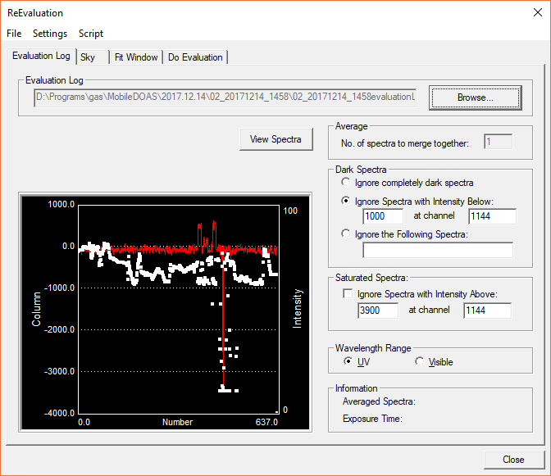
Figure 18 ReEvaluation dialog
It is possible to view the spectra in the measurement by pressing the button ‘View Spectra’, more about this in section 6.1.
There are several groups in the first page, their function is as follows:

Dark Spectra
Here it is possible to select if some spectra shall not be evaluated. For example, spectra with very low intensity will give very bad values, and it can therefore be justified to ignore some measurement points already in the evaluation instead of removing them later, in the post-flux calculation. There are three options:
- Ignore completely dark spectra. Only spectra where there is no light whatsoever will be ignored.
- Ignore Spectra with Intensity below: Lets the user select the channel at which the intensity should be judged and a desired threshold intensity for ignoring spectra.
- Ignore the Following Spectra: If the user knows the indices of some spectra that should be ignored, their indices can be typed into the edit-box as a comma, or space separated list.

Saturated Spectra
Similar to the ‘Dark Spectra’ box above, but here the user can select to ignore spectra with too much light. Spectra with too high light-level are saturated and does not contain any information in the saturated regions. The user has here the possibility to specify a pixel/channel to judge the intensity and the desired maximum level of intensity that should be allowed at that pixel/channel. Saturated spectra will only be ignored if the checkbox is checked.

Wavelength Range
In the evaluation of a spectrum, the spectra will automatically be corrected for stray-light using a simple heuristic method. This correction is different if the spectrum starts in the deep UV-region or in the (near) visible region. Select the ‘UV’ – radio button of the spectrometer starts at a wavelength of 300 nm or less.

STEP 2 – The Sky Spectrum
The measurement is evaluated using one spectrum as ‘sky’ reference. This spectrum is used to remove Fraunhofer structures in the measured spectra, and all evaluated values will be relative to this spectrum. The sky spectrum can be selected in several ways, and the different options will give different qualities of the resulting measurement value.
- Use fist spectrum as sky reference – The default option, this is also the behavior for the real-time evaluation.
- Use average of all spectra as sky reference – An average value of all spectra will be used as sky reference. This can improve the quality of the fit, if all spectra in the measurement are good.
- Use the following spectrum: A specified spectrum will be used as sky-reference. This can improve or worsen the fit, depending on which spectrum is chosen. This can make it easier to compare several measurements.

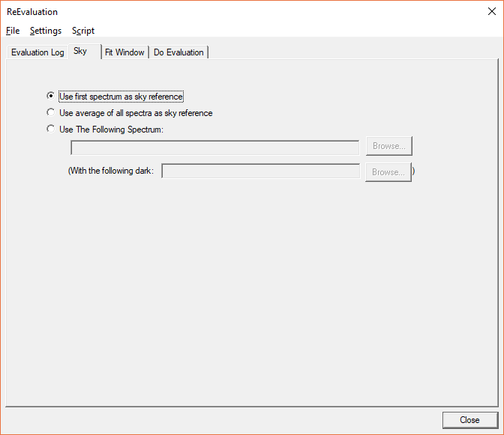
Figure 19 Sky tab in the ReEvaluation dialog

STEP 3 – The Fit Window
The most important step in the ReEvaluation dialog is to select the parameters for the evaluation of the measured spectra. The settings here are similar to that of the Evaluation tab in the Configure dialog. Refer to section 2.3 on usage.

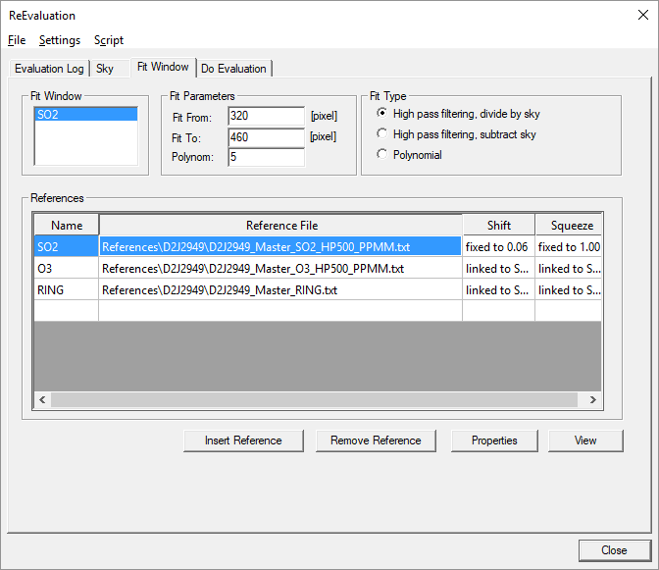
Figure 20 The Fit Window tab of the ReEvaluation dialog.

Storing Fit Window Settings
When you have configured a set of parameters that works well for your spectrometer then you can save these settings to a file (so that you don’t have to type in the same things the next time). To do so select the menu option ‘Settings→Save Settings to File’ and select where to store the file. The next time you open the re-evaluation dialog these settings can be re-read from the file by selecting the menu option ‘Settings→Load Settings from File’. Notice that it is good to make sure that the settings actually work well for your spectrometer before storing them to file. This can be done by running the re-evaluation as described below and when this is done (and all looked fine) select the menu option ‘Settings→Save Settings to File’. The stored files will have the file extension of ‘rxml’.

STEP 4 – Re-Evaluating
The final page in the ReEvaluation – dialog is the ‘Do Evaluation’ – page. Pressing the ‘Evaluate NOW’ button will cause the program to evaluate all the spectra in the measurement using the chosen settings. The spectral fit of each evaluated spectrum will be shown in the graph in the upper right part of the page, and any messages will be shown in the text-box in the upper left part of the page.

Pressing the ‘Pause’ – button will cause the re-evaluation to make a pause after the evaluation of each spectrum, to enable visual inspection of the fit. The fit will continue after pressing the ‘Next…’ button, which replaces the ‘Evaluate NOW’ button.
Pressing the ‘Cancel’ – button to the right of the ‘Evaluate NOW’ button will cause the program to stop the ReEvaluation.
Note – do not press the ‘OK’, ‘Cancel’ or ‘Close’ buttons in the lower right part of the dialog when spectra are evaluating.
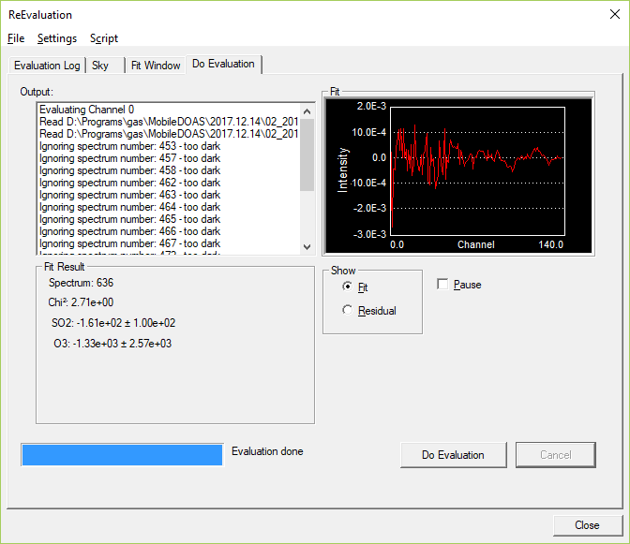
Figure 21 Do Evaluation tab in Evaluation dialog

Scripting the Re-Evaluation (Advanced)
If you have a large set of MobileDOAS measurements that you need to ReEvaluate then the possibility to create ReEvaluation scripts can prove useful. You need to prepare this by saving the settings in the fit window page to file (see section 5.3.1). The scripts are created through the ReEvaluation Script dialog which is accessed from the ReEvaluation dialog by the menu option ‘Script→Create Script’, this opens the dialog shown in Figure 21.
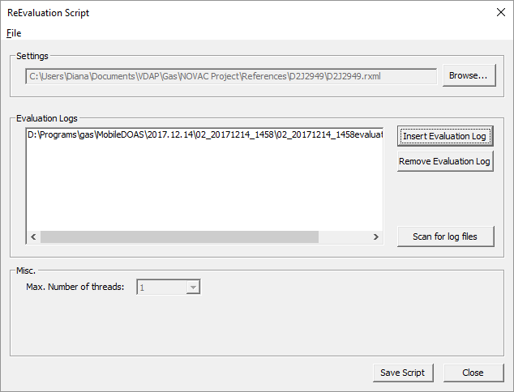
Figure 22 ReEvaluation Script dialog
Begin by selecting the file containing the settings from the fit window page by pressing the button ‘Browse’ and select the RXML – file created earlier. You then need to specify the evaluation logs from the measurements you wish to re-evaluate. There are two ways to do this;
- Press the ‘Insert Evaluation Log’ button and select an evaluation log file that you wish to process. Press this button again for each evaluation log file you wish to include.
- Press the ‘Scan for log files’ button and select a directory. This will scan the directory structure for evaluation log files and automatically insert all evaluation log files in all sub-directories to the one you chose.
You can always remove an evaluation log file from the list by selecting it in the list of files and pressing the button ‘Remove Evaluation Log’.
When you are happy with your settings, press the button ‘Save Script’ in the bottom of the dialog to store the script to file. The file is given the file-ending .rs. You can later open this script again by opening the same dialog and selecting the menu option ‘File→Load Script’.
To run a ReEvaluation script, go to the ReEvaluation dialog and select the menu option ‘Script→Run Script’. This will automatically start the re-evaluation of the spectra and the results of the spectral fitting will be shown in the graph in the ‘Do Evaluation’ page. Notice that it can take a very long time for the script to finish.

Other Measurement Modes

Viewing Spectra Directly From the Spectrometer
Sometimes it is useful to be able to view spectra directly from the spectrometer without saving the spectra, e.g. when checking the light level, adjusting the optics of the instrument or checking that the fiber is not damaged. There is a special measurement mode in MobileDOAS which does this, to start this click “Control→View Spectrometer Output” in the main menu or click the button in the toolbar. This will open two new windows, as can be seen in Figure 22.
In this measurement mode are spectra continuously collected using the settings that are found in the “Spectrum collection settings” window. To exit this mode, press the stop button in the toolbar or close the program.
The window “Spectrum collection settings” allow you to change the exposure time that is used when acquiring spectra and the number of spectra that are averaged together. If more than one spectrometer is connected to the computer, you can also select which spectrometer should be used. Pressing the button “Save spectrum” allows you to save the last acquired spectrum (the one shown on the screen).
The window “Spectrum scale” modifies the scaling of the plot.
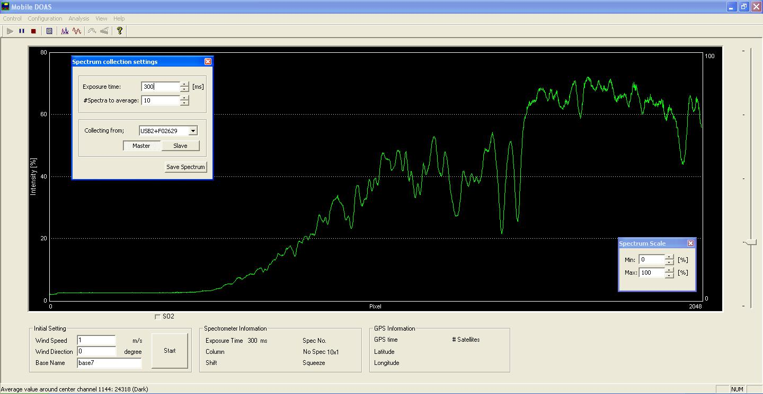
Figure 23 Real-time spectra viewing

Real-Time Analysis From a Directory
MobileDOAS can view and analyze spectra collected externally by watching a directory for new spectrum (.std) files. The option is available via the “Control->Real-Time Analysis From Directory” menu option. When this mode of collection is started, it first looks for starting files in the directory specified in the “Directory” tab of the configuration dialog. For automatic and fixed exposure time modes, the program requires sky (sky_0.std) and dark (dark_0.std) files. If the files are in the watch directory when collection is initiated, it will use those files. Otherwise it will use the default files specified in the “Directory” configuration. For adaptive mode, the program will similarly look for sky, darkcur (darkcur_0.std), and offset (offset_0.std) files. After the required files are read, the program will check the watch directory for normal spectrum files (e.g. 00001_0.std). If a file is found it will read the file, analyze it, and plot the spectra and column. After a file is processed it will wait X milliseconds, where X is the value specified for sleep time in the configuration, and check the directory for a new file. During each check, only the newest spectrum file is read and plotted. Whenever a new file is not found, it will wait and periodically check the directory for it.
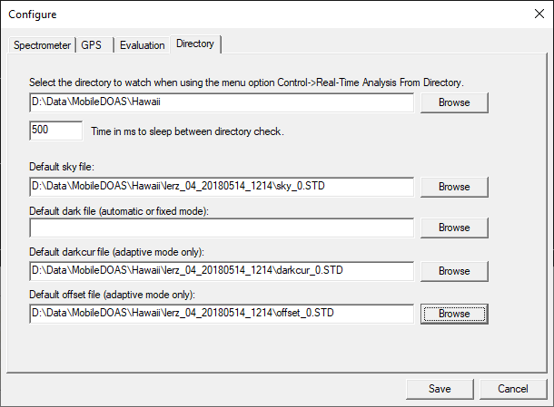
Figure 24 Options for collecting spectra from a directory

Other Functions

Viewing Collected Spectra
It is possible to view the spectra collected in a measurement by opening the Spectrum Inspection Dialog. This can be found by either:
- Clicking on the menu option ‘Analysis→View Measured Spectra’ from the menu in the main window.
- Opening the ReEvaluation dialog, selecting an evaluation log file and pressing the ‘View Spectra’ button.
In this dialog you can select an evaluation log file by pressing the ‘Browse’ button. Once the evaluation log file is opened you can see each of the measured spectra and the properties for each single spectrum. The spectra can be browsed through by moving the slider bar just above the spectrum graph. Notice that the evaluation log file must be in the same directory as the measured spectra.
It is possible to zoom in the spectrum by clicking and dragging with the left mouse button in the graph. Clicking the right mouse button will restore the zoom level to its original value.
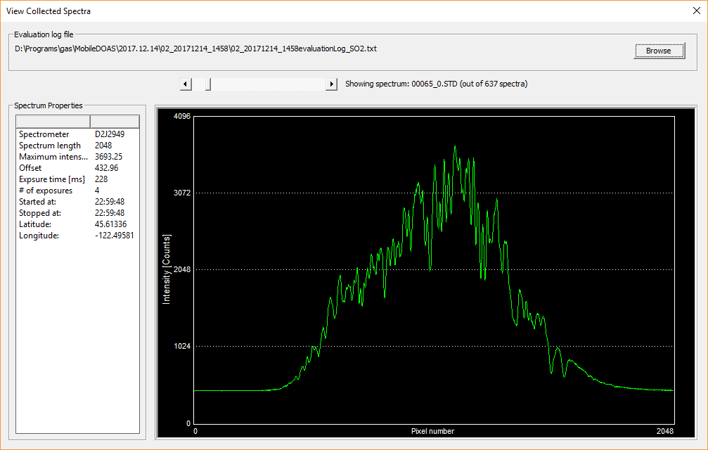
Figure 25 View Collected Spectra dialog

The Route Dialog
You can see a plot of the route traversed during a measurement by first opening the measurement in the Post Flux Calculation dialog then pressing the menu option ‘View→Show Route Map’ or by right-clicking in the graph and clicking the menu option ‘Show Route Map’. The route graph shows the position for each measured spectrum on a square latitude-longitude plot. The start point of the traverse is marked with a big green square
The graph can also show the position of the source as a red square if the check button “Show Source” is checked and a latitude and longitude is typed into the “Lat” and “Lon” boxes.
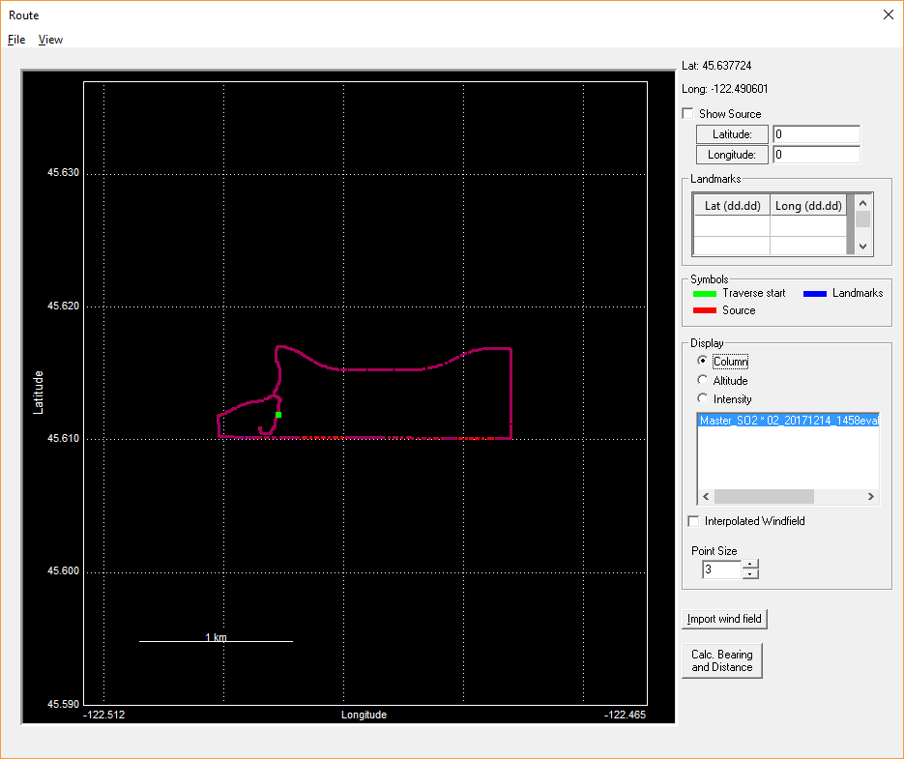
Figure 26 Route dialog opened from Post Flux Calculation dialog
On the right hand side in the window there is are three radio buttons in the “Display” section. Checking the radio button “Column” will make the graph show the measured column values using a color range varying from blue as the lowest values ranging to red as the highest values. Using the radio buttons the plot can also be made to show the Column error or the altitude of the measurement, on a relative scale.

View Options
In the menu ‘View’ found in the route dialog there are many options for how to draw the graph, e.g. can the column values in the graph be shown either by color (with blue indicating the lowest values, and red as the highest) or by size of the squares (larger squares correspond to higher values).

Zoom
It is possible to zoom the graph by clicking and dragging the mouse cursor in the graph. Starting the click from the upper left corner and dragging the cursor to the bottom right corner increases the zoom (i.e. zooms in). Starting the click from the lower right corner and dragging the cursor to the upper left corner decreases the zoom (i.e. zooms out). The original zoom-level is restored by right clicking anywhere in the graph.

Distance and Bearing Calculation
It is possible to calculate the distance and bearing between any two points on the graph. Start by pressing the “Calc. Bearing and Distance” button on the right. The program will tell you to click on the first point in the graph. When clicking on the second point in the graph the program will tell you the distance and initial bearing between the two points.

Landmarks
To mark other points on the route graph, type in their latitude and longitude in the grid under ‘Landmarks’. If a wind-field has been imported for the currently shown measurement, the direction of the wind at each measurement-point can be shown by marking the checkbox ‘Interpolated Windfield’ found in the ‘Display’ group on the right hand side of the dialog. The colors of the background, the grid and the lines displaying the wind-field can be changed. The entire plot can be saved to an image file from the ‘File -> Save Graph as Image’ menu.

Exporting Evaluated Results to Google Earth
The gas columns from a measurement with MobileDOAS can be exported to KML for viewing in Google Earth. This is done by opening the evaluation log file in the Post Flux Calculation dialog and selecting the menu option “File→Export traverse to Google Earth”. This will bring up a dialog asking for a file name and where to store the file. After pressing “Save” here another dialog will pop up asking for which scaling height to use in the file. The scaling height is the height that the highest column in the measurement will take, what value you should use depends on the terrain around the measurement and the size of the measurement. You can try this process several times with different scaling heights and try which one looks good for you.
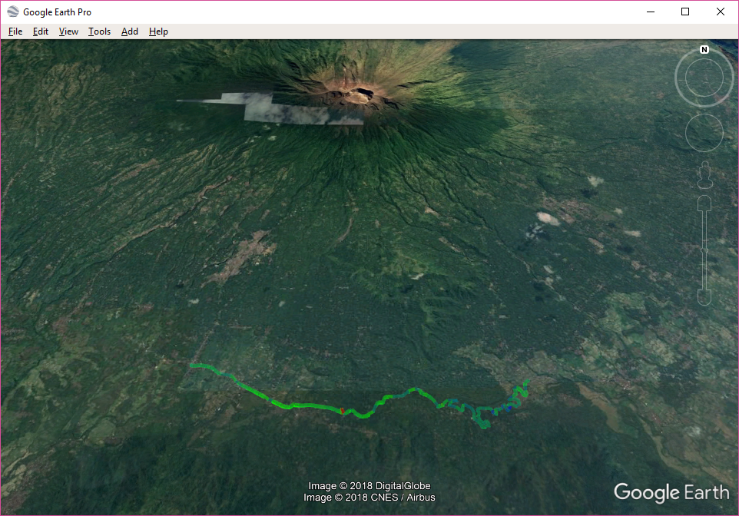
Figure 27 Measurement made in MobileDOAS exported to KML and displayed in Google Earth

Testing the GPS Connection
When using a GPS-receiver with USB-port that simulates a serial-port there can sometimes be an uncertainty of which serial-port contains the GPS-receiver. This can be tested by pressing ‘Control→Test The GPS’ in the menu in the main-window. This will sequentially run through the serial-ports 1 to 10 and test each one for the presence of a GPS-receiver. When a GPS-receiver is found, the user will be informed of the name and number of the serial-port through a message-box.

Plot Setting
You can set the background color and the plot color. Choose “Plot Setting->Set Background Color” to change background color. Choose “Plot Setting->Set Plot Color” to change the histogram color.

Pause and Exit

Click on the toolbar to pause the program.

Click on the toolbar to exit the program.

File Formats
Software versions prior to 4.4 used cfg.txt as the configuration file. This file format has been deprecated and it is recommended that the configuration file is recreated using the latest version of MobileDOAS.
MobileDOAS version 4.4 and higher uses cfg.xml as the configuration file. All versions of MobileDOAS are capable of reading the old file format (cfg.txt) however as from version 4.4 MobileDOAS can only write the new file format (cfg.xml).

Parameters
The configuration file consists of a number of parameter definitions and a number of sections. These are all described below. An example of a cfg.xml file can be seen in section 8.2.
Parameter | Description | Scope | Example
serialPort | The port ot use, normally USB but can also be any COM port. | USB, COM1, COM2, … | USB
timeResolution | Time between two consecutive spectra measurements in milliseconds. Used for the exposure time calculation. | >500 | 5000
nchannels | Number of channels to use in the spectrometer | 1 or 2 | 1
maxColumn | Beep volume = (current column/max column)*max volume |  | 200

Intensity Section
The parameters described in the intensity section are used to determine the exposure time for the spectra. The parameters used are:
Parameter | Description | Scope | Example
Channel | The pixel around which to measure the intensity of the spectrum. | 1 to 2047 | 1150
Percent | The desired intensity of the spectrum around the pixel specified by Channel in percent. | 0 to 100 | 80
FixExpTime | How to calculate the exposure time:  0 – Automatic exposure time  >0 – Fixed exposure time in milliseconds  < 0 – Adaptive exposure time |  | 0

GPS Section
The GPS section defines how (and if) MobileDOAS should communicate with the GPS receiver.
Parameter | Description | Scope | Example
use | Use GPS receiver or not | 1 – use GPS receiver;  0 – do not use GPS receiver | 1
baudrate | The baud rate to use when communicating with the GPS | 1200 to 115200 | 4800
Port | The serial port to use when communicating with the GPS | COM1, COM2, … | COM4

The Offset section
The offset section defines how MobileDOAS should correct for the offset of the spectra. This feature enables a first level compensation for stray-light in the spectrometer but can also compensate for a changing offset level (for spectrometers which have a problem with this).
If both from and to are set to 0 then no offset correction will be performed.
Parameter | Description | Scope | Example
from | The lowest pixel to use when calculating offset | 1 to 2048 | 50
to | The highest pixel to use when calculating offset | 1 to 2048 | 200

The Fit Window Section
The fit window section defines how to evaluate the spectra that are collected in the measurement. There can be several fit windows defined, they must however differ either in the channel they use or in the name.
The fit window section also contains a number of Reference-sections, each defining how to fit a single reference file to the spectrum.
Parameter | Description | Scope | Example
name | The name of the fit window | Any string | SO2
fitLow | The lowest pixel to use when performing the DOAS fit | 1 to 2048 | 340
fitHigh | The highest pixel to use when performing the DOAS fit | 1 to 2048 | 561
spec_channel | The channel on the spectrometer that this fit window is valid for | 0 or 1 | 0
polynomial | The order of the polynomial to include in the DOAS fit | 0 to 5 | 5

The parameters of the reference section:
Parameter | Description | Scope | Example
name | The name of the reference | Any string | SO2
path | The full path to the reference file, including directory and file name. | Any string | C:\spec\SO2_reference.xs
gasFactor | The conversion factor to convert from ppmm to mg/m2 | >0 (depends on the gas) | 561
shift | The shift to apply to the reference when performing the DOAS fit |  | fix to 0.0
squeeze | The squeeze to apply to the reference when performing the DOAS fit |  | fix to 1.0

Example of Configuration File
<?xml version="1.0" encoding="ISO-8859-1"?>
<!-- This is the configuration file MobileDOAS -->

<Configuration>
<serialPort>USB</serialPort>
<timeResolution>1000</timeResolution>
<nchannels>1</nchannels>
<maxColumn>1500.00</maxColumn>
<Intensity>
<Percent>70</Percent>
<Channel>1144</Channel>
<FixExpTime>0</FixExpTime>
</Intensity>
<GPS>
<use>1</use>
<baudrate>4800</baudrate>
<port>COM3</port>
</GPS>
<Offset>
<from>50</from>
<to>100</to>
</Offset>
<FitWindow>
<name>SO2</name>
<fitLow>400</fitLow>
<fitHigh>628</fitHigh>
<spec_channel>0</spec_channel>
<polynomial>5</polynomial>
<Reference>
<name>SO2</name> <path>C:\References\D2J2949\D2J2949_Master_SO2_HP500_PPMM.txt</path>
<gasFactor>2.66</gasFactor>
<shift>fix to 0.00</shift>
<squeeze>fix to 1.00</squeeze>
</Reference>
<Reference>
<name>O3</name>
<path>C:\References\D2J2949\D2J2949_Master_O3_HP500_PPMM.txt</path>
<gasFactor>1.99</gasFactor>
<shift>link to 0</shift>
<squeeze>link to 1</squeeze>
</Reference>
<Reference>
<name>RING</name>
<path>C:\References\D2J2949\D2J2949_Master_RING.txt</path>
<gasFactor>2.66</gasFactor>
<shift>link to 0</shift>
<squeeze>link to 1</squeeze>
</Reference>
</FitWindow>
</Configuration>

Reference File
The reference files should contain the differential cross section of 1 ppmm of a single specie of interest e.g. SO2 or NO2.
The reference files that are used should be in ASCII format and contain only one or two columns. If the file contains only one column, then this should specify the magnitude of the reference cross section. If the file contains two columns then the left should specify the wavelength.
The file can end with .txt or .xs.

Spectrum File
The program records all the spectra in the extended STD file format, which is a human readable ASCII – file format.
- The sky spectrum is stored as sky.STD file.
- The dark spectrum is stored in dark.STD file.
- All other spectra are stored in STD files named with continuous numbers.
If using multi-channel spectrometers, the spectra from the master channel will end with “_0.STD” and the spectra from the slave channel will end with “_1.STD”.

Evaluation Log File
The program generates the evaluation file in which evaluation results are stored.
The beginning of the file is the copy of configuration. After that comes a table containing the GPS time, latitude, longitude, altitude (from the GPS), number of spectra averaged in each saved spectrum, exposure time of the spectrum (in ms), average intensity, column, column error and the name and path to the spectrum file.

Example of Evaluation Log File
***Desktop Mobile Program***
VERSION=6.0
FILETYPE=evaluationlog
BASENAME=test39
WINDSPEED=8.000000
WINDDIRECTION=0.000000
***copy of related configuration file ***
SERIALPORT=USB
GPSBAUD=4800
GPSPORT=COM4
TIMERESOLUTION=1000
FIXEXPTIME=0
FITFROM=400
FITTO=628
POLYNOM=5
FIXSHIFT=1
FIXSQUEEZE=1
SPECCENTER=1144
PERCENT=0.700000
MAXCOLUMN=1500.000000
GASFACTOR=2.660000
REFFILE=C:\Users\Diana\Documents\VDAP\Gas\NOVAC Project\References\D2J2949\D2J2949_Master_SO2_HP500_PPMM.txt
REFFILE=C:\Users\Diana\Documents\VDAP\Gas\NOVAC Project\References\D2J2949\D2J2949_Master_O3_HP500_PPMM.txt
REFFILE=C:\Users\Diana\Documents\VDAP\Gas\NOVAC Project\References\D2J2949\D2J2949_Master_RING.txt

***Spectrometer Information***
SERIAL=D2J2949
DETECTORSIZE=2048
DYNAMICRANGE=4096
MODEL=ADC1000-USB

#Time Lat Long Alt NSpec ExpTime Intens(Master) Master_Column_SO2 Master_ColumnError_SO2 Master_Column_O3 Master_ColumnError_O3 Master_Column_RING Master_ColumnError_RING STD-File(Master)

23:51:08 45.618945 -122.477610 89.0 270 3 395 0.000000 0.000000 0.000000 0.000000 0.000000 0.000000 C:\Users\Diana\git\MobileDOAS\x64\Debug\2018.01.04\test39_20180104_1550\00000_0.STD
23:51:11 45.618945 -122.477610 89.0 270 3 395 0.000000 0.000000 0.000000 0.000000 0.000000 0.000000 C:\Users\Diana\git\MobileDOAS\x64\Debug\2018.01.04\test39_20180104_1550\00001_0.STD
23:51:15 45.618945 -122.477610 89.0 270 3 395 0.000000 0.000000 0.000000 0.000000 0.000000 0.000000 C:\Users\Diana\git\MobileDOAS\x64\Debug\2018.01.04\test39_20180104_1550\00002_0.STD

Flux Calculation File
Flux calculation file (fluxCalculations.txt) is generated after the post flux calculation. It is located in the same directory with the evaluation log file that has been calculated.

Sample Content of Flux Calculation File
524.547038 [ton/day]
Processed file: C:\Evaluation Logs\TEST05_20171202_0909evaluationLog_SO2.txt
Processed time: 2017.12.21 15:01:24
Wind Speed=10.000000
Wind Direction=0.000000
Source latitude=0.000000
Source longitude=0.000000
Column offset=-8.276690
PlumeWidth=97 [m]
TraverseLength=31155 [m]

File Format to Import Modeled Wind-Field
The MobileDOAS can import the results from meteorological models into the post-flux calculation in order to improve the quality of the calculated flux. The wind field is in plain ASCII for simplicity. The ordering is primarily on position, with one paragraph for each position. Each paragraph starts with the line:
Lat=XX.XXXX Long=YY.YYYYYY

The latitude is positive on the northern hemisphere and the longitude is positive in the eastern hemisphere.
The following line is a header-line for the data-table for that position. The header-line should have the following format:
Altitude Hour WD [deg] WS [m/s] Hour WD [deg] WS [m/s]

Where the three strings ‘Hour WD [deg] WS [m/s]’ is repeated once for each time-stamp available for that altitude. Notice that each item is separated by tabs, except for the separation between the item (‘WD’ or ‘WS’) and their unit which are separated by spaces.

The data-table is sorted with one altitude per line and three columns for each time-stamp. An example of a line in the data-table matching the above given header-line:
98.07 21 140.58 10.85 22 147.84 11.36

The unit of the altitude is optional, this is only to give the data meaning to the user and is not used in the flux calculation. The unit of the wind speed must be meters per second and the wind direction must be in degrees.
Each paragraph is followed by one or more empty lines, marking the end of the paragraph. There cannot be more than 24 time-values for each altitude (each accompanied with one wind direction and one wind speed) and no more than 50 altitudes for each measurement point.

Example of a Small Wind-Field Data File
Lat=19.491840 |  | Long=-99.015170
Altitude Hour |  | WD [deg] |  | WS [m/s] |  | Hour | WD [deg] | WS [m/s]
28.55 | 21 | 136.77 | 9.35 | 22 | 144.89 | 9.74
98.07 | 21 | 140.58 | 10.85 | 22 | 147.84 | 11.36
192.71 | 21 | 143.82 | 11.06 | 22 | 150.58 | 11.62
313.09 | 21 | 147.63 | 10.86 | 22 | 153.99 | 11.41
Lat=19.493700 |  | Long=-99.015380
Altitude Hour |  | WD [deg] |  | WS [m/s] |  | Hour | WD [deg] | WS [m/s]
28.55 | 20 | 140.08 | 6.74 | 21 | 136.77 | 9.35
98.07 | 20 | 143.00 | 7.73 | 21 | 140.58 | 10.85
192.71 | 20 | 145.26 | 7.84 | 21 | 143.82 | 11.06
313.09 | 20 | 147.86 | 7.66 | 21 | 147.63 | 10.86
Lat=19.512640 |  | Long=-99.014650
Altitude Hour |  | WD [deg] |  | WS [m/s] |  | Hour | WD [deg] | WS [m/s]
28.54 | 21 | 140.11 | 8.86 | 22 | 147.05 | 9.92
98.03 | 21 | 142.39 | 10.34 | 22 | 149.01 | 11.57
192.61 | 21 | 144.40 | 10.57 | 22 | 151.06 | 11.82
312.93 | 21 | 146.89 | 10.40 | 22 | 153.81 | 11.60

Troubleshooting
All suggestions presented in this chapter aim to allow the users to solve the most common problems they may encounter.
Communication problem, restart data collection
Description | The communication between the spectrometer and the computer does not work or the spectrometer has no power.
Solution | Check whether the serial cable is well connected and whether the spectrometer has power.
Timeout
Description | The communication between the spectrometer and the computer does not work or the spectrometer has no power.
Solution | Check whether the serial cable is well connected and whether the spectrometer has power.
Spectra are collecting
Description | You have clicked the “Start” button a second time.
Solution | This does not affect the operation of the program.
First byte of transmission is incorrect
Description | The communication between the spectrometer and the computer does not work correctly. This only happens when communicating with the spectrometer through a serial cable.
Solution | Check the physical connection and restart the program.
Cannot handle more than X channels. Changed number of channels to 2
Description | You have specified too many channels in the configuration file.
Solution | This will change your settings to use only two channels. Next time change the settings before starting the program.
A negative amount of channels defined in the configuration file. This does not make sense, will change number of channels to 1
or
Zero channels defined in the configuration file. This does not make sense, will change number of channels to 1
Description | You have specified an illegal number of channels in the configuration file.
Solution | Revise the settings and restart.
There are no reference-files defined in the configuration file. Please check settings and restart.
Description | You have not specified any references in the cfg.xml file or there are errors in cfg.xml.
Solution | Check the settings and restart.
Cannot open reference file: XYZ for reading
or
Cannot read reference file XYZ Please check the file location and restart collection
Description | One of the reference files specified in cfg.xml is in the wrong format, not readable or not existing.
Solution | Check the settings and restart.
There are X columns in the reference file. This programs wants reference files with one or two columns.
Description | One of the reference files specified in cfg.xml is in the wrong format.
Solution | Check the reference files specified in cfg.xml and restart.
Length of the reference file is: X values. Cannot handle references with more than Y data-points.
Description | One of the reference files specified in cfg.xml is too long.
Solution | Check the reference files specified in cfg.xml and restart.
Could not open evaluation log file. No data was written!
or
Could not write log file: XYZ. Not enough free space?
Description | The evaluation log file could not be opened for writing.
Solution | Check that the disk is not full and that you have write access permission to the directory. (Attempt to make file manually to verify.)
Could not create output directory.
Description | The output directory could not be created in the directory where MobileDOAS executable resides.
Solution | Check that the disk is not full and that you have write access permission to the directory. (Attempt to make file manually to verify.)

No spectrometer found. Make sure that the spectrometer is attached properly to the USB-port and re-start the program.
Description | The program could not contact the spectrometer.
Solution | Check that the spectrometer is plugged in. If it is then unplug it, wait a little and plug it in again to see if it helps.
Cfg.txt specifies 2 channels to be used but spectrometer can only handle one. Changing configuration to handle only one channel.
Description | The configuration specifies that two channels are to be used but the spectrometer only has one.
Solution | Check cfg.xml and restart.
Fit exception
Description | The evaluation procedure is not correct.
Solution | Check that the reference file is correct, that the fit range is valid and that you have not specified the same reference file twice in a fit window.
Failed to initialize spectrometer
or
NAK1
or
TimeoutX
Description | This can happen when using the serial port to communicate with the spectrometer. Either a failure in the serial cable or in the power supply to the spectrometer.
Solution | Check the physical connection to the spectrometer, check that the spectrometer has power and restart the program.
Could not communicate with GPS. No GPS-data can be retrieved!
Description | The communication with the GPS failed for some reason.
Solution | Stop the program. Check the physical connection to the GPS receiver, check that the correct baud rate and serial port has been entered in the settings.
Illegal GPS-Port. No GPS-data can be retrieved!
Description | The serial port for the GPS receiver that is specified in the configuration does not exist on this computer.
Solution | Check the settings and restart.
It seems like the dark spectrum is not completely dark, consider restarting the program.
Description | MobileDOAS tries to judge if the collected dark spectrum is actually dark.
Solution | Look at the dark-current spectrum that is drawn on the screen (typically in green). If this is not a dark spectrum, then restart the program and try again. If this is a dark spectrum then you can continue the measurement.
It seems like the sky spectrum is dark, consider restarting the program
Description | MobileDOAS tries to judge if the collected sky spectrum has enough intensity to be useful.
Solution | Look at the spectrum that is drawn on the screen (typically in green). If this indeed has too little light, then restart the program and try again. If this is an ok spectrum then you can continue the measurement.

Length of the reference file is: X values. Cannot handle references with more than Y data-points.
Description | One of the reference files specified in cfg.xml is too long.
Solution | Check the reference files specified in cfg.xml and restart.

MobileDOAS version 4.4 and below used cfg.txt as configuration file. If you are upgrading from these older versions, it is recommended that you create cfg.xml using the configuration dialog per section 2.

