Interactive Scripts

# Instructions

Complete the array practice problems below by having MATLAB compute them sequentially from a .m file. **Use disp() or fprintf() to send answers to the command window.**

Most of the variable names should be given in the problem. If not, name them something that makes sense. Please make sure that you are commenting appropriately and that you are following the problem instructions.

# Problems

1. The Heat Index *HI*, calculated from the air temperature and relative humidity, is the apparent temperature felt by the body. An equation used by the National Weather Service for calculating *HI* is given by: $HI=−42.379+2.04901523T+10.14333127R−0.22475541TR−6.83783×{10}^{−3}T^{2}−5.481717×{10}^{−2}R^{2}+1.22874×{10}^{−3}T^{2}R+8.5282×{10}^{−4}TR^{2}−1.99×{10}^{−6}T^{2}R^{2}$ 
      
   where *T* is the temp in degrees Fahrenheit and *R* is the relative humidity in integer percentage. Write a MATLAB program in a script file that calculates *HI.* For input the program *should ask the user* to enter values for *T* and *R*. For output the program displays the message: “The Heat Index temperature is: XX” where XX is the value of the heat index rounded to the nearest integer.
2. The stress intensity factor *K* at a crack in a beam exposed to pure bending *M* is given by:  
   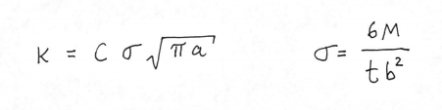  
   *a* is the crack length, *b* is the width, *t* is the thickness, and *C* is a parameter that depends on the geometry of the specimen and crack.  
   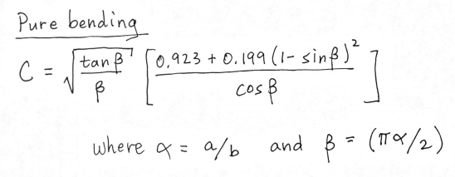  
   Write a program in a script file that calculates the stress intensity factor *K*. The program should prompt the user to input the values of *M*, *b*, *t*, and *a*. The output should be in the form of a paragraph combining text and numbers. Something like “The stress intensity factor for a beam that is 0.25 m wide and 0.01 m thick with an edge crack of 0.05 m and an applied moment of 20 N-m is XX pa-sqrt(m).” where XX stands for the value of *K.*