Transmission Media
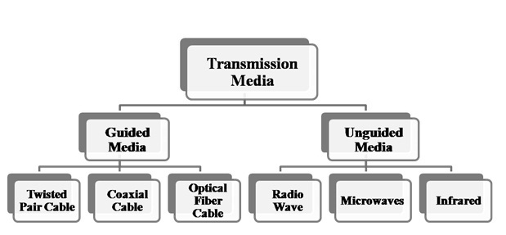

Guided Media It is defined as the physical medium through which the signals are transmitted. It is also known as Bounded media.
Guided Media− In guided media, transmitted data travels through cabling system that has a fixed path. For example, copper wires, fibre optic wires, etc.
Types Of Guided media:
The degree of reduction in noise interference is determined by the number of turns per foot. Increasing the number of turns per foot decreases noise interference.
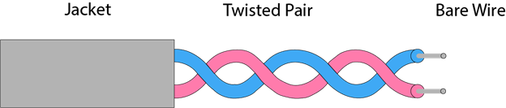

Types of Twisted pair:
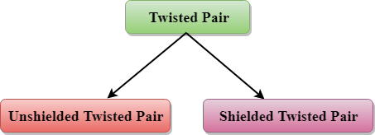

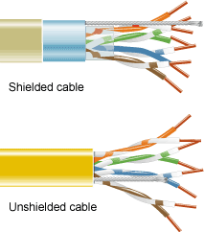
Unshielded Twisted Pair:
An unshielded twisted pair is widely used in telecommunication. Following are the categories of the unshielded twisted pair cable:
- Category 1: Category 1 is used for telephone lines that have low-speed data.
- Category 2: It can support upto 4Mbps.
- Category 3: It can support upto 16Mbps.
- Category 4: It can support upto 20Mbps. Therefore, it can be used for long-distance communication.
- Category 5: It can support upto 200Mbps.
Advantages Of Unshielded Twisted Pair:
- It is cheap.
- Installation of the unshielded twisted pair is easy.
- It can be used for high-speed LAN.
Disadvantage:
- This cable can only be used for shorter distances because of attenuation.

Shielded Twisted Pair
A shielded twisted pair is a cable that contains the mesh surrounding the wire that allows the higher transmission rate.
Characteristics Of Shielded Twisted Pair:
- The cost of the shielded twisted pair cable is not very high and not very low.
- An installation of STP is easy.
- It has higher capacity as compared to unshielded twisted pair cable.
- It has a higher attenuation.
- It is shielded that provides the higher data transmission rate.
Disadvantages
- It is more expensive as compared to UTP and coaxial cable.
- It has a higher attenuation rate.

Coaxial Cable
- Coaxial cable is very commonly used transmission media, for example, TV wire is usually a coaxial cable.
- The name of the cable is coaxial as it contains two conductors parallel to each other.
- It has a higher frequency as compared to Twisted pair cable.
- The inner conductor of the coaxial cable is made up of copper, and the outer conductor is made up of copper mesh. The middle core is made up of non-conductive cover that separates the inner conductor from the outer conductor.
- The middle core is responsible for the data transferring whereas the copper mesh prevents from the EMI(Electromagnetic interference).
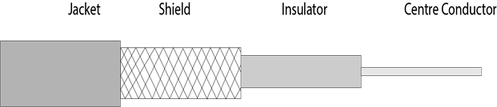
Coaxial cable is of two types:
- Baseband transmission: It is defined as the process of transmitting a single signal at high speed.
- Broadband transmission: It is defined as the process of transmitting multiple signals simultaneously.
Advantages Of Coaxial cable:
- The data can be transmitted at high speed.
- It has better shielding as compared to twisted pair cable.
- It provides higher bandwidth.
Disadvantages Of Coaxial cable:
- It is more expensive as compared to twisted pair cable.
- If any fault occurs in the cable causes the failure in the entire network.

Fibre Optic
- Fibre optic cable is a cable that uses electrical signals for communication.
- Fibre optic is a cable that holds the optical fibres coated in plastic that are used to send the data by pulses of light.
- The plastic coating protects the optical fibres from heat, cold, electromagnetic interference from other types of wiring.
- Fibre optics provide faster data transmission than copper wires.
Diagrammatic representation of fibre optic cable:
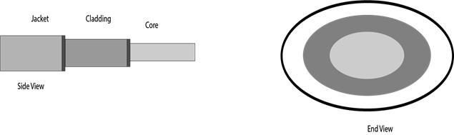
Basic elements of Fibre optic cable:
- Core: The optical fibre consists of a narrow strand of glass or plastic known as a core. A core is a light transmission area of the fibre. The more the area of the core, the more light will be transmitted into the fibre.
- Cladding: The concentric layer of glass is known as cladding. The main functionality of the cladding is to provide the lower refractive index at the core interface as to cause the reflection within the core so that the light waves are transmitted through the fibre.
- Jacket: The protective coating consisting of plastic is known as a jacket. The main purpose of a jacket is to preserve the fibre strength, absorb shock and extra fibre protection.
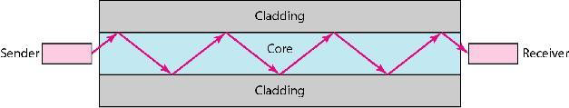
Unguided Media − In unguided media, transmitted data travels through free space in form of electromagnetic signal. For example, radio waves, lasers, etc

Infrared
Low frequency infrared waves are used for very short distance communication like TV remote, wireless speakers, automatic doors, hand held devices etc. Infrared signals can propagate within a room but cannot penetrate walls. However, due to such short range, it is considered to be one of the most secure transmission modes.
Microwaves –
It is a line of sight transmission i.e. the sending and receiving antennas need to be properly aligned with each other. The distance covered by the signal is directly proportional to the height of the antenna. Frequency Range:1GHz – 300GHz. These are majorly used for mobile phone communication and television distribution

Radio Wave
Transmission of data using radio frequencies is called radio-wave transmission. We all are familiar with radio channels that broadcast entertainment programs. Radio stations transmit radio waves using transmitters, which are received by the receiver installed in our devices.
Both transmitters and receivers use antennas to radiate or capture radio signals. These radio frequencies can also be used for direct voice communication within the allocated range. This range is usually 10 miles.

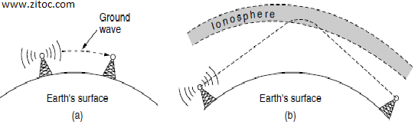

Analog to Digital conversion
A digital system is one whose signal has a finite number of discrete values. So, the digital system works on digital signals and is limited to binary values 0 or 1. Digital systems are used to process information in digital form. The digital system has wide applications in digital instruments like calculators, computers, Telephones, etc.
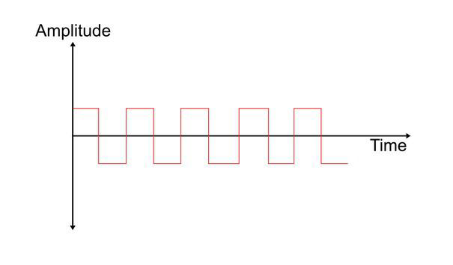
Analog system is one that uses continous time signal or analog signal which is a sinusoidal waveform. Analog system transmits the output in their raw form reducing the time of translation. The amplitude of the signal varies continuously with the time. Analog signals are used to represent sound, temperature, light intensity etc.
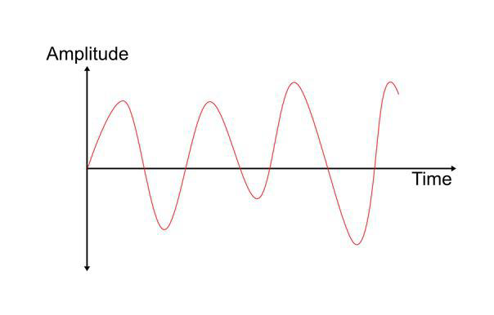
1. Digital-to-Digital Conversion:(Digital data into digital signal data is sent to printer).
This involves representing digital information (like the binary code used by computers) using different digital signals. It's essentially encoding the data. For example, converting a series of bits (0s and 1s) into a specific sequence of voltage pulses for transmission over a wire is a digital-to-digital conversion. This process is also known as line coding.
2. Analog-to-Digital Conversion (ADC):(Analog to digital signal human voice transmitted to digital channel).
This process converts continuous signals (like sound waves or voltage fluctuations) into a digital representation. An analog-to-digital converter (ADC) takes a continuous analog signal as input and produces a corresponding digital value (a number). This is essential for processing real-world data with digital systems. The process typically involves sampling the analog signal at specific intervals and then quantizing the sampled values to discrete levels.
3. Digital-to-Analog Conversion (DAC):(Digital signal is to be transmitted over Telephone line).
This converts digital data back into an analog signal. A digital-to-analog converter (DAC) takes digital data as input and produces a corresponding continuous analog signal. This is used when digital data needs to be converted back into a form that can be used by analog devices like speakers or motors.
4. Analog-to-Analog Conversion:Radio station convert voice signal (analog)into radio waves(analog).
This involves modifying one analog signal into another analog signal. Examples include changing the amplitude, frequency, or phase of a signal. This is used in various applications like radio transmission, where different characteristics of a signal can be used to represent different data.

Pulse Amplitude Modulation (PAM) is a key modulation technique used in digital communication for transmitting analog data and is one of the most widely used types of analog-to-digital conversion. Its process is simple where the amplitude of a sequence of pulses changes with the instantaneous amplitude of the analog message signal. The analog signal that is to be modulated is sampled by a sequence of pulses that are amplitude-modulated on the carrier to produce the amplitude-modulated pulses.

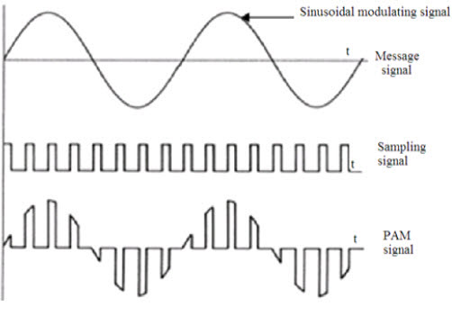

Pulse Code Modulation is the technique used for reworking analog signals into digital signals. PCM has a good or sensible signal-to-noise ratio. For transmission, Pulse Code Modulation wants high transmitter bandwidth. PCM technique is split into three elements, initial is the transmission at the provision end, second regeneration at the transmission path and conjointly the receiving end.
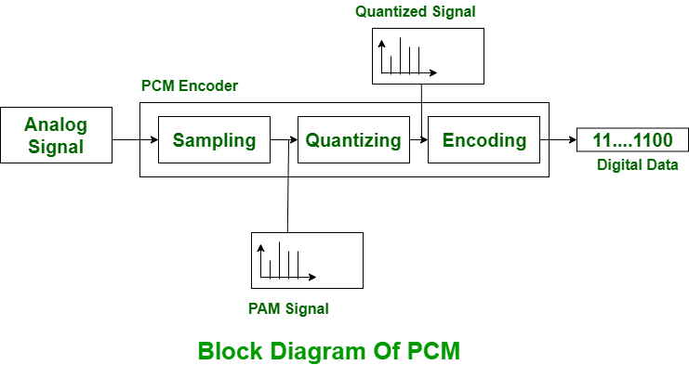

Delta modulation is an analog to digital and digital to analog signal conversion technique. Delta modulation is employed to realize high signal to noise ratio. It uses one bit PCM code to realize digital transmission of analog signal. With delta modulation, instead of transmit a coded illustration of a sample solely one bit is transmitted, that merely indicates whether or not the sample is larger or smaller than the previous sample. it's the best type or simplest type of Differential Pulse Code Modulation. Delta modulation signal is smaller than Pulse Code Modulation system. If signal is large, the next bit in digital data is 1 otherwise 0.
