Undergraduate Research Proposal

**Stochastic Modeling in Aggregation of Nanoparticles**

Advisor: Dr. James Brenner

Student: Alan Daou

**Abstract**

Control over the distribution of particle sizes is central to the nanotechnology industry, particularly with regard to color, electrical properties, catalytic behavior, sensing by electronic noses and tongues, and all other surface properties. To make this possible, nanoparticles (NPs) are typically surrounded by either cationic or anionic surfactants to put a surface charge on the NP’s, thereby ensuring repulsion with similarly charged NP’s. Sometimes NP’s are surrounded by nonionic capping agents that rely solely on the steric bulk of the capping agent to provide a barrier to NP aggregation. Often, capping agents are chosen to provide both an electrostatic and a steric barrier to aggregation.

This project will involve the development of a hybrid Monte Carlo (MC) and molecular dynamics (MD) simulation of nanoparticles in an appropriate suspension fluid (as opposed to a solvent) such that the capped NP’s will have a finite chance of interacting with each other and/or with desorbed capping agent ligands. The MD portion of the simulation will approximate the electrokinetic (diffusion plus an electrically-driven convective flow), ultrasonic, and gravitational flows present in NP suspensions. The Monte Carlo portion of the model will simulate the probability for desorption or adsorption of a capping agent ligand with a NP, as well as the reaction of two NP’s with each other to form a single larger nanoparticle.

**Nature of nanoparticles under investigation**

Nanoparticles exhibit numerous material properties that are different than their bulk counterparts, including higher band gap energy, size-dependent tunable color, enhanced strength, etc. However, as nanoparticles' surface charge dissipates, the NP's aggregate into larger structures. This research will consist of a stochastic (Monte Carlo) simulation of a set of elementary reaction steps into more condensed structures, with the hope of gaining a better understanding of how to prevent such aggregation in the future. Examples of experimental work studying such aggregation include a) the formation of porous synthetic zeolites (refs. to be compiled by Brenner in Jan., 2018) that are the workhorse of the catalyst industry (refs. to be compiled by Brenner in Jan., 2018), b) the nucleation and growth of ammonium dihydrogen phosphate (ADP) common to children's science fair kits (refs. to be compiled by Brenner in Jan., 2018), c) Au (refs. to be compiled by Williams in Jan., 2018) and Ag (refs. to be compiled by Brenner in Jan., 2018) nanoparticles; and d) a number of protein misfolding disorders such as Alzheimer's disease (refs. to be compiled by Brenner in Jan., 2018), Parkinson's disease (refs. to be compiled by Brenner in Jan., 2018), sickle cell anemia (refs. to be compiled by Brenner in Jan., 2018), and others (refs. to be compiled by Brenner in Jan., 2018).

An attempt to minimize the Gibbs free energy (G0) of the entire system will force particles to aggregate in different ways. The Gibbs free energy can be broken down into a bulk term and a surface term. When the repulsive energy associated with the charges located on the perimeter of each NP is overcome by the attractive energy of two entities becoming one entity, then aggregation occurs. In between, while the NP’s are surrounded by their counterions in suspension, there is a finite probability that ions the same in charge as the NP’s will attack the hydration layer surrounding the NP’s. Gradually, the surface charge on the NP’s, as typically quantified by the zeta potential, degrades, at a rate that is proportional to the total ion concentration in the suspension.

Nanoparticles are often approximated as colloidal spheres with a dipole (or as magnetic spheres) (refs.), as seen for Au NP aggregation in Figures 1A-D (ref.). If the zeta potential on each NP is high enough, they can form long chains (as seen in Image A; ref.). Branching can occur off of such chains or when the chains intersect (Image B; ref.). Sintering, defined as aggregation of nanostructures into larger, more condensed structures can result from two parallel chains side by side forming one thicker chain (Image C), and complete condensation into one large entity (Image D). Notice, particularly in D, that as the crystal diameters become larger for metallic NP’s, the crystals become much more faceted because certain planes of atoms prefer to be at the surface in order to minimize the Gibbs free energy in the system.

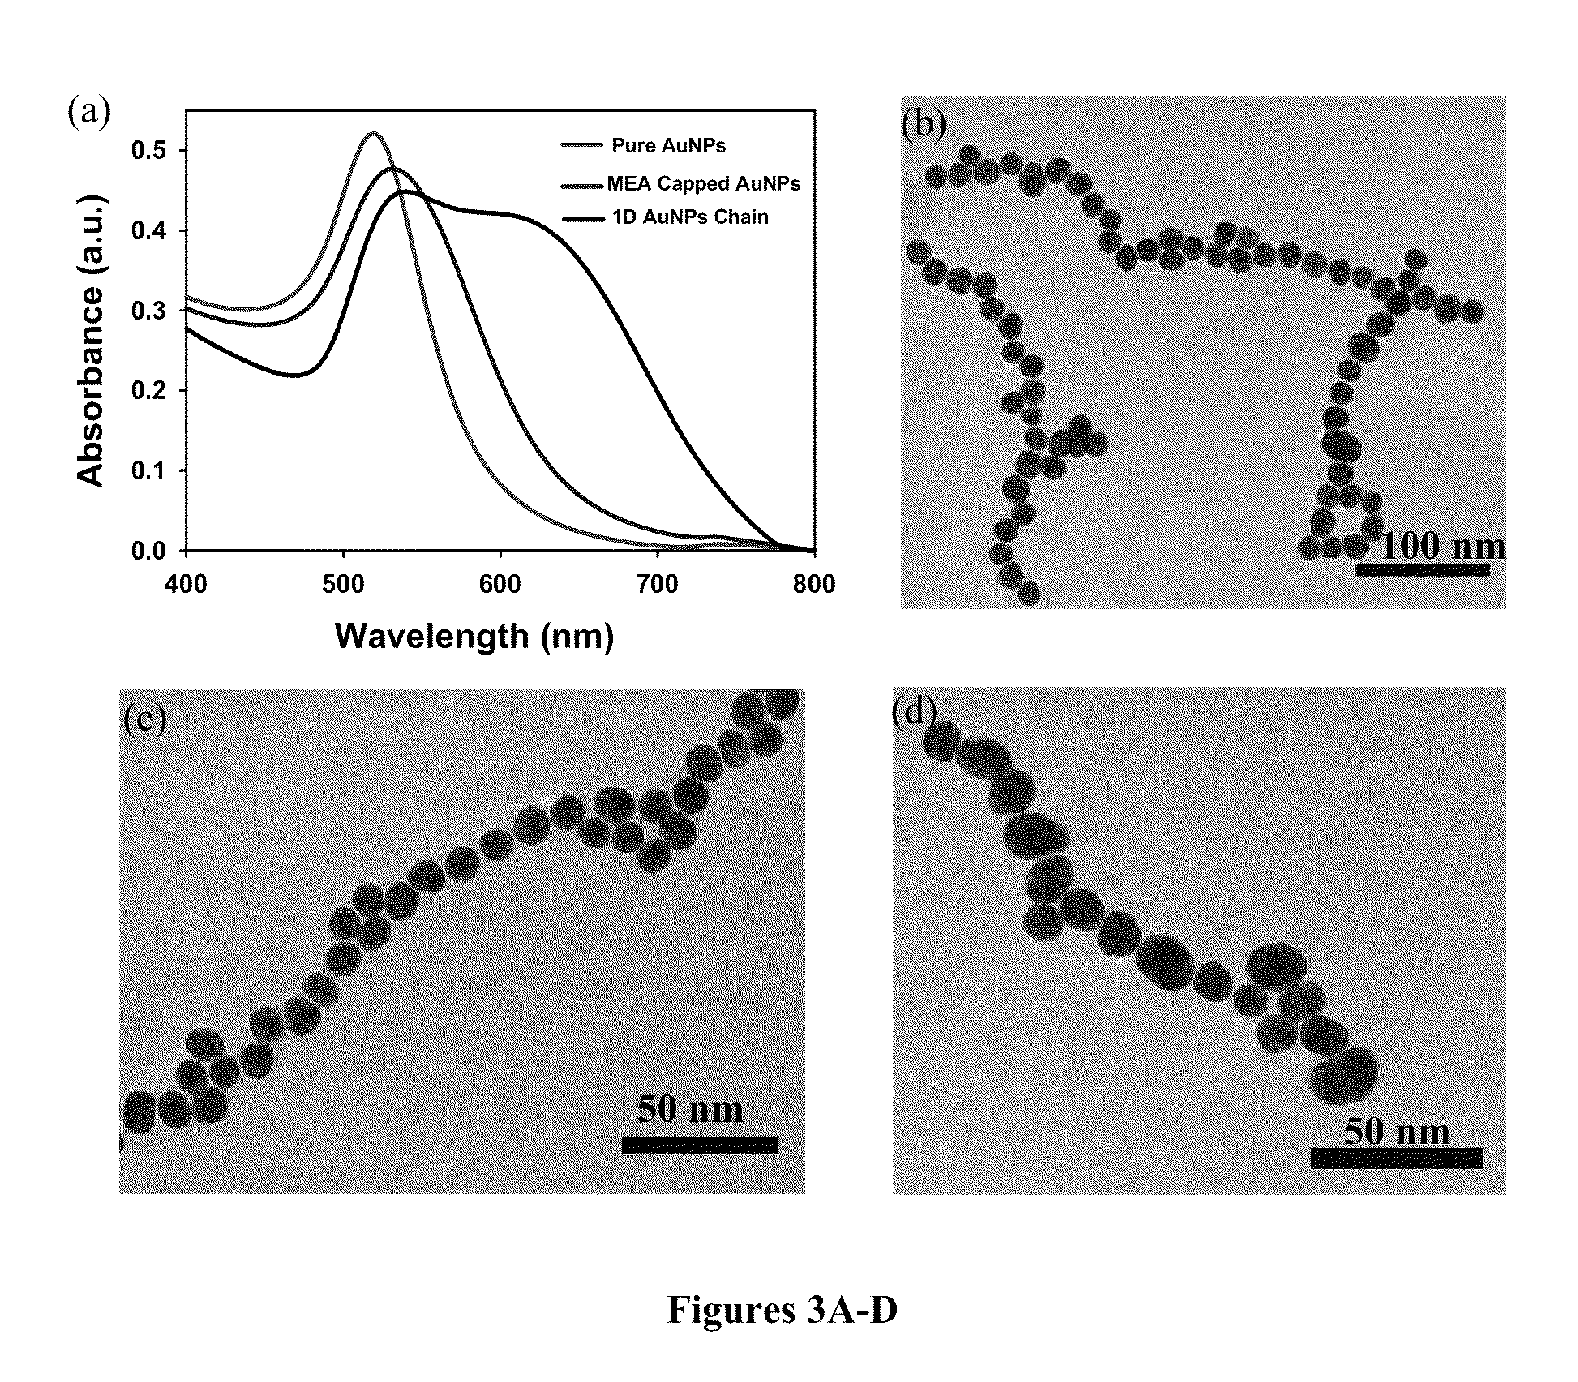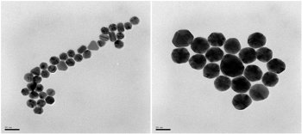

**Image A Image B**

**Image C Image D**

Figures 1A-1D) A); B); C) scale of 50nm; D) scale of 50 nm; (ref. Where is this from?)

**Mathematical application**

Understanding this phenomenon, the purpose of this research is to make a stochastic model that describes how these particles will aggregate while suspended. To do this, several key things need to be understood. Each of the types of aggregation have a specific probability of occurring, which is due to the lowering of the zeta potential (or surface charge) around each NP. The Gibbs free energy of the particles is directly correlated to the possibility of the particles spontaneously aggregating on their own. Another key part of this comes from the diffusion of the system, which is directly related to Keq and the concentration of the nanoparticles in the system. Another contribution to this area of research is Smoluchowski’s equation, which details how the density of particles change over time as they aggregate. Below are the equations for the Gibbs free energy and Smoluchowski equation (insert ref.), respectively.

$$f\left(zeta potential\right)=∆G=-RTln\left(K_{eq}\right)$$

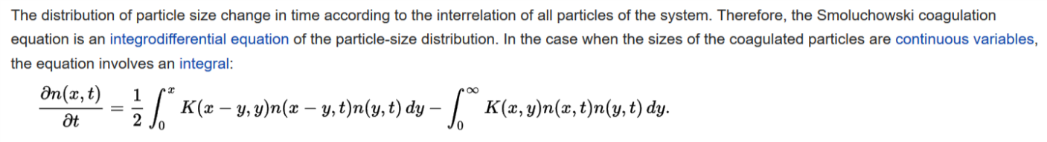

Following the different types of aggregation listed above, imagine each type having a probability of occurring, and the probabilities can be mapped like below for each particle. If one atom on a particle attaches itself to another particle, then there is a much higher probability that the other atoms with each particle will do the same, and this can also be mapped out in the following way.

|  |  |
| --- | --- |
| 1 | Full aggregation |
| …. |  |
| p(i) | Xi |
| … |  |
| p(2) | X2 |
| p(1) | Event type 1 (X1) |
| 0 | No movement |

With there being a possibility of aggregation, there is also a possibility of de-aggregation, particle motion without aggregation, or nothing happening to any of the particles at all. INSERT key photo The possibility of particles de-aggregating is small, but finite.

Altogether, this can be representative of Brownian motion or a Poisson process (in relation to how they are dispersed and how much their zeta potentials would be for each particle). Altogether, this is representative of a Levy process and can be investigated mathematically to predict how they will interact with other particles in their environment.

AlgorithmFlowsheet.pptx contains an algorithm developed by Alan Daou, Ayo Adebisi, and Dr. Brenner. This flowchart represents the task plan for the entire project.

1. Literature review (conducted and summarized in Power Point form; to be summarized in word format by 2/7/2018)
2. Reading and setting of input data (done)
3. Creation of an NxNxN grid with initial positions of nanoparticles (done)
4. An initialization of all variables subroutine (done)
5. A Lennard-Jones (LJ) energy function calculator (To be done by 1/31/2018)
6. A nearest neighbors subroutine (2/14/2018)
7. Use LJ calculations to determine the next positions of particles (2/28/2018)
8. Output positions of particles onto a grid in movie form (Started; to be done by 3/14/18)
9. Equilibration subroutine (3/31/18)
10. Poster presentation (4/6/18)
11. Completed first simulation of Au ions and NP’s in solution forming nanoparticulate aggregates (4/21/18)
12. Final report (4/27/18)
13. Adding in the effects of different types of surfactants/soaps (at different concentrations) in the model. These surfactants are meant to reduce the possibility of aggregation (summer, if Alan continues).

To get a C, the student needs to conduct and summarize relevant literature in PowerPoint form (1)

To get a B, the student needs to complete items 2-4

To get an A, the student needs to complete items 1-8, 10, and 12.