Configuration Recommendations:
Code Execution Environment: MATLAB R2022a+
Recommended RAM: ≥ 32 GB
Maximum Runtime: ~ 100 hours

User Guide：
1) Unzip the package and open the files in MATLAB
2) Open('main.m')
3) Variable 'solution' takes a value from the set {1, 2, 3, 4}, which are respectively correspond to four initial solutions.
4) Variable 'grouping rule' takes a value from the set {0, 1, 2}, which are respectively correspond to initial grouping rule, re-grouping rule and secondary re-grouping rule
5) Variable 'search' takes a value from the set {1, 2}, which are respectively correspond to AB and AG
6) Run('main.m')
7) Openvar('results_KN'), 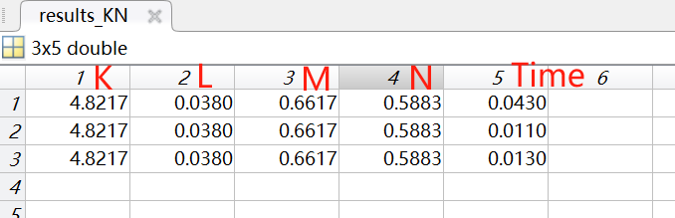
where the i-th row maps to the i-th grouping rule, and columns 1 through 5 respectively correspond to the value of K, L, M, N, Time.

8) Openvar(' sign_error ')
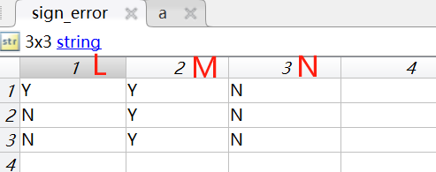
where the i-th row maps to the i-th grouping rule, and columns 1 through 3 respectively correspond to the value of K, L, M, N, Time.

