Customer Shopping Behavior & Revenue Performance Analysis
- Problem Statement
Retail organizations generate large volumes of transactional data through everyday customer purchases, yet many fail to translate this data into actionable insights that support strategic decision-making. Key information regarding customer demographics, product performance, purchasing behavior, and promotional effectiveness often remains underutilized without a structured analytical approach.
This project addresses the challenge of understanding what drives revenue performance in a retail environment. Specifically, it seeks to identify which products and customer segments contribute the most value, how purchasing behavior varies across locations, seasons, and demographic groups, and whether promotional strategies such as discounts and subscription programs effectively influence customer spending.
Without clear answers to these questions, businesses risk misallocating resources, maintaining ineffective product offerings, and missing opportunities to improve customer retention and revenue growth. Therefore, this project applies structured data analysis techniques using SQL, Python and PowerBI to transform raw transactional data into meaningful insights, enabling more informed decisions across product planning, marketing, and customer engagement strategies.
- Project Objective
The objective of this project is to analyze customer shopping behavior and identify key factors that influence revenue performance in a retail environment. By examining transaction data, customer demographics, and product purchasing patterns, this analysis aims to uncover insights that can support data-driven business decisions.
Specifically, the project focuses on the following objectives:
- Identify the most valuable customer segments contributing to overall revenue.
- Determine which product categories and individual products generate the highest sales.
- Evaluate the impact of discounts on customer spending behavior.
- Analyze geographic locations that contribute the most revenue.
- Understand purchasing patterns across different customer age groups.
- Assess whether subscription programs influence customer spending.
- Identify seasonal trends in customer purchasing behavior.
- Discover products with the highest customer satisfaction ratings.
- Examine repeat purchasing behavior to identify loyal customers.
These objectives guide the analytical process and help translate raw transactional data into meaningful business insights that can improve marketing strategies, product planning, and customer engagement.

- Data Overview
The dataset used in this project contains customer transaction data that captures shopping behavior in a retail environment. It consists of 3,900 records and 18 columns, where each record represents an individual customer purchase.
The dataset includes variables related to customer demographics, product details, and transaction characteristics, such as age, gender, location, item purchased, product category, purchase amount, season of purchase, and review rating. Additional attributes including subscription status, discount usage, previous purchases, and purchase frequency provide further insight into customer behavior and purchasing patterns.
This dataset enables the analysis of customer spending behavior, product performance, geographic sales distribution, and seasonal trends. By examining these attributes, the dataset provides a strong foundation for identifying key revenue drivers and understanding the factors that influence customer purchasing decisions.
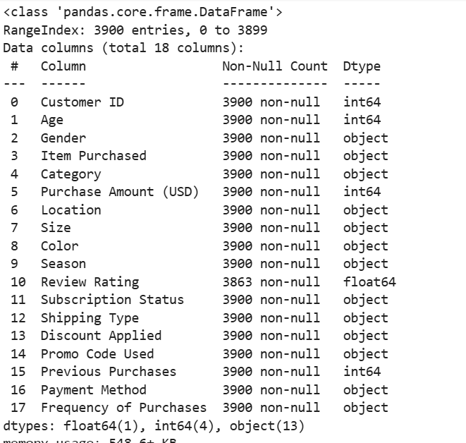

- Data Preparation
Before conducting the analysis, several preprocessing steps were performed to ensure that the dataset was clean, structured, and suitable for analytical querying. Python (Pandas) in a Jupyter Notebook was used for initial exploration, transformation, and preparation of the dataset before loading it into PostgreSQL for SQL-based analysis.
5.1 Data Exploration
The dataset was initially explored using Python (Pandas) to understand its structure and verify data quality. Basic exploratory checks were conducted to inspect the dataset dimensions, column names, data types, and sample records.
Functions such as head(), info(), and describe() were used to review the dataset and confirm that numerical variables such as age, purchase_amount_usd, and previous_purchases were correctly formatted. Categorical variables including category, location, season, and subscription_status were also examined to ensure that values were consistent across the dataset.
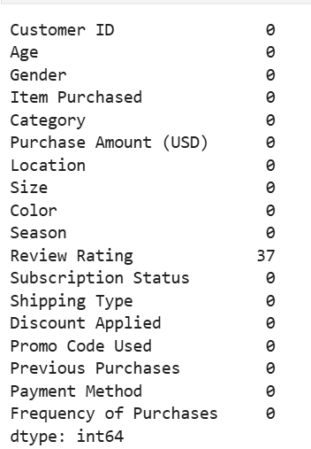 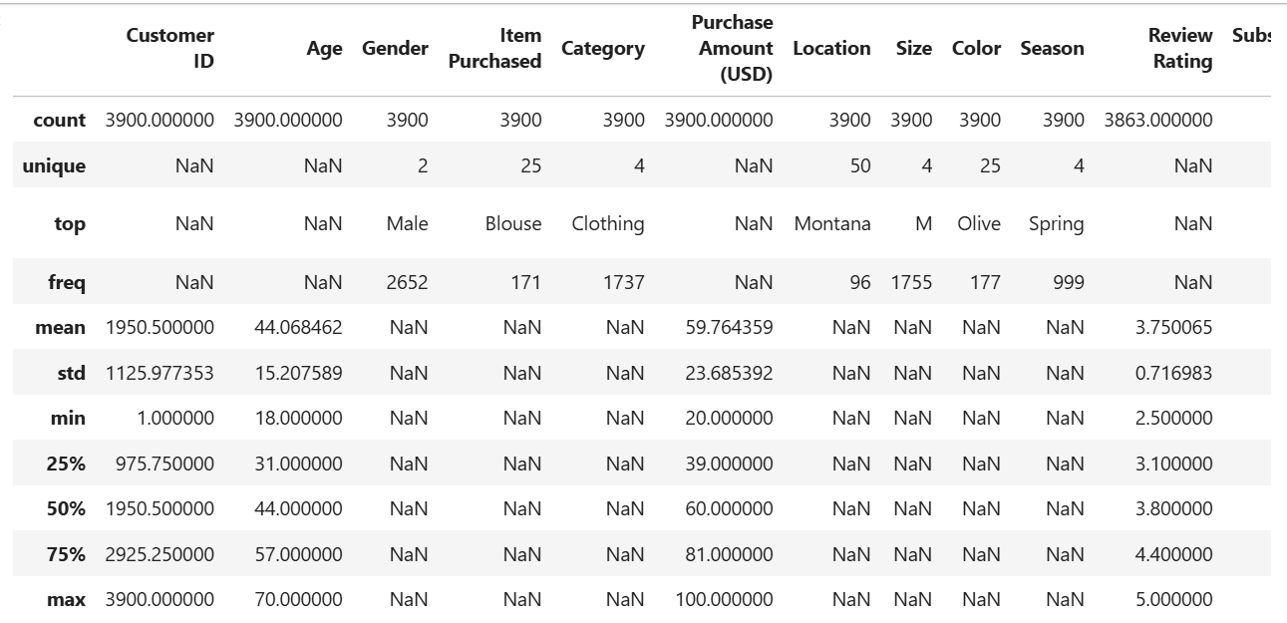
This step helped verify that the dataset contained 3,900 records and 18 variables, and ensured the data was ready for further preprocessing.
5.2 Data Cleaning
To maintain consistency and improve query efficiency, column names were standardized using snake_case formatting. This ensured compatibility with SQL queries and improved readability throughout the analysis.
During the cleaning process, a redundant variable promo_code_used was identified and removed because it contained identical values to the discount_applied column. Removing duplicate information prevented potential inconsistencies during analysis.
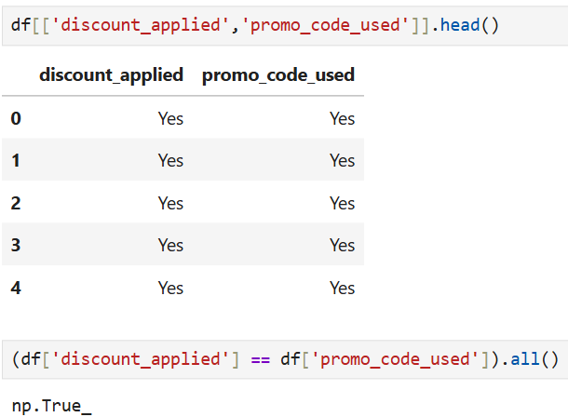
Additionally, data types for key variables were reviewed to ensure that numerical fields such as purchase_amount_usd, age, and previous_purchases were properly formatted for aggregation and statistical calculations.
5.3 Feature Engineering
To improve customer segmentation analysis, a new variable age_group was created based on the age column. Customers were divided into four groups Youngster, Adult, Middle-aged, and Senior using quantile-based binning.
This transformation simplified the analysis of purchasing patterns across different age segments and allowed for more meaningful comparisons in the SQL analysis.
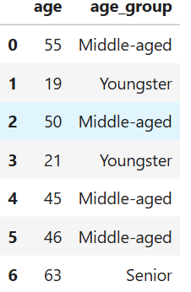
The newly created feature helped identify how spending behavior differs across age groups.
5.4 Data Loading
After preprocessing and feature engineering were completed in Python, the cleaned dataset was loaded into a PostgreSQL database by connecting the Jupyter Notebook to a local PostgreSQL server.
Storing the dataset in a relational database environment enabled efficient querying and analysis using SQL. The structured data in PostgreSQL was then used to perform aggregations, segmentation analysis, and revenue calculations across multiple dimensions such as customer demographics, product categories, geographic locations, and seasonal trends.
Dataset → Python (Data Exploration & Cleaning) → PostgreSQL (Data Storage & SQL Analysis) → Power BI (Visualization)

- Business Questions & SQL Analysis
Business Question 1:
Who are the most valuable customer segments?
Solution:
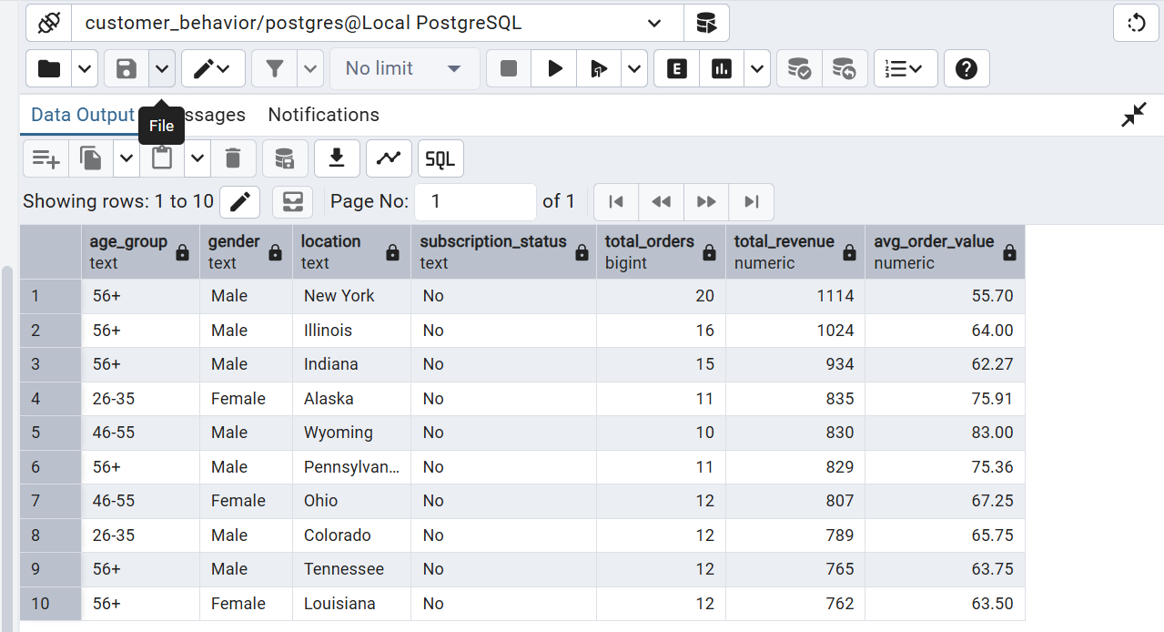

Customers in the 56+ age group generate the highest total revenue ($65,256), followed by customers aged 46–55 ($45,619) and 26–35 ($44,342).
Business Interpretation: Older customers contribute significantly more revenue due to higher purchasing frequency.
Business Decision: The business should Target older customer segments (46+). Offer loyalty programs and premium product recommendations to retain them.
Business Question 2:
Which product categories generate the highest revenue?
Solution:
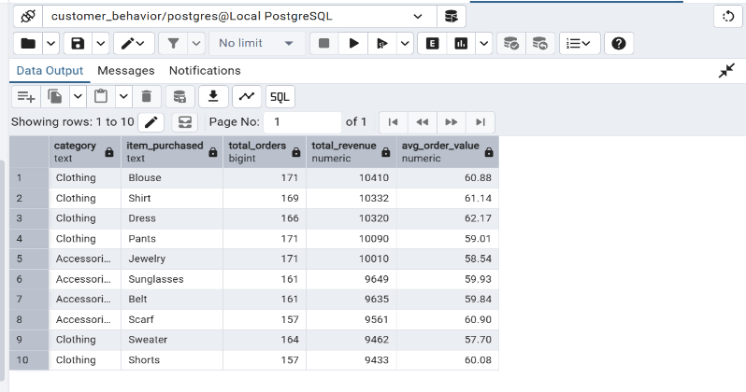
Clothing dominates the revenue stream, accounting for the largest share of total sales.
Business Decision: The business should:
- Expand Clothing inventory
- Introducing new clothing collections
- Focus marketing campaigns on this category.
Business Question 3:
Which individual products generate the highest revenue?
Solution
Top products include:
- Blouse – $10,410
- Shirt – $10,332
- Dress – $10,320
- Pants – $10,090
- Jewelry – $10,010
Business Interpretation: A small group of products generates a large share of revenue, especially within the clothing category.
Business Decision:
The business should:
- Promote these top-performing products
- Ensure consistent inventory availability
- Bundle them with complementary items.
Business Question 4:
Do customers who receive discounts spend more?
Solution:
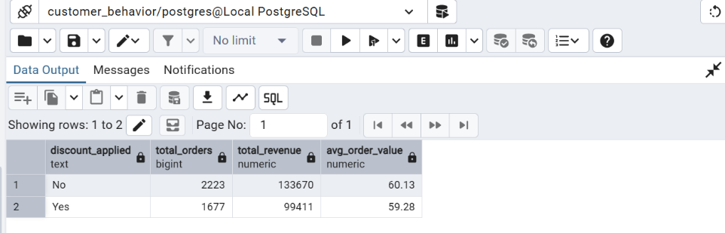
Business Interpretation: Customers who receive discounts spend slightly less per order compared to customers without discounts.
Business Decision: Discount strategies should be optimized because:
- They may increase order volume
- But they do not increase average spending per transaction
Business Question 5:
Which locations generate the highest revenue?
Solution:
Top revenue-generating locations:
- Montana – $5,784
- Illinois – $5,617
- California – $5,605
- Idaho – $5,587
- Nevada – $5,514
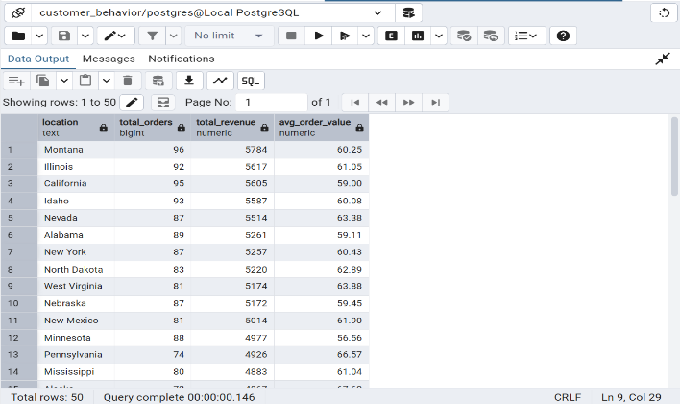
Business Interpretation: Sales are distributed across multiple regions, with several states contributing similar revenue levels.
Business Decision: The business can:
- Increase marketing campaigns in top-performing states
- Explore expansion in similar regions with similar demographics.
Business Question 6:
Which age groups spend the most?
Solution:
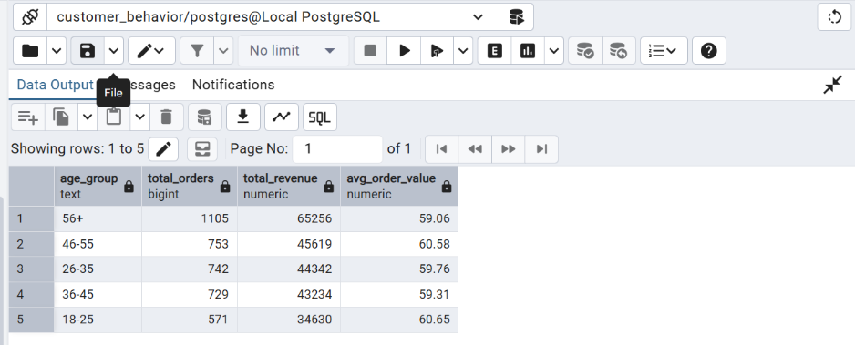
Business Interpretation: Older customers generate more revenue overall due to more frequent purchases.
However: 18 – 25 age group spends more.
Business Decision: Two strategies emerge:
- Younger customers spend more per purchase
- Older customers purchase more frequentl
Both segments are valuable in different ways.
Business Question 7:
Do subscribed customers spend more?
Solution:
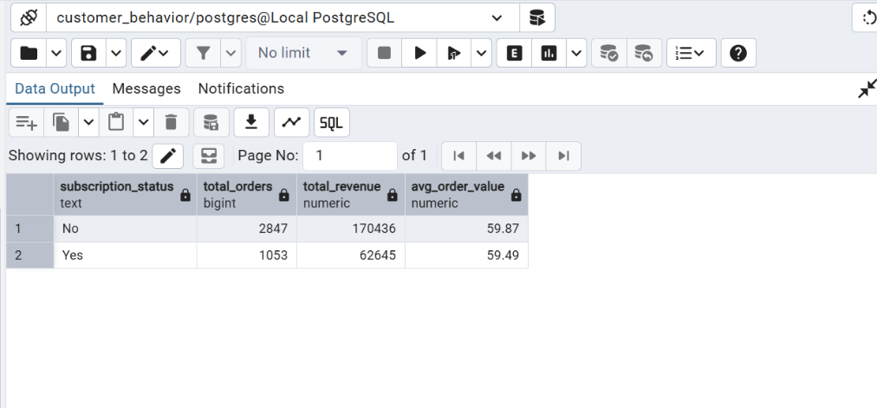
Business Interpretation: Non-subscribed customers currently generate significantly more revenue.
Business Decision: The business should evaluate:
- Whether the subscription program provides enough value
- If incentives should be improved to increase subscription adoption.
Business Question 8:
What seasonal trends exist in purchasing behavior?
Solution:
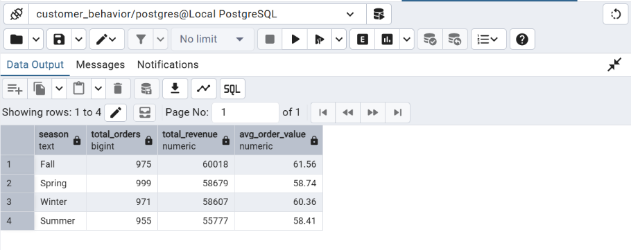
Business Interpretation: Sales remain relatively stable across seasons, but Fall performs slightly better.
Business Decision: The company should:
- Increase marketing campaigns in Fall
- Prepare inventory for seasonal spikes.
Business Question 9:
Which products have the highest customer satisfaction?
Solution
Business Interpretation These products have the highest customer satisfaction levels, indicating strong product acceptance.

These products have the highest customer satisfaction levels, indicating strong product acceptance
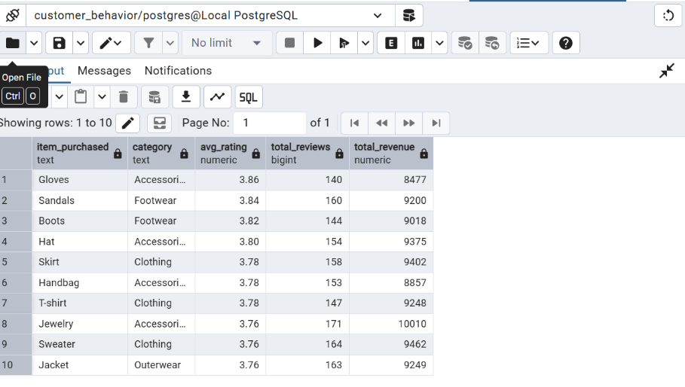
Business Decision: The business can:
- Promote these products in marketing campaigns
- Use them as recommended products.

- Key Insights
The analysis of customer shopping behavior revealed several key insights related to revenue performance, customer demographics, and product demand.
Customer Base and Revenue Performance
The dataset includes approximately 3,900 customers, generating a total revenue of $233,081 with an average customer spend of $59.76. The overall average product review rating is 3.75, indicating moderate customer satisfaction across the product catalog.
Gender-Based Revenue Distribution
Male customers contribute a significantly larger portion of total revenue, accounting for approximately 67.7% of total sales, while female customers account for about 32.3%. This suggests that male customers represent the dominant purchasing segment within the dataset.
Customer Age Segmentation
Revenue analysis across age groups shows that younger and middle-aged customer segments contribute a large portion of overall sales. These segments demonstrate strong purchasing activity and represent key target groups for marketing and product promotions.
Product Category Performance
Among all product categories, Clothing generates the highest revenue, followed by Accessories and Footwear, while Outerwear contributes the lowest revenue share. This indicates that clothing products play a central role in driving overall retail sales.
Subscription Program Impact
The analysis shows that many customers are non-subscribers (approximately 92.7%), while only 7.3% of customers subscribed to the program. Despite the relatively small subscriber base, subscription customers show comparable average spending behavior to non-subscribers.
Customer Segmentation and Loyalty
Customer segmentation analysis identifies four primary customer groups: Loyal, Established, Growing, and new customers. Loyal customers represent the largest group, accounting for 1,549 customers and generating approximately $92,984 in revenue. Established customers also contribute significantly with $69,706 in revenue, highlighting the importance of repeat purchasing behavior in overall business performance.
Overall, the findings indicate that product category performance, customer demographics, and repeat purchasing behavior are key drivers of revenue performance, providing valuable insights that can inform marketing strategies, customer engagement initiatives, and product planning decisions.

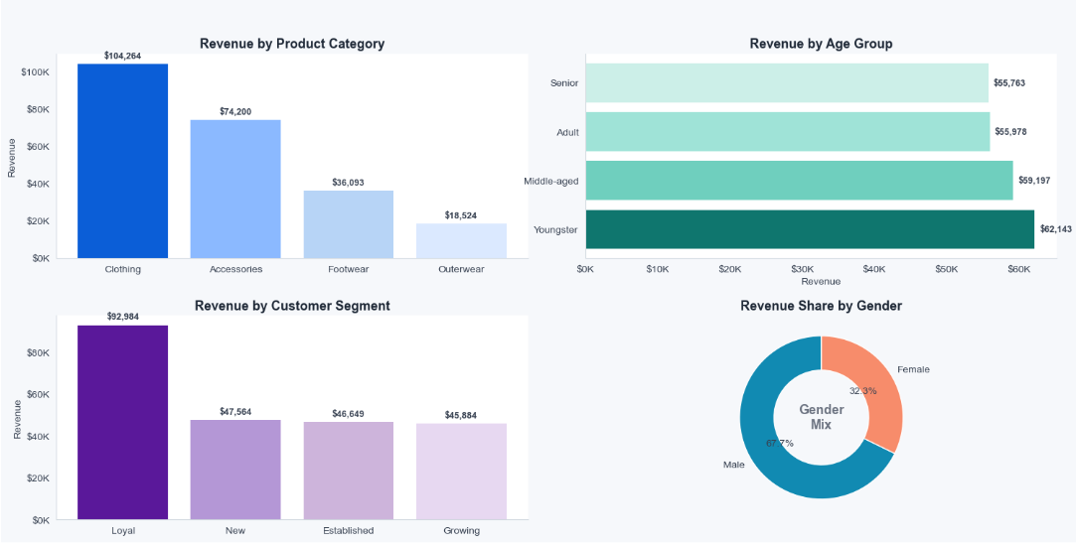

- Business Recommendations
Based on the analysis of customer shopping behavior and revenue performance, several strategic recommendations can be made to improve revenue growth and customer engagement.

Focus on High-Performing Product Categories
The analysis shows that Clothing generates the highest revenue, followed by Accessories. Businesses should prioritize inventory, promotions, and marketing campaigns around these high-performing categories to maximize revenue impact.
Strengthen Customer Retention Programs
Loyal customers contribute the largest share of total revenue. Implementing loyalty programs, exclusive discounts, and personalized offers can help retain these high-value customers and encourage repeat purchases.
Target High-Spending Customer Segments
Young and middle-aged customers generate the most revenue among age groups. Marketing campaigns should be tailored toward these segments through targeted advertising and personalized product recommendations.
Optimize Regional Sales Strategy
Certain locations contribute higher revenue than others. Businesses should analyze these high-performing regions and replicate successful strategies in lower-performing markets to increase overall sales.

Improve Product Promotion Strategies
Discounts and promotional campaigns should be carefully optimized, as the analysis suggests that discount usage does not always significantly increase average spending. Businesses should focus on targeted promotions instead of broad discounting.

- Conclusion
Overall, this project demonstrates the value of data-driven decision making in modern retail environments. By combining data analysis, structured querying, and visualization techniques, organizations can better understand customer behavior, optimize product strategies, and identify opportunities to improve revenue performance. The insights generated through this analysis provide a foundation for strategic business planning, targeted marketing efforts, and improved customer engagement initiatives.

