Monthly Active Users Trend
Fig 1. Active users in thousands
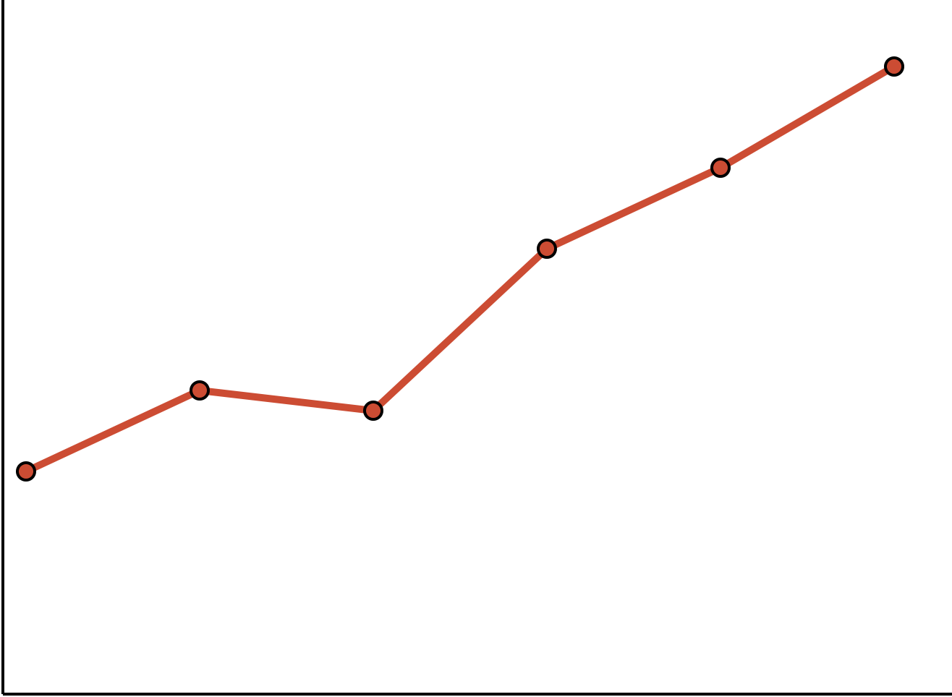
Jan | Feb | Mar | Apr | May | Jun
110 | 150 | 140 | 220 | 260 | 310
Growth driven by the referral program launch.

