Trailhead Manufacturing
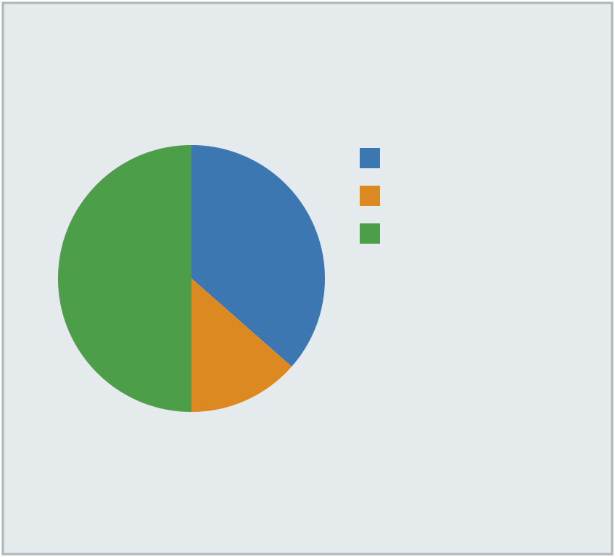
Trusted Expertise, Local Service | Our Track Record | North (27)
Who We Serve
Clients rely on us for clear | We combine practical experience
communication, transparent pricing, | with modern tooling to keep
and dependable delivery. Our team | projects on time and on budget.
works with organizations of every | Clients rely on us for clear
size to deliver measurable results | communication, transparent pricing, | South (10)
on schedule. From initial planning | and dependable delivery. Our team | West (37)
through final handoff, a dedicated | works with organizations of every
coordinator manages every detail. | size to deliver measurable results
What We Do | on schedule.
 | At a Glance
From initial planning through final
handoff, a dedicated coordinator | • Quarterly reviews keep your goals
manages every detail. We combine | front and center throughout the
practical experience with modern | engagement.
tooling to keep projects on time and | • Clients rely on us for clear
on budget. | communication, transparent pricing,
 | and dependable delivery.
- Our certified staff bring an
average of 6 years of hands-on
industry experience.
- We maintain a 96% on-time
completion rate across all active
accounts.
Contact us: (897) 448-0430

3177 Sunset Blvd, Minneapolis, MN 55401

