Junction Dynamics
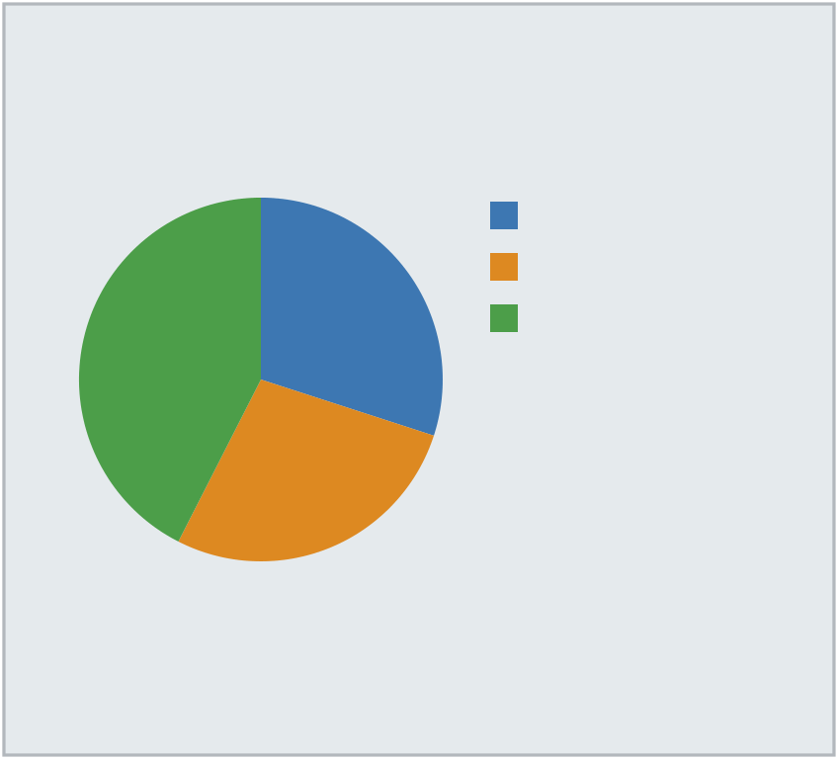
Solutions That Scale With You | Who We Serve | North (24)
What We Do
From initial planning through final | Quarterly reviews keep your goals
handoff, a dedicated coordinator | front and center throughout the
manages every detail. Quarterly | engagement. We combine practical
reviews keep your goals front and | experience with modern tooling to
center throughout the engagement. | keep projects on time and on | South (22)
Our team works with organizations | budget. | West (34)
of every size to deliver measurable | At a Glance
results on schedule.
Our Approach | • We combine practical experience
 | with modern tooling to keep
Every engagement starts with a | projects on time and on budget.
detailed assessment of your current | • We maintain a 98% on-time
operations. Our team works with | completion rate across all active
organizations of every size to | accounts.
deliver measurable results on | • Founded in 1985, we have grown
schedule. From initial planning
 | into a trusted partner for clients
through final handoff, a dedicated
 | across the region.
coordinator manages every detail.

Contact us: (267) 874-0886

5112 Maple Dr, Phoenix, AZ 85001

