Quarterly Metrics Review
Figure 1: Headcount by Department
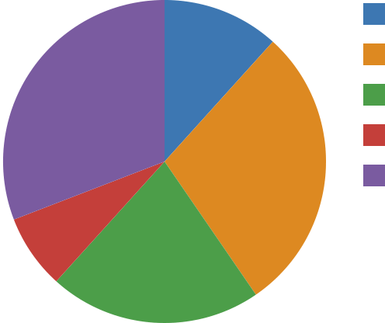 | East (22)  North (54)  West (40)  South (14)  Central (58)
Figure 2: Headcount by Department

Jan | Feb | Mar | Apr | May

