KPI Snapshot
Figure 1: Monthly Revenue | HR (25) | Figure 2: Support Tickets by Region
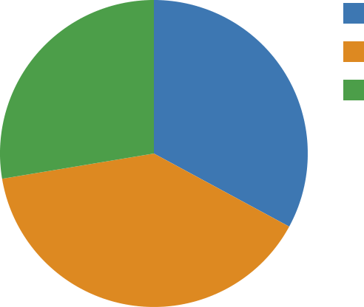 |  | 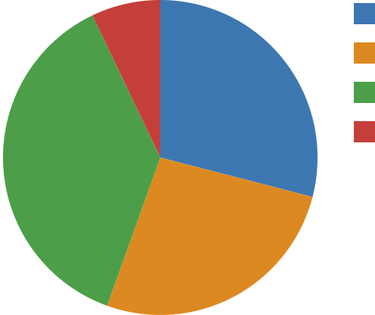 | Finance (45) Eng (41)  HR (58)  Ops (11)
 | Finance (30)
 | Eng (21)

