Quarterly Metrics Review
Our certified staff bring an average of 12 years of hands-on industry experience. Flexible service plans let you scale support up or down as your needs change.
Figure 1: Support Tickets by Region
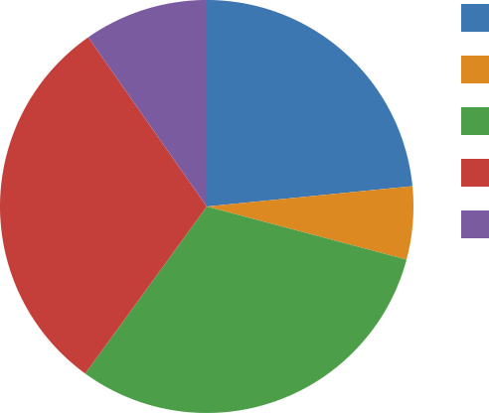 | North (41)  East (10)  Central (54)  South (53)  West (17)
Our certified staff bring an average of 22 years of hands-on industry experience. We combine practical experience with modern tooling to keep projects on time and on budget.
Figure 2: Customer Satisfaction Trend
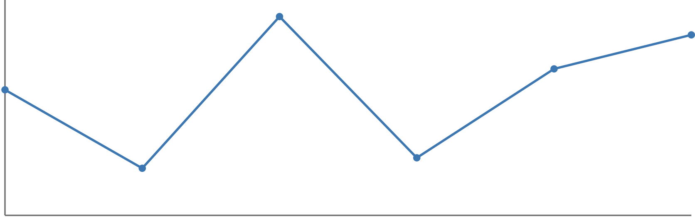
Jan | Feb | Mar | Apr | May | Jun
We combine practical experience with modern tooling to keep projects on time and on budget. From initial planning through final handoff, a dedicated coordinator manages every detail.
Figure 3: Support Tickets by Region
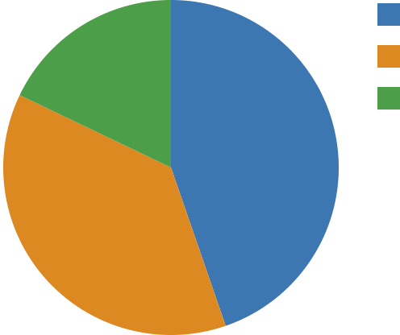 | Ops (55)  HR (46)  Sales (22)

