Quarterly Metrics Review
Figure 1: Customer Satisfaction Trend
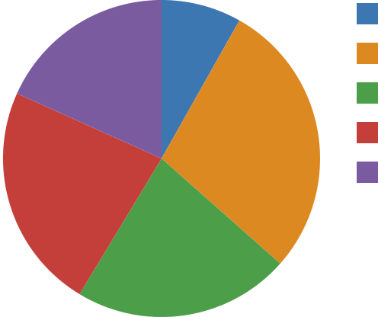 | Ops (17)  Sales (59)  Finance (46)  HR (48)  Eng (38)
Figure 2: Headcount by Department

Jan | Feb | Mar | Apr
Figure 3: Website Traffic

Jan | Feb | Mar | Apr | May | Jun | Jul | Aug

Figure 4: Monthly Revenue
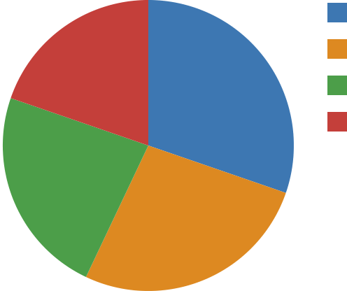 | Eng (43)  Ops (38)  Sales (33)  HR (28)
Figure 5: Support Tickets by Region
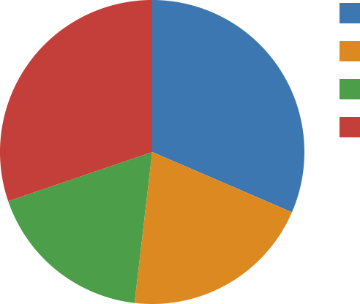 | West (51)  North (33)  Central (29)  South (49)

