Operations Dashboard Export

Figure 1: Customer Satisfaction Trend

Figure 2: Monthly Revenue
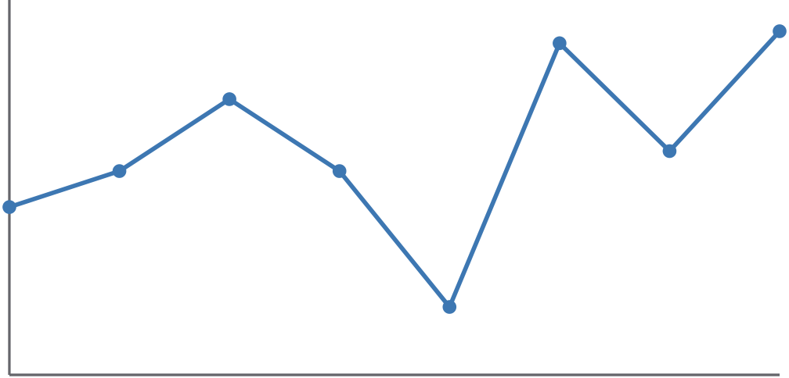

Jan | Feb | Mar | Apr | May | Jun | Jul | Aug | Jan | Feb | Mar | Apr | May | Jun | Jul | Aug

