KPI Snapshot
Clients rely on us for clear communication, transparent pricing, and dependable delivery. Founded in 2018, we have grown into a trusted partner for clients across the region.
Figure 1: Budget Allocation

Jan | Feb | Mar | Apr | May | Jun
Flexible service plans let you scale support up or down as your needs change. We maintain a 91% on-time completion rate across all active accounts.
Figure 2: Market Share
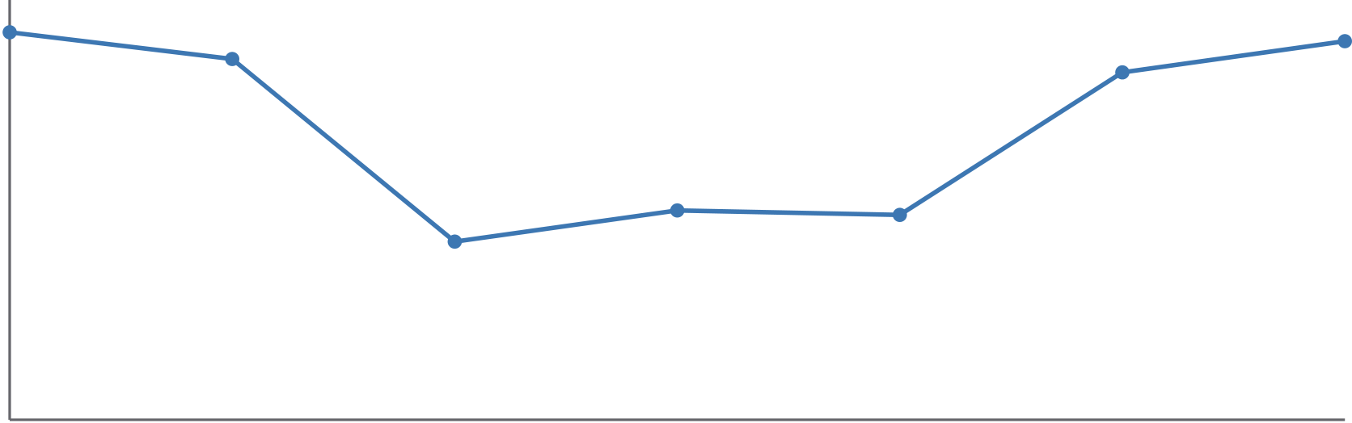
Jan | Feb | Mar | Apr | May | Jun | Jul
Clients rely on us for clear communication, transparent pricing, and dependable delivery. Flexible service plans let you scale support up or down as your needs change.
Figure 3: Customer Satisfaction Trend

Jan | Feb | Mar | Apr | May

Every engagement starts with a detailed assessment of your current operations. Flexible service plans let you scale support up or down as your needs change.
Figure 4: Monthly Revenue
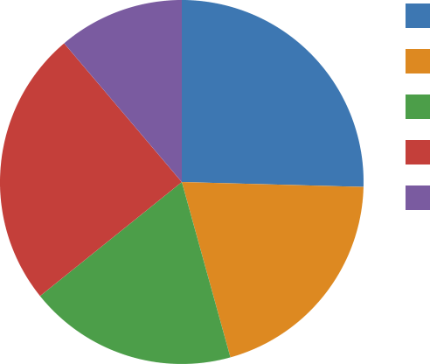 | West (59)  South (47)  East (43)  North (57)  Central (26)
Every engagement starts with a detailed assessment of your current operations. Founded in 2010, we have grown into a trusted partner for clients across the region.
Figure 5: Headcount by Department

Jan | Feb | Mar | Apr | May | Jun
Our certified staff bring an average of 21 years of hands-on industry experience. We combine practical experience with modern tooling to keep projects on time and on budget.
Figure 6: Units Shipped
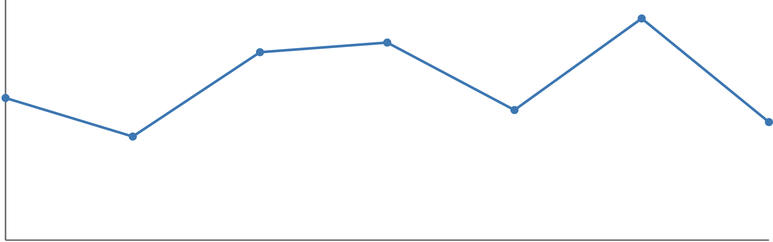
Jan | Feb | Mar | Apr | May | Jun | Jul

