Annual Performance Report
Figure 1: Market Share

Jan | Feb | Mar | Apr | May | Jun
Figure 2: Market Share
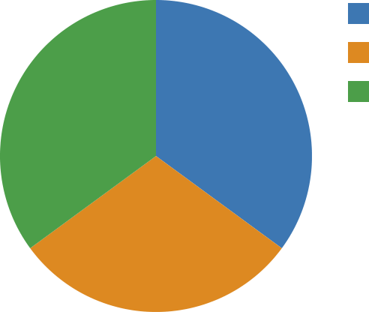 | Finance (54)  Ops (46)  Eng (54)
Figure 3: Website Traffic

Jan | Feb | Mar | Apr

Figure 4: Units Shipped
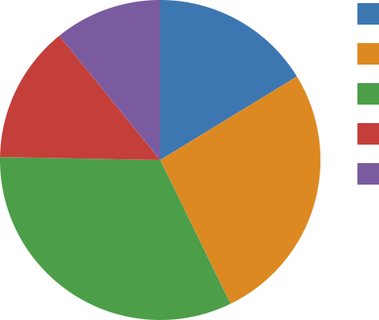 | Sales (27)  Eng (44)  Finance (54)  Ops (23)  HR (18)

