## Supporting information for: How to Quantify Behavioural and Trophic Variation Among-Individuals: A case study of the invasive round goby

Nicholas P. Moran, André W. Visser, Jane W. Behrens

## S1. Sampling gear and effort

Round gobies, prey items and primary producer sampling was conducted simultaneously over 2 days. Passive fishing gear set on 16/05/2022 at …, and left for 24 hours. Active sampling was for prey items (and also for

4x large double fykes: 3 m funnels, 0.5 cm mesh size, 8 x 0.6 m wing, 2 cm mesh; 4x small double fykes: 2 m funnel, 1 cm mesh, 5 x 0.4 m wing, 2 cm mesh

8x box traps: 44 x 25 x 25 cm, 0.5 cm mesh size, 6 cm aperture; 8x cylinder traps: 55 x 30 cm, 0.5 cm mesh size, 10 cm aperture

Baits consisted of commercial frozen seafood mix of clams, mussels and shrimp (*Mytilus* sp., *Veneridae* spp. *Pandalus* spp.), mixed with canned sweetcorn and packed in fine knit elastic stocking material, so that fish could not consume the bait itself.

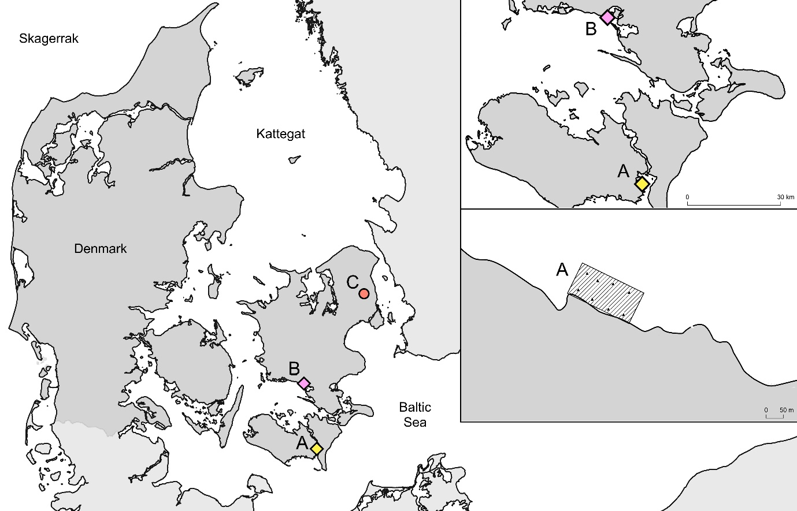

Figure 1. Main map, includes collection sites Guldborgsund (A) and Karrebaek (C), in relation to the Baltic Sea and the housing laboratory at DTU Lyngby (C). Inset top right, includes specific locations of collection sites A and B within their estuaries. Inset middle right, the 200 x 100m (2 ha) sampling area within Guldborgsund (black horizontal zone), with specific locations of eight sampling replicates (black triangles) within the area.

## S2. Tagging and tissue sampling effects on behaviour

#### Overview of pilot experiment

We conducted an further pilot experiment to test effects of individual tagging and tissue sampling procedures on the ability to measure round goby behavioural traits. We predicted that PIT tag and fin clip procedures have no effect on activity and edge use behavioural traits over short- (2 day) and medium-time periods (10 day) post-procedure. Additionally, we tested growth and survival effects over a 10 week period and predicted no treatment effect.

Round gobies were collected from a local fisherman on 1 October 2020 from Karrebæk Fjord (55.1923°, 11.67241°), a site approximately 50 km north east Guldborgsund. Karrebæk is also a shallow estuarine environment that was invaded soon after Guldborgsund (~2011), so can also be considered a comparable well-established population characterised by high population densities (Azour et al., 2015). Any fish with visible scale damage, wounds or signs of disease (lethargy, sores, high external parasite load etc.) were not collected.

Fish (n = 48) undertook a pre-treatment *Activity* assay (*day 0*), following an extended period of acclimation (40 days, 1/10/20 – 10/11/20). This extended period was included to minimise any effects of laboratory acclimation on behavioural responses and survival in each treatment group. Fish were subject to one of three tagging/sampling treatments: Control (no-PIT tag, not tissue sampling); Tagged (PIT tagged); Fin-clipped (PIT tagged and tissue sampled).

#### Data collection and analysis

Three trials were conducted to measure short and medium-term behavioural effects of tagging and sampling; one pre-treatment (*day 0*) and two post-treatment (*day 2* and *day 10*). Previous studies have shown little to no physiological effects over …….. The *Activity* assay was conducted following the same procedures as in the main experiment. The *Exploratory* assay was not used here, as the

Continuous moderators were z-transformed to aid interpretation (Schielzeth, 2010).

#### Results

## S3. Prey groupings

.

## S4. Sensitivity analyses – Survivorship bias

Of the 55 fish originally returned to the lab, 8 fish (14.5%) died during the pre-trial accliamtino period.

## S5. Sensitivity Analysis: Isotopic discrimination factors

We also sought to validate the use of fin clips to estimate the recent diet of round gobies, and estimate δ13C and δ15N isotopic discrimination factors for fin and muscle tissue of round gobies. These values were used to conduct an exploratory analysis to measure the influence of behavioural trait on round goby’s diets, by testing for correlations/covariation between personality traits and trophic/diet variation.

These fish were also maintained in the laboratory, to measure their isotopic discrimination factor of fin and muscle tissue in relation to a standardised laboratory diet