Mã lớp: 22324-CT29502

Họ và tên: Nguyễn Phúc Nguyên Khoa

MSSV: B2110083

Ex 2.1:

* Install the circuit to connect the Arduino Uno to the LCD 1602
* Write a proggram to display Hello World on LCD 1602

1. Sơ đồ mạch

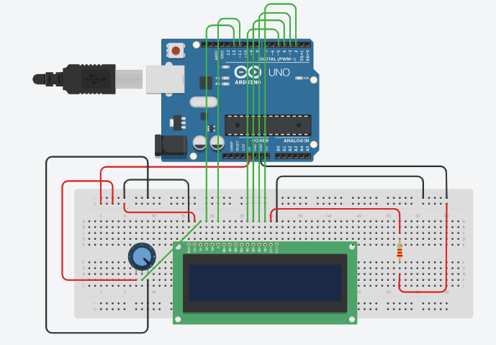

1. Sơ đồ chân

|  |  |  |  |
| --- | --- | --- | --- |
| Arduino | LCD1602 | Potentiometer | Ghi chú |
| D2 | DB7 |  |  |
| D3 | DB6 |  |  |
| D4 | DB5 |  |  |
| D5 | DB4 |  |  |
| D11 | Enable |  |  |
| D12 | Register Select |  |  |
| 5V | VCC |  |  |
| 5V |  | Terminal 1 |  |
| 5V | LED Anode |  |  |
| GND | GND |  |  |
| GND |  | Terminal 2 |  |
| GND | LED Cathode |  |  |
|  | Contrast | Wiper |  |

1. Mã lệnh

Ex 2.2:

* Install the circuit to connect the Arduino Uno to the TMP36 temperature sensor and LCD1602
* Write a program to read temperature from the temperature sensor and display it on the LCD

1. Sơ đồ mạch

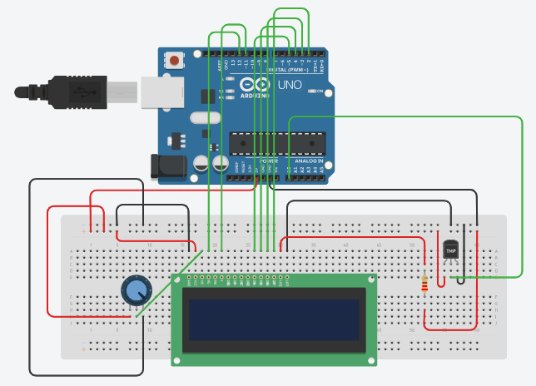

1. Sơ đồ chân

|  |  |  |  |  |
| --- | --- | --- | --- | --- |
| Arduino | LCD1602 | Potentiometer | TMP36 | Ghi chú |
| D2 | DB7 |  |  |  |
| D3 | DB6 |  |  |  |
| D4 | DB5 |  |  |  |
| D5 | DB4 |  |  |  |
| D11 | Enable |  |  |  |
| D12 | Register Select |  |  |  |
| 5V | VCC |  |  |  |
| 5V |  | Terminal 1 |  |  |
| 5V | LED Anode |  |  |  |
| GND | GND |  |  |  |
| GND |  | Terminal 2 |  |  |
| GND | LED Cathode |  |  |  |
|  | Contrast | Wiper |  |  |
| 5V |  |  | Power |  |
| GND |  |  | GND |  |
| A0 |  |  | Vout |  |

1. Mã lệnh

