Mã lớp: 12324-CT29501

Họ và tên: Nguyễn Phúc Nguyên Khoa

MSSV: B2110083

**Ex 2.1 Create a program that**

**– when the user enters ‘1’ all lights turn on**

**– when the user enters ‘2’ all lights flash**

**– when the user enters ‘3’ lights cycle repeatedly**

**– when the user enters ‘q’ or ‘e’ the lights turn off**

**– when + or - is pressed the speed of the LED increases or decreases**

1. *Sơ đồ mạch*

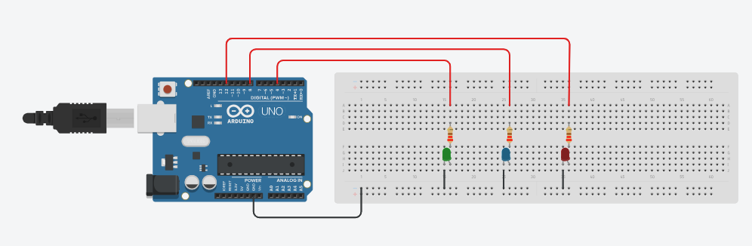

1. *Sơ đồ chân*

|  |  |  |  |  |
| --- | --- | --- | --- | --- |
| Arduino | Green led | Blue led | Red led | Ghi chú |
| D4 | Anode |  |  |  |
| D8 |  | Anode |  |  |
| D12 |  |  | Anode |  |
| GND | Cathode | Cathode | Cathode |  |

1. *Mã lệnh*

|  |  |
| --- | --- |
|  |  |
|  |  |

**Ex 2.2:**

**- Install the circuit to connect the Arduino Uno to the TMP36 temperature sensor.**

**- Write a program to read the measured temperature from the temperature sensor and display it on the computer screen**

1. *Sơ đồ mạch*

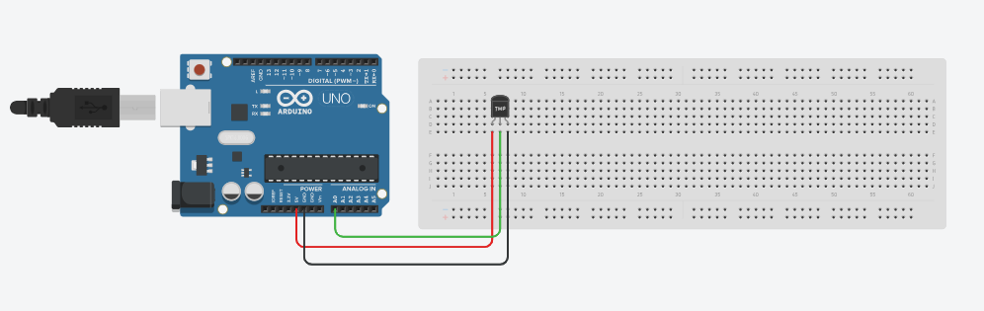

1. *Sơ đồ chân*

|  |  |  |
| --- | --- | --- |
| Arduino | TMP36 | Ghi chú |
| 5V | Power |  |
| GND | GND |  |
| A0 | VOUT |  |

1. *Mã lệnh*

