# 2022 Chisana Caribou Herd Composition Count Survey Results, Wrangell - St. Elias National Park and Preserve, Alaska

#### Scott D. Miller

#### 2023-11-27

# 2022 Composition Count Survey Results, Wrangell - St. Elias National Park and Preserve

Scott D. Miller  
Information Technology Specialist/Data Manager  
National Park Service, Arctic Inventory and Monitoring Network  
240 W. 5th Ave.  
Anchorage, AK 99501

# Executive summary

[to be written by author based on the info below]

# Introduction

Caribou abundance, survivorship and herd composition have been monitored at Wrangell - St. Elias National Park and Preserve (WRST) since the early 1980s for the Chisana herd, and the 1990s for the Mentasta herd (Table 1). Monitoring of caribou populations in WRST employs the use of radiocollars and radiotelemetry to locate groups and to provide a mark/recapture estimate of population size as well as age and sex composition. Population assessment is made in two efforts: a post-calving (June) census, when cows are grouped and calf production can be determined; and a fall (Sept. - Oct.) composition count when bulls associate with cows during the rut. With the mark-recapture estimate of cows from the spring survey and the herd composition obtained from the fall count, the herd size, composition, and calf recruitment can be estimated. Both annual surveys are conducted by aerial observation from a helicopter and small airplane.

Table 1. Length of record for monitoring of the Chisana and Mentasta caribou herds in WRST for radiotracking and herd composition and abundance surveys.

| **Herd** | **Survey type** | **Earliest** | **Latest survey** | **Years of record** |
| --- | --- | --- | --- | --- |
| Chisana | Census surveys | 1980 | 2022 | 42 |
| Chisana | Radiotracking | 1988 | 2022 | 34 |
| Mentasta | Census surveys | 1991 | 2022 | 31 |
| Mentasta | Radiotracking | 1993 | 2022 | 29 |

# Methods

Monitoring protocols were formalized in a collaboration between the Park and the Central Alaska Inventory and Monitoring Program in 2018 (Putera and Miller, 2018). These protocols, as well as associated standard operating procedures, reports, journal articles and data are available through the NPS’’s Integrated Resource Management Applications portal at <https://irma.nps.gov/DataStore/Reference/Profile/2217176>.

# Results

## Distribution

Caribou were distributed as shown in Figure 1.

## Warning in CPL_read_ogr(dsn, layer, query, as.character(options), quiet, : GDAL

## Error 1: Corrupted .shp file : shape 262 : nEntitySize = 8

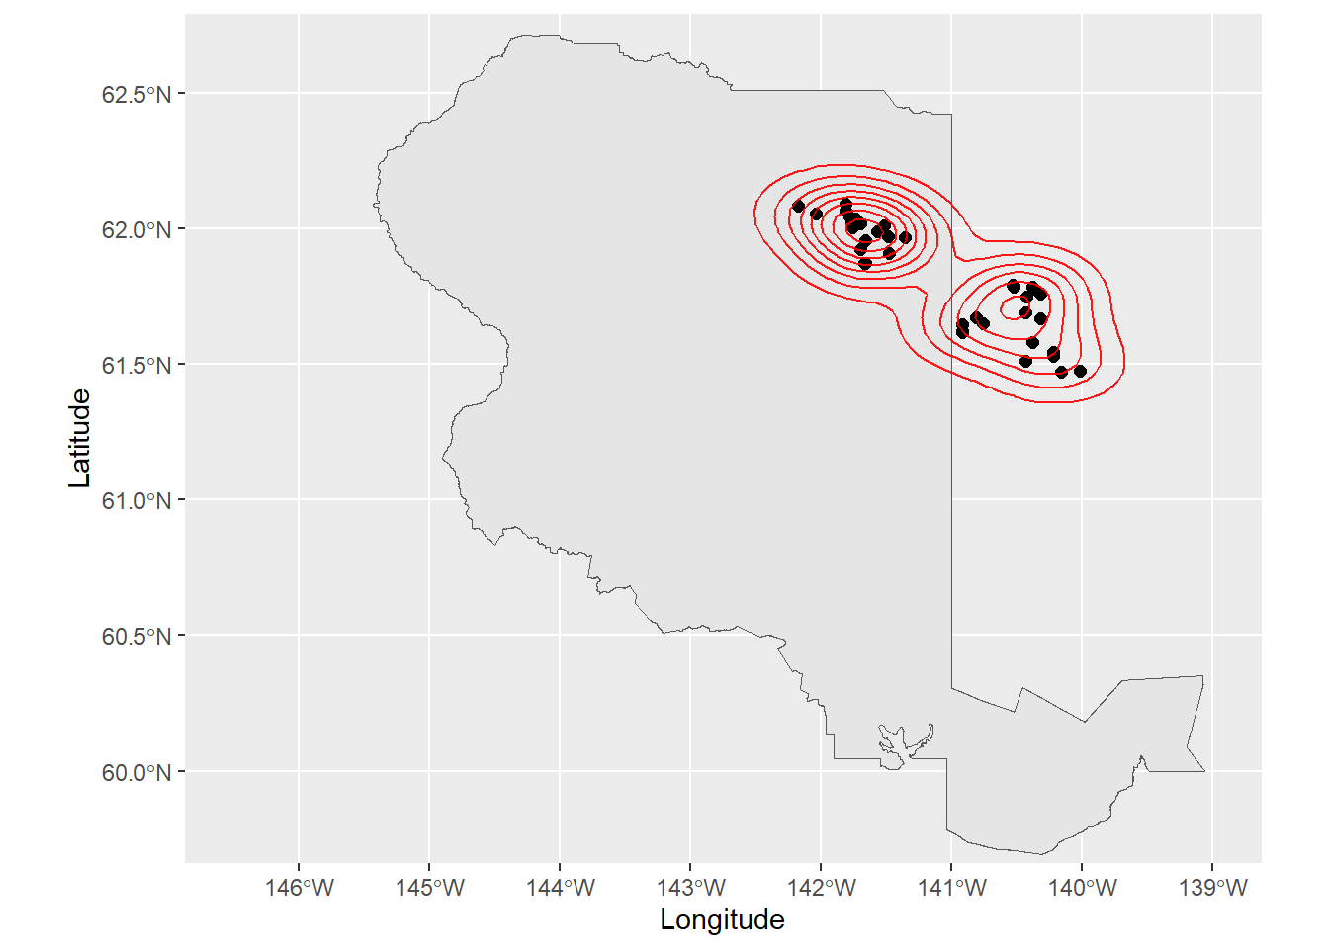

Figure 1. Distribution and density of caribou groups during the 2022 Fall Chisana Caribou Composition Survey.

## Composition

Table 2. Composition survey results.

|  | **1** |
| --- | --- |
| Survey name | 2022 Fall Chisana Caribou Composition Survey |
| Herd | Chisana |
| Survey type | CC |
| Type of survey | Composition count |
| Cow | 313 |
| Calf | 65 |
| Small bull | 78 |
| Medium bull |  |
| Large bull | 82 |
| Bull (composition survey) | 160 |
| Adult (composition survey) | 473 |
| Caribou (composition survey) | 540 |
| Unknown | 2 |
| Calf, male |  |
| Calf, female |  |
| Calf, unclassified |  |
| Calves/100 cows | 20.76677 |
| Bulls/100 cows (composition survey) | 51.11821 |
| Total groups observed | 39 |
| Groups in the survey area |  |
| Groups out of the survey area |  |
| Marked groups | 20 |
| Marked groups seen | 17 |
| Marked groups not seen | 3 |
| Percent marked groups seen | 85 |
| Percent marked groups not seen | 15 |
| Total collared animals observed | 42 |
| Number of frequencies that were available on survey date (Animal_Movement) | 46 |
| Collars not heard or not searched | 4 |
| Total groups marked seen | 36 |
| Start date | 2022-10-14 |
| End date | 2022-10-14 |
| Survey days | 1 |
| Search areas | 2 |

Table 3. Composition survey results by search area. [DEFINE THE SEARCH AREAS].

|  | **1** | **2** |
| --- | --- | --- |
| Survey name | 2022 Fall Chisana Caribou Composition Survey | 2022 Fall Chisana Caribou Composition Survey |
| Herd | Chisana | Chisana |
| Type of survey | Composition count | Composition count |
| SearchArea | AK | YG |
| Cow | 159 | 154 |
| Calf | 41 | 24 |
| Small bull | 34 | 44 |
| Medium bull |  |  |
| Large bull | 47 | 35 |
| Bull (composition survey) | 81 | 79 |
| Adult (composition survey) | 240 | 233 |
| Caribou (composition survey) | 281 | 259 |
| Unknown |  | 2 |
| Calf, male |  |  |
| Calf, female |  |  |
| Calf, unclassified |  |  |
| Calves/100 cows | 25.78616 | 15.58442 |
| Bulls/100 cows (composition survey) | 50.9434 | 51.2987 |
| Total groups observed | 19 | 20 |
| Groups in the survey area |  |  |
| Groups out of the survey area |  |  |
| Marked groups | 11 | 9 |
| Marked groups seen | 9 | 8 |
| Marked groups not seen | 2 | 1 |
| Percent marked groups seen | 81.81818 | 88.88889 |
| Percent marked groups not seen | 18.18182 | 11.11111 |
| Total collared animals observed | 29 | 13 |
| Total groups marked seen | 17 | 19 |
| Start date | 2022-10-14 | 2022-10-14 |
| End date | 2022-10-14 | 2022-10-14 |
| Survey days | 1 | 1 |
| Search areas | 1 | 1 |
| Park | WRST | WRST |
| Year | 2022 | 2022 |