**SOP ?? – WRST Caribou Monitoring Database Application**

Standard Operating Procedure #??

Version 1.0 (6/14/2016)

**Revision History Log:**

|  |  |  |  |  |  |
| --- | --- | --- | --- | --- | --- |
| **Previous Version #** | **Revision Date** | **Author** | **Changes Made** | **Reason for Change** | **New Version #** |
|  |  |  |  |  |  |
|  |  |  |  |  |  |
|  |  |  |  |  |  |
|  |  |  |  |  |  |
|  |  |  |  |  |  |
| Add rows as needed for each change or set of changes associated with each version. | | | | | |

**Table of contents**

Introduction 3

System architecture 6

Obtaining the WRST Caribou Monitoring Database Application 9

Application configuration: ODBC connections 12

Data entry 15

Caribou data entry procedures 17

Adding a new caribou 20

Editing a caribou 24

Deleting a caribou 27

Caribou attribute definitions 30

Capture data entry procedures 33

Adding capture data to a caribou 36

Editing capture data for a caribou 39

Deleting a capture record 42

Capture attribute definitions 45

Survey data entry procedures 49

Adding a survey record 52

Editing a survey record 55

Deleting a survey record 60

Animal Movement 64

**Introduction**

The [National Park Service Central Alaska Network Inventory and Monitoring program](https://science.nature.nps.gov/im/units/cakn/vitalsign.cfm?vsid=49) monitors the abundance, distribution, and demographics of the Mentasta and Chisana caribou herds in Wrangell-St. Elias National Park. Data is collected according to the WRST caribou monitoring protocol and standard operating procedures. The Caribou Monitoring Database Application is the primary tool used for data entry and quality control procedures.

*Created with the Personal Edition of HelpNDoc:* [*Easily create iPhone documentation*](http://www.helpndoc.com/feature-tour/iphone-website-generation)

**System architecture**

The WRST_Caribou Monitoring Database Application is a compiled front-end application built using Microsoft Access. WRST caribou data is stored in two SQL Server databases. GPS collar data is stored in the Alaska Region's Animal Movements database while aerial survey and capture data is stored in the Central Alaska Inventory and Monitoring Network's WRST_Caribou monitoring database. The Access application is a presentation layer; it does not store any data.

The application connects to the two databases using Open DataBase Connectivity (ODBC). Open Database Connectivity (ODBC) is a standard application programming interface (API) for accessing database management systems (DBMS).

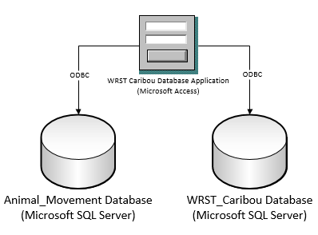

Fig. 1. Application architecture. The front-end application connects to two databases. GPS collar data is stored in the Animal Movements database while aerial survey and capture data is stored in the WRST_Caribou database. The application connects to the databases using Open DataBase Connectivity.

*Created with the Personal Edition of HelpNDoc:* [*Generate Kindle eBooks with ease*](http://www.helpndoc.com/feature-tour/create-ebooks-for-amazon-kindle)

**Obtaining the WRST Caribou Monitoring Database Application**

The WRST Caribou Monitoring Database Application is available from GitHub at the following URL:

<https://github.com/NPS-ARCN-CAKN/WRST-Caribou>

Download the application and all related files using the Download ZIP button. Use the compiled WRST_Caribou.accde application.

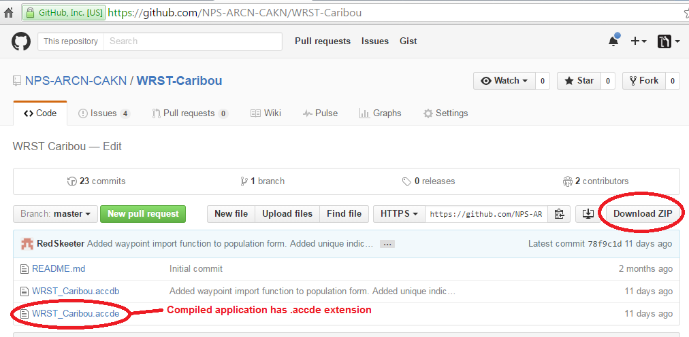

*Created with the Personal Edition of HelpNDoc:* [*Full-featured multi-format Help generator*](http://www.helpndoc.com/help-authoring-tool)

**Application configuration: ODBC connections**

The WRST Caribou Database Application is a front-end application that connects to two remote databases. See System architecture for more information. You must set up two ODBC connections before you can use the application. ODBC connections are set up on Windows using the ODBC administrator. Instructions are available on the Microsoft Developer Network website at [https://msdn.microsoft.com/en-us/library/windows/desktop/dn170503%28v=vs.85%29.aspx](https://msdn.microsoft.com/en-us/library/windows/desktop/dn170503(v=vs.85).aspx). Consult the [Central Alaska Network data manager](http://science.nature.nps.gov/im/units/cakn/contactus.cfm) for database connection information.

*Created with the Personal Edition of HelpNDoc:* [*Free Qt Help documentation generator*](http://www.helpndoc.com)

**Data entry**

*Created with the Personal Edition of HelpNDoc:* [*Full-featured Help generator*](http://www.helpndoc.com/feature-tour)

**Caribou data entry procedures**

Use the Caribou/Captures form to add, edit or delete caribou from the system or edit capture information for individual caribou.

* Adding a new caribou
* Editing a caribou
* Deleting a caribou
* Caribou attribute definitions

*Created with the Personal Edition of HelpNDoc:* [*Easy CHM and documentation editor*](http://www.helpndoc.com)

***Adding a new caribou***

# Procedure

Adding a new caribou to the WRST caribou data management system is a two part process. You must add the caribou to the Animal Movement database first. Once the Caribou record exists in the Animal Movements database you must then create a new, matching Caribou record in the WRST_Caribou database using the same ProjectID-AnimalID combination.

1. Add a caribou to the Animal Movements database using the help file.
2. Record the ProjectID and AnimalID of the new caribou.
3. Open the caribou monitoring application
4. Click the Edit caribou/captures button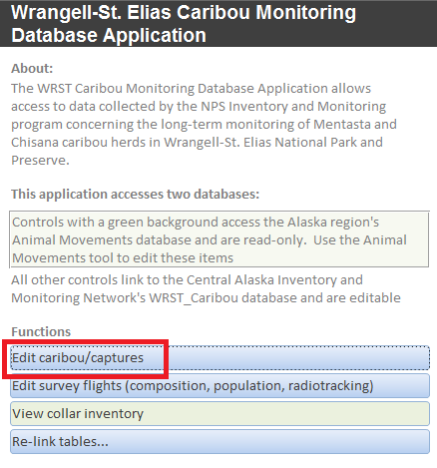
5. At the bottom of the form is button to add a record. Click it.
6. 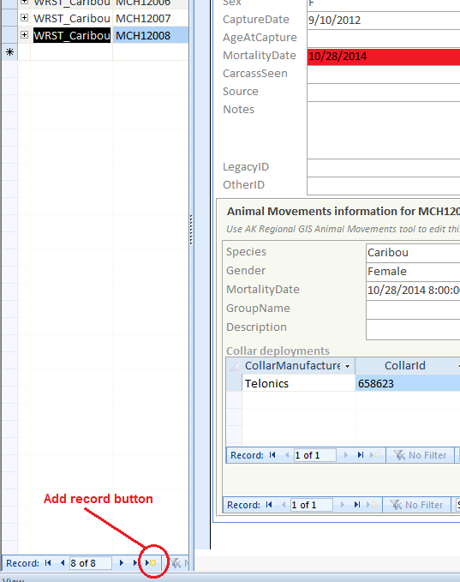
7. A blank form appears
8. Fill in the ProjectID and AnimalID from the beginning of the procedure.
9. Move off the new record or close the form to save the record.

*Created with the Personal Edition of HelpNDoc:* [*Generate EPub eBooks with ease*](http://www.helpndoc.com/create-epub-ebooks)

***Editing a caribou***

# Procedure

1. Open the Caribou/Capture form
2. Select the caribou you would like to edit from the caribou inventory on the left of the form
3. Make your edits in the details form on the right part of the form.
4. Your edits will be saved automatically when you move off the record or close the form

Note: the Animal Movements information subform showing caribou attributes and collar deploymints appears to the bottom of the detail screen. This information is read-only in the WRST Caribou Monitoring Database Application. Changes to the Animal Movements subform must be made through the Animal Movement tool.

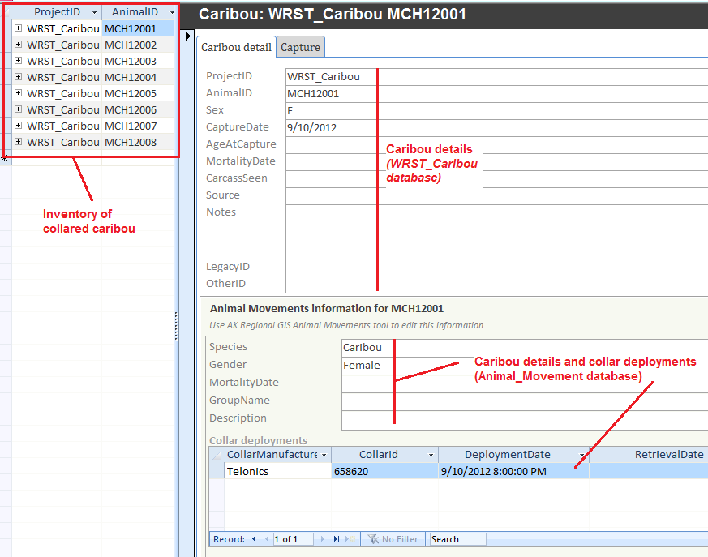

*Created with the Personal Edition of HelpNDoc:* [*Produce online help for Qt applications*](http://www.helpndoc.com/feature-tour/create-help-files-for-the-qt-help-framework)

***Deleting a caribou***

# Procedure

1. Open the Caribou/Capture form
2. Locate the caribou you would like to delete in the caribou inventory on the left of the form
3. Click the record selector corresponding to the caribou selected above
4. Tap your keyboard's Delete key
5. Confirm or cancel the deletion.

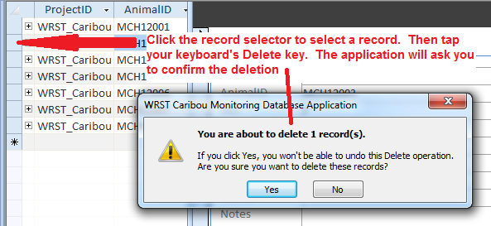

*Created with the Personal Edition of HelpNDoc:* [*News and information about help authoring tools and software*](http://www.helpauthoringsoftware.com)

***Caribou attribute definitions***

# Caribou column definitions

Column definitions for the caribou form appear below. See data entry and editing procedures for more information.

|  |  |  |  |  |  |
| --- | --- | --- | --- | --- | --- |
| Column | Nullable | Data Type | Length | Constraint | Description |
| ProjectID | NO | varchar | 16 | PRIMARY KEY | ProjectID associated with the caribou in the Animal Movements database |
| AnimalID | NO | varchar | 16 | PRIMARY KEY | AnimalID of the caribou in the Animal Movements database |
| Sex | YES | varchar | 1 | NULL | F=Female, M=Male |
| CaptureDate | YES | date | NULL | NULL | Date animal was captured |
| AgeAtCapture | YES | int | NULL | NULL | Estimated age at capture |
| MortalityDate | YES | datetime | NULL | NULL | Approximate year of death. |
| MortalityLocation | YES | geography | -1 | NULL | Mortality location. Point feature. WGS1984 Geographic Coordinate System |
| CarcassSeen | YES | int | NULL | NULL | 0=No, 1=Yes. Was a carcass seen at the caribou's death location (yes/no)? |
| Source | YES | varchar | 255 | NULL | Source of the data if it was imported from legacy data files. |
| Notes | YES | varchar | 4000 | NULL | Notes |
| LegacyID | YES | varchar | 50 | NULL | ID of the caribou prior to this database |
| OtherID | YES | varchar | 50 | NULL | Any other IDs this caribou had before this databases was built |
| RecordInsertedDate | NO | datetime | NULL | NULL | Datetime the record was inserted |
| RecordInsertedBy | NO | nvarchar | 50 | NULL | Username of person who inserted the record |

*Created with the Personal Edition of HelpNDoc:* [*Create cross-platform Qt Help files*](http://www.helpndoc.com/feature-tour/create-help-files-for-the-qt-help-framework)

**Capture data entry procedures**

Use the Caribou/Captures form to add, edit or delete caribou capture records.

* Adding capture data to a caribou
* Editing capture data for a caribou
* Deleting a capture record
* Capture attribute definitions

*Created with the Personal Edition of HelpNDoc:* [*Free help authoring tool*](http://www.helpndoc.com/help-authoring-tool)

***Adding capture data to a caribou***

# Procedure

1. Open the caribou monitoring application
2. Click the Edit caribou/captures button
3. Using the caribou inventory on the left of the form, select the caribou to which you would like to add a capture record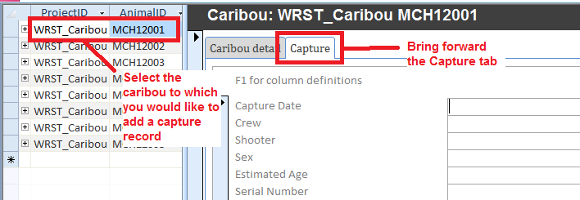
4. Click on the Capture tab
5. Enter data
6. Close the form or move off the record to save your changes

*Created with the Personal Edition of HelpNDoc:* [*Write EPub books for the iPad*](http://www.helpndoc.com/create-epub-ebooks)

***Editing capture data for a caribou***

# Procedure

1. Open the caribou monitoring application
2. Click the Edit caribou/captures button
3. Using the caribou inventory on the left of the form, select the caribou to which you would like to add a capture record
4. Click on the Capture tab
5. Edit the capture record using the form's fields
6. Close the form or move off the record to save your changes

*Created with the Personal Edition of HelpNDoc:* [*Easily create EBooks*](http://www.helpndoc.com/feature-tour)

***Deleting a capture record***

# Procedure

1. Open the Caribou/Capture form
2. Locate the caribou whose capture data you would like to delete using the caribou inventory on the left of the form
3. Click the Capture record's record selector. ***Note****: Do not confuse the Caribou record's record selector with the Capture record's record selector. They appear close together. See diagram.*
4. Tap your keyboard's Delete key
5. Confirm or cancel the deletion.

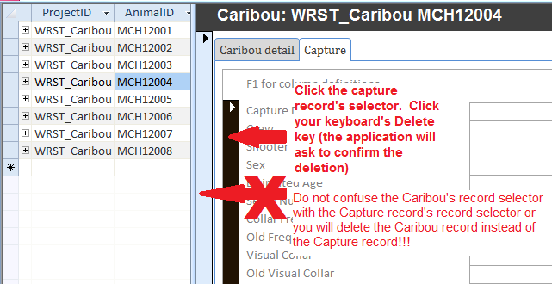

*Created with the Personal Edition of HelpNDoc:* [*Easily create Web Help sites*](http://www.helpndoc.com/feature-tour)

***Capture attribute definitions***

# Caribou capture form: Column definitions

Column definitions for the capture subform of the Caribou/Capture form appear below. See data entry and editing procedures for more information.

|  |  |  |  |  |  |
| --- | --- | --- | --- | --- | --- |
| **Column** | **Nullable** | **Data Type** | **Length** | **Constraint** | **Description** |
| AnimalID | NO | varchar | 16 | NULL | Foreign key to the Caribou table |
| CaptureDate | NO | datetime | NULL | NULL | Date the caribou was captured |
| Crew | YES | varchar | 255 | NULL | Names of crew members |
| Shooter | NO | varchar | 20 | NULL | Name of the person who shot the caribou. |
| Frequency | YES | decimal | NULL | NULL | Collar frequency |
| VisualCollar | YES | varchar | 4 | NULL | Visual collar color and number. |
| SerialNumber | YES | int | NULL | NULL | Serial number of radiocollar |
| CaptureLatitude | YES | decimal | NULL | NULL | Latitude where the caribou was captured (Decimal degrees. Geographic coordinates, WGS84 datum). |
| CaptureLongitude | YES | decimal | NULL | NULL | Longitude where the caribou was captured (Decmial degrees. Geographic coordinates, WGS84 datum). |
| OldFrequency | YES | decimal | NULL | NULL | Former frequency |
| OldVisualCollar | YES | varchar | 4 | NULL | Former visual collar code |
| GeneralLocation | YES | varchar | 255 | NULL | General location |
| TimeStartChase | YES | time | NULL | NULL | Start of the chase (24hr time format). |
| TimeFirstHitBounce | YES | time | NULL | NULL | Time of the first hit/bounce (24hr time format). |
| TimeSecordHitBounce | YES | time | NULL | NULL | Time of the second hit/bounce (24hr time format). |
| TimeThirdHitBounce | YES | time | NULL | NULL | Time of the third hit/bounce (24hr time format). |
| TimeVisibleEffect | YES | time | NULL | NULL | Time of first visible effect (24hr time format). |
| TimeAnimalDown | YES | time | NULL | NULL | Time animal subdued (24hr time format). |
| DartLocation | YES | varchar | 50 | NULL | Description of where the dart hit |
| Anesthetic | YES | varchar | 50 | NULL | Immobilizing anesthetic |
| AnestheticDosage(mg) | YES | decimal | NULL | NULL | Mg of anesthetic (per dart) |
| AnestheticConcentration(mg/ml) | YES | int | NULL | NULL | Concentration of anesthetic (mg/ml) |
| Sedative | YES | varchar | 50 | NULL | Sedative given during immobilization |
| SedativeDosage(mg) | YES | decimal | NULL | NULL | Mg of sedative (per dart) |
| SedativeConcentration(mg/ml) | YES | int | NULL | NULL | Concentration of sedative (mg/ml) |
| NumHits | YES | int | NULL | NULL | Number of dart hits |
| NumMisses | YES | int | NULL | NULL | Number of dart misses |
| DrugEffect | YES | int | NULL | NULL | 1-5 (Light --> Heavy |
| InitialBodyTemp | YES | decimal | NULL | NULL | Initial body temperature (Centigrade) |
| InitialBodyTempTime | YES | time | NULL | NULL | Initial body temperature time (24hr) |
| FinalBodyTemperature | YES | decimal | NULL | NULL | Final body temperature (Centigrade) |
| FinalBodyTemperatureTime | YES | time | NULL | NULL | Final body temperature time (24hr) |
| AdditionalDrugs | YES | varchar | 100 | NULL | Additional drugs |
| WithCalf | YES | int | NULL | NULL | Was the caribou with a calf? True/False. |
| Lactating | YES | int | NULL | NULL | Was the caribou lactating? True/False |
| BodyCondition | YES | varchar | 10 | NULL | Fat, Good, Poor, Emaciated |
| Weight_Kg | YES | decimal | NULL | NULL | Weight in kilograms |
| BodyLength | YES | decimal | NULL | NULL | Body length in centimeters |
| NeckCircumference | YES | decimal | NULL | NULL | Neck circumference in centimeters |
| Jaw | YES | decimal | NULL | NULL | Jaw length in centimeters. |
| MetatarsusLength | YES | decimal | NULL | NULL | Metatarsus measurement in centimeters |
| HindfootLength | YES | decimal | NULL | NULL | Hindfoot measurement in centimeters. |
| ChestGirth | YES | decimal | NULL | NULL | Chest girth in centimeters |
| BloodSampleRed | YES | int | NULL | NULL | ??? |
| BloodSamplePurple | YES | int | NULL | NULL | ???? |
| BloodSampleGreen | YES | int | NULL | NULL | ??? |
| AnestheticReversal | YES | varchar | 50 | NULL | Drug used to reverse effects of anesthetic |
| AnestheticReversalDosage(mg) | YES | decimal | NULL | NULL | Drug reversal dose using Naltrexone. Units ?? |
| AnestheticReversalConcentration | YES | int | NULL | NULL | Concentration of anesthetic reversal given |
| AnestheticReversalRoute | YES | varchar | 50 | NULL | Route of reversal dose |
| AnestheticReversalTime | YES | time | NULL | NULL | Time (24hr) anesthetic reversal administered |
| SedativeReversal | YES | varchar | 50 | NULL | Drug used to reverse effects of sedative |
| SedativeReversalDosage(mg) | YES | decimal | NULL | NULL | Time (24hr) of dosing of Tolazoline. |
| TimeStanding | YES | time | NULL | NULL | Time (24hr) caribou stood up. |
| TimeMobile | YES | time | NULL | NULL | Time (24hr) caribou became mobile |
| Comments | YES | varchar | 1000 | NULL | Comments |
| CaptureID | NO | varchar | 50 | NULL | Primary key |
| RecordInsertedDate | NO | datetime | NULL | NULL | Datetime the record was inserted |
| RecordInsertedBy | NO | nvarchar | 50 | NULL | Username of person who inserted the record |
| ProjectID | NO | varchar | 16 | NULL | ProjectID associated with the caribou in the Animal Movements database |
| TS | YES | timestamp | NULL | NULL | Timestamp. Access front-end needs this to avoid write conflict errors. No other purpose. |
| EstimatedAge | YES | int | NULL | NULL | NULL |
| SedativeReversalRoute | YES | varchar | 50 | NULL | NULL |
| SedativeReversalConcentration(mg/ml) | YES | int | NULL | NULL | NULL |
| Sex | NO | int | NULL | NULL | NULL |
| SedativeReversalTime | YES | time | NULL | NULL | NULL |

*Created with the Personal Edition of HelpNDoc:* [*Create cross-platform Qt Help files*](http://www.helpndoc.com/feature-tour/create-help-files-for-the-qt-help-framework)

**Survey data entry procedures**

The Survey form allows you to edit data collected during composition count, population or radiotracking surveys.

*Created with the Personal Edition of HelpNDoc:* [*Easy Qt Help documentation editor*](http://www.helpndoc.com)

***Adding a survey record***

# Procedure

1. Open the WRST Caribou Monitoring Database Application
2. Click the Edit survey flights (composition, population, radiotracking button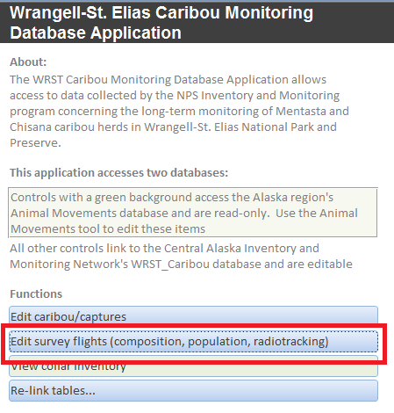
3. The Survey Flights form opens
4. Click the New (blank) record button at the bottom of the form.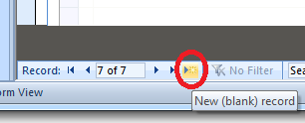
5. Enter the new Survey Flight data into the form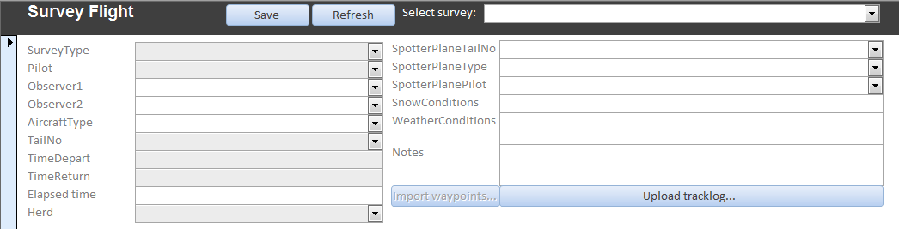
6.  Note: You won't be allowed to upload survey flight waypoints until the record is saved. At that time the Import Waypoints button will be enabled. See Editing a composition count survey record for more information on importing waypoints.
7. Save the record by clicking Save, moving off the record or closing the form.

*Created with the Personal Edition of HelpNDoc:* [*Full-featured Documentation generator*](http://www.helpndoc.com)

***Editing a survey record***

# Procedure

1. Open the WRST Caribou Monitoring Database Application
2. Click the Edit survey flights (composition, population, radiotracking button
3. The Survey Flights form opens
4. Select the flight you would like to edit using the flight selector dropdown tool 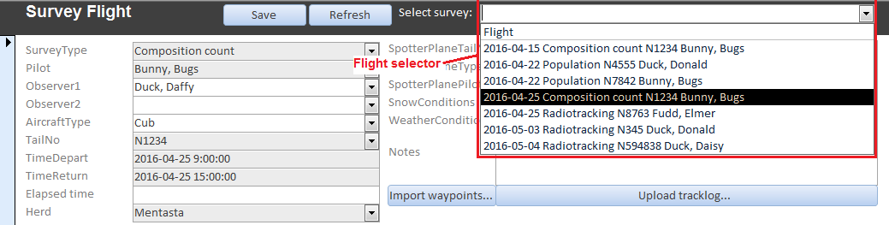
5. Make your edits. Note: You may not edit a certified Survey record. A Survey record is certified if a date appears in the CertificationDate text box.
6. Save the record by clicking Save, moving off the record or closing the form.
7. See Importing survey GPS waypoints to add waypoints and animal group attributes to the survey record.

# Waypoints importing procedure

Once a survey record is created the survey results can be entered. These results consist of spatial locations of animals or animal groups and their associated attributes and/or an inventory of collared animals in the group. The easiest way to accomplish this task is to import the GPS waypoints into the database and then modify the records.

GPS waypoints must be in shapefile format, WGS84 GCS coordinate system (lat/lon) as exported from [DNRGPS](http://www.dnr.state.mn.us/mis/gis/DNRGPS/DNRGPS.html) software. See the waypoints file specification below and the [DNRGPS](http://maps1.dnr.state.mn.us/dnrgps/index.html) documentation for help.

1. Navigate to the survey record to which you would like to import waypoints
2. Click the Import waypoints... button
3. Confirm 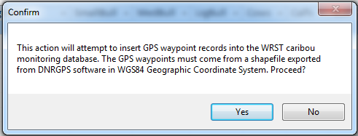
4. Navigate to the directory containing the DNRGPS shapefile containing the waypoints you would like to import
5. Select the .dbf file of the waypoints shapefile
6. 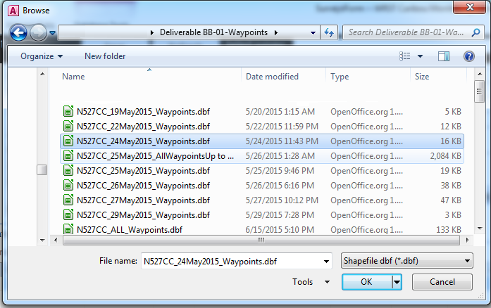
7. Click OK
8. If the waypoints imported successfully you will receive a message: 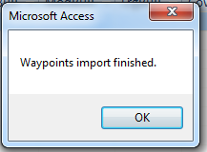
9. Click OK
10. It may take a few seconds for the record to requery and the waypoints to appear.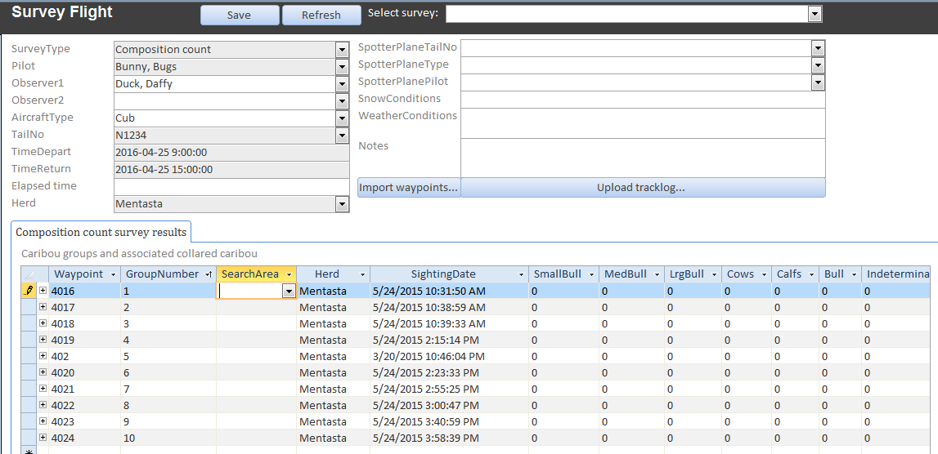
11. Edit the waypoint records to reflect the information on the survey data sheets, e.g., edit the record's SearchArea, Herd, animal group attributes, etc.
12. Click Save, close the form or move off the record to save.

# Record any radiocollar frequencies detected in the caribou group

The example below shows a composition count survey record but procedures are similar for population and radiotracking surveys.

Next, match any radiocollar frequencies that were detected in the waypoint's animal group from the data sheet to specific caribou from the Animal Movements GPS collar database.

1. Expand the waypoint record node for a waypoint record containing a detected radiocollar frequency
2. Select the frequency from the dropdown list. If your frequency does not appear then you must enter the radiocollar data into the Animal Movements database.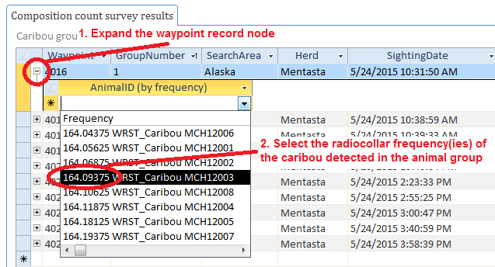
3. Add as many frequency records as needed to match the frequency data found on the data sheet. This example shows that two collared caribou were detected in the animal group at waypoint 4016 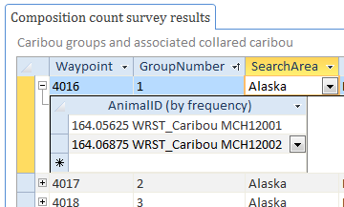

*Created with the Personal Edition of HelpNDoc:* [*Easy to use tool to create HTML Help files and Help web sites*](http://www.helpndoc.com/help-authoring-tool)

***Deleting a survey record***

# Procedure

1. Open the WRST Caribou Monitoring Database Application
2. Click the Edit survey flights (composition, population, radiotracking button
3. The Survey Flights form opens
4. Select the flight you would like to delete using the flight selector dropdown tool 
5. Click the record selector to the right of the form 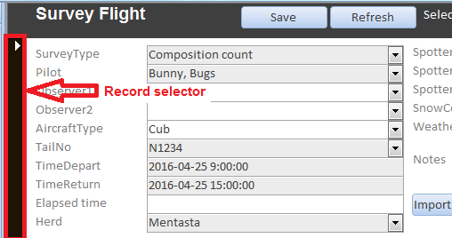
6. Click your keyboard's Delete button
7. Click Yes to confirm the record deletion 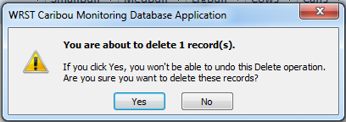

*Created with the Personal Edition of HelpNDoc:* [*Full-featured EPub generator*](http://www.helpndoc.com/create-epub-ebooks)

**Animal Movement**

The Animal Movement tool is available from the NPS Alaska Region GIS drive at X:\GIS\Apps\AnimalMovement.

Documentation for the Animal Movement tool can be found in GitHub: <https://github.com/regan-sarwas/AnimalMovement/blob/master/Documentation/Documentation.rst>

*Created with the Personal Edition of HelpNDoc:* [*Full-featured Documentation generator*](http://www.helpndoc.com)